Ex.No. : 2

DDL Commands with Constraints – PRIMARY, FOREIGN KEY, UNIQUE, CHECK

#### Questions:

1. Alter the table STUDENT with following structure.

|  |  |  |
| --- | --- | --- |
| # | Column Name | Constraints |
| 1 | RegNo | PRIMARY  KEY |
| 2 | MobileNo | NOT NULL |

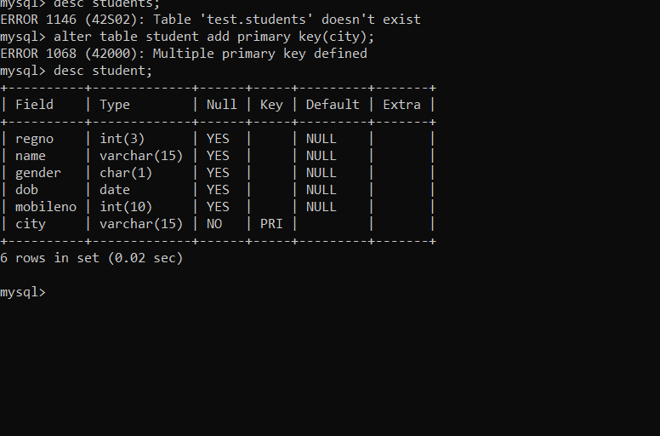

1. Alter the table name FACULTY with following structure. The DeptNo in this table refers the DeptNo in the DEPARTMENT table.

|  |  |  |
| --- | --- | --- |
| # | Column Name | Constraints |
| 1 | FacNo | PRIMARY  KEY |
| 2 | Gender | CHECK  ‘M’ or ‘F’ |

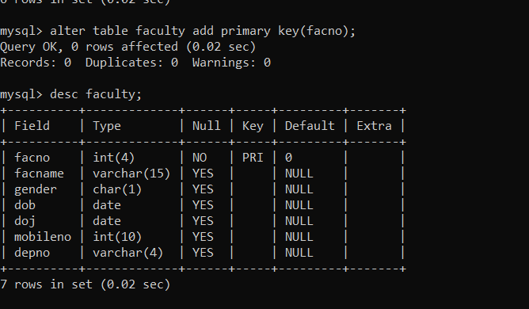

4)Alter the table name DEPARTMENT with following structure.

|  |  |  |
| --- | --- | --- |
| # | Column  Name | Constraint |
| 1 | DeptNo | PRIMARY  KEY |

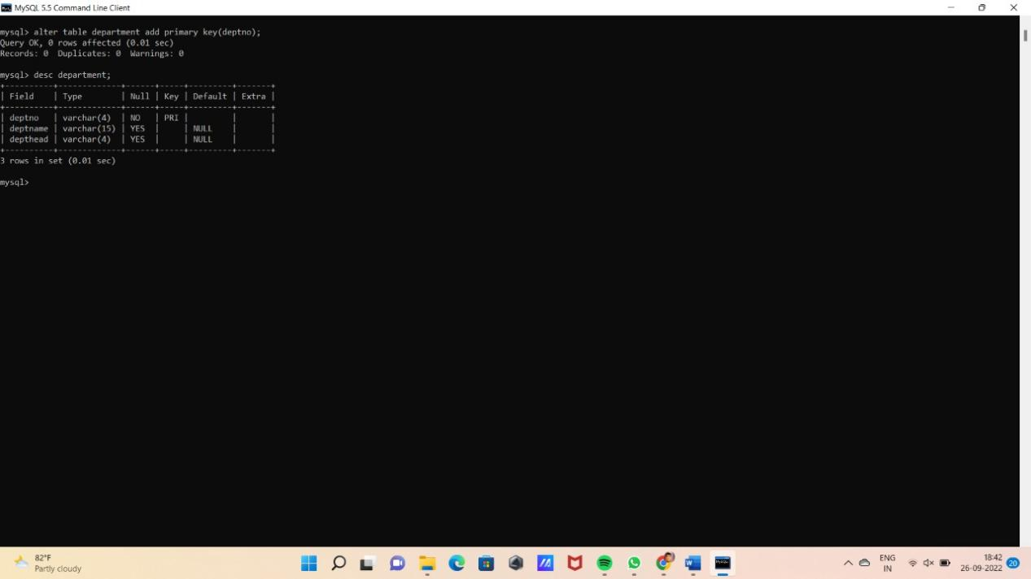

5)Alter the table name COURSE with following structure.

|  |  |  |
| --- | --- | --- |
| # | Column  Name | Constraint |
| 1 | CourseNo | PRIMARY  KEY |
| 2 | SemNo | 1 to 6 |

