**Exp no: 7**

Sub-Query and Correlated Sub-Query:

1. Which of the student’s score is greater than the highest score?
2. Which of the students’ have written more than one assessment test?
3. Which faculty has joined recently and when?
4. List the course and score of assessments that have the value more than the average score each Course

##### OUTPUTS:

1)

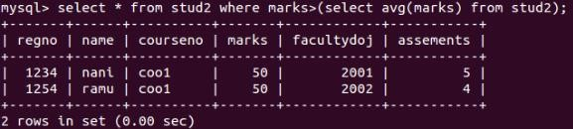

2)



3)

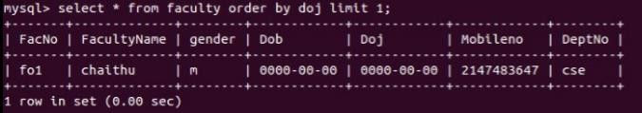

4)

