**Django- ReactJS**

**Django:**

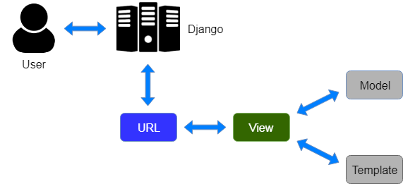

**Pro’s:**

* **we can use for both frontend and backend as well**
* **we can create multiple applications in the project**
* **fast development.**
* **it provides in-built pre-defined features and lib (admin panel, roles)**
* **it’s ORM Framework (much faster and query independent)**
* **Django community is big (we can easily find the solutions)**
* **It supports Django template Engine (here we can write CSS html JavaScript)**
* **We can give multiple Database’s connections**
* **We can create Rest API’S so we can use those in JavaScript Frameworks**
* **We can also execute python scripts if required.**
* **Good Performance.**

**Con’s:**

* **Django knowledge is required to write templates to design frontend pages (Jinja)**

**ReactJS:**

**Pro’s:**

* **Faster Development**
* **Reusable components**
* **Light weight**

**Con’s:**

* **we can use for frontend only. For backend we need to create API's using DJANGO/.NET/NODEJS (Express JS)**
* **we cannot call python scripts directly.**
* **Person should have basic knowledge on ReactJS**

**DJANGO with ReactJS**

[**https://www.geeksforgeeks.org/integrating-django-with-reactjs-using-django-rest-framework/?ref=rp**](https://www.geeksforgeeks.org/integrating-django-with-reactjs-using-django-rest-framework/?ref=rp)