Dear All,

We would like to inform you that your actual investment proofs are required for the investment declaration submitted by you during the beginning of the Fin. Year 2023-24. We need the actual investment proofs to calculate the income tax for the fin .year 23-24. Please Upload Savings Proofs in Keka Portal on or before 12th-Jan-2024 as per the instructions below.

Keka Portal Login:
=>My Finances
=>Manage Tax
=>Declarations

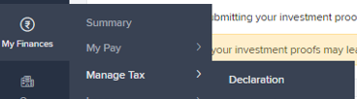

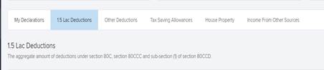

=>Edit Declaration

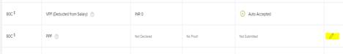

=>Upload Documents at Proofs submission.

=>Save.

Please find attached formats for submission of actual investment proofs for the purpose of TDS for financial year 2023-24. Proposed investment declaration given for this financial year 2023-2024 would be replaced with your actual investment proofs in January 2024.
=========================================================================================================================================

Guidelines:
þ Upload income tax proofs in Keka Portal for FY 2023-24.
þ Mention your Employee name on all the attached Income tax proofs and declarations.
þ PAN Copy & Address are mandatory. Please do not fail to furnish the same.
þ Submit all the supporting documents pertaining to current financial year . However you may submit your last years' LIC receipts for the premium paid during December 2023 to March 2024, which are due to be paid post Dec 31st 2023 for claiming deduction.
þ Please submit your actual investments by 12th-Jan-2024. Any investment proofs submitted after 12th-Jan-2024 will not be considered. Tax will be computed on the basis of the actual investment proofs submitted by you, and tax will be deducted accordingly from January 2024 salary onwards.
þ In case we don't receive your declaration by the above mentioned deadline, it will be assumed that you have not claimed any deductions / exemptions; and only the items which are deducted by the company (viz. PF) will be considered to arrive at your final tax liability.
According to section 206AA it is mandatory for employees to furnish PAN in case of receipt of any sum or income or amount, on which tax is deductible. If employee fails to furnish his/her PAN to the employer, the employer has been made responsible to make TDS at 20% or applicable slab rate whichever higher. TDS deducted once will not be refunded.

Deductions available from salary income:

Sr. No. | Description of Investment/s | Documents Required
1. | House Rent paid to the Landlord | Original Rent Receipts for every Quarter (with Revenue Stamp above Rs. 4999/-). Receipt should contain PAN of Landlord if Rent for the year exceeds one Lakh per annum.  April’23 to June’23 –Receipt Date should be between the April’23 to June’23  July’23 to Sept’23- Receipt Date should be between the April’23 to June’23  Oct’23 to Dec’23 – Receipt Date should be between the Oct’23 to Dec ’23  Jan’24 to March’24– Receipt Date should be in the month of Jan’24
2. | Interest on Housing Loan | Certificate from Bank / Financial Institution with interest and principal break up for housing loan repayment, Form 12C and Computation of Income or Loss from House Property - Annexure to Form 12C.
3. | Eligible Investments, Contribution and Subscriptions – 80C | Copy of the investment done during the year.
4. | Mediclaim – 80D | Mediclaim Policy Copy and Premium paid Certificate.
5. | Others Investments | Copy of the investment done during the year.

Thanks for your support and co-operation.

