Automating Data Import and Relationship Mapping Using Import Sets & Dot Walking
Team Leader: SIVANESAN.M
Team Members: SATHISKUMAR, SARATHKUMAR, SATHIYAGANESH, SHRIRAM.J
Course: Bachelor of Computer Applications (BCA)
Academic Year: 2025 - 2026

Acknowledgement
We would like to express our sincere gratitude to our faculty members and institution for providing us the opportunity to work on this project titled 'Automating Data Import and Relationship Mapping Using Import Sets & Dot Walking'. This project helped us gain practical knowledge of the ServiceNow platform and understand real-world IT service management workflows. We also thank our teammates for their collaboration and support throughout the development of this project.

Abstract
This project demonstrates how ServiceNow can automate the process of importing employee data and establishing relationships between data tables using Import Sets, Transform Maps, and Dot Walking. The system imports employee records from external files and ensures that relevant details such as department and manager information are automatically displayed when incidents are assigned. This automation improves efficiency, reduces manual work, and ensures accurate data management within the organization.

1. Introduction
ServiceNow is a widely used cloud platform for IT service management and workflow automation. Organizations often need to integrate external data sources such as HR systems with ServiceNow. Manually entering this data can be inefficient and error-prone. Import Sets allow data to be imported from external files while Transform Maps enable mapping of fields between staging tables and target tables. Dot Walking is a powerful feature that allows users to retrieve related data across tables without manually opening each record.
ServiceNow is a widely used cloud platform for IT service management and workflow automation. Organizations often need to integrate external data sources such as HR systems with ServiceNow. Manually entering this data can be inefficient and error-prone. Import Sets allow data to be imported from external files while Transform Maps enable mapping of fields between staging tables and target tables. Dot Walking is a powerful feature that allows users to retrieve related data across tables without manually opening each record.
ServiceNow is a widely used cloud platform for IT service management and workflow automation. Organizations often need to integrate external data sources such as HR systems with ServiceNow. Manually entering this data can be inefficient and error-prone. Import Sets allow data to be imported from external files while Transform Maps enable mapping of fields between staging tables and target tables. Dot Walking is a powerful feature that allows users to retrieve related data across tables without manually opening each record.
ServiceNow is a widely used cloud platform for IT service management and workflow automation. Organizations often need to integrate external data sources such as HR systems with ServiceNow. Manually entering this data can be inefficient and error-prone. Import Sets allow data to be imported from external files while Transform Maps enable mapping of fields between staging tables and target tables. Dot Walking is a powerful feature that allows users to retrieve related data across tables without manually opening each record.

2. Problem Statement
Organizations frequently need to import employee details such as name, email, department, and manager from external systems. Without automation, administrators must manually enter this data into ServiceNow, which is time-consuming and may lead to errors. The challenge is to automate the data import process and automatically establish relationships between employees and their managers.
Organizations frequently need to import employee details such as name, email, department, and manager from external systems. Without automation, administrators must manually enter this data into ServiceNow, which is time-consuming and may lead to errors. The challenge is to automate the data import process and automatically establish relationships between employees and their managers.
Organizations frequently need to import employee details such as name, email, department, and manager from external systems. Without automation, administrators must manually enter this data into ServiceNow, which is time-consuming and may lead to errors. The challenge is to automate the data import process and automatically establish relationships between employees and their managers.

3. Objectives
- Import employee records from external CSV files into ServiceNow.
- Create Import Set tables automatically.
- Map imported data to the ServiceNow user table using Transform Maps.
- Establish relationships between employee, department, and manager.
- Use Dot Walking to retrieve related information.
- Improve efficiency in incident management workflows.

4. Background Study
ServiceNow provides several features for data management and integration. Import Sets are used to import external data into staging tables. Transform Maps define how the imported data should be mapped to target tables. Dot Walking allows access to fields in related tables through reference fields. These features enable organizations to automate workflows and manage large datasets efficiently.
ServiceNow provides several features for data management and integration. Import Sets are used to import external data into staging tables. Transform Maps define how the imported data should be mapped to target tables. Dot Walking allows access to fields in related tables through reference fields. These features enable organizations to automate workflows and manage large datasets efficiently.
ServiceNow provides several features for data management and integration. Import Sets are used to import external data into staging tables. Transform Maps define how the imported data should be mapped to target tables. Dot Walking allows access to fields in related tables through reference fields. These features enable organizations to automate workflows and manage large datasets efficiently.
ServiceNow provides several features for data management and integration. Import Sets are used to import external data into staging tables. Transform Maps define how the imported data should be mapped to target tables. Dot Walking allows access to fields in related tables through reference fields. These features enable organizations to automate workflows and manage large datasets efficiently.

5. System Architecture
The system architecture consists of an external data source, ServiceNow Import Set staging table, Transform Map processing layer, and the target user table. The incident management module retrieves related data through dot walking when incidents are assigned to employees.
The system architecture consists of an external data source, ServiceNow Import Set staging table, Transform Map processing layer, and the target user table. The incident management module retrieves related data through dot walking when incidents are assigned to employees.
The system architecture consists of an external data source, ServiceNow Import Set staging table, Transform Map processing layer, and the target user table. The incident management module retrieves related data through dot walking when incidents are assigned to employees.

6. Implementation

Implementation Step
Searching for Import Sets in ServiceNow navigation.
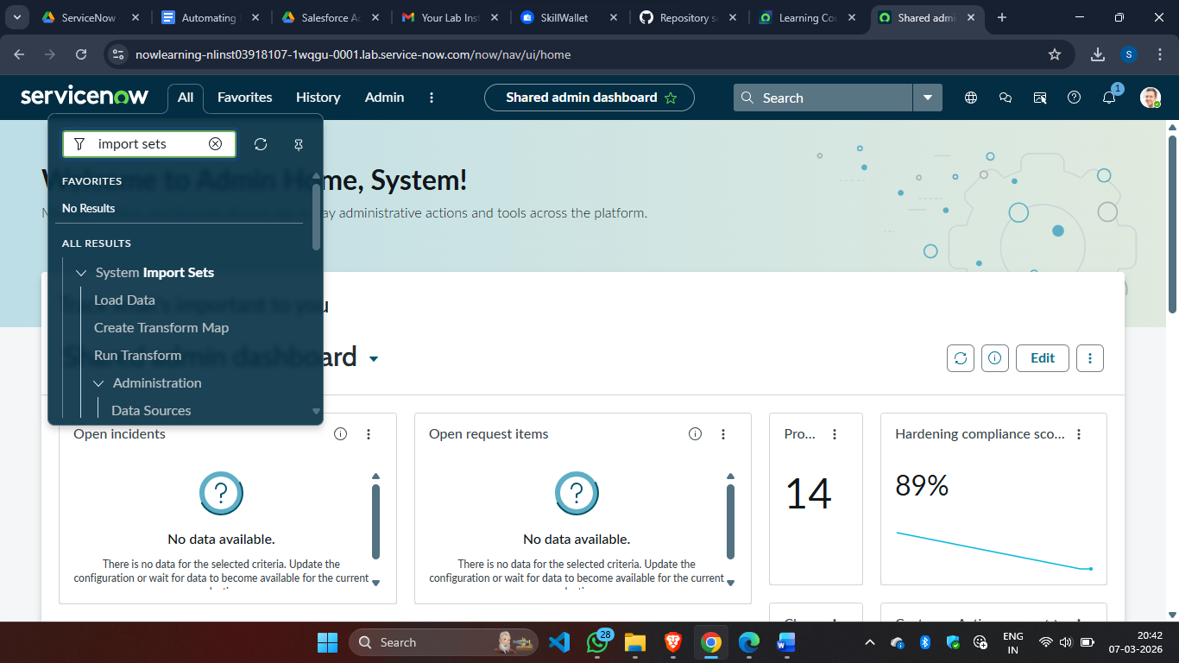
This step demonstrates how the ServiceNow interface is used to configure the import process. Administrators define the import table, map the fields to the target table, and execute the transform process.
This step demonstrates how the ServiceNow interface is used to configure the import process. Administrators define the import table, map the fields to the target table, and execute the transform process.

Implementation Step
Loading employee data and creating an Import Set table.
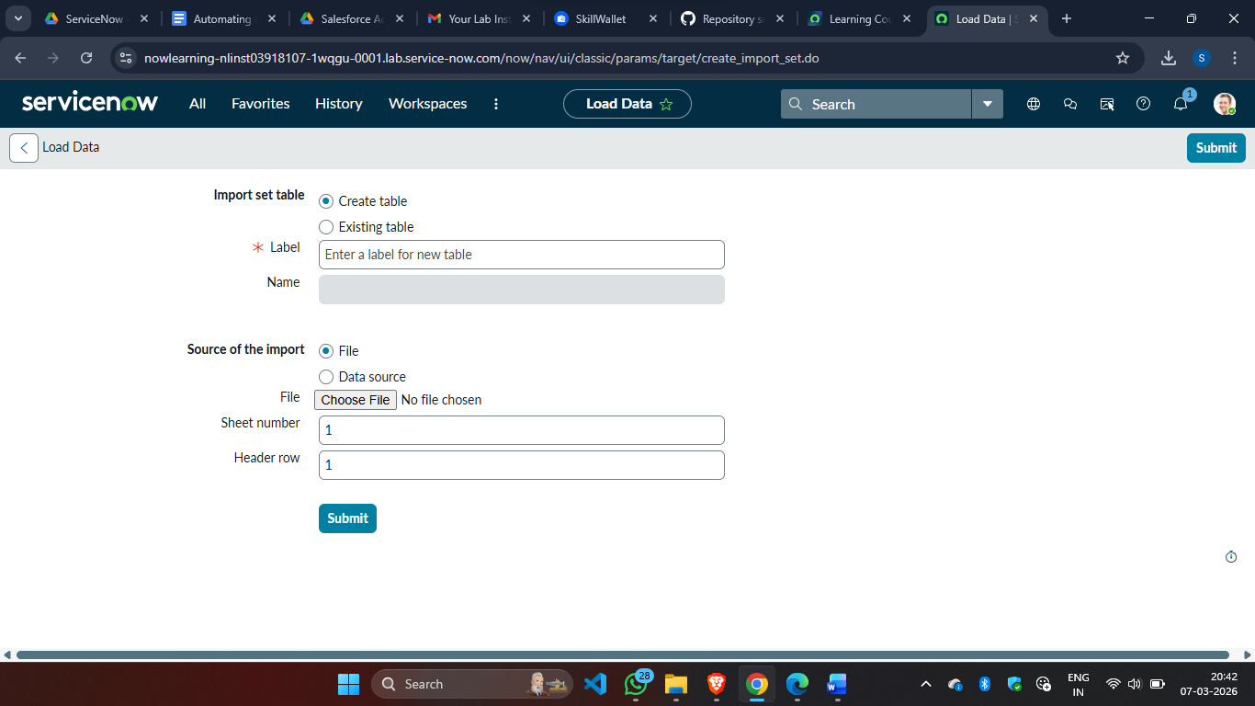
This step demonstrates how the ServiceNow interface is used to configure the import process. Administrators define the import table, map the fields to the target table, and execute the transform process.
This step demonstrates how the ServiceNow interface is used to configure the import process. Administrators define the import table, map the fields to the target table, and execute the transform process.

Implementation Step
Creating a Transform Map to map fields between tables.
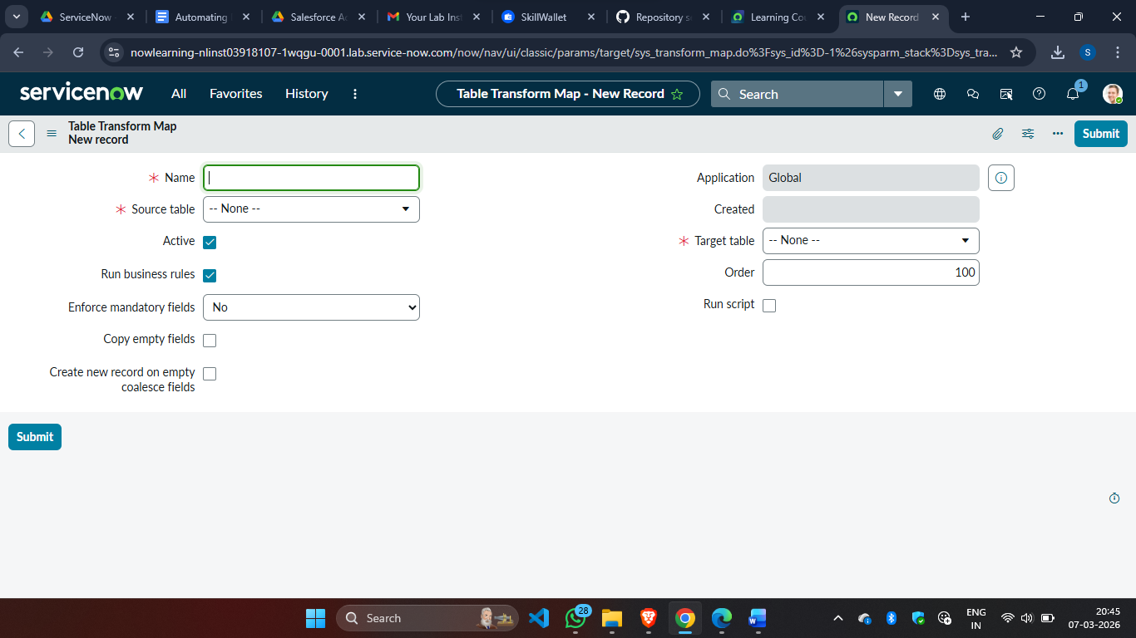
This step demonstrates how the ServiceNow interface is used to configure the import process. Administrators define the import table, map the fields to the target table, and execute the transform process.
This step demonstrates how the ServiceNow interface is used to configure the import process. Administrators define the import table, map the fields to the target table, and execute the transform process.

Implementation Step
Configuring the Transform Map layout and fields.
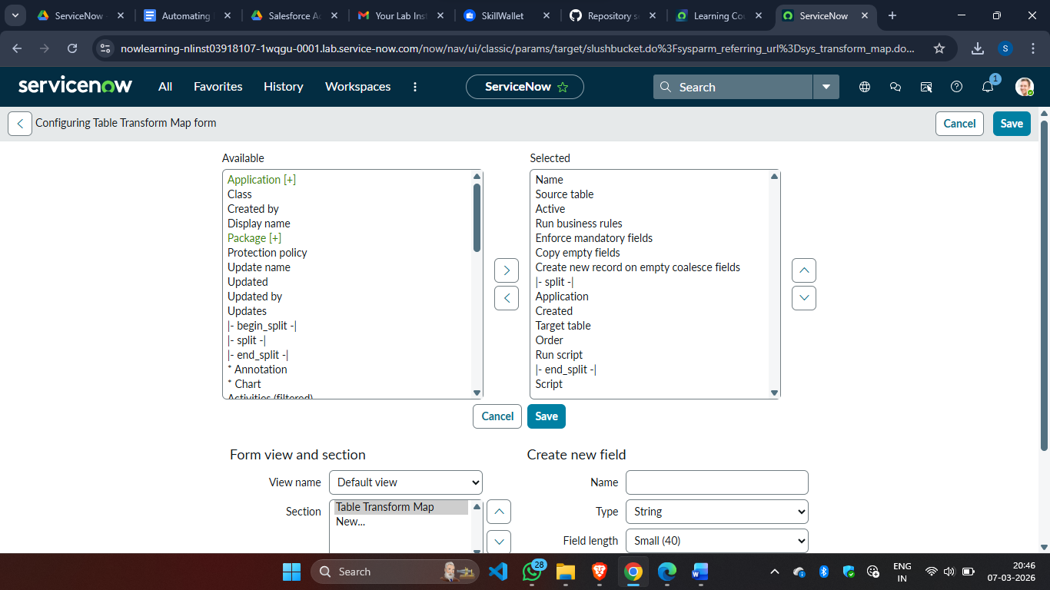
This step demonstrates how the ServiceNow interface is used to configure the import process. Administrators define the import table, map the fields to the target table, and execute the transform process.
This step demonstrates how the ServiceNow interface is used to configure the import process. Administrators define the import table, map the fields to the target table, and execute the transform process.

7. Testing
The system was tested using multiple datasets to ensure that the import process works correctly and that relationships are mapped accurately.
Test Case | Input | Expected Result | Status
Import CSV File | Employee dataset | Records imported successfully | Pass
Transform Map | Imported data | Fields mapped correctly | Pass
Incident Assignment | Assign employee | Department auto displays | Pass
Dot Walking | Assign user | Manager email auto displays | Pass

8. Advantages
- Reduces manual data entry.
- Improves data accuracy.
- Automates relationship mapping.
- Enhances incident management efficiency.
- Scalable for large datasets.

9. Future Scope
Future enhancements could include integrating ServiceNow with external APIs for real-time data synchronization, implementing advanced reporting features, and using AI-based analytics for predictive incident management.
Future enhancements could include integrating ServiceNow with external APIs for real-time data synchronization, implementing advanced reporting features, and using AI-based analytics for predictive incident management.

10. Conclusion
This project successfully demonstrates the use of ServiceNow Import Sets, Transform Maps, and Dot Walking to automate data import and relationship mapping. The system improves operational efficiency and reduces manual work for administrators.

