Digital Nurture 4.0
Week 1
Data Structures and Algorithm
Exercise 2: E-commerce Platform Search Function

PROGRAM:
ECommerceSearchExample.java
import java.util.Arrays;
import java.util.Comparator;
public class ECommerceSearchExample {
static class Product {
int productId;
String productName;
String category;
public Product(int productId, String productName, String category) {
this.productId = productId;
this.productName = productName;
this.category = category;
}
@Override
public String toString() {
return "[" + productId + ", " + productName + ", " + category + "]";
}
}
public static Product linearSearch(Product[] products, int targetId) {
for (Product product : products) {
if (product.productId == targetId) {
return product;
}
}
return null;
}
public static Product binarySearch(Product[] products, int targetId) {
int low = 0, high = products.length - 1;
while (low <= high) {
int mid = (low + high) / 2;
if (products[mid].productId == targetId) {
return products[mid];
} else if (products[mid].productId < targetId) {
low = mid + 1;
} else {
high = mid - 1;
}
}
return null;
}
public static void main(String[] args) {
Product[] products = {
new Product(105, "Mouse", "Electronics"),
new Product(101, "Laptop", "Electronics"),
new Product(103, "Shoes", "Fashion"),
new Product(102, "Phone", "Electronics"),
new Product(104, "T-shirt", "Fashion")
};
int searchId = 103;
Product foundLinear = linearSearch(products, searchId);
System.out.println("Linear Search Result for ID " + searchId + ": " + foundLinear);
Arrays.sort(products, Comparator.comparingInt(p -> p.productId));
Product foundBinary = binarySearch(products, searchId);
System.out.println("Binary Search Result for ID " + searchId + ": " + foundBinary);
}
}

OUTPUT:
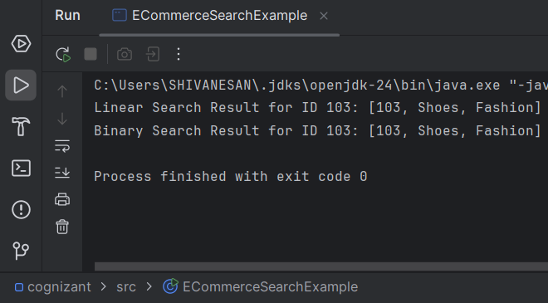

Exercise 7: Financial Forecasting
PROGRAM:
FinancialForecast.java
public class FinancialForecast {
public static double forecast(double presentValue, double growthRate, int years) {
if (years == 0) {
return presentValue;
}
return forecast(presentValue, growthRate, years - 1) * (1 + growthRate);
}
public static void main(String[] args) {
double initialValue = 10000;
double growthRate = 0.10;
int years = 5;
double futureValue = forecast(initialValue, growthRate, years);
System.out.printf("Future Value after %d years: %.2f%n", years, futureValue);
}
}

OUTPUT:

