Digital Nurture 4.0
Week 1
1.Design Principle & Patterns
Exercise 1: Implementing the singleton pattern

PROGRAM:
Logger.java
public class Logger {
private static Logger instance;
private Logger() {
System.out.println("Logger instance created.");
}
public static Logger getInstance() {
if (instance == null) {
instance = new Logger();
}
return instance;
}
public void log(String message) {
System.out.println("Log: " + message);
}
}

main.java
public class main {
public static void main(String[] args) {
Logger logger1 = Logger.getInstance();
Logger logger2 = Logger.getInstance();
logger1.log("First log message");
logger2.log("Second log message");
if (logger1 == logger2) {
System.out.println("Only one instance exists. Singleton works!");
} else {
System.out.println("Multiple instances exist. Singleton failed.");
}
}

OUTPUT:

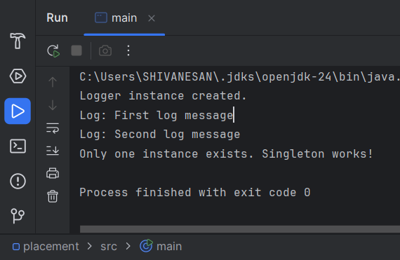

Exercise 2: Implementing the Factory Method Pattern

PROGRAM:
public class FactoryMethodPatternExample {
interface Document {
void open();
}
static class WordDocument implements Document {
public void open() {
System.out.println("Opening Word document...");
}
}
static class PdfDocument implements Document {
public void open() {
System.out.println("Opening PDF document...");
}
}
static class ExcelDocument implements Document {
public void open() {
System.out.println("Opening Excel document...");
}
}
static abstract class DocumentFactory {
public abstract Document createDocument();
}
static class WordDocumentFactory extends DocumentFactory {
public Document createDocument() {
return new WordDocument();
}
}
static class PdfDocumentFactory extends DocumentFactory {
public Document createDocument() {
return new PdfDocument();
}
}
static class ExcelDocumentFactory extends DocumentFactory {
public Document createDocument() {
return new ExcelDocument();
}
}
public static void main(String[] args) {
DocumentFactory wordFactory = new WordDocumentFactory();
Document word = wordFactory.createDocument();
word.open();
DocumentFactory pdfFactory = new PdfDocumentFactory();
Document pdf = pdfFactory.createDocument();
pdf.open();
DocumentFactory excelFactory = new ExcelDocumentFactory();
Document excel = excelFactory.createDocument();
excel.open();
}
}

OUTPUT:

