

NAME:SIVANE.S

UNIQUE ID:E0121027

PROGRAM:BTECH AIML

COURSE:WEB DESIGNING FRONT END DEVELOPMENT

**RESTAURANT WEBSITE**

The following guidelines are intended for all Btech AIML students to create a website and write a practical report on it.

This report has been prepared for a restaurant website called “***SHAKES & CAKES”*** ,which is a café like restaurant which have a flavorized menu of **cheese cakes** and **shakes.**

This website has a nav bar containing:

* Home
* Menu
* About
* Contact

IN THE HOME , we have the page where it shows the restaurant name 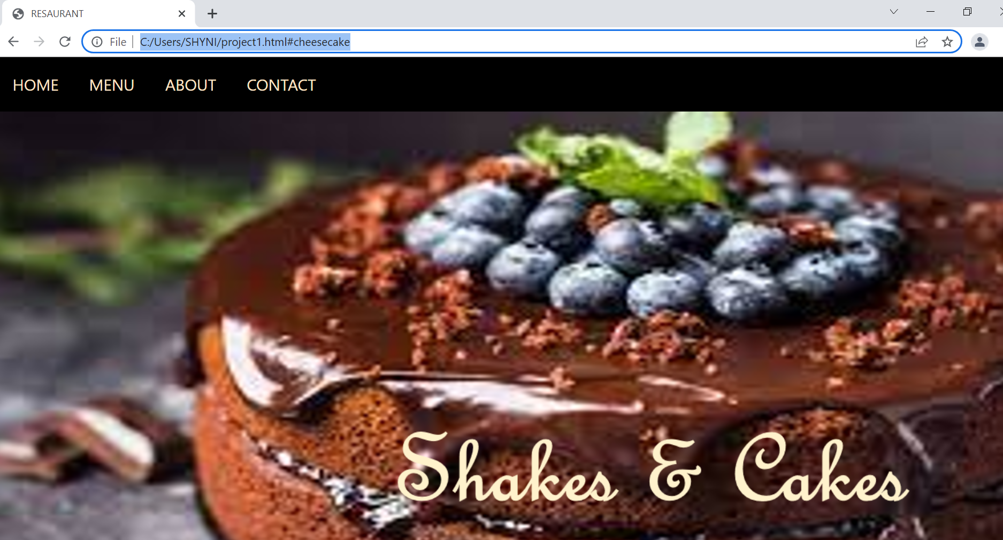

Then when we touch the MENU PAGE, we have the menu stating :

* Cheese cake
* Shakes



We have cheese cake menu when we touch the cheese cake section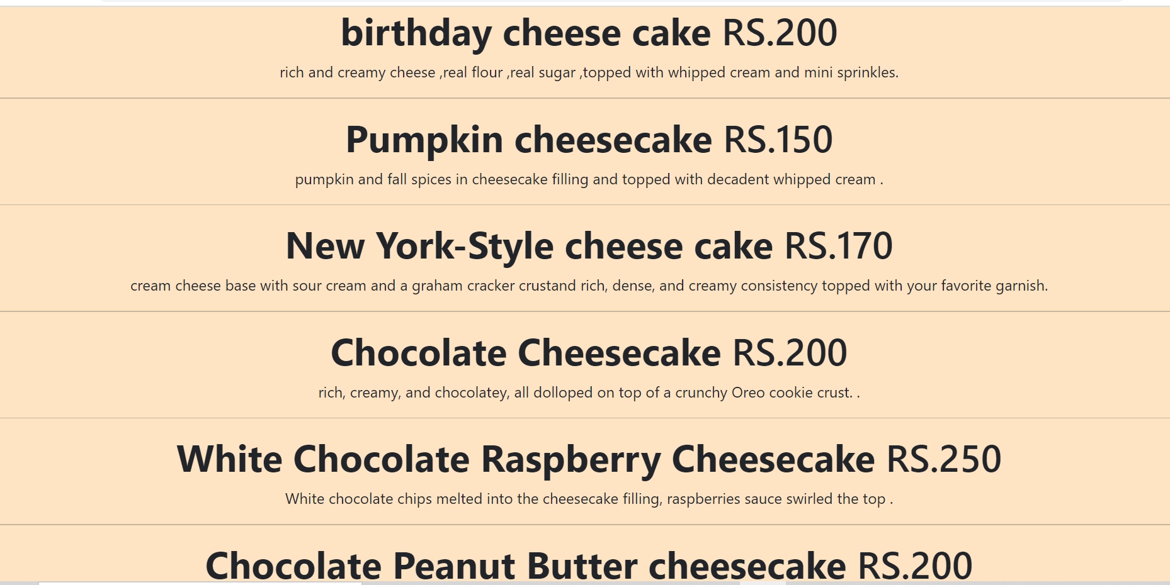

Then we have shakes menu when we touch the shakes section: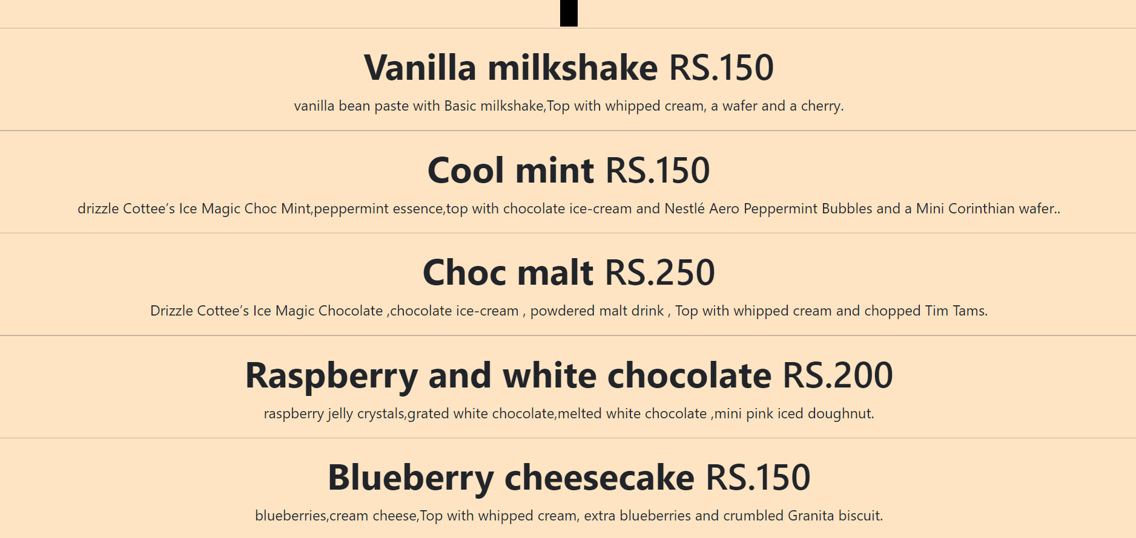

About section:

In the about section ,we have information about the restaurant “***Shakes &Cakes”***



Contact section:

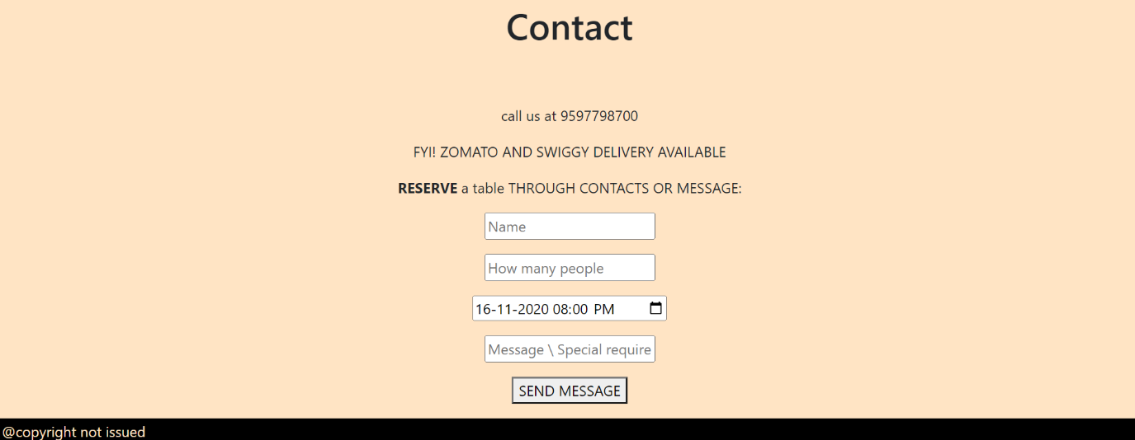

In the contacts, we can reserve a table by giving the name ,number .of people ,dates ,message and we can send the message by pressing the send message button.

**THANK YOU**