1. Create cluster





1. Create namespace and download Prometheus and install (used Helm, but you can choose to use operators too)

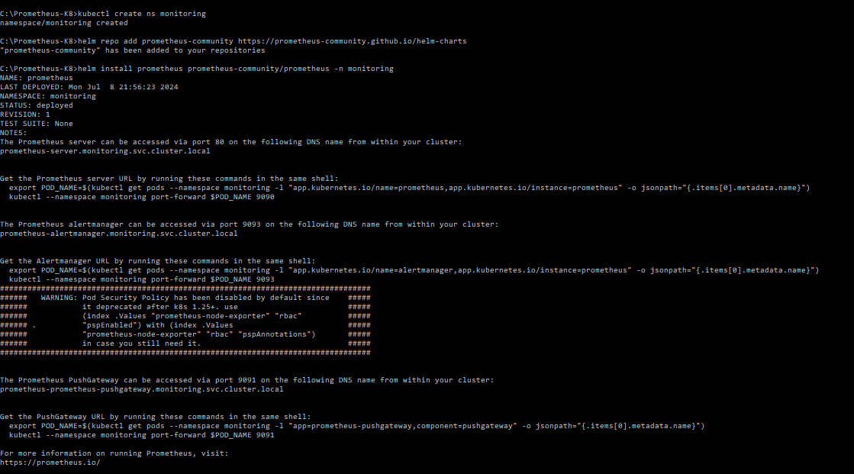

1. Ensure Pods are running

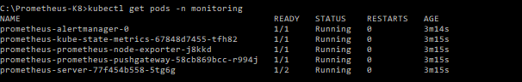

1. Get the pushgateway service

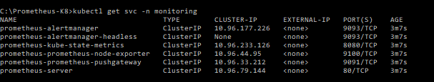

1. Can either expose the service via nodeport or port-forward like below for quick setup

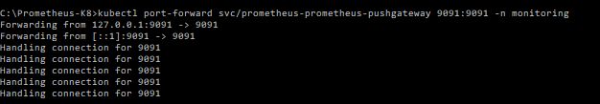

1. Browse <http://localhost:9091>

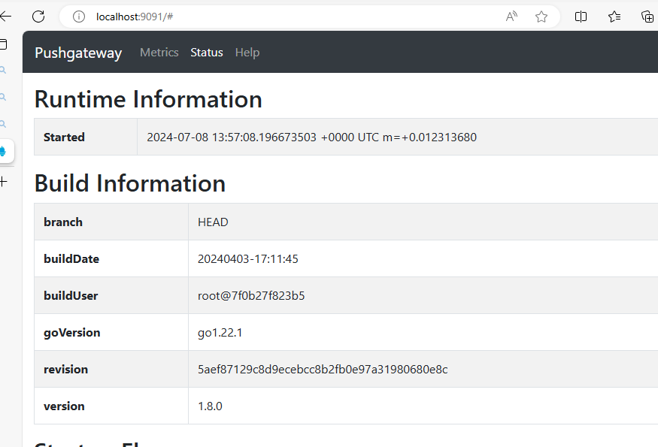

1. Push metric to gateway – e.g: batch job completion time

Create a bash script as below

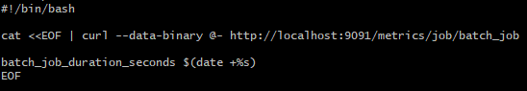

1. Run it

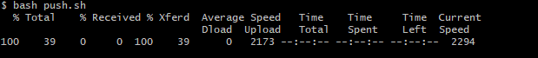

1. Check in PushGateway UI under metrics tab

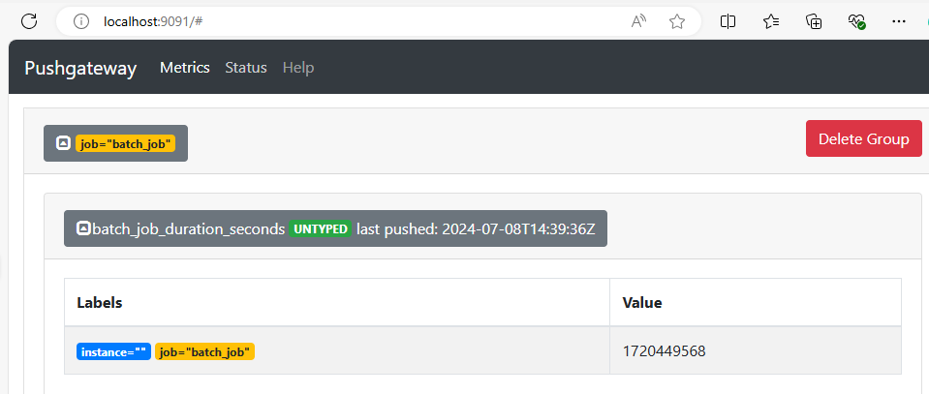

1. Can query the Prometheus server to confirm if Prometheus have scrape it correctly

