Linux Production Software – Quick Start

When you power up 1
For Development: 3
Appendix A. 6

When you power up a unit using the Linux Production Software, the first screen you get is for scanning or manually entering the CMA number:
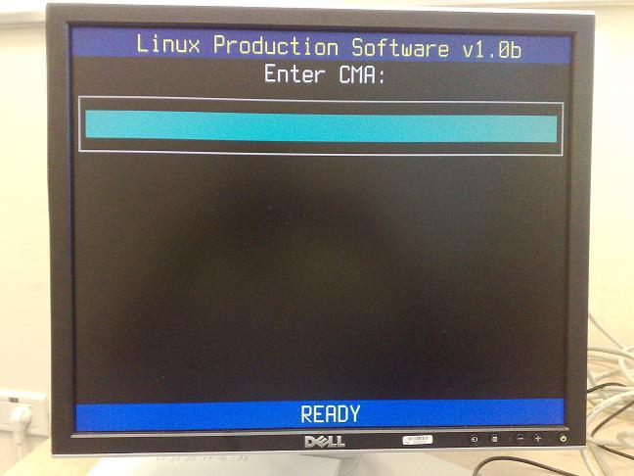
Once the CMA number has been entered a second input field will appear asking you to either manually enter the MAC address for the unit or scan it using the barcoe scanner:

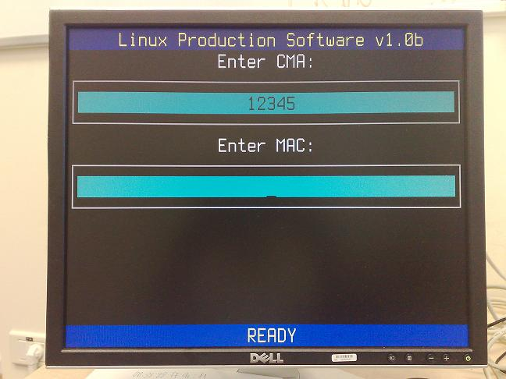

Once you enter / scan the MAC , relevant data will be collected and transmitted to the production server. The program will notify that it tries to contact the server:

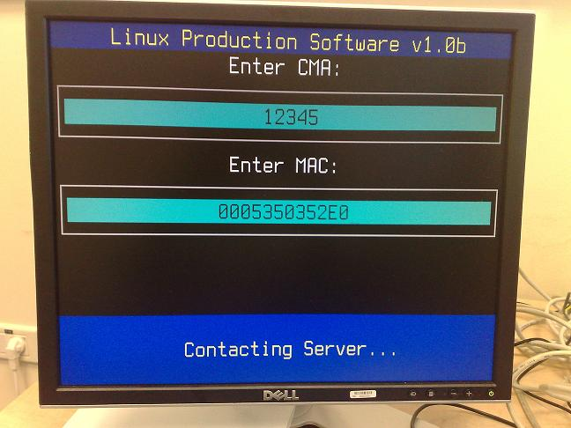
Upon successful connection and server information retrieval, the program will write the necessary data onto the unit and when it completes the process successfully it will notify by a green OK indicator:
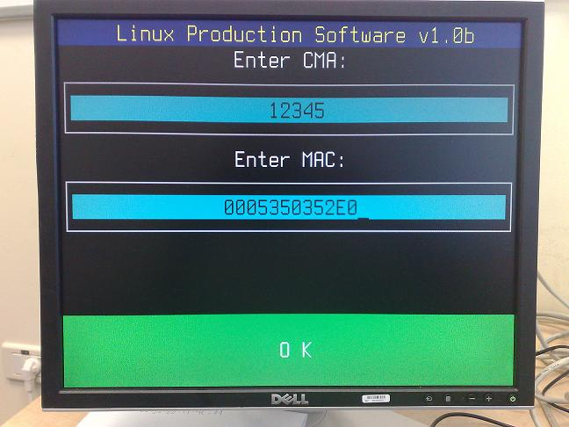

At this stage it is safe to cut the power to the unit, replace it with the next unit and repeat the process.

For Development:

The program sends the following hardware configuration string over an http post request, values are single quoted:

format_str = "'%s','%s','%s','%d','%d','%d','%d','%d','%d','%d','%d','%d', \
'%d','%d','%d','%d','%d','%d','%d','%d','%d', \
'%2.3f A','%2.3f V','%2.3f V','%2.3f V', \
'%s','%s'"
result_str = format_str % (MAC,
CMA,
StationMAC,
RAMonBoard,
FlashOnBoard,
SerialPorts,
ParallelPorts1,
SerialPorts2,
USBPorts,
AudioIn,
AudioOut,
CPUType,
DisplayType,
BusSpeed,
WirelessType,
SmartCardType,
ModemType,
SubboardType,
DebugBoard,
DebugMode,
LCD,
Current,
Supply5V,
Supply3V,
Corevdd,
UniqueID,
GetLocalIP())

The Production client will also parse any string of the following form:
ServerError: ……description…..
As a pure server error, will display it as error on screen together with the description string provided after the colon (:). This should be used for example in the case that an sql query fails, which is not a communication nor client error but needs to be propagated to the client operator for resolution.

A corresponding sample request string as received by a server script would be something similar to:

\'0005350352E0\',
\'12345\',
\'0005350352E0\',
\'0\',
\'256\',
\'0\',
\'0\',
\'0\',
\'4\',
\'1\',
\'1\',
\'400\',
\'2\',
\'200\',
\'0\',
\'0\',
\'0\',
\'0\',
\'0\',
\'0\',
\'0\',
\'0.000 A\',
\'0.000 V\',
\'0.000 V\',
\'0.000 V\',
\'FFFFFFFFD8FFFFFF32512BF9070039E2\',
\'192.168.9.156\'

The Linux Production Software expects the response containing the signature to be of the following format:

sig1 is: 66666666666666666232666666666666316533633066623030373030303938363285F9D30C83820293E640854E1BF87F0405EC5C5DBE5E2683FCB03FA16B62741A289F0ED934313EF2236163BFAB5832
sig2 is: 66666666666666666232666666666666316533633066623030373030303938363285F9D30C83820293E640854E1BF87F0405EC5C5DBE5E2683FCB03FA16B62741A289F0ED934313EF2236163BFAB5832
sig3 is: 66666666666666666232666666666666316533633066623030373030303938363285F9D30C83820293E640854E1BF87F0405EC5C5DBE5E2683FCB03FA16B62741A289F0ED934313EF2236163BFAB5832
sig4 is: 66666666666666666232666666666666316533633066623030373030303938363285F9D30C83820293E640854E1BF87F0405EC5C5DBE5E2683FCB03FA16B62741A289F0ED934313EF2236163BFAB5832
Or, in case the server wants to notify of an error in processing, for example:
ServerError: Could not contact SQL Server.

Appendix A.

This is a snippet for emulating the server response written in PHP:

<?php
$hwconfig = $_POST["hwconfig"];
$signature1 = "66666666666666666232666666666666316533633066623030373030303938363285F9D30C83820293E640854E1BF87F0405EC5C5DBE5E2683FCB03FA16B62741A289F0ED934313EF2236163BFAB5832";
$signature2 = "4D000000000000000000000000000000000000000000000000000000000000005CC34FD4F49EDB0DD9F4497C32DBE8A36B481BD2D7AD7A7FDE5A501398E6793C011859FC57EE675D0D8B83341850282D";

sleep(10);

echo "sig1 is: $signature1\n";
echo "sig2 is: $signature1\n";
echo "sig3 is: $signature1\n";
echo "sig4 is: $signature1";

?>

