

HH - library

* **Faculty: Hồ Hoàn Kiếm**
* **Batch:**
* **Team Member:**
  + - * **Nguyễn Võ Phước Hưng**
      * **Trần Lê Thanh Hoàng**

Table of Contents

1. Review 1

* **Problem Definition..……………………………………………….01**
* **Customer Request Specification……………………………………………………….02**

1. Review 2

* ***Use Case Diagram* 04**
* ***Class Diagram* 15**
* ***Sequence Diagram* 16**
* ***ERD* 18**
* ***Entity Description* 19**
* ***Table Relationship Diagram* 26**

1. Review 3

* Interface Design…………………………………………………..27
* Site Map…………………………………………………………...51
* Report……………………………………………………………..53
* Tasksheet………………………………………………………….56

REVIEW 1

**Problem Definition**

1. **The Object Of The Project:**

This project will manager all books in library. This will be accessible to all customers who have a valid User Id and Password. This system provides the following facilities:

* Manage book in library.
* Manage loaned books.
* Extension of time to borrow books.
* Search books that what you want to borrow.
* Suggestion some books.

**Specification**

1. **Functional Requirements:**

Following is a list of functionalities of the system. More functionalities that you find appropriate can be added to this list.

* Customer must have a valid User Id and password to login the system.
* When a valid password is entered. The system will check role this account. If this account is a member. The system will appear with form for reader and information of them. On the other hand, if this is a admin. The system will appear with form for admin.
* Main menu include: Form for Admin, and form for user depend on their role.
* Admin can manage reader, author, borrow and book.

# Hardware/ Software Requirements

3-tier architecture, the web site becomes more interactive with users, security and easily updated.

1. **System Requirement**

* **For Users**
  + **Hardware**
    - CPU: Pentium IV 2.0 GHz or higher
    - RAM: 512 MB or higher
  + **Software**
    - OS: Windows 7/XP Professional/Server 2003…
    - Browser: Internet Explorer 8.0 or higher
* **For Software Developers**
  + **Hardware**
    - CPU: Pentium IV 2.0 GHz or higher
    - RAM: 512 MB or higher
  + **Software**
    - OS: Windows XP Professional/Server 2003…
    - Environment: Microsoft .NET Framework 3.5
    - Database Management System: Microsoft SQL Server 2008
    - IDE: Microsoft Visual Studio 2010
    - Web Server: Internet Information Services (IIS) JSP / Servlets Dev. Kit

|  |  |  |
| --- | --- | --- |
| **Date:** | **Prepared by Project**  **Team Leader:** | **Approved by**  **Mr Ho Hoan Kiem** |
| **Signature** |  |  |

REVIEW

**USE CASE DIAGRAM**

**Customer :**

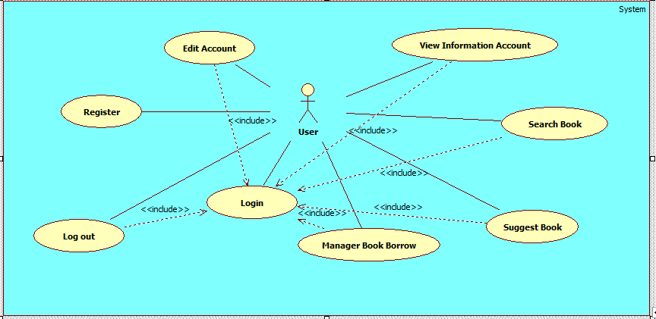

**Administrators :**

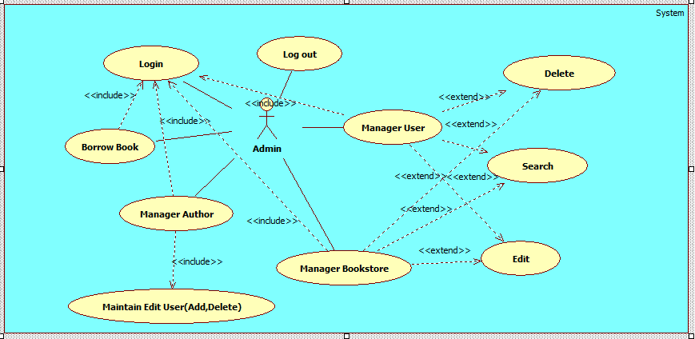

**USE CASE DESCRIPTION**

1. **Actor:**
2. **Usecase:**

|  |  |
| --- | --- |
| **Usecase** | Register |
| **Short Description** | Register account to become a member of app. |
| **Pre-Conditions** |  |
| **Post-Conditions** |  |
| **Main flow** | _ Guest must provide mandatory information :   * Username. * Password. * Confirm Password.   _ Guest clicks on Register label.  _ System checks the information which guest provided.  _ System create new account for guest that registers to this app.  _ Guest becomes a member of this app. |
| **Alternative flow(s)** | _ If the mandatory information that guest provided, is missed or not exactly, system notifys the error. All cases are :   * LoginID has existed in Database and less than 6 or more than 12 characters. * Password is less than 6 characters. * Confirm Password and Password are not the same. * Any fields are blank. |

|  |  |
| --- | --- |
| **Usecase** | Login |
| **Short Description** | Log in website to use any function of member. |
| **Pre-Conditions** |  |
| **Post-Conditions** |  |
| **Main flow** | _Guest inputs the login information :   * Username. * Password.   _Guest clicks on the Login button.  _System check the Login ID and Password.  _If Login ID and Password are valid, system will check role of this account.  _ If a wrong password, you must enter ID and pass word again.  _ If your role is a user. The system will appear the form for User. On the other hand, if you are admin, the system will show form for Admin. |
| **Alternative flow(s)** | _If Login ID field or Password field is invalid form or blank when guest clicks on the “Login” button, system will notify the error. |

|  |  |
| --- | --- |
| **Usecase** | Edit Account |
| **Short Description** | Edit member’s information. |
| **Pre-Conditions** |  |
| **Post-Conditions** |  |
| **Main flow** | _Guest login to this app.  _Member clicks Thay đổi thông tin button to edit his(her) information.  _Member edits information and save this action.  _System check this information and save it on the server.  _System notify report to member. |
| **Alternative flow(s)** | _If any information edit are invalid, system will notify the error. |

|  |  |
| --- | --- |
| **Usecase** | Edit Password |
| **Short Description** | Edit User’s password |
| **Pre-Conditions** |  |
| **Post-Conditions** |  |
| **Main flow** | _ Guest login to this app.  _Member clicks Thay đổi mật khẩu button to edit his(her) password.  _Member edits password and save this action.  _System check this information and save it on the server.  _System notify report to member. |
| **Alternative flow(s)** | _If any information transaction are invalid, system’ll notify the error, and rollback. |

|  |  |
| --- | --- |
| **Usecase** | Log out |
| **Short Description** | Logout from this account |
| **Pre-Conditions** |  |
| **Post-Conditions** |  |
| **Main flow** | _User click Đăng xuất button.  _ This account will be log out. |
| **Alternative flow(s)** |  |

|  |  |
| --- | --- |
| **Usecase** | Manage Book Borrowed |
| **Short Description** | Manage all book borrowed of user. |
| **Pre-Conditions** |  |
| **Post-Conditions** |  |
| **Main flow** | _User click Quản lý sách mượn button. _ System will show a new form for Quản lý sách mượn. |
| **Alternative flow(s)** |  |

|  |  |
| --- | --- |
| **Usecase** | Search Book |
| **Short Description** | Search Book. |
| **Pre-Conditions** |  |
| **Post-Conditions** |  |
| **Main flow** | _User click Tìm kiếm sách button..  _ System will show a new form for Tìm kiếm sách |
| **Alternative flow(s)** |  |

|  |  |
| --- | --- |
| **Usecase** | Suggest Book to Admin |
| **Short Description** | Administrator view customer’s information. |
| **Pre-Conditions** |  |
| **Post-Conditions** |  |
| **Main flow** | _User click Đề xuất button.  _ System will show a new form Đề xuất sách. |
| **Alternative flow(s)** |  |

|  |  |
| --- | --- |
| **Usecase** | Administrator Manage User |
| **Short Description** | Manage User. |
| **Pre-Conditions** |  |
| **Post-Conditions** |  |
| **Main flow** | _ Admin click Quản lý độc giả button.  _ System will show a new form for Manage User  _ Admin can add, edit, delete user. |
| **Alternative flow(s)** | _ If any information edit are invalid, system’ll notify the error. |

|  |  |
| --- | --- |
| **Usecase** | Administrator Manage Author |
| **Short Description** | Manage news of this website. |
| **Pre-Conditions** |  |
| **Post-Conditions** |  |
| **Main flow** | _ Admin click Quản lý tác giả button.  _ System will show a new form for Manage Author  _ Admin can add, edit, delete an author. |
| **Alternative flow(s)** | _ If any information edit are invalid, system’ll notify the error. |

|  |  |
| --- | --- |
| **Usecase** | Borrow and return Book |
| **Short Description** | Admin can manage book. |
| **Pre-Conditions** |  |
| **Post-Conditions** |  |
| **Main flow** | _ Admin click Quản lý mượn trả button.  _ System will show a new form for Manage Book  _ Admin have 2 tab.  _ 1. Manage return book of user.  _ 2. Manage borrow book of user. |
| **Alternative flow(s)** | _ If any information edit are invalid, system’ll notify the error. |

|  |  |
| --- | --- |
| **Usecase** | Manage Book |
| **Short Description** | Manage all book in library. |
| **Pre-Conditions** |  |
| **Post-Conditions** |  |
| **Main flow** | _ Admin click Quản lý kho sách button.  _ System will show a new form for Manage Book  _ Admin can search by ISBN, category, publisher, suggest. |
| **Alternative flow(s)** |  |

**CLASS DIAGRAM**

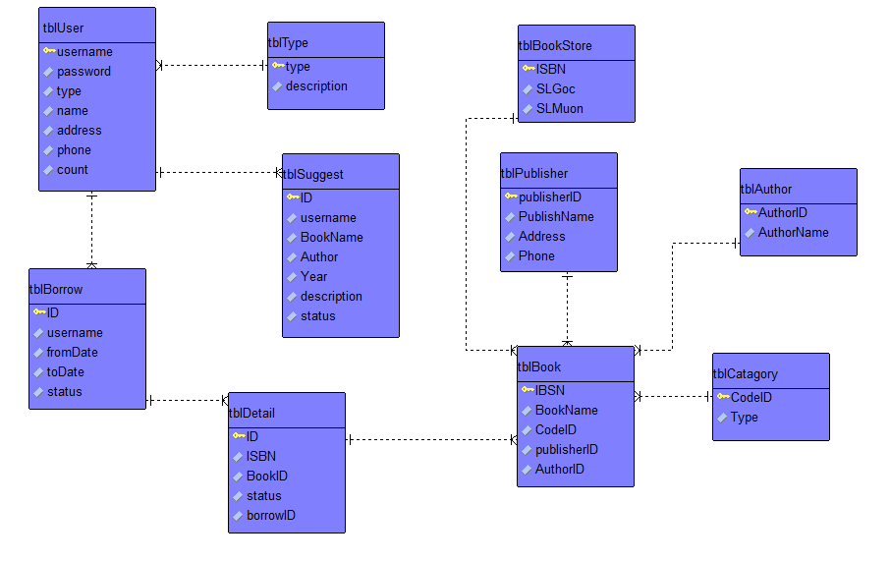

**ENTITY DESCRIPTION**

**1.BookStore Information :**

**BookStore**

**2. User Information :  
3. Type :**

**User  
Information**

**4. Catagory :  
  
  
  
  
  
  
  
  
5. Book :  
  
6. Borrow :**

**Book**

**Catagory**

**Type**

**Borrow**

**7. Detail:**

**8. Author:**

**Detail**

**Author**

**9. Account Admin :**

**Publisher**

**10. Suggest :**

**Suggest**

**TABLE DESIGN**

1. **Account User :**

|  |  |  |  |  |  |
| --- | --- | --- | --- | --- | --- |
| **No** | **Column Name** | **Data Type** | **Size** | **Check** | **Description** |
| 1 | **🗝**Username | Varchar | 15 | Not Null | User ID |
| 2 | Passwords | Varchar | 20 | Not Null | User Password |
| 3 | Type | Int |  | Not Null | Type User |
| 4 | Name | Varchar | 20 | Not Null | Name of User |
| 5 | Address | Varchar | 250 | Not Null | Address of User |
| 6 | Phone | Varchar | 13 | Not Null | Phone of User |
| 7 | Count | Int |  | Not Null | Number of book borrowed |

1. **Type :**

|  |  |  |  |  |  |
| --- | --- | --- | --- | --- | --- |
| **No** | **Column Name** | **Data Type** | **Size** | **Check** | **Description** |
| 1 | **🗝**Type | Int | Identity | Not Null | ID |
| 2 | Description | Varchar | 9 | Not Null | Define of Type |

1. **Book Store :**

|  |  |  |  |  |  |
| --- | --- | --- | --- | --- | --- |
| **No** | **Column Name** | **Data Type** | **Size** | **Check** | **Description** |
| 1 | **🗝**ISBN | Varchar |  | Not Null | ISBN ID |
| 2 | SLGOC | Int | 30 | Not Null |  |
| 3 | SLMUON | Int | 6 | Not Null |  |

1. **Suggest Book:**

|  |  |  |  |  |  |
| --- | --- | --- | --- | --- | --- |
| **No** | **Column Name** | **Data Type** | **Size** | **Check** | **Description** |
| 1 | **🗝**ID | Int | Identity | Not Null | ID |
| 2 | Username | Varchar | 50 | Not Null | Username of User |
| 3 | BookName | Varchar | 50 | Not Null | Name of Book |
| 4 | Author | Varchar | 50 | Not Null | Name of Author |
| 5 | Year | Varchar | 30 | Not Null | Year |
| 6 | Description | nText |  | Not Null | Description of book |
| 7 | Status | Bit |  | Not Null |  |

1. **Publisher:**

|  |  |  |  |  |  |
| --- | --- | --- | --- | --- | --- |
| **No** | **Column Name** | **Data Type** | **Size** | **Check** | **Description** |
| 1 | **🗝**Publisher ID | Varchar | 50 | Not Null | Publisher ID |
| 2 | Publisher Name | Varchar | 50 | Not Null | Publisher Name |
| 3 | Address | Varchar | 200 | Not Null | Address of Publisher |
| 4 | Phone | Varchar | 200 | Not Null | Phone of Publisher |

1. **Author :**

|  |  |  |  |  |  |
| --- | --- | --- | --- | --- | --- |
| **No** | **Column Name** | **Data Type** | **Size** | **Check** | **Description** |
| 1 | **🗝**Author ID | Varchar | 50 | Not Null | Author ID |
| 2 | Author Name | Varchar | 300 | Not Null | Author Name |

1. **Borrow:**

|  |  |  |  |  |  |
| --- | --- | --- | --- | --- | --- |
| **No** | **Column Name** | **Data Type** | **Size** | **Check** | **Description** |
| 1 | **🗝**ID | Int |  | Not Null | BorrowedID |
| 2 | Username | Varchar | 30 | Not Null | Username |
| 3 | fromDate | Date |  | Not Null | Date Borrow |
| 4 | toDate | Date |  | Not Null | Date Return |
| 5 | Status | Bit |  | Not Null | State of user |

1. **Category:**

|  |  |  |  |  |  |
| --- | --- | --- | --- | --- | --- |
| **No** | **Column Name** | **Data Type** | **Size** | **Check** | **Description** |
| 1 | **🗝Code**ID | Varchar | 100 | Not Null | Category ID |
| 2 | Type | Varchar | 30 | Not Null | Type of category |

1. **Book :**

|  |  |  |  |  |  |
| --- | --- | --- | --- | --- | --- |
| **No** | **Column Name** | **Data Type** | **Size** | **Check** | **Description** |
| 1 | **🗝**ISBN | Varchar | 30 | Not Null | ISBN of Book |
| 2 | BookName | Varchar | 100 | Not Null | Name of Book |
| 3 | CodeID | Varchar | 25 | Not Null | Book ID |
| 4 | PublisherID | Varchar | 25 | Not Null | PublisherID |
| 5 | AuthorID | Varchar | 25 | Not Null | AuthorID |

**10.Detail:**

|  |  |  |  |  |  |
| --- | --- | --- | --- | --- | --- |
| **No** | **Column Name** | **Data Type** | **Size** | **Check** | **Description** |
| 1 | **🗝**ID | Int | 30 | Not Null | Details ID |
| 2 | ISBN | Varchar | 100 | Not Null | Book ISBN |
| 3 | BookID | Varchar | 25 | Not Null | Book ID |
| 4 | Status | Bit |  | Not Null | State |
| 5 | BorrowID | Int |  | Not Null | ID Borrowed |

**Note**

**🗝** Primary key

✓ Unique constraint

**TABLE RELATIONSHIP DIAGRAM**

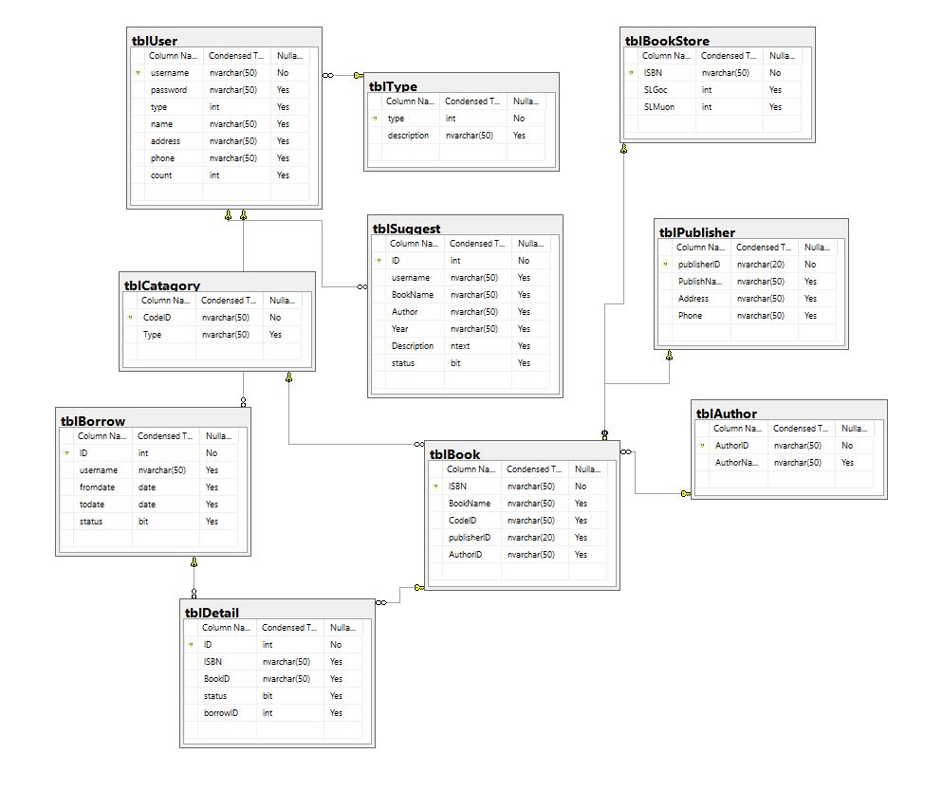

|  |  |  |
| --- | --- | --- |
| **Date:** | **Prepared by Project Group 4**  **Team Leader:** | **Approved by**  **Mr. Ho Hoan Kiem** |
| **Signature** |  |  |

**INTERFACE DESIGN**

1. **Home Page**



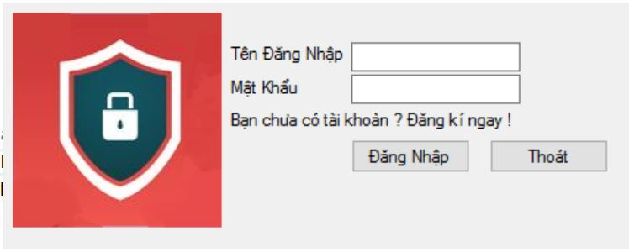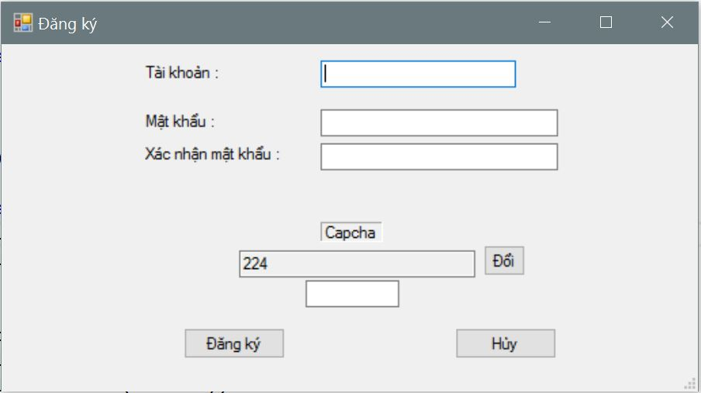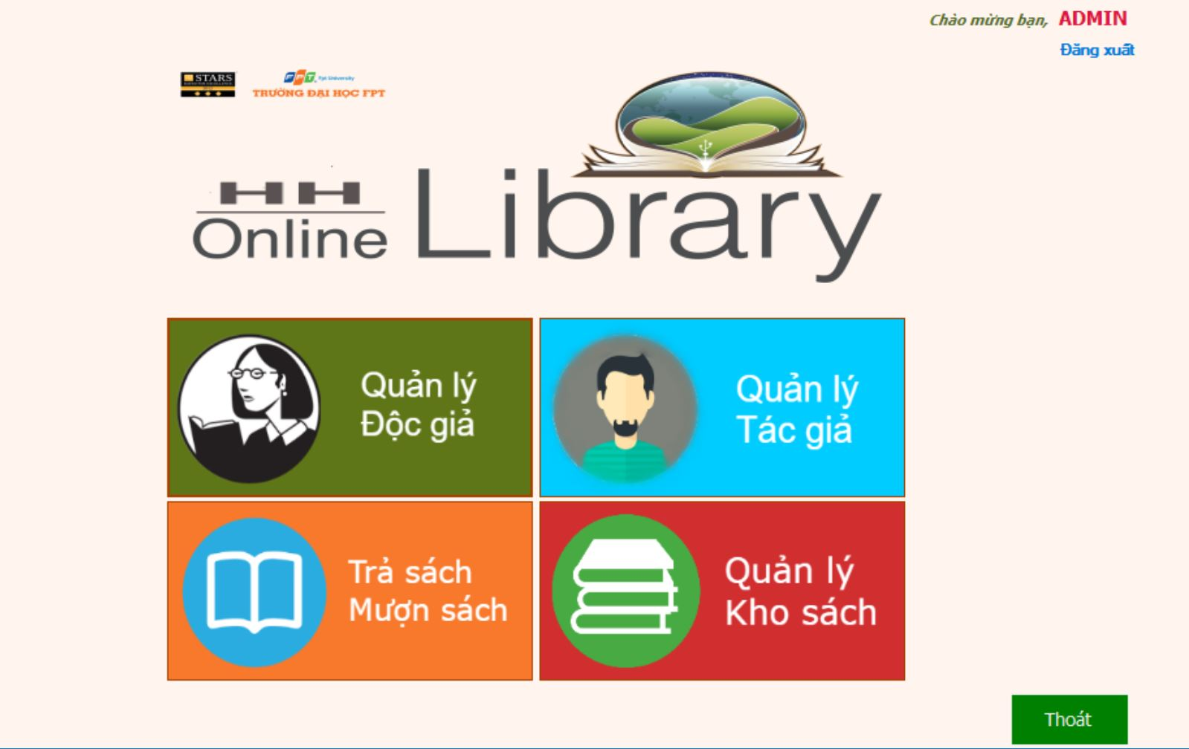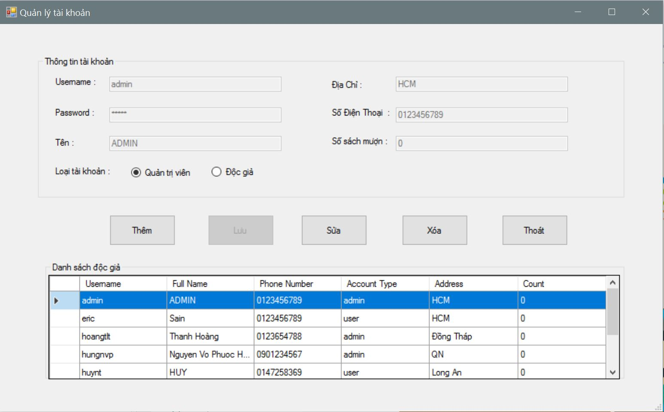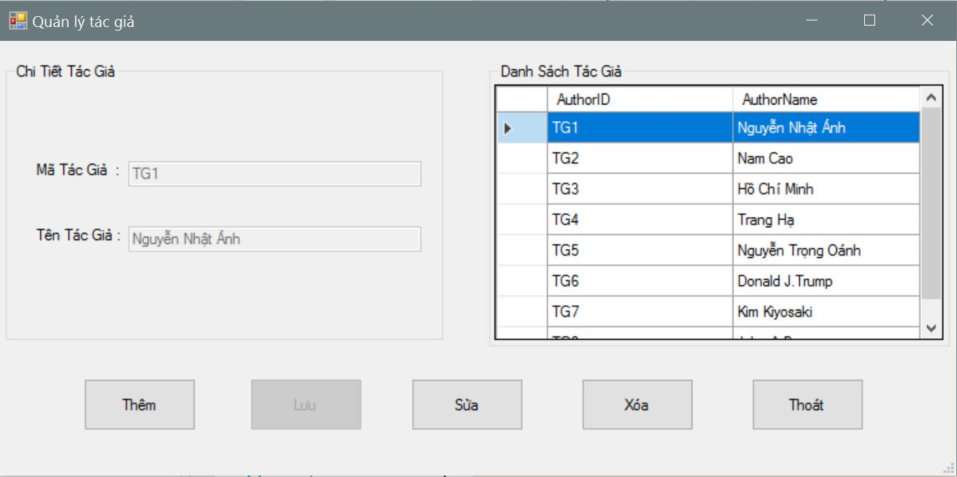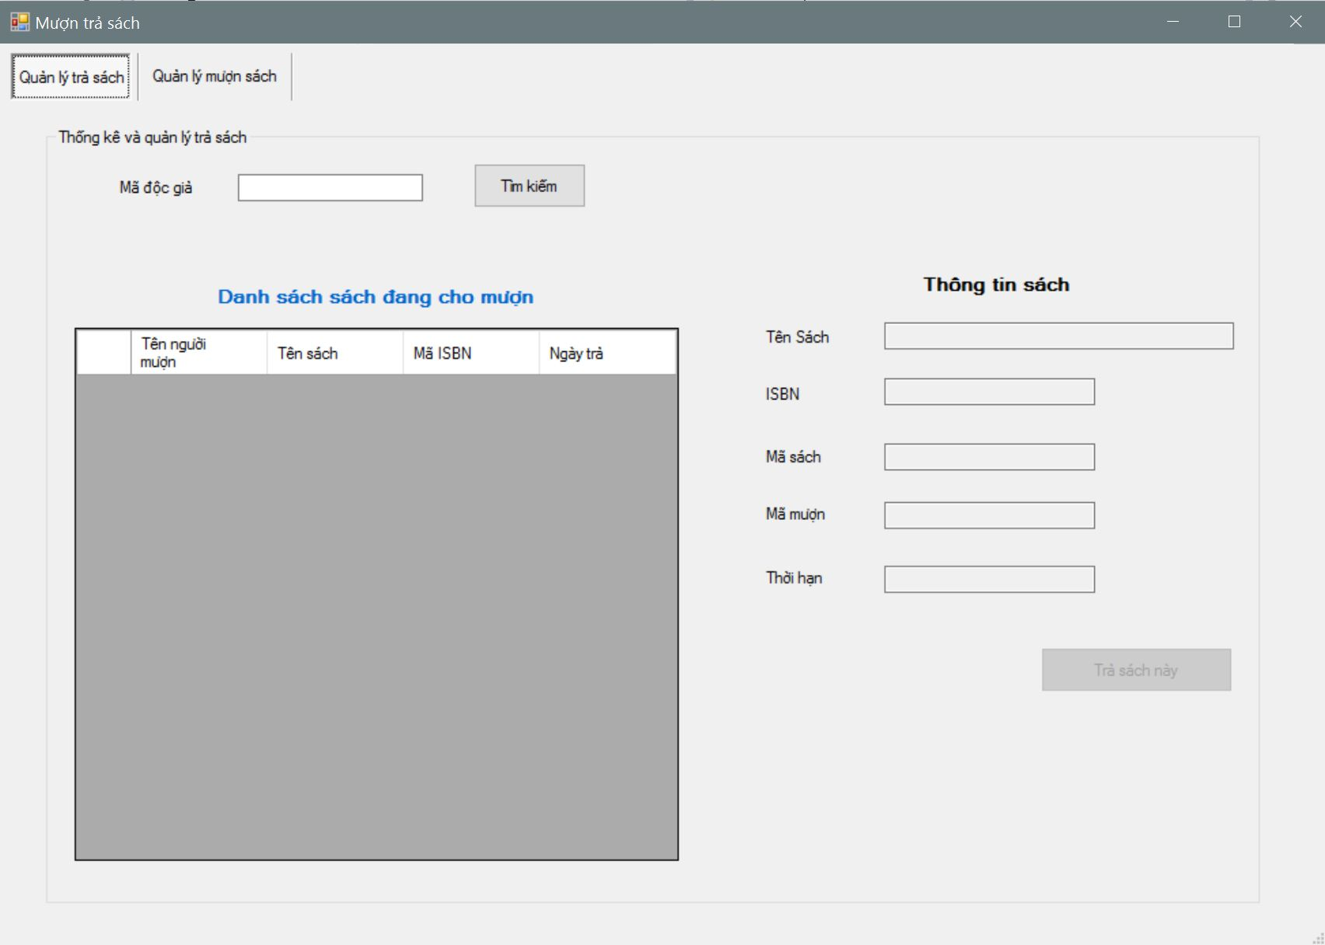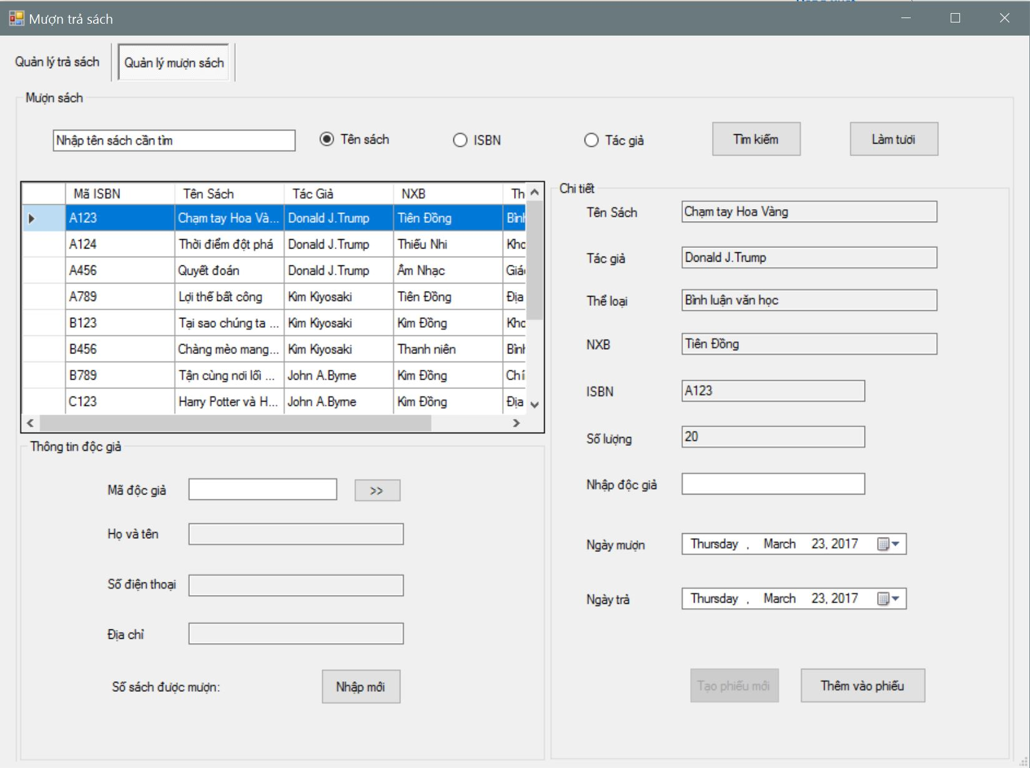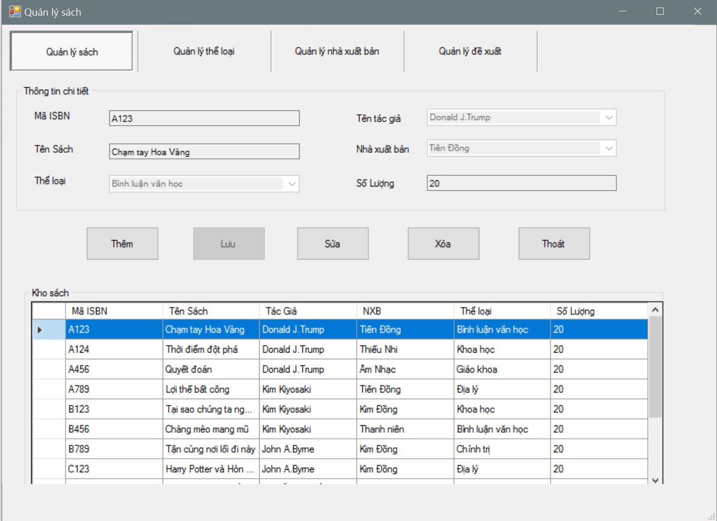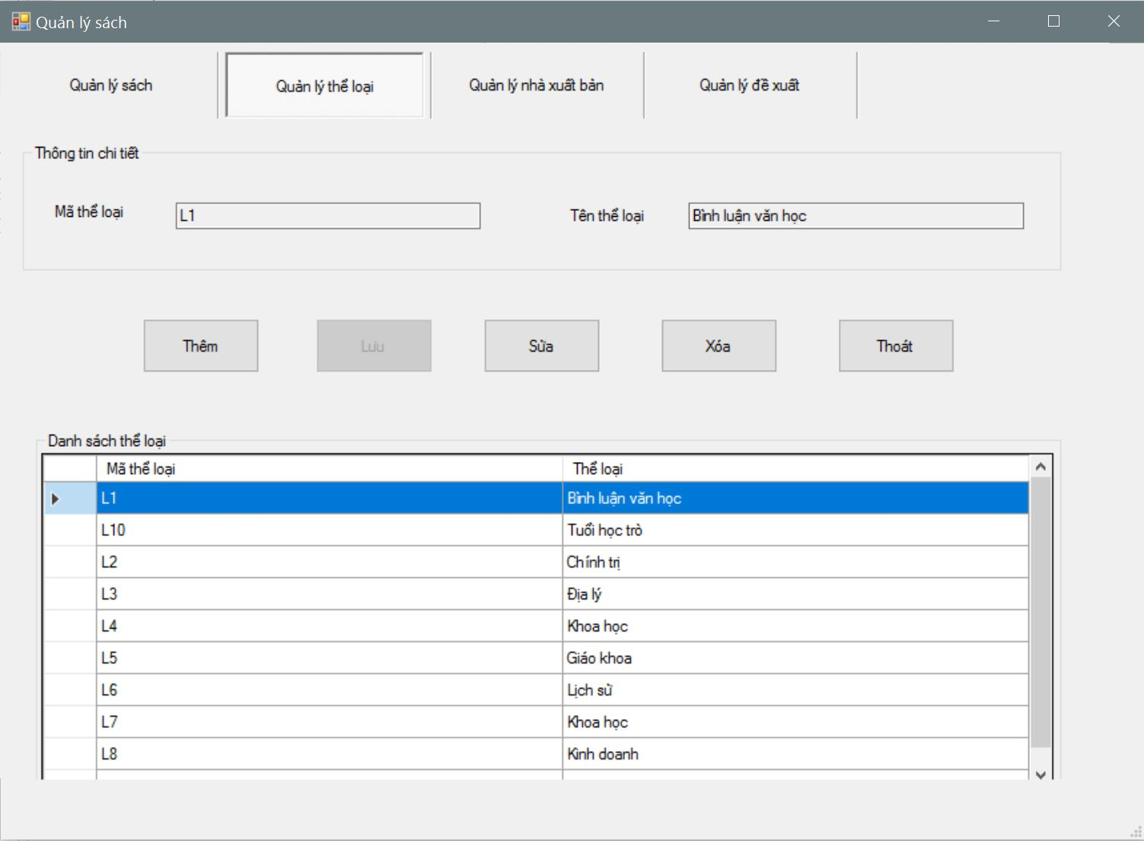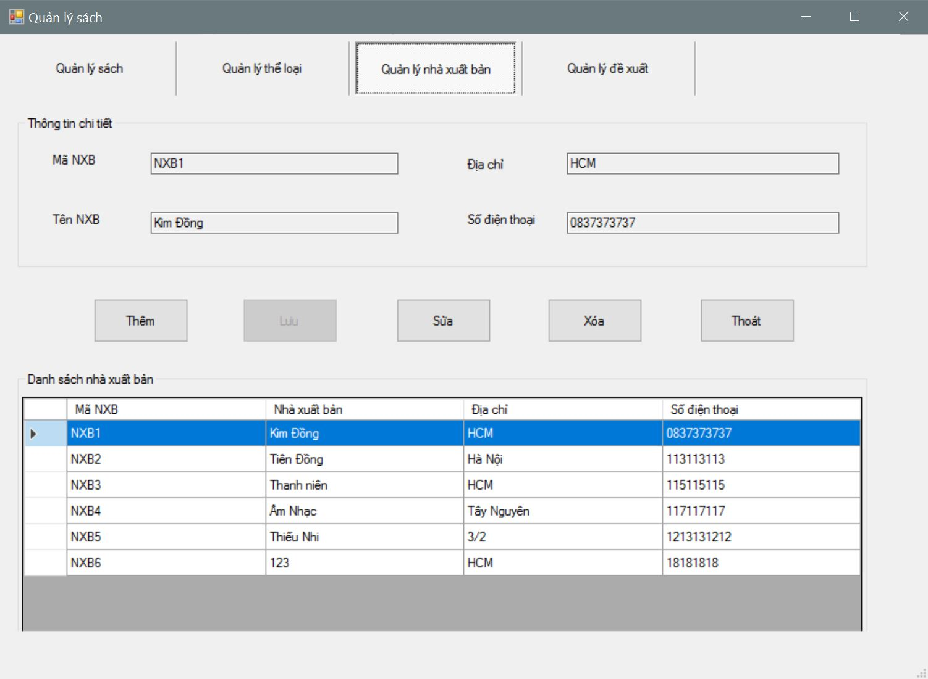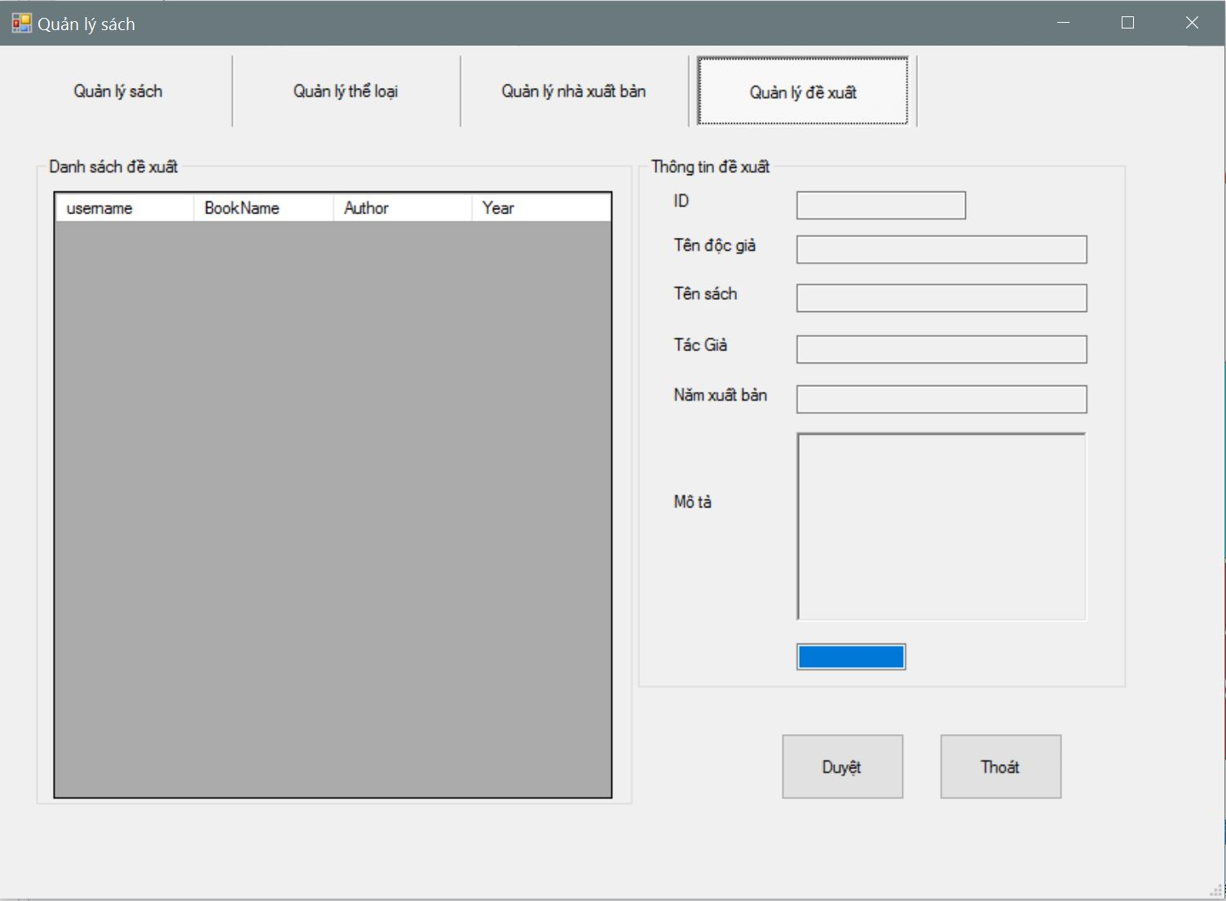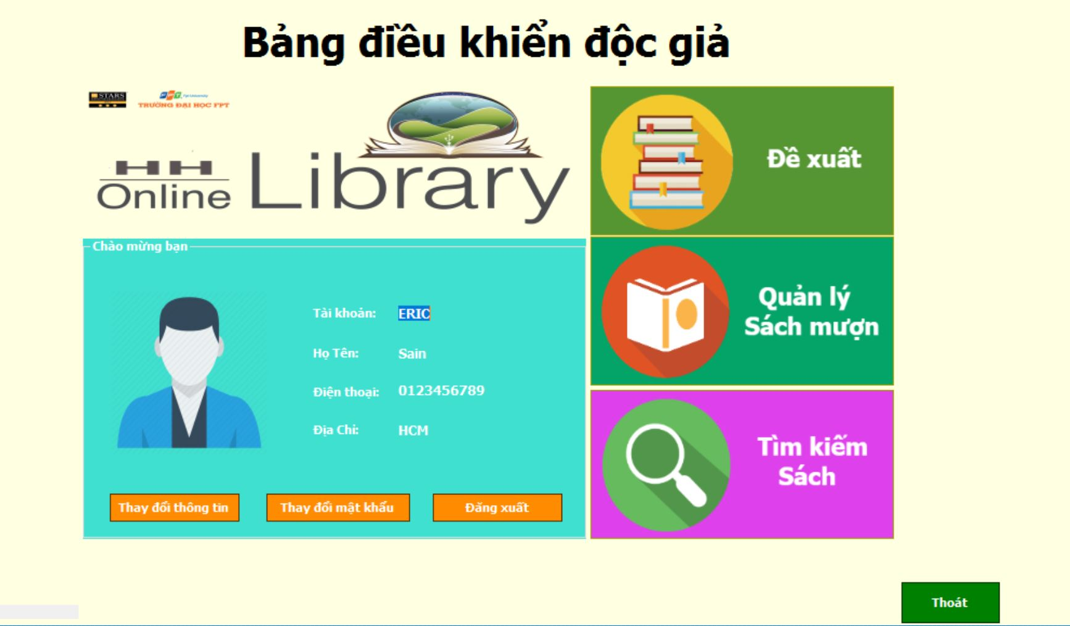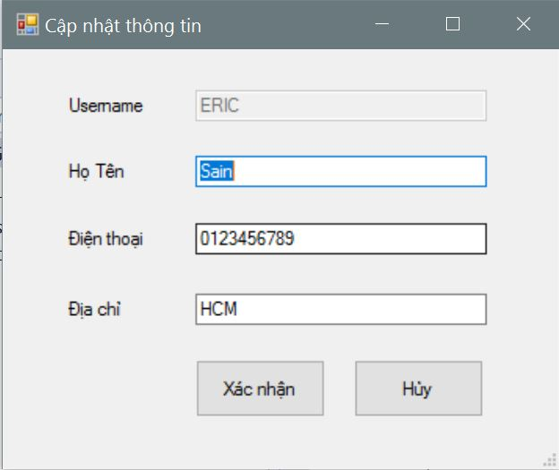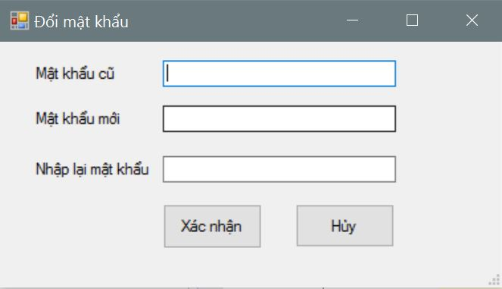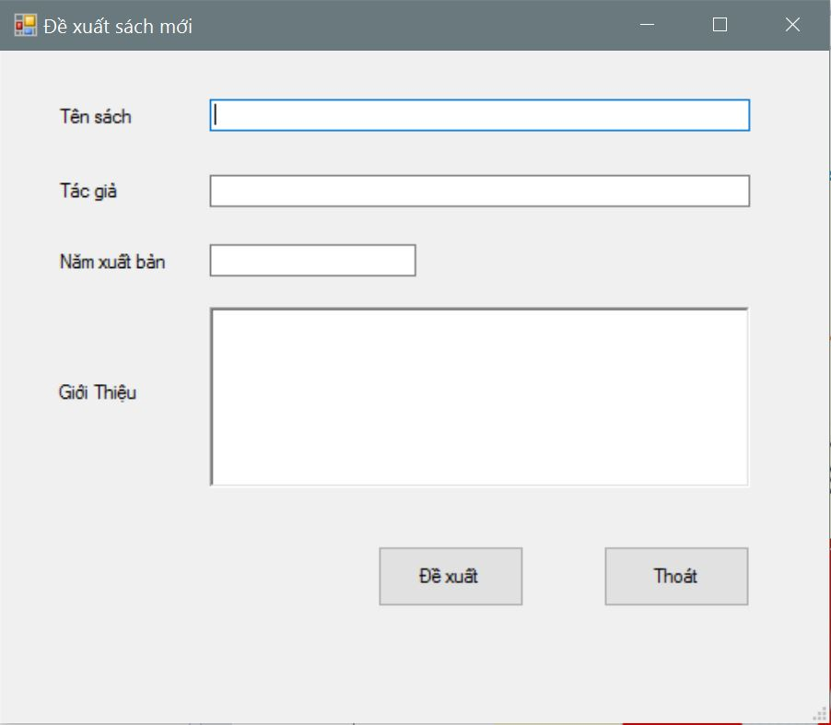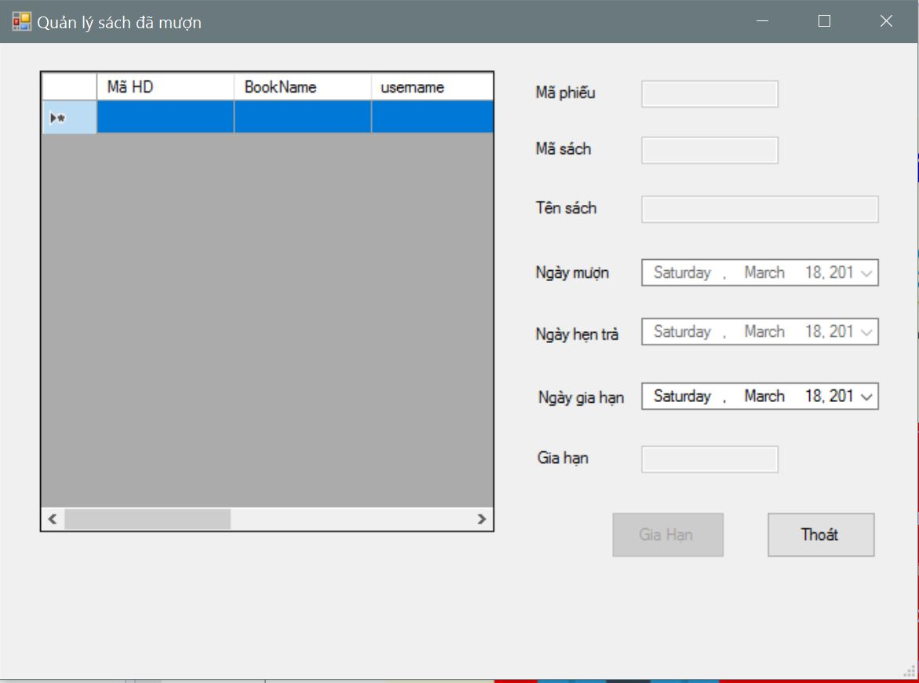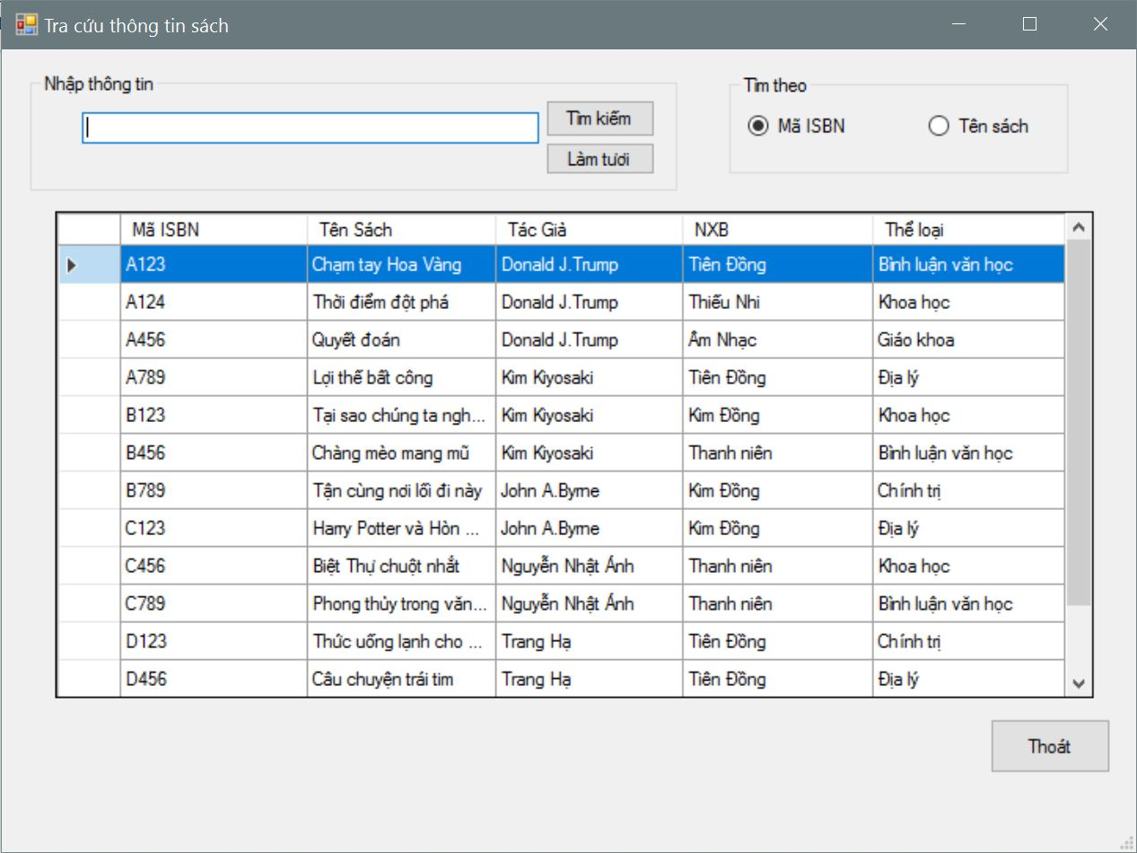

|  |  |  |
| --- | --- | --- |
| **Date:** | **Prepared by Project**  **Team Leader:** | **Approved by**  **Mr. Ho Hoan Kiem** |
| **Signature** |  |  |