Issues:
- For Login and Sign Up pages - use lighter grey shades for input fields, include additional login options like Google and Apple, and add a password visibility (eye) icon for better usability. And add forgot password below the secret key text box.

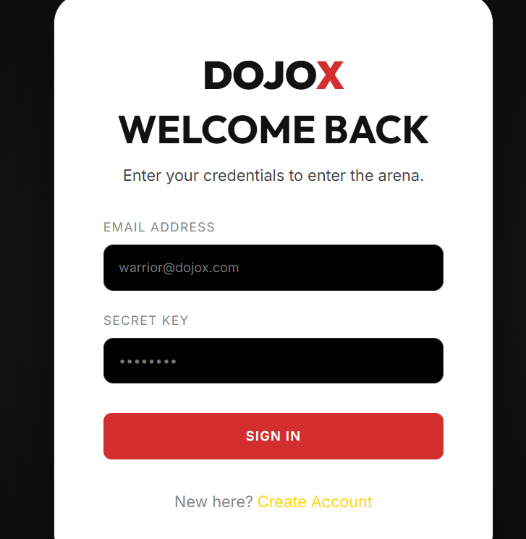

- Ensure proper spacing between header icons and keep them aligned to the same height for a clean layout, and rename “Portal” to “Login” for clarity.

- Maintain a consistent red color across the design instead of using yellow or other colors. It has contrast issues
- On the Modern page - the hero section - fix button alignment in, and avoid introducing additional colors.

- On the Program page, add top spacing for tabs and remove any watermarks from images. Include a well-structured footer design.

+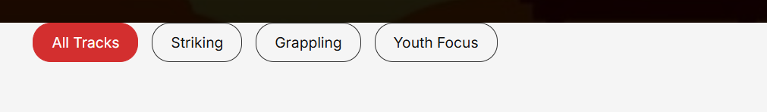 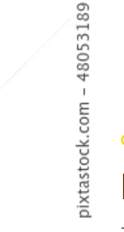+
- In intruction page – The H2 font size should be consistent throughout the page.

- Pricing page - Ensure images are properly added on and increase the H2 font size on the page and looks good and professional.

- In blog page – Some containers have images that are being cut off; this issue needs to be fixed.
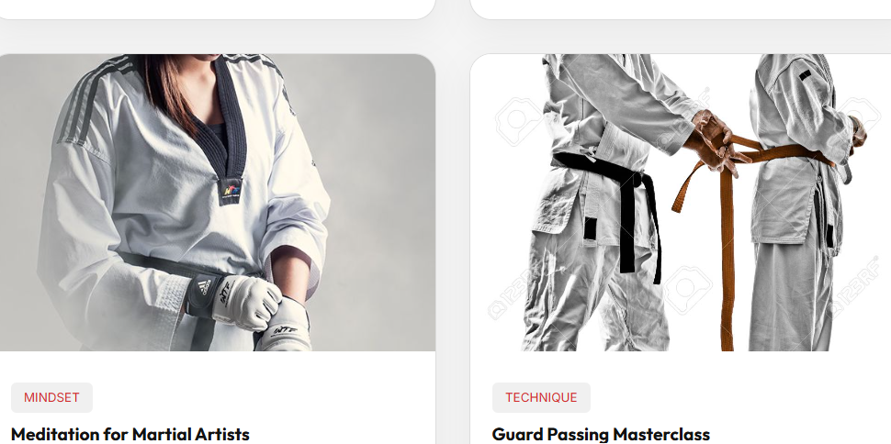
- In contact page – Add appropriate social media icons next to the corresponding names.

- Use professional icons in the dashboard side navigation and fully develop the dashboard with a clear, polished layout.. Also, use red color consistently for links to maintain branding.

Responsiveness :
In 360 , 768, 1024px -nav bar layout and alignment issue.
In mobile responsiveness testing need to work
In tabs some more issues are there. Need to work full responsiveness

