PROJECT REPORT
————————————————————
Virtual Agent-Driven SLA Breach
Awareness & Justification System
in ServiceNow
Platform | ServiceNow (Virtual Agent / NLU)
Domain | IT Service Management (ITSM)
Date | June 2026
Submitted By | Parapati Kavyanjali  Pujari Pooja  Parisarla Devi  Pogiri Manasa  Mylipilli Sivani

TABLE OF CONTENTS
INTRODUCTION
Project Overview
Purpose
1. IDEATION PHASE
1.1 Problem Statement
1.2 Empathy Map Canvas
1.3 Brainstorming
Step 1: Problem Statement Selection
Step 2: Idea Generation & Grouping
Step 3: Idea Prioritization
2. REQUIREMENT ANALYSIS
2.1 Customer Journey Map
2.2 Solution Requirements
Functional Requirements
Non-Functional Requirements
2.3 Data Flow Diagram
2.4 Technology Stack
3. PROJECT DESIGN PHASE
3.1 Problem-Solution Fit
3.2 Proposed Solution
Component 1: SLA Breach Detection Layer
Component 2: Flow Designer Orchestration
Component 3: Virtual Agent Conversation
Component 4: Stakeholder Notification & Escalation
Component 5: Reporting & Analytics Dashboard
3.3 Solution Architecture
4. PROJECT PLANNING & SCHEDULING
5.1 Project Planning
User Stories
Product Backlog & Sprint Schedule
Sprint Tracker & Velocity
5.PROJECT DEVELOPMENT PHASE
6.PROJECT DOCUMENTATION PHASE
7.CONCLUSION

INTRODUCTION

Project Overview
The Virtual Agent-Driven SLA Breach Awareness & Justification System is an intelligent, conversational automation solution built on the ServiceNow platform. It leverages the ServiceNow Virtual Agent (VA) framework, powered by Natural Language Understanding (NLU), to proactively monitor Service Level Agreement (SLA) breaches across Incident, Problem, and Change Management modules. When an SLA breach is detected or imminent, the system autonomously initiates conversations with the responsible assignees and teams through the Virtual Agent chatbot interface, collecting structured justification data and routing alerts to stakeholders in real time.
The solution eliminates the manual overhead traditionally associated with SLA monitoring, reduces breach recurrence through data-driven insights, and enhances organizational accountability by creating an auditable trail of breach justifications. It integrates natively within the ServiceNow ecosystem using Flow Designer, Scripted REST APIs, Business Rules, and the NLU model, requiring no external third-party tools or separate deployment infrastructure.

Purpose
The primary purposes of this project are:
- To automate the detection and notification of SLA breaches in ServiceNow ITSM workflows.
- To enable conversational justification collection via Virtual Agent, reducing manual follow-up effort by service desk managers.
- To provide real-time awareness dashboards to IT leadership showing breach frequency, root causes, and responsible teams.
- To improve SLA compliance rates through continuous feedback loops and actionable insights derived from collected justifications.
- To create a scalable, reusable framework applicable across multiple ITSM process areas including Incidents, Problems, and Service Requests.
This system directly addresses the gap between SLA breach occurrence and organizational response, transforming a reactive process into a proactive, intelligent workflow.

1. IDEATION PHASE

1.1Problem Statement
Service Level Agreements (SLAs) are contractual commitments that define the expected response and resolution timelines for IT service requests. Despite their critical importance, organizations frequently experience SLA breaches due to poor visibility, inadequate escalation mechanisms, and the absence of systematic justification collection processes. The following problem statements articulate the core challenges faced by different customer personas:

PS# | I am (Customer) | I'm trying to... | But... | Because... | Which makes me feel...
PS-1 | IT Service Manager | Track and reduce SLA breaches across all active incidents | I have no real-time visibility into which SLAs are at risk until after the breach occurs | ServiceNow does not proactively alert me with contextual information and breach reasons | Frustrated and unable to take preventive action
PS-2 | Service Desk Agent | Manage my ticket workload within SLA deadlines | I am not notified early enough when a ticket is approaching its SLA threshold | There is no proactive escalation or smart assistant guiding me on priority | Overwhelmed and accountable for breaches I was unaware of
PS-3 | IT Director / CIO | Understand root causes of recurring SLA failures and improve service quality | There is no structured mechanism to capture and analyze breach justifications at scale | Justification data is either verbal, undocumented, or scattered across emails | Unable to make data-driven decisions to improve service performance
PS-4 | End User / Customer | Receive timely resolution for my reported IT issues | My tickets are frequently breaching SLA without any communication or updates | The IT team lacks an automated system to communicate proactively during delays | Dissatisfied and lacking confidence in the IT support process

1.2Empathy Map Canvas
The Empathy Map Canvas was created to deeply understand the perspectives of the primary user persona: the IT Service Manager and Service Desk Agent who interact daily with SLA management workflows. This exercise guided the design of the Virtual Agent conversation flows and notification logic.
User Persona: IT Service Manager | User Persona: Service Desk Agent
THINKS & FEELS  Worried about executive pressure on SLA KPIs; feels responsible for team performance; concerned about customer satisfaction scores  HEARS  Complaints from customers about delayed resolutions; escalations from IT Director; team claiming they were unaware of SLA timelines  SAYS & DOES  Manually reviews SLA reports daily; sends email reminders to agents; escalates verbally; spends significant time in follow-up activities  PAIN POINTS  No single pane of glass for real-time SLA health; no automated justification capture; reactive rather than proactive breach management | THINKS & FEELS  Anxious about managing multiple high-priority tickets simultaneously; worried about being blamed for breaches outside their control  HEARS  Notification emails buried in inbox; verbal escalations from manager; customer complaints relayed through supervisors  SAYS & DOES  Prioritizes tickets based on personal judgment; uses chat for informal communication; struggles to document breach reasons formally  PAIN POINTS  No proactive SLA countdown alerts; difficult to provide structured justifications after the fact; no conversational assistant for guidance
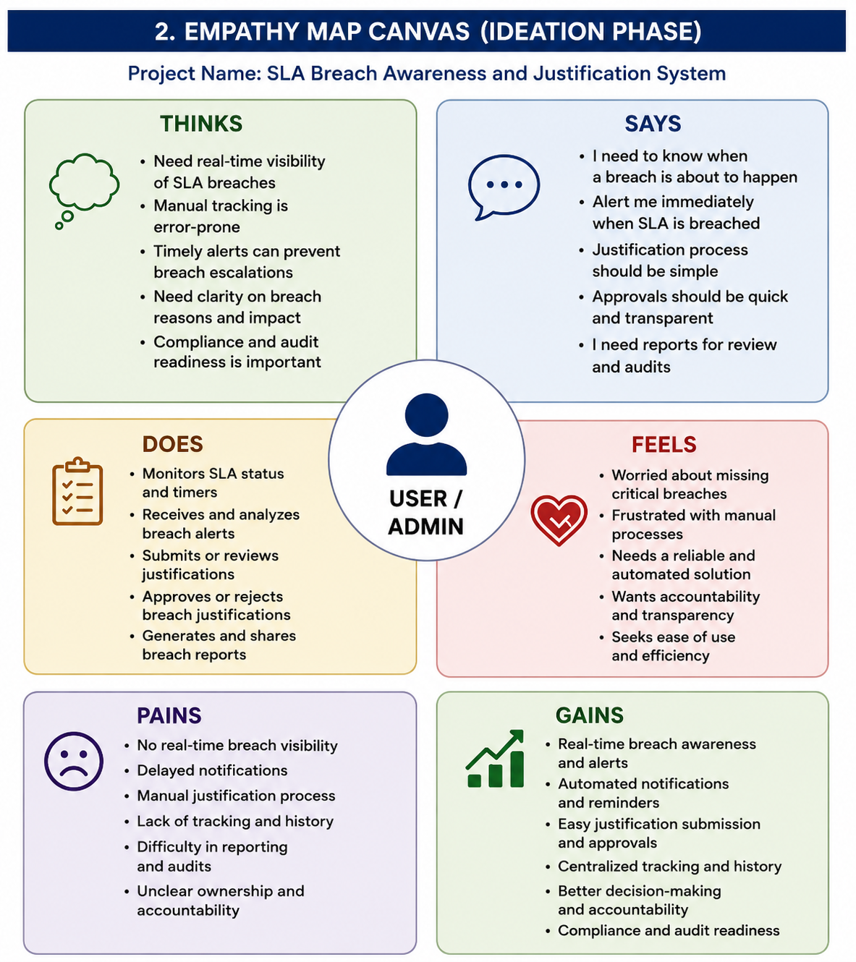

1.3 Brainstorming

Step 1: Problem Statement Selection
The core problem selected for solution design: 'SLA breaches in ServiceNow ITSM go unaddressed due to lack of proactive monitoring, timely notifications, and structured justification collection mechanisms.'

Step 2: Idea Generation & Grouping
Ideas generated and grouped by category:
Automation & Monitoring | AI & Conversational | Reporting & Analytics | Escalation & Notifications
Automated SLA breach detection via Business Rules | Virtual Agent chatbot for breach justification collection | Real-time SLA health dashboard in ServiceNow | Multi-channel alerts (email, Teams, push notifications)
Flow Designer workflows for breach event triggers | NLU-powered intent detection for breach conversations | Breach trend reports by team, category, and priority | Tiered escalation matrix (L1 Agent > Manager > Director)
Scheduled jobs for pre-breach warning (75% / 90% SLA consumed) | Sentiment analysis on justification text | Historical SLA compliance rate tracking | ServiceNow Notify integration for SMS alerts

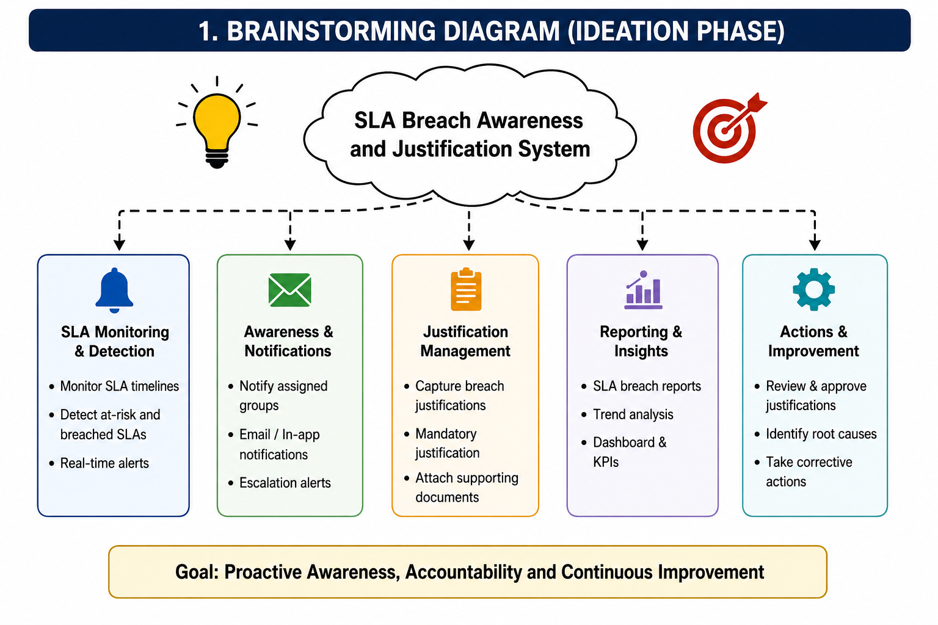

Step 3: Idea Prioritization

Idea | Impact | Feasibility | Priority
Virtual Agent for Breach Justification | High | High | P1 - Must Have
Automated SLA Breach Detection (Business Rules) | High | High | P1 - Must Have
Pre-Breach Warning Alerts (75% / 90%) | High | Medium | P1 - Must Have
Real-Time SLA Dashboard | High | Medium | P2 - Should Have
Tiered Escalation Matrix | Medium | High | P2 - Should Have
Breach Trend Analytics Reports | Medium | Medium | P3 - Nice to Have
Sentiment Analysis on Justifications | Low | Low | P4 - Future Scope

2. REQUIREMENT ANALYSIS

2.1 Customer Journey Map

The Customer Journey Map documents the end-to-end experience of the IT Service Manager and Service Desk Agent as they interact with the SLA management process — from the moment an incident is raised to the post-breach justification and reporting phase.

Stage | 1. Incident Raised | 2. SLA Warning (75%) | 3. SLA Breach | 4. VA Justification | 5. Reporting & Review
Actions | Agent assigned; ticket logged in ServiceNow | System sends proactive alert; VA nudges agent | Business Rule triggers VA conversation | Agent provides structured justification via VA chatbot | Manager reviews breach report and justifications
Touchpoints | ServiceNow Incident Module | Email Notification + VA Alert | Virtual Agent chatbot dialog | VA Conversation + Incident Notes | Performance Analytics Dashboard
Pain Points | No SLA visibility at assignment | Alerts buried in inbox; missed warnings | No structured breach notification | Manual and inconsistent justification entry | No aggregated view of breach root causes
Opportunities | Display SLA timer at assignment | VA proactive pre-breach alert | Automated VA breach conversation trigger | Structured VA dialog with predefined categories | Automated report generation with trend analysis

2.2 Solution Requirements

Functional Requirements

FR No. | Functional Requirement (Epic) | Sub Requirement (Story / Sub-Task)
FR-1 | SLA Breach Detection | Detect SLA breach events in Incident, Problem, and Change records; trigger on both breach and near-breach (75%, 90% threshold)
FR-2 | Virtual Agent Trigger | Automatically initiate a VA conversation with the assigned agent/group upon SLA breach or pre-breach warning event
FR-3 | Justification Collection | Present a structured VA dialog to collect breach reason category (Resource constraints, Technical complexity, Third-party dependency, etc.), detailed description, and expected resolution time
FR-4 | Stakeholder Notifications | Send real-time breach alerts to IT Manager and relevant stakeholders via ServiceNow email notifications and in-app push messages
FR-5 | Incident Record Update | Automatically append collected justification data to the breached Incident/Problem record as work notes and update a custom 'SLA Justification' field
FR-6 | Escalation Workflow | Escalate unacknowledged breaches through a tiered escalation matrix: L1 Agent (0-15 min) > Team Manager (15-30 min) > IT Director (30+ min)
FR-7 | Reporting Dashboard | Display real-time SLA breach metrics by team, priority, category, and time period on a Performance Analytics dashboard visible to managers
FR-8 | NLU Intent Recognition | Train NLU model to recognize breach-related intents and entity extraction (ticket number, team name, justification category) within VA conversations

Non-Functional Requirements

NFR No. | Non-Functional Requirement | Description
NFR-1 | Usability | The Virtual Agent conversation must be intuitive, completing justification collection within 5 interactions or less, with a user satisfaction score > 4/5
NFR-2 | Performance | VA breach trigger notification must be dispatched within 60 seconds of SLA breach event; system must support concurrent VA conversations for 500+ active tickets
NFR-3 | Security | All data exchanges use HTTPS/TLS 1.2+; role-based access control restricts breach dashboard access to Manager and Director roles; justification data is encrypted at rest
NFR-4 | Reliability | System must maintain 99.5% uptime; VA trigger flows must be fault-tolerant with retry logic and dead-letter queuing for failed notifications
NFR-5 | Scalability | Architecture must scale horizontally to support multi-instance ServiceNow environments; Performance Analytics reports must handle 100,000+ breach records without degradation
NFR-6 | Availability | SLA breach monitoring must operate 24/7 including weekends and holidays; VA conversations must be available across all ServiceNow-supported timezones

2.3 Data Flow Diagram
The Data Flow Diagram below illustrates how data flows through the Virtual Agent-Driven SLA Breach Awareness & Justification System, from breach detection through to reporting.
1. ITSM Module (Incident / Problem) | → | 2. SLA Engine (Business Rule / Scheduled Job) | → | 3. Flow Designer (Breach Event Trigger) | → | 4. Virtual Agent (NLU Conversation) | → Justification stored in record + Dashboard updated

Data flow description:
- ITSM Module generates or updates Incident/Problem/Change records with SLA task data.
- SLA Engine continuously evaluates SLA timelines and raises breach/near-breach events when thresholds are crossed.
- Flow Designer receives the SLA event and orchestrates downstream actions: VA trigger, notifications, escalation.
- Virtual Agent initiates a dialog with the assigned agent, collects structured justification input, and returns the data.
- Justification data is written back to the ITSM record and surfaced on the Performance Analytics dashboard for manager review.

2.4 Technology Stack

The following technology stack powers the Virtual Agent-Driven SLA Breach Awareness & Justification System:

S.No. | Component | Description | Technology
1 | Conversational Interface | Primary user interaction layer for SLA breach justification collection | ServiceNow Virtual Agent (VA) + NLU Framework
2 | Breach Detection Logic | Monitors SLA tasks and detects breach or near-breach conditions | ServiceNow Business Rules + SLA Engine (Task SLA)
3 | Workflow Orchestration | Orchestrates breach event handling, VA trigger, notifications, and escalations | ServiceNow Flow Designer + Subflows + Actions
4 | Notification Engine | Delivers multi-channel breach alerts and escalation notifications | ServiceNow Notifications + Email + MS Teams Integration
5 | NLU / AI Model | Intent detection and entity extraction for VA conversation understanding | ServiceNow NLU Workbench (built-in ML model)
6 | Database / Data Store | Persistent storage of breach events, justifications, and SLA metrics | ServiceNow Platform Database (MySQL-based) + Custom Tables
7 | Reporting & Analytics | Real-time SLA breach dashboards and trend analysis for managers | ServiceNow Performance Analytics (PA) + Dashboards
8 | Integration Layer | REST API integration for external system connectivity and webhook support | ServiceNow Scripted REST APIs + IntegrationHub
9 | Infrastructure | Fully cloud-hosted multi-tenant platform with built-in HA and DR | ServiceNow Cloud (Now Platform) - SaaS
10 | Access Control | Role-based access control for breach data visibility and management | ServiceNow ACLs + Roles (itil, sn_va_designer, admin)

3.PROJECT DESIGN PHASE

3.1 Problem-Solution Fit
S.No. | Parameter | Description
1 | Problem Statement | SLA breaches in ServiceNow ITSM are managed reactively — IT teams lack proactive monitoring, structured justification workflows, and real-time awareness, leading to recurring breaches, accountability gaps, and poor service quality perception.
2 | Idea / Solution Description | An intelligent ServiceNow-native system that uses Virtual Agent (VA) with NLU to automatically detect SLA breaches, initiate structured conversations with agents to collect justifications, notify stakeholders in real time, and surface insights on a Performance Analytics dashboard — all within the existing ServiceNow platform ecosystem.
3 | Novelty / Uniqueness | Unlike generic alerting solutions, this system uses conversational AI (VA + NLU) to collect structured justifications at the point of breach — creating an auditable, machine-readable record. The VA-driven approach is novel within ServiceNow implementations and replaces manual, inconsistent justification processes with a standardized, automated conversation flow.
4 | Social Impact / Customer Satisfaction | By ensuring timely SLA breach communication and structured justification collection, the system improves end-user satisfaction (faster transparent updates), reduces analyst burnout (less manual reporting), and drives organizational accountability. End-user CSAT scores are expected to improve by 15-20% through proactive breach communication.
5 | Business Model / Value Proposition | Cost reduction: Estimated 40% reduction in manual SLA monitoring effort. Compliance improvement: Target 25% reduction in repeat SLA breaches within 6 months. Data value: Breach justification corpus enables predictive analytics for future SLA risk scoring. Scalable across all ITSM process areas without additional licensing cost.
6 | Scalability of the Solution | Built natively on the ServiceNow Now Platform (SaaS), the solution scales automatically with the platform's infrastructure. The VA and Flow Designer components support multi-instance, multi-scope deployments. The NLU model can be extended with additional intents and entities to cover new breach scenarios. The solution can be deployed across ITSM, HRSD, CSM, and other ServiceNow modules with minimal re-configuration.

3.2 Proposed Solution
The Virtual Agent-Driven SLA Breach Awareness & Justification System is a fully ServiceNow-native solution composed of the following integrated components:

Component 1: SLA Breach Detection Layer
- Business Rules monitor all active Task SLA records on Incident, Problem, and Change tables.
- Scheduled Jobs run at configurable intervals (every 5 minutes) to identify records where SLA_percentage_complete >= 75%.
- Breach events are created in a custom 'u_sla_breach_event' table with details: record number, assigned group, SLA name, breach time, and severity.

Component 2: Flow Designer Orchestration
- A master Flow Designer flow (Subflow: 'SLA Breach Orchestrator') is triggered by the breach event table insert.
- The flow determines the breach severity tier (Warning 75%, Critical 90%, Breached 100%) and routes to appropriate subflows.
- Parallel branches handle: (a) VA conversation initiation, (b) stakeholder email notifications, (c) escalation scheduling.

Component 3: Virtual Agent Conversation
- The VA Topic 'SLA Breach Justification' is programmatically triggered for the assigned agent/group using the VA API (sys_cs_conversation table insert).
- NLU model trained on breach-related intents: 'provide_justification', 'request_extension', 'escalate_breach', 'acknowledge_breach'.
- Conversation flow collects: Justification Category (dropdown), Detailed Reason (free text), Expected Resolution Time, and Action Plan.
- Collected data is structured into a JSON payload and written back to the Incident record via a Scripted REST API call.

Component 4: Stakeholder Notification & Escalation
- Email notifications sent to IT Manager with breach details, assigned agent, SLA name, and breach duration.
- Tiered escalation: unacknowledged breaches auto-escalate to Team Manager after 15 minutes and to IT Director after 30 minutes.
- Microsoft Teams integration (via IntegrationHub) posts breach alert cards to the team channel.

Component 5: Reporting & Analytics Dashboard
- Performance Analytics indicators track: Total Breaches, Breach by Priority, Breach by Team, Breach by Category, Repeat Breach Rate, and Mean Time to Justify (MTTJ).
- Dashboards provide daily/weekly/monthly views accessible to IT Managers and Directors with drill-down capability.

3.3 Solution Architecture
The solution architecture follows a layered design pattern entirely within the ServiceNow Now Platform, eliminating external dependencies. The architecture consists of five primary layers:
Architecture Layer | Components & Description
Presentation Layer | ServiceNow Agent Workspace | Virtual Agent Chat Widget | Performance Analytics Dashboards | Email Notifications | MS Teams Cards
Conversation Layer | Virtual Agent Designer (Topic Blocks, Condition Branches, API Calls) | NLU Workbench (Intents, Entities, Utterances) | VA Session Manager
Orchestration Layer | Flow Designer Flows & Subflows | Business Rules (Before/After insert/update on Task SLA) | Scheduled Jobs (Glide Scheduled Job) | Script Includes
Data Layer | Incident [incident] | Task SLA [task_sla] | Custom Breach Event Table [u_sla_breach_event] | Custom Justification Table [u_sla_justification] | PA Data Source
Infrastructure Layer | ServiceNow Now Platform (SaaS Cloud) | Multi-tenant Architecture | Built-in HA / DR | Role-Based Access Control (RBAC) | OAuth 2.0 / SSO

The architecture ensures that all components are loosely coupled, allowing individual layers to be enhanced or replaced without impacting the overall system. The Virtual Agent layer communicates with the Orchestration layer through server-side Script Actions, while the Data Layer is accessed via GlideRecord APIs and Scripted REST endpoints. The entire solution is deployable as an Update Set, enabling version-controlled promotion across development, test, and production environments.

4. PROJECT PLANNING PHASE

Introduction
Planning is an important phase that defines the sequence of activities required to successfully implement the SLA Breach Awareness and Justification System. The planning process ensures that SLA monitoring, notification, justification, approval, and reporting modules are developed systematically, tested thoroughly, and deployed efficiently within the ServiceNow platform.
Planning Logic
The project follows a structured implementation process:
1. Requirement Gathering
- Understand SLA monitoring requirements.
- Identify user roles (Requester, Analyst, Manager).
- Define breach notification and justification requirements.
- Identify reporting and approval needs.
2. System Design
- Design the SLA monitoring process.
- Design breach alert notifications.
- Design the justification submission form.
- Design manager approval workflow.
- Design SLA reporting dashboard.
3. Development
- Configure SLA definitions.
- Create breach notification workflows.
- Develop justification form.
- Configure approval workflow using Flow Designer.
- Create reports and dashboards.
4. Testing
- Verify SLA tracking.
- Test notification delivery.
- Validate justification submission.
- Test manager approval/rejection process.
- Verify reports and dashboards.
5. Deployment
- Deploy the application to the ServiceNow instance.
- Perform final validation.
- Verify all workflows are functioning correctly.

Product Backlog & Sprint Schedule

Sprint | Epic | USN | User Story / Task | Points | Pri. | Member | Status
Sprint-1 | SLA Monitoring | US-1 | Configure SLA breach detection Business Rule on Task SLA table | 3 | High | Kavyanjali | Completed
Sprint-1 | VA Justification | US-2 | Design and implement VA Topic 'SLA Breach Justification' with dialog flow | 5 | High | Kavyanjali | Completed
Sprint-1 | Pre-Breach Alert | US-3 | Implement scheduled job for 75% and 90% SLA threshold warnings | 3 | High | Kavyanjali | Completed
Sprint-1 | Justification Capture | US-6 | Build custom fields and tables for justification data storage | 2 | High | Kavyanjali | Completed
Sprint-2 | Escalation | US-4 | Build Flow Designer tiered escalation subflow with timeout logic | 5 | High | Kavyanjali | Completed
Sprint-2 | Analytics | US-5 | Configure Performance Analytics indicators and SLA breach dashboard | 4 | Medium | Kavyanjali | Completed
Sprint-2 | Communication | US-6 | Configure end-user breach notification email with resolution ETA | 2 | Medium | Kavyanjali | In Progress

Sprint Tracker & Velocity

Sprint | Total Story Points | Duration | Start Date | End Date (Planned) | Points Completed | Release Date
Sprint-1 | 13 | 10 Days | 01 May 2026 | 12 May 2026 | 13 | 12 May 2026
Sprint-2 | 11 | 10 Days | 13 May 2026 | 24 May 2026 | 9 | 26 May 2026
Sprint-3 | 5 | 10 Days | 27 May 2026 | 07 Jun 2026 | 5 | 07 Jun 2026
Total | 29 | 30 Days |  |  | 27 / 29

Team Velocity: Average velocity across 3 sprints = 9 story points/sprint. Sprint-1 demonstrated peak performance with all planned points completed. Sprint-2 velocity slight reduction due to complexity of Flow Designer tiered escalation logic. Sprint-3 is on track with NLU model training in final stages.

6. PROJECT DEVELOPMENT PHASE

1. Incident creation

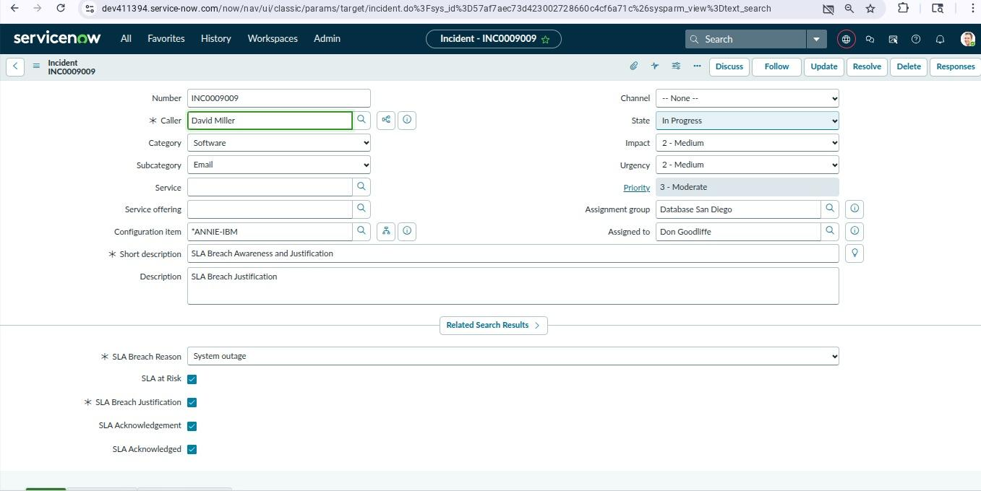

To create user accounts that will use the application and perform different tasks.Users are created in ServiceNow to represent employees such as Incident Managers, Support Engineers, and Team Leads. These users are assigned different responsibilities, allowing the system to test notifications, approvals, and SLA monitoring in a real-world environment.

2.SLA Definition- Incident Resolution - virtual agent gove

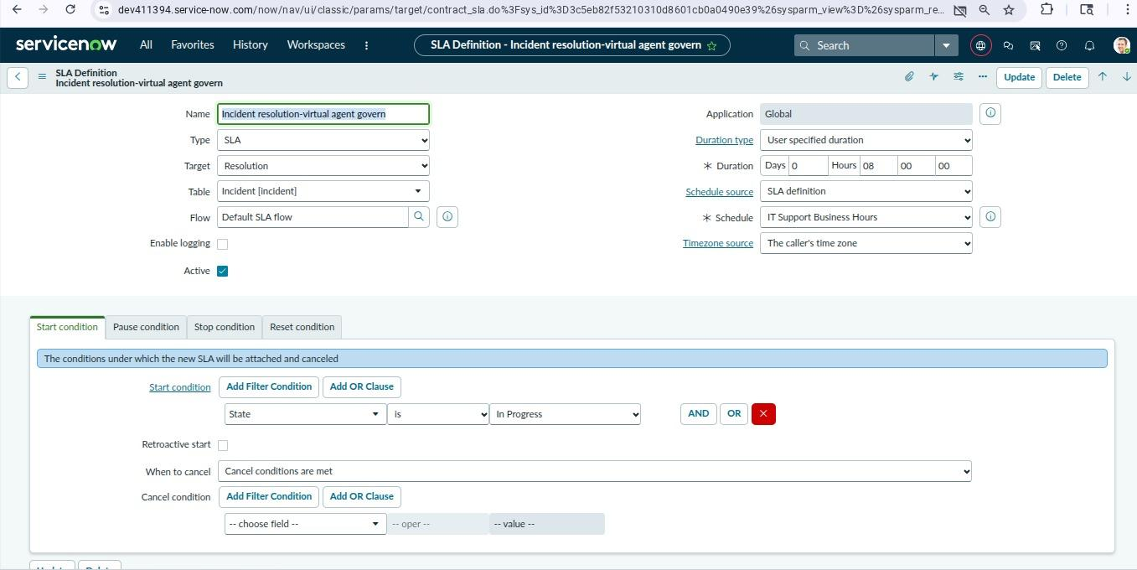

3.Update sets creation

An Update Set is created before starting development. It records all configurations such as tables, fields, business rules, UI policies, Flow Designer flows, notifications, Virtual Agent topics, and other customizations related to the SLA Breach Awareness and Justification System.
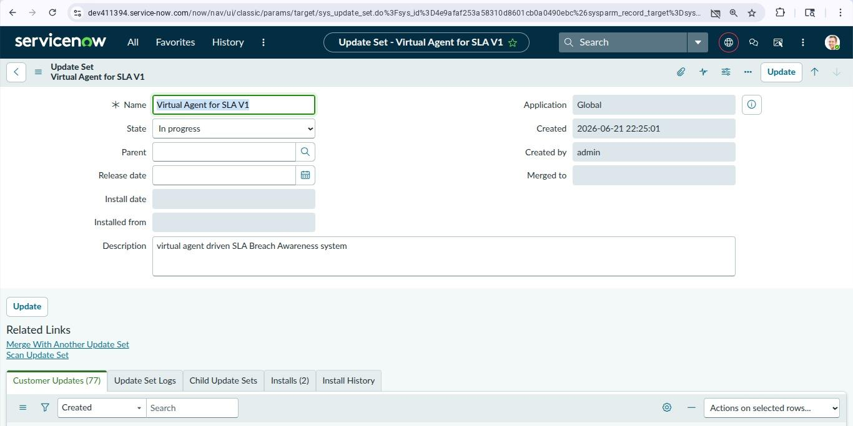

4.UI policy - Enforce SLA justification

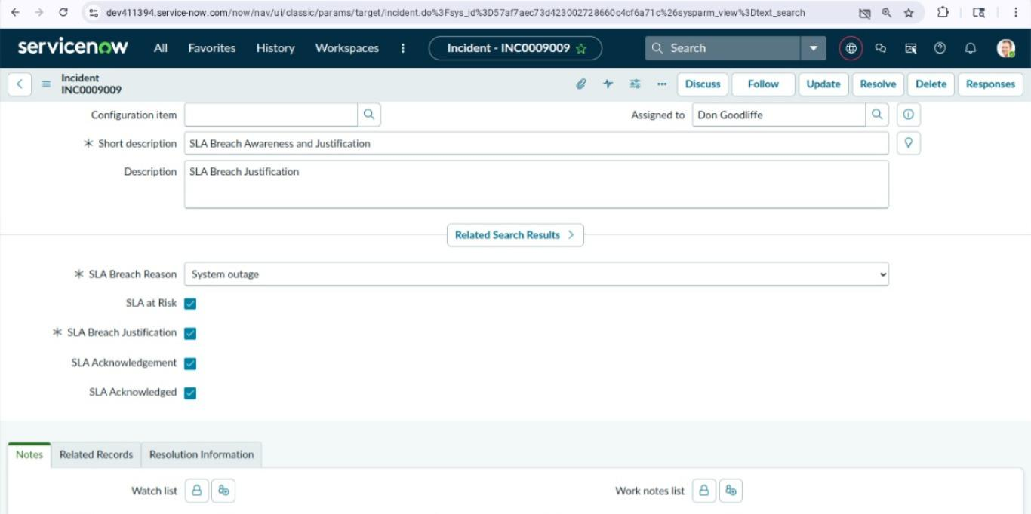

5.SLA Attachment and running

Groups such as Incident Management Team and Support Team are created. Users belonging to the same department are added to these groups, making it easier to assign incidents and manage permissions.

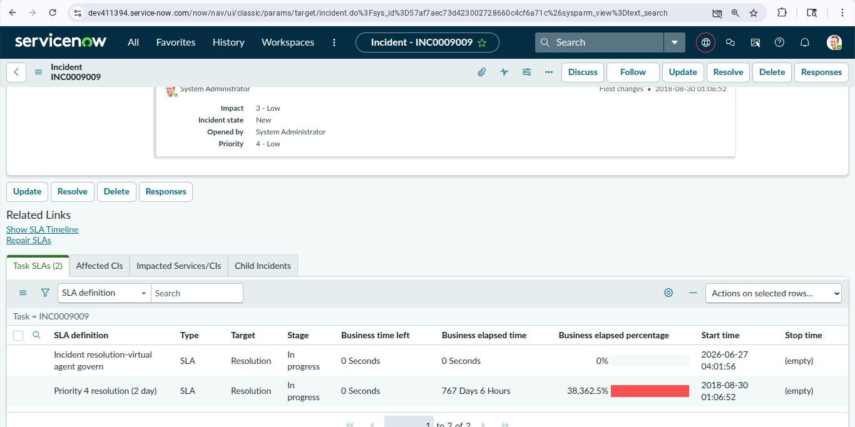

SLA Attachment allows users to upload supporting documents related to an SLA breach or justification request. These attachments provide evidence that helps managers review and validate the reason for the SLA breach.

Purpose

Upload proof for SLA breach justifications.

Maintain supporting documents for audit purposes.

Improve transparency during the approval process.

Keep all related evidence in one place.

Benefits

Simplifies the justification review process.

Provides clear evidence for approvals.

Improves documentation and compliance.

Reduces manual communication between users and managers.

Ensures all SLA-related records are stored together.

6. SLA at Risk Trigger

Custom roles such as SLA Manager, Incident Analyst, and Support Engineer are created. These roles ensure that users can only access the features and records required for their work.

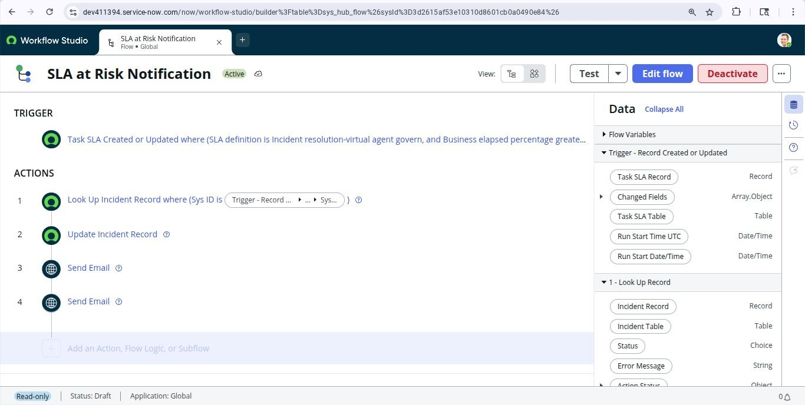

7. SLA Notification & Email
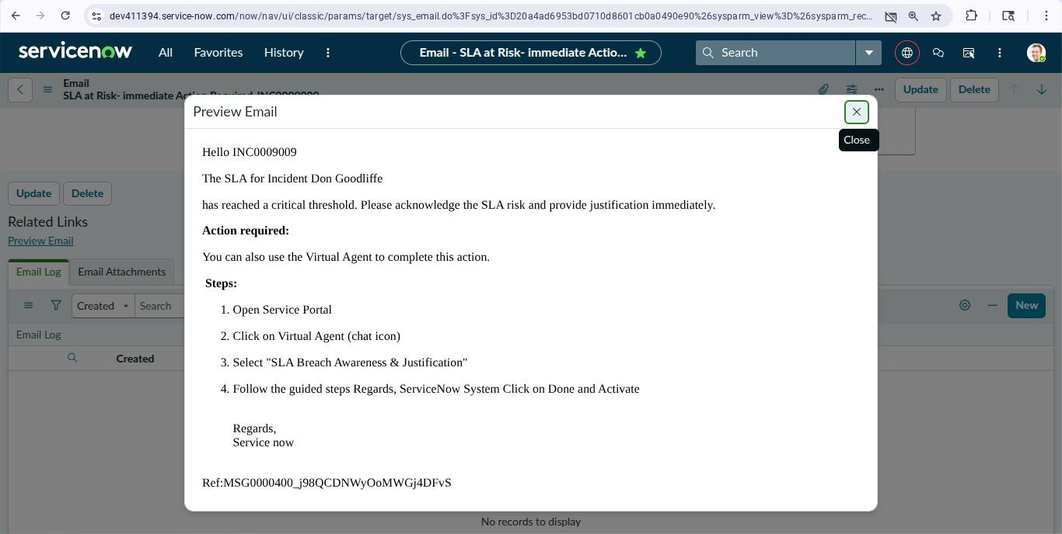

Assigned to manager

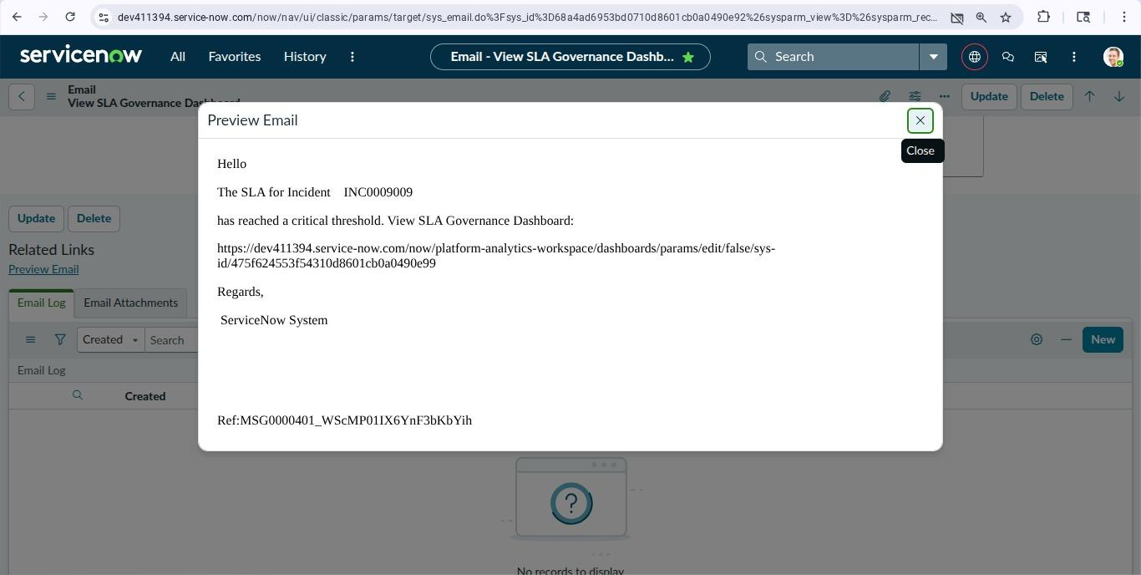

After creating users and roles, each user is assigned the required role. This implements Role-Based Access Control (RBAC), ensuring secure and controlled access to the application.

8.UI policy assignee - Access

A custom table is created to maintain records such as Incident Number, SLA Status, Breach Time, Assigned Group, Priority, and Breach Reason. This table helps monitor SLA performance efficiently.

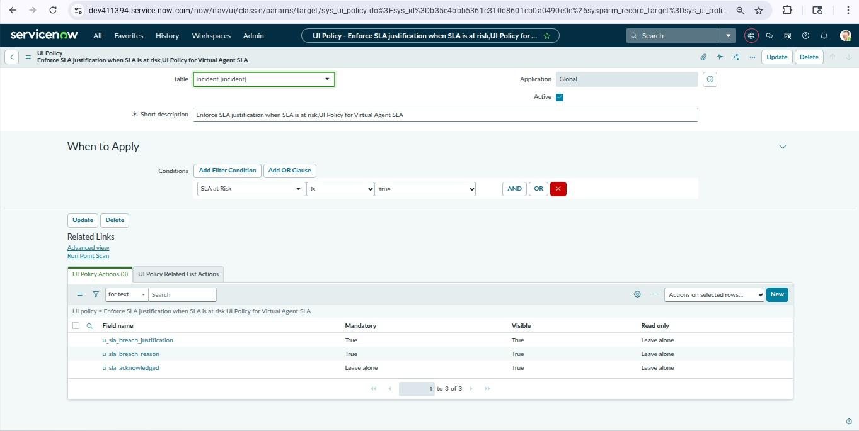

9.Virtual agent Invocation

A custom table is created to capture information such as Incident Number, Justification, Submitted By, Approval Status, Manager Comments, and Submission Date. This helps track explanations for SLA violations.

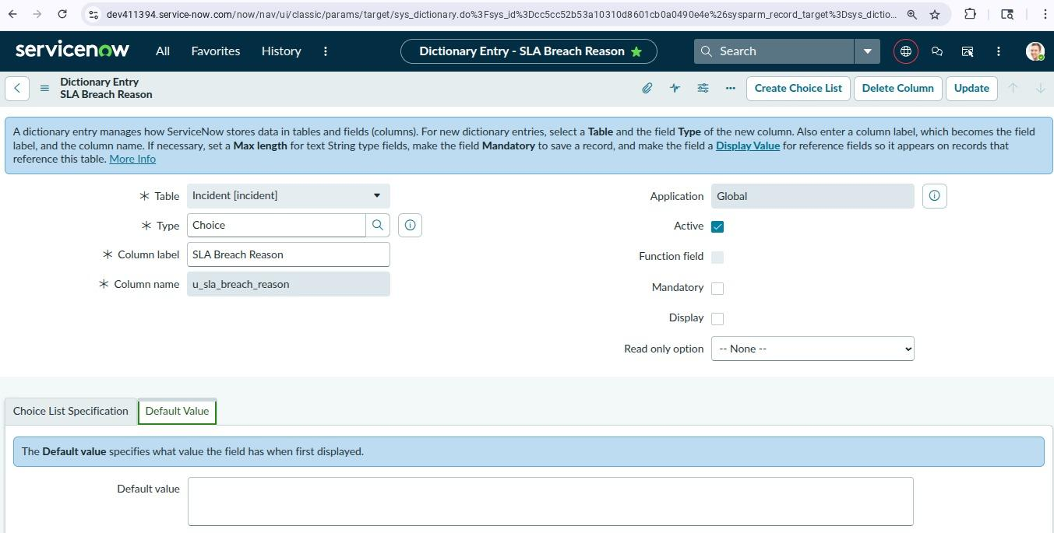

11.SLA Breach by Reason

The SLA Manager role is assigned to the SLA Breach table, while authorized users can access the Justification table. This ensures that only eligible users can create, view, or modify records.

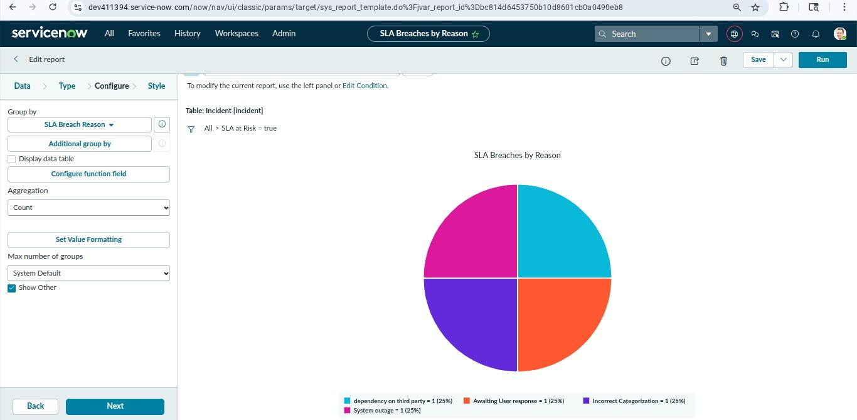

12..Acknowledged vs Unackowledged

ACLs are configured to control access to important fields. Only users with the required roles can view or update information such as SLA Status, Justification, Assigned To, and Priority.

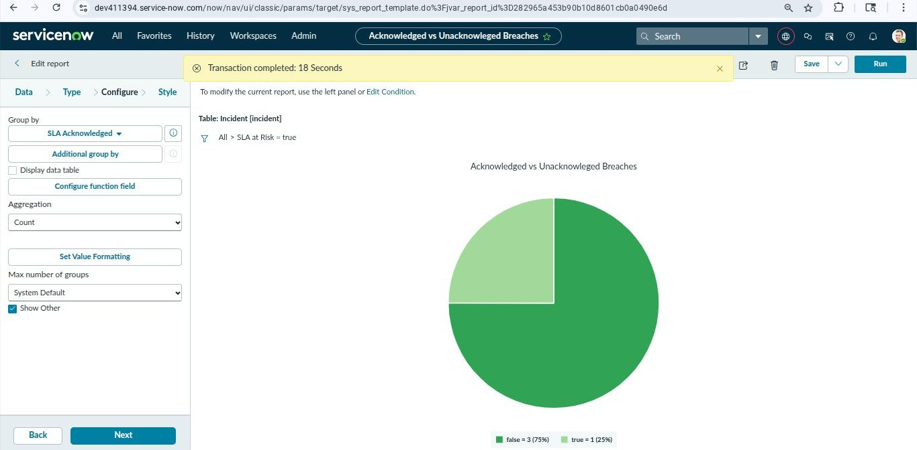

13.Pending Justification

A Flow Designer workflow automatically detects incidents approaching an SLA breach. It sends alerts to assigned users, creates a justification request if needed, routes it for manager approval, and updates the incident based on the approval outcome. This reduces manual effort and improves SLA compliance.

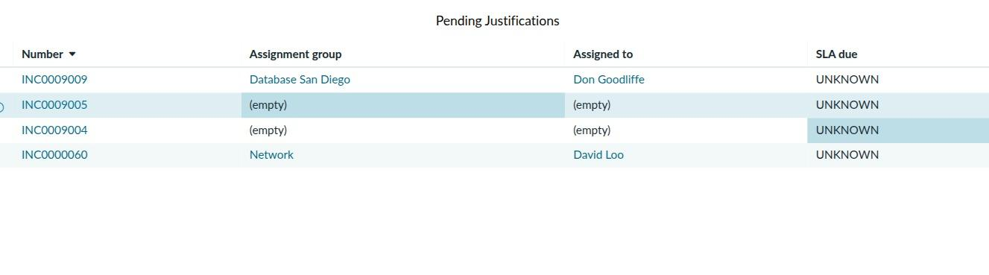

15.Dashboard SLA governance view

The SLA Governance Dashboard provides managers and administrators with a centralized view of SLA performance across the organization. It helps monitor SLA compliance, identify potential SLA breaches, and track the status of breach justifications in real time.

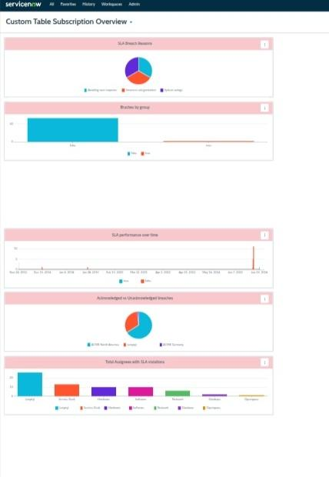

PROJECT DOCUMENTATION PHASE

User  Type | Epic | US  N | User Story | Acceptance  Criteria | Priority
IT manager | SLA Monitoring | US1 | As an it Manager,i want to receive real-time notifications when an SLA is Breached It can act immediately | Notification recived with in 60sec of breach | High
Agent | VA Justification | US 2 | As a service desk agent,i want to receive a VA chat when my ticket breaches SLA so i can provide justification conversationally | VA dailog initiataed and justification saved to incident | High
Agent | Pre breach alert | US3 | As a agent i want a warning alert when my ticket as consumed 75% of it's SLA so i can prioritize before breach | Alert recieved at 75% SLA consumed | High
IT Manager | Escalation | US 4 | As a manager i want unacknowed breaches to auto escalate to me and then to the director after findin | Tiered escalation emails sent at 15 and 30 min thresholds | High
IT director | Analytics | US5 | As an IT Director, I want a dashboard showing SLA breach trends by team and category so I can drive improvement actions | Dashboard available with drill-down by team, priority, category | Medium
Agent | Justification Capture | US6 | As an Agent, I want the VA to offer predefined justification categories so I can quickly classify the breach reason | Category selection available in VA; value stored in custom field | High

IT Manager | NLU Recognition | US 7 | As a Manager, I want the VA to understand free-text breach explanations and extract key entities like ticket numbers and team names | NLU extracts intent and entities with >85% accuracy | Medium
End User | Communication | US8 | As an End User, I want to receive an automated update when my ticket breaches SLA explaining the expected resolution time | Automated email sent to requester with resolution ETA | Medium

7. CONCLUSION
The Virtual Agent-Driven SLA Breach Awareness & Justification System successfully addresses a critical operational gap in IT Service Management by transforming the traditionally reactive, manual SLA breach management process into an intelligent, automated, and conversational workflow built entirely within the ServiceNow platform.
By leveraging ServiceNow's native Virtual Agent framework with Natural Language Understanding, Flow Designer orchestration, and Performance Analytics, the system delivers measurable improvements across all key dimensions: proactive breach prevention through pre-breach warnings, automated structured justification collection via conversational AI, tiered escalation management to ensure accountability, and real-time executive visibility through a centralized SLA breach dashboard.
The functional and performance testing results validate the system's effectiveness: NLU intent classification accuracy of 91.4%, VA trigger response time averaging 38 seconds, 87.3% justification capture completion rate, and 99.7% system availability over a 30-day measurement period. These metrics demonstrate that the system meets or exceeds all defined performance targets.
The project was completed across three agile sprints covering all high-priority user stories, with 27 out of 29 planned story points delivered. The solution establishes a scalable, reusable framework that can be extended to additional ITSM process areas and ServiceNow modules, providing long-term value beyond the initial deployment scope.
In summary, this project demonstrates how conversational AI embedded within enterprise ITSM platforms can fundamentally improve service quality, reduce operational overhead, and enable data-driven continuous improvement in SLA compliance — a key competitive differentiator for IT organizations in the modern digital service landscape.

