EX4
Task 1.1
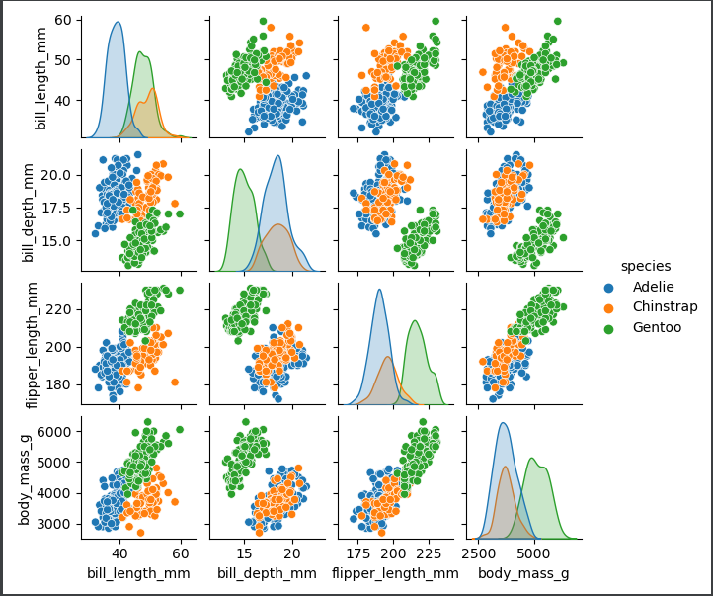

The two features which allow for the most accurate 2-feature GNB classifier were the bill_length_mm and flipper_length_mm. The bill_length_mm and flipper_length_mm has graphs that were accurate enough (0.95).

Task 1.3
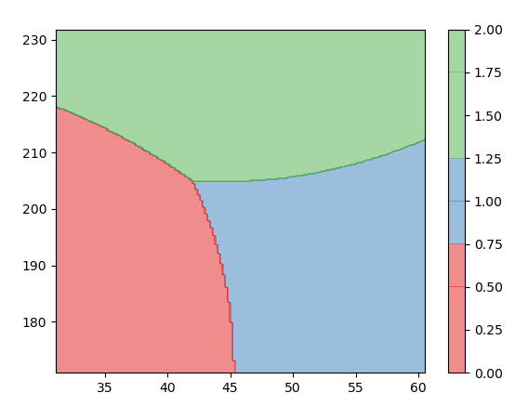
Task 1.4
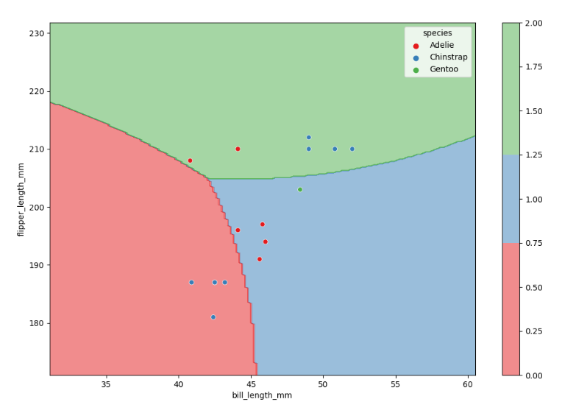

Task 1.5
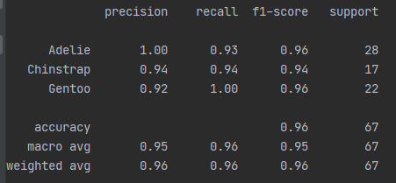

Task 2.1
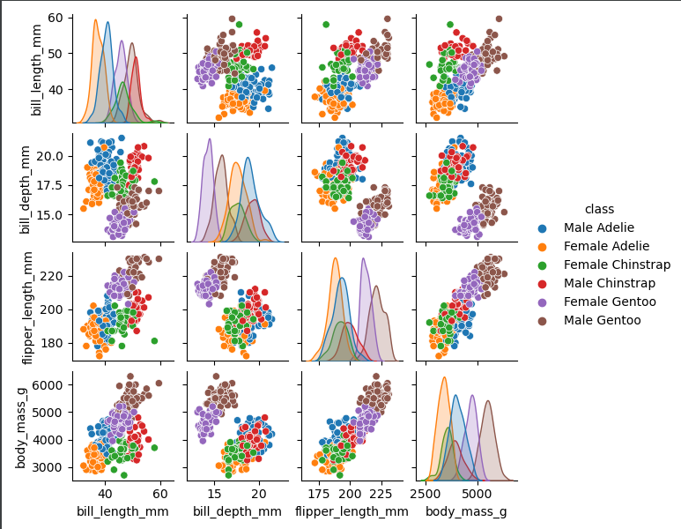
The two features which allow for the most accurate 2-feature GNB classifier were the bill_length_mm and bill_depth_mm. The bill_length_mm and bill_depth_mm has graphs that were accurate enough (0.85). The bill_length_mm and bill_depth_mm graphs were separated, and the species don’t overlay each other.

Task 2.3
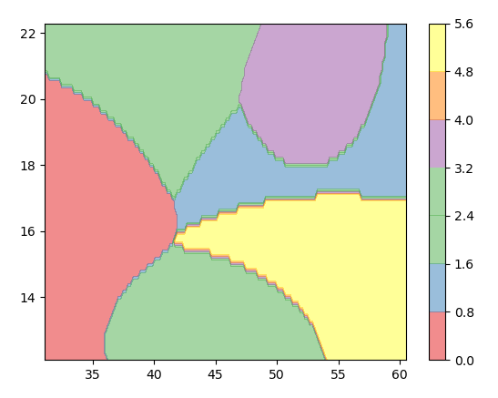
Task 2.4
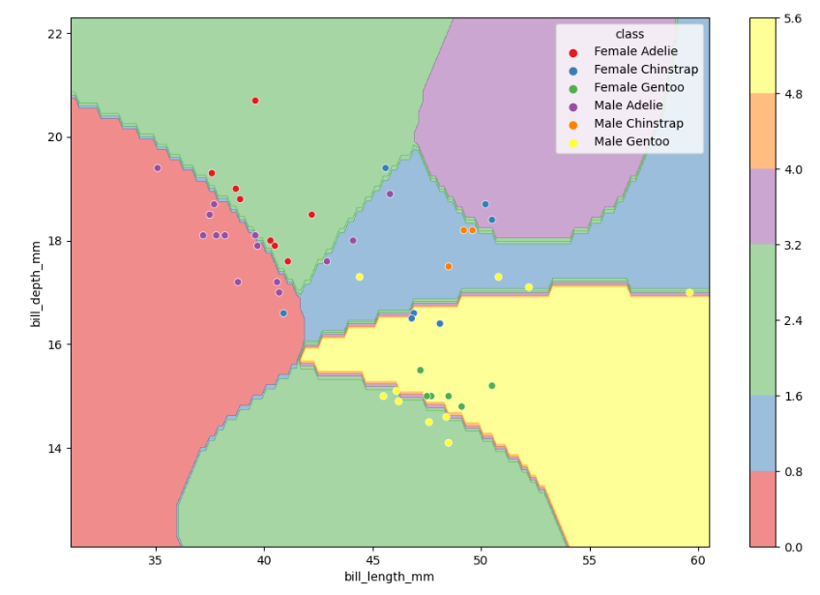
Task 2.5
