2.

create database movie1;

use movie1;

create table movie(movid int primary key,mcat varchar(10) not null,movlang varchar(10),movlen int,movrat int);

create table ticket(movid int,movshwid int,price int,paymdth varchar(10),pricecat varchar(10),foreign key(movid)references movie(movid),foreign key(movshwid)references movieshow(movshwid));

create table movieshow(movshwid int primary key,mshwdat varchar(10) not null,mid int,foreign key(mid)references movie(movid));

create table staff(sid int primary key,sname varchar(15) not null,scno bigint,notmale varchar(10));

insert into Staff values(1,"Udhay",1151161179,"N");

insert into Staff values(2,"Maliga",9291458791,"Y");

insert into Staff(sid,sname,scno) values(3,"Ramu",8996578425);

insert into Staff(sid,sname,scno) values(5,"Kamal",1692369874);

insert into Staff values(4,"Adi",1801145789,"N");

insert into Staff values(6,"Charu",1542225558,"Y");

select * from staff;

set foreign_key_checks=0;

drop table ticket;

delete from staff where sname="Adi";

update staff set sname="Kamala" where sid=5;

select * from staff;

update staff set scno=1112223339 where sname="Charu";

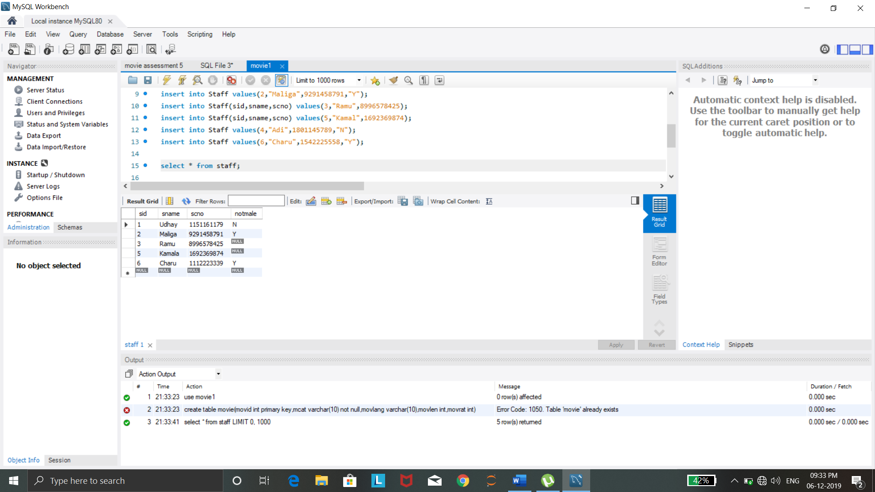

3.

create database dept;

use dept;

create table dept(deptid int primary key,deptname varchar(30) not null,deptblkno varchar(10));

create table stud(studid int,studname varchar(10) not null,studaddr varchar(30),city varchar(10),deptid int,foreign key(deptid)references dept(deptid));

create table staff(staffid int primary key,staffname varchar(10) not null,deptid int,foreign key(deptid)references dept(deptid));

create table sub(subid int primary key,subname varchar(15) not null,subcode varchar(10),staffid int,foreign key(staffid)references staff(staffid));

insert into dept(deptid,deptname) values(1,"CSE");

insert into dept values(2,"ECE","Block 2");

insert into dept values(3,"IT","Block 3");

insert into dept values(4,"CIVIL","Block 4");

insert into dept values(5,"Mechanical","Block 4");

insert into dept values(6,"Aero","Block 1");

select * from dept;

set foreign_key_checks=0;

drop table staff;

delete from dept where deptname="Mechanical";

update dept set deptname="Aeronautical" where deptname="Aero";

select * from dept;

update dept set deptblkno="NewBlock1" where deptname="CSE";

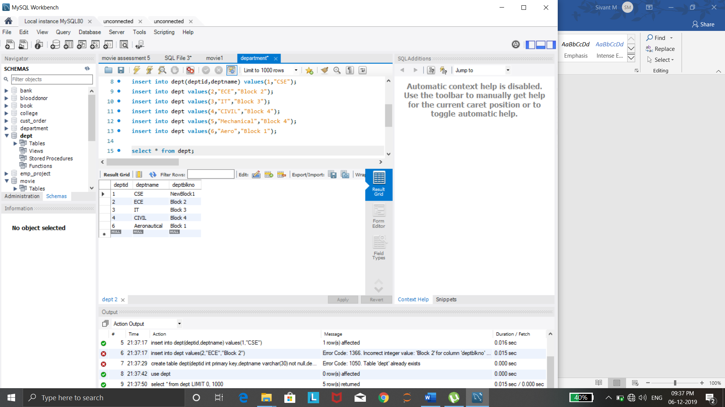

4.

create database department;

use department;

create database COLLEGE;

use COLLEGE;

create table stud(student_id int primary key,gender varchar(10),dob date,firstname varchar(10),middlename varchar(10),lastname varchar(10),otherstddtls varchar(50));

create table course(crid int primary key,crname varchar(20),othercrdetls varchar(30));

create table courseschl(crshlid int primary key,othercrschldetls varchar(30),crid int,foreign key(crid) references course(crid));

create table courseregistration(crshid int,foreign key(crshid) references courseschl(crshlid),stdid int,foreign key(stdid) references stud(student_id),primary key(crshid,stdid));

insert into course values(1,"C","Quarter1");

insert into course values(2,"C++","Quarter2");

insert into course values(3,"JAVA","Quarter3");

insert into course values(4,"PYTHON","Quarter1");

insert into course(crid,crname) values(5,"IOT");

insert into course values(6,"English","Quarter2");

set foreign_key_checks=0;

Drop table stud;

delete from course where crname="C++";

Update course Set crname="Problem Solving in C" where crname="C";

select * From course;

update course Set othercrdetls="Quarter1" where crname="English";

