**VPC - POC**

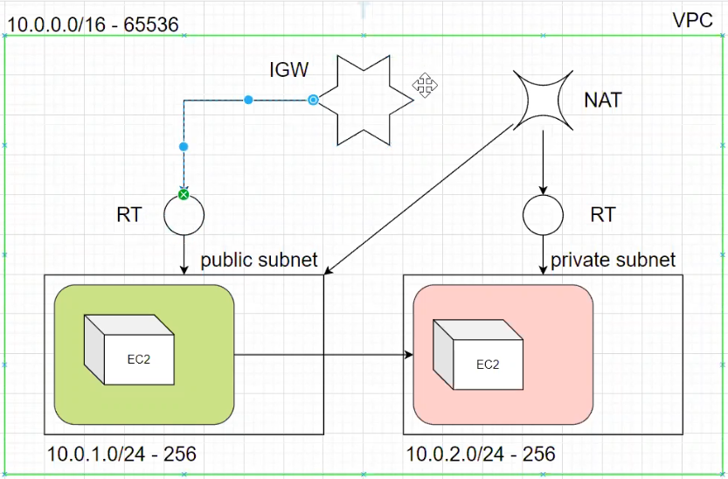

Steps to Create and set up a VPC in AWS environment:

=============================================

1. Create a own VPC.

2. Create a Public and Private subnet for different Available AZs by assigning different CIDR blocks.

3. Create Internet Gateway & attach it to the VPC.

4. Create Routing table [RT], One as Public & One as Private by associating the appropriate subnets to it.

5. Edit the Public route table's Route alone and map the IGW, not the Private and leave it as it is.

6. Create Two Security Groups - One for Public [Edit the Inbound rules with RDP, HTTP/HTTPS, SSH and map 0.0.0.0/0 in the source] & One for Private [Edit the inbound rules and map the SG of Public in the source].

7. Create Two EC2s one in public and one in private subnets with proper Security Groups.

8. Login into Public and check the internet connection.

9. Create NAT gateway with new Elastic IP for the internet connection in the Private Subnet. Map it to Private RT.

10. Now login into the Private EC2 and verify the connectivity and Internet facility.