HR Attrition Analysis Dashboard
Project 1 — Table: Cleaned | 500 Employees | Tools: Excel + Power BI

1. Project Overview and Objective
This project involves cleaning, transforming, and analysing raw HR employee data using Excel and creating an interactive Power BI dashboard to derive meaningful insights on employee attrition.
The main objective is to identify the key factors driving employee attrition across departments, age groups, job roles, and locations — and to present actionable insights through a dynamic, interactive Power BI dashboard.
2. Data Sources
- Source Description and Timeline: Simulated HR employee dataset (Kaggle / UCI-style) | 2024
- Domain: Human Resources (HR) Analytics
3. Problem Statement
- To analyse employee attrition rates across departments, job roles, age groups, and cities to identify high-risk segments.
- To study the impact of overtime, work-life balance, and job satisfaction on employee attrition.
- To evaluate performance ratings and monthly income patterns across job roles for HR decision-making.
- To understand the correlation between marital status, training hours, and employee retention.
4. Attribute (Column / Features) Details

Attribute Name | Data Type | Description
EmployeeID | String | Unique identifier for each employee
Age2 | Numeric (Integer) | Age of the employee in years
Gender | Categorical | Gender (Male / Female)
Department | Categorical | Department (HR, IT, Finance, Marketing, Operations, Sales)
JobRole | Categorical | Role/designation of the employee
MonthlyIncome2 | Numeric (Integer) | Monthly income of the employee
JobSatisfaction2 | Numeric (1-5) | Employee job satisfaction score
PerformanceRating | Numeric (1-5) | Employee performance rating
WorkLifeBalance2 | Numeric (1-5) | Work-life balance score
Overtime | Categorical | Whether employee works overtime (Yes / No)
YearsAtCompany | Numeric (Integer) | Total years at the company
Attrition | Categorical | Whether employee left the company (Yes / No)
MaritalStatus | Categorical | Marital status (Single / Married / Divorced)
TrainingHours | Numeric (Integer) | Number of training hours completed
City | Categorical | City where the employee is located
Age Group | Calculated Column | Age group bucket: 18-25, 26-35, 36-45, 46+

5. Tools & Technologies
- Excel: Data cleaning, transformation, and Pivot Tables.
- Power BI: Data modelling, DAX calculations, visualization, and interactive dashboard creation.
6. Data Pre-Processing (Excel / Power Query)
Tasks Performed:
- Data Cleaning & Transformation: Removed duplicates, handled missing values in JobSatisfaction, PerformanceRating, WorkLifeBalance. Standardised inconsistent JobRole entries (e.g., 'mAnager', 'Enginee') using PROPER() function — new column JobRole2 created.
- Filtering & Sorting: Applied Conditional Formatting (Attrition: Yes=Red, No=Green). Organised data for relevant records.
- Pivot Tables: Employee count by Department (Finance:70, HR:79, IT:90, Marketing:79, Operations:96, Sales:86 — Total:500). Attrition by Department & Gender. Sum of Income by JobRole. MaritalStatus count (Divorced:171, Married:169, Single:160).

SCREENSHOT — EXCEL DATA PRE-PROCESSING
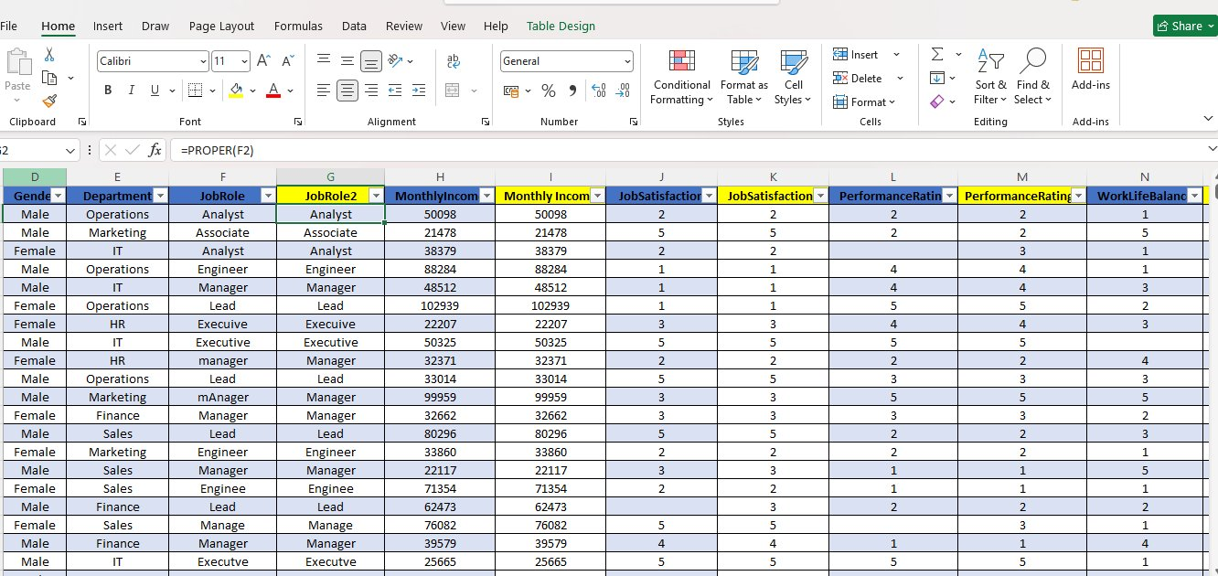
Screenshot 1: Excel — Processed Sheet (PROPER() function applied for JobRole2)
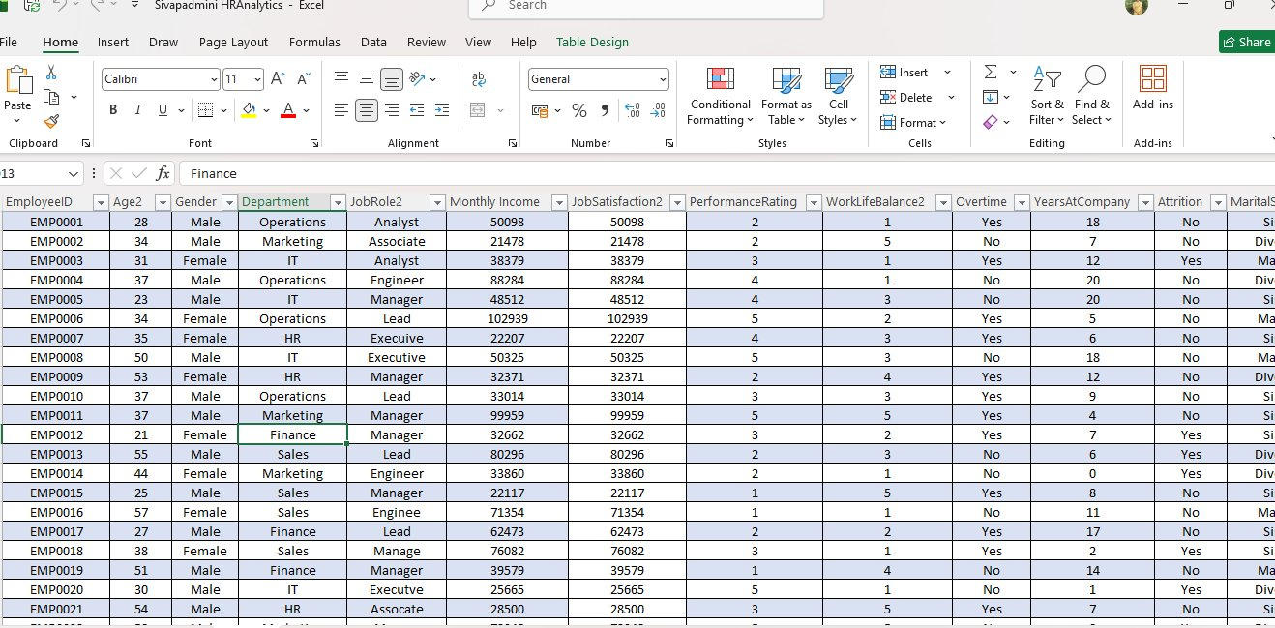
Screenshot 2: Excel — Cleaned Sheet (Full employee table with all columns)
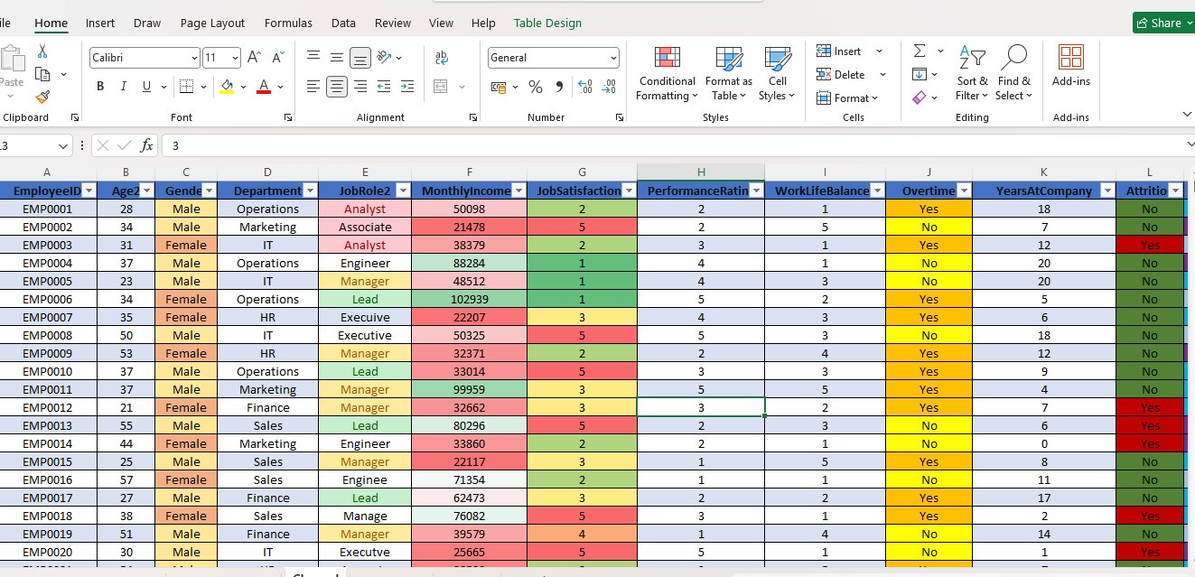
Screenshot 3: Excel — Conditional Formatting applied on Cleaned Sheet
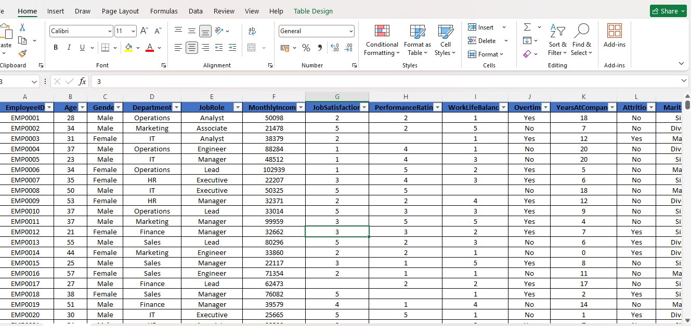
Screenshot 4: Excel — Final Clean Table
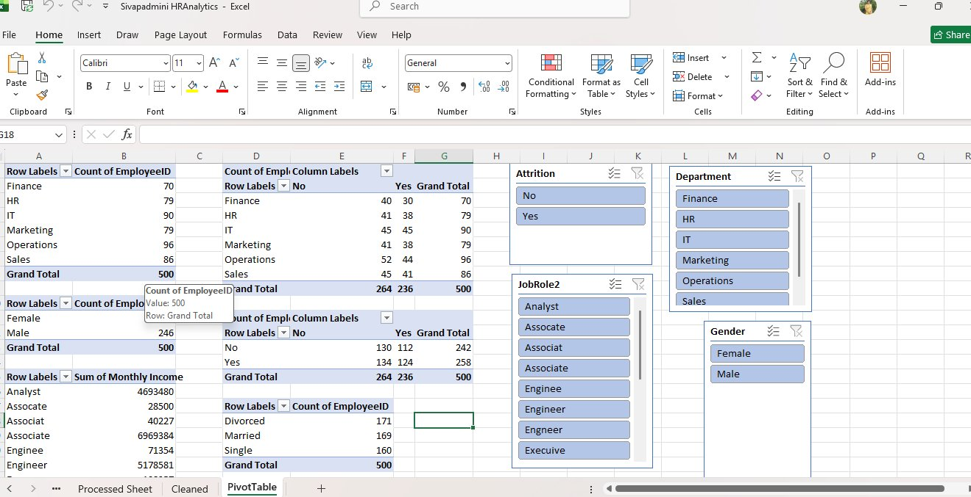
Screenshot 5: Excel — PivotTable Sheet (Department, Gender, Attrition summaries)
7. Data Modelling and DAX (Power BI)
- Data Model: Loaded 'Cleaned' sheet from Excel into Power BI. Single flat table (Cleaned) used as the primary data source.

SCREENSHOT OF DATA MODELLING
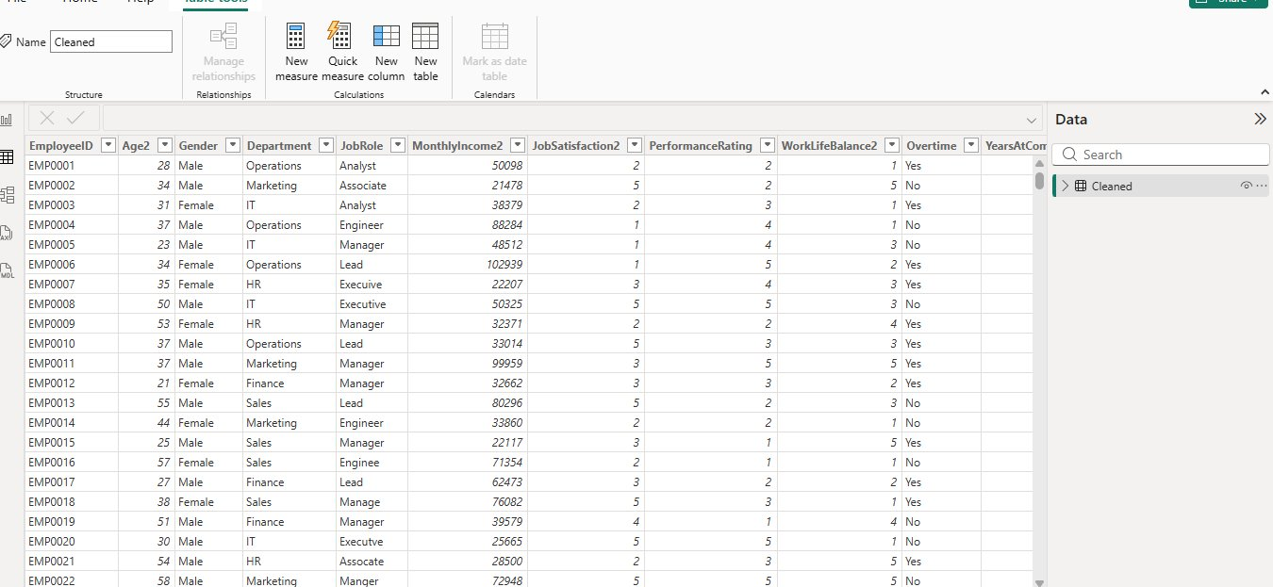
Screenshot 6: Power BI — Table View of 'Cleaned' Dataset

Calculated Columns & DAX Measures:
Measure / Column | Type | DAX Formula
Age Group | Calculated Column | SWITCH(TRUE(), Cleaned[Age2]<=25,"18-25", Cleaned[Age2]<=35,"26-35", Cleaned[Age2]<=45,"36-45", "46+")
Total Employees | Measure | Total Employees = COUNT(Cleaned[EmployeeID])
Attrition Count | Measure | CALCULATE(COUNT(Cleaned[EmployeeID]), Cleaned[Attrition]="Yes")
Attrition Rate | Measure | DIVIDE([Attrition Count],[Total Employees])*100

SCREENSHOT — DAX MEASURES
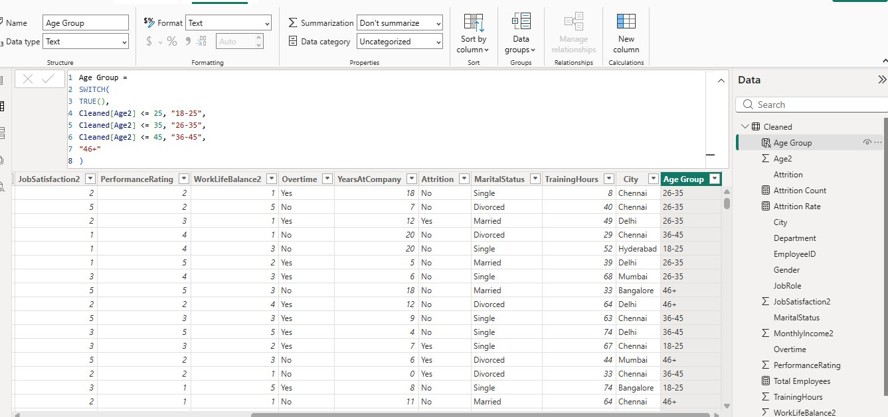
Screenshot 7: DAX — Age Group Calculated Column
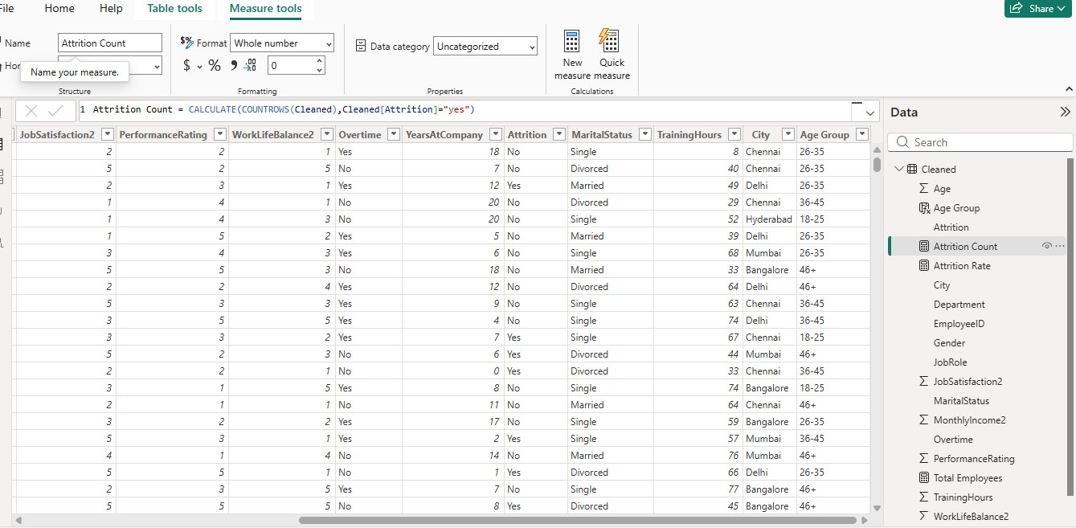
Screenshot 8: DAX — Attrition Count Measure
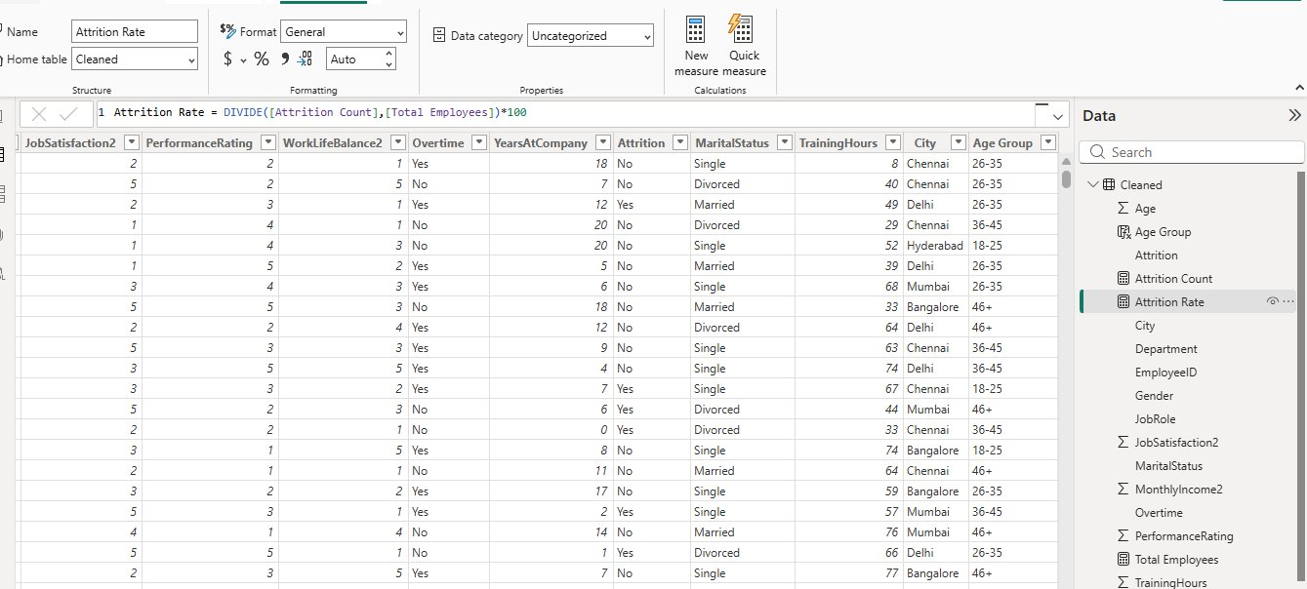
Screenshot 9: DAX — Attrition Rate Measure
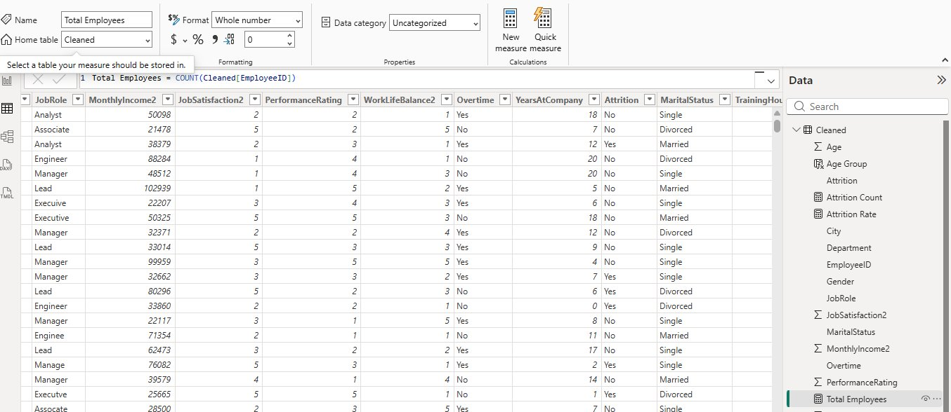
Screenshot 10: DAX — Total Employees Measure
8. Analysis and Visualizations (Power BI)
Dashboard Features:

Visual Type | Purpose / Description
KPI Cards (3) | Total Employees (503), Total Attrition (236), Attrition Rate (46.92%)
Stacked Bar Chart | Attrition Count by Age Group (Yes / No)
Treemap | Department-wise Employee Distribution by Age Group and Gender
Filled Map | Employee Distribution by City / Location (India)
Funnel Chart | Attrition Funnel by JobRole (Attrition Count vs Total)
Line Chart | Employee Growth Trend by JobRole and Gender
Scatter Plot | Attrition Correlation Analysis (Monthly Income vs Age)
Donut Chart | Attrition Distribution (Yes / No %)
Stacked Bar Chart | Department-wise Attrition Trend
Gauge Visual | Employee Count & Attrition by Gender (Goal tracking)

Slicers: Attrition, Department, Gender, Age Group, Overtime, Income Category — Dropdown & Tile styles.
Interactivity: Drill-down enabled on Age Group and Department visuals. Bookmarks and clear titles on all visuals.

SCREENSHOT OF DASHBOARD / REPORT
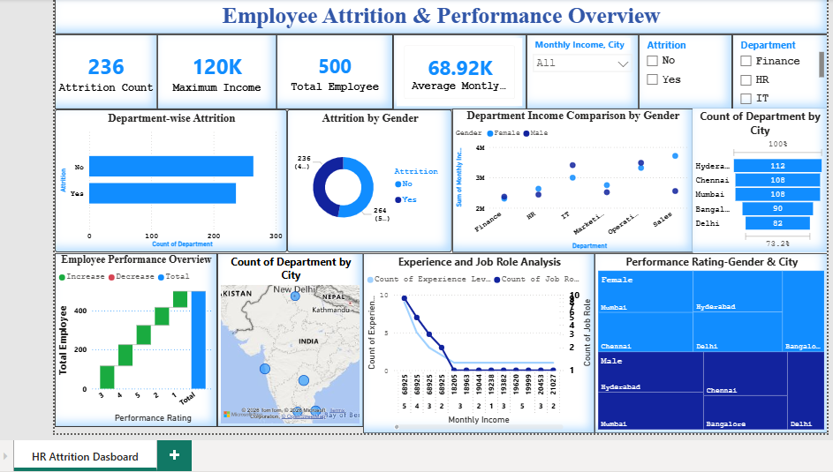
Screenshot 11: Power BI — HR Attrition Analysis Dashboard
9. Insights & Conclusions
Key Findings:
- Total 500 employees analysed; 236 (47.2%) showed attrition — a significantly high rate.
- IT and Operations departments have the highest employee count; Finance has the lowest.
- Age group 18-25 shows the highest attrition risk — early-career turnover is a major concern.
- Employees working overtime are significantly more likely to leave.
- Analysts and Managers dominate the attrition funnel.
- Mumbai and Delhi have the highest employee concentration based on the location map.

Analysis Insights:
- Descriptive: 236 employees left out of 500. Attrition spread across all departments, highest in IT and Operations.
- Diagnosis: High overtime, low job satisfaction (1-2), and poor work-life balance (rating 1) are strongly correlated with attrition.
- Predictive: Young employees (18-25) in Analyst/Manager roles with overtime and low satisfaction are the highest attrition risk group.
- Prescriptive: HR should reduce mandatory overtime, improve work-life balance policies, and provide career growth paths for employees aged 18-35.
10. Conclusions
The integration of Excel and Power BI proved effective for end-to-end HR data analysis — from raw data cleaning to interactive visual reporting. The dashboard provides HR managers with a comprehensive, real-time view of workforce attrition patterns and the key drivers behind them, enabling data-driven HR decisions and proactive retention strategies.

Employee Attrition & Performance Overview
Project 2 — Table: Transformation | Power Query Enhanced | Tools: Excel + Power BI

1. Project Overview and Objective
This is an enhanced version of the HR Attrition analysis using a Transformation table built in Power Query with additional conditional columns (Experience Level, Income Category) and new DAX measures for deeper performance and income analysis.
The objective is to visualise employee attrition alongside income and performance metrics — comparing departments, genders, and cities through an advanced interactive dashboard.
2. Data Sources
- Source Description and Timeline: Same HR employee dataset — enhanced via Power Query transformations | 2024
- Domain: Human Resources Analytics — Performance & Income Analysis
- Table Name: Transformation (Power Query cleaned and transformed)
3. Problem Statement
- To analyse attrition by department, gender, age, and job role with enhanced income and performance metrics.
- To compare income distribution across departments and genders.
- To study performance ratings across cities and identify regional patterns.
- To understand how experience level and income category relate to attrition.
4. Attribute (Column / Features) Details

Attribute Name | Data Type | Description
EmployeeID | String | Unique identifier for each employee
Age | Numeric (Integer) | Age of the employee in years
Gender | Categorical | Gender (Male / Female)
Department | Categorical | Department (HR, IT, Finance, Marketing, Operations, Sales)
Job Role | Categorical | Role/designation of the employee
Monthly Income | Numeric (Integer) | Monthly income of the employee
Job Satisfaction | Numeric (1-5) | Employee job satisfaction score
Performance Rating | Numeric (1-5) | Employee performance rating
WorkLife Balance | Numeric (1-5) | Work-life balance score
Overtime | Categorical | Whether employee works overtime (Yes / No)
Years At Company | Numeric (Integer) | Total years at the company
Attrition | Categorical | Whether employee left the company (Yes / No)
Marital Status | Categorical | Marital status (Single / Married / Divorced)
City | Categorical | City where the employee is located
Experience Level | Power Query Column | Fresher (≤2yrs), Junior (≤5yrs), Mid-Level (≤10yrs), Senior (>10yrs)
Income Category | Power Query Column | Low (<30K), Medium (30K–70K), High (>70K)

5. Tools & Technologies
- Excel: Data cleaning, transformation, and Pivot Tables.
- Power BI: Data modelling, Power Query transformations, DAX calculations, and interactive dashboard creation.
6. Data Pre-Processing (Excel / Power Query)
Tasks Performed:
- Data Cleaning & Transformation: Trim & Clean on Job Role column, Replace Values (Yes/No), Remove Duplicates on EmployeeID, Data Type standardisation.
- Conditional Columns added via Power Query:
- Experience Level — YearsAtCompany ≤2 → Fresher | ≤5 → Junior | ≤10 → Mid-Level | Else → Senior
- Income Category — Monthly Income ≤30,000 → Low | ≤70,000 → Medium | Else → High
- Pivot Tables: Employee count, Attrition by Department and Gender, Income summaries.
- Convert data into Fact and Dimension Table: Single Transformation flat table used for this project.
7. Data Modelling and DAX (Power BI)
- Data Model: Single flat 'Transformation' table loaded from Power Query. All measures stored in Transformation table. No relationships required (single table model).

SCREENSHOT OF DATA MODELLING
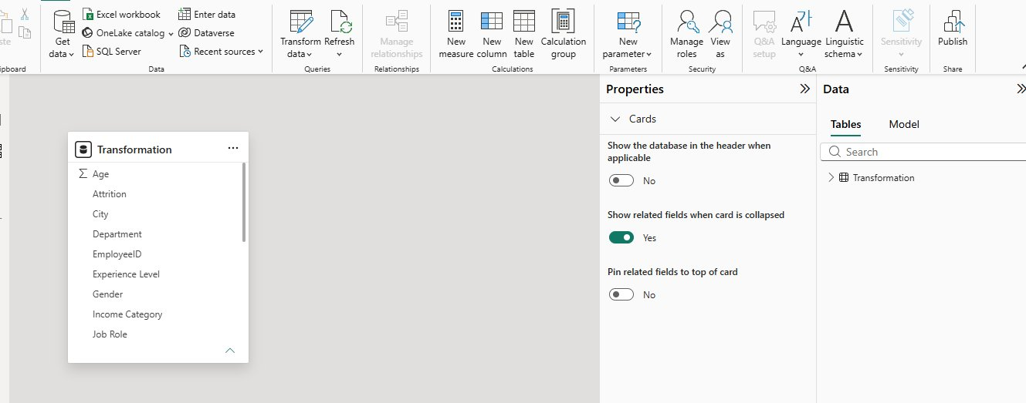
Screenshot 12: Power BI — Data Model View (Transformation Table)

Calculated Columns & DAX Measures:
Measure / Column | Type | DAX Formula
Total Employee | Measure | Total Employee = Count(Transformation[EmployeeID])
Attrition Count | Measure | CALCULATE(COUNT(Transformation[EmployeeID]), Transformation[Attrition]="Yes")
Average Montly Income | Measure | Average Montly Income = AVERAGE(Transformation[Monthly Income])
Maximum Income | Measure | Maximum Income = MAX(Transformation[Monthly Income])

SCREENSHOT — DAX MEASURES
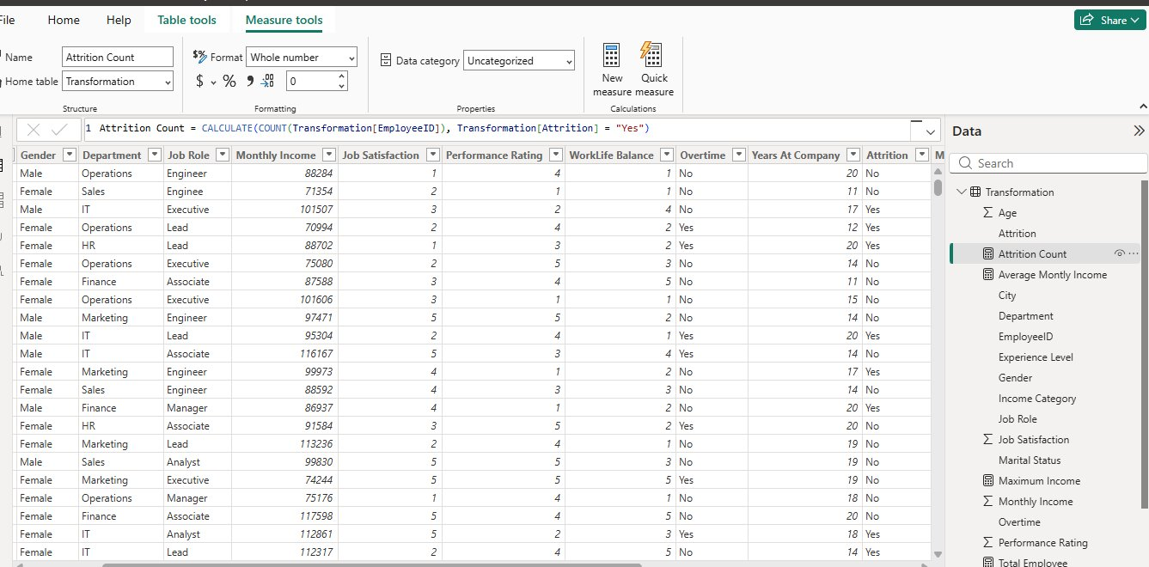
Screenshot 13: DAX — Attrition Count Measure
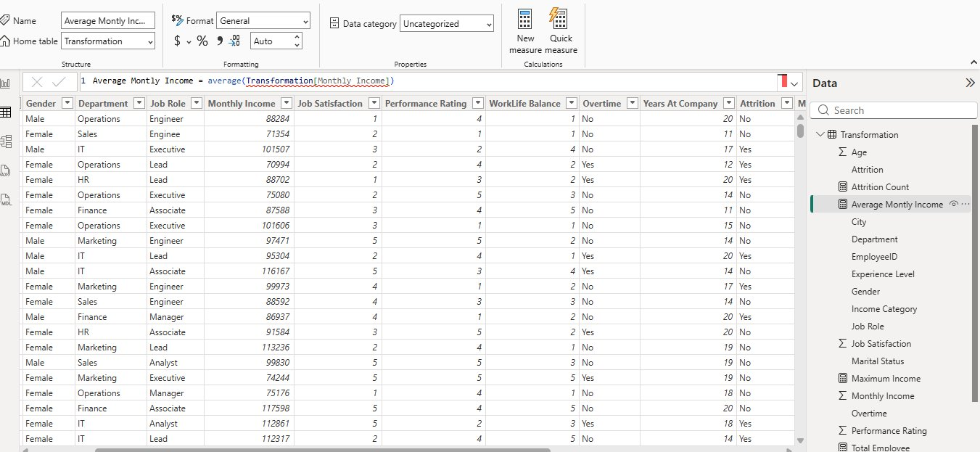
Screenshot 14: DAX — Average Monthly Income Measure
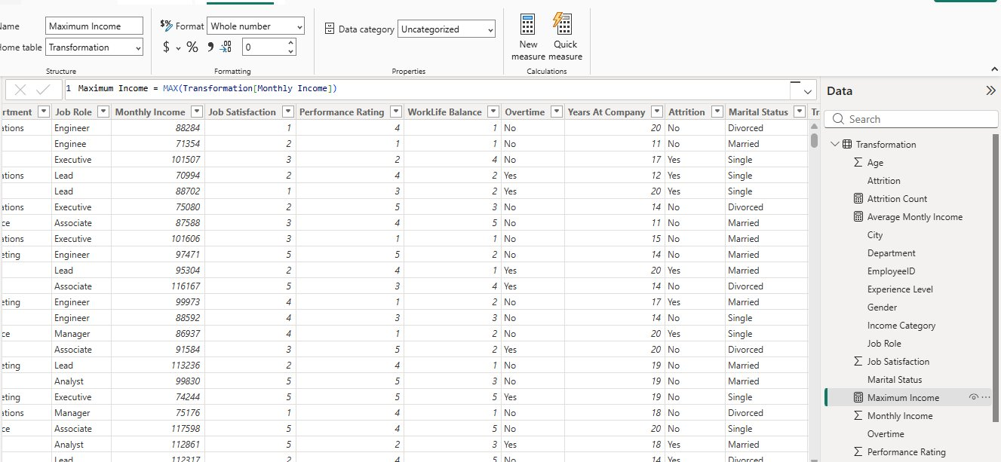
Screenshot 15: DAX — Maximum Income Measure
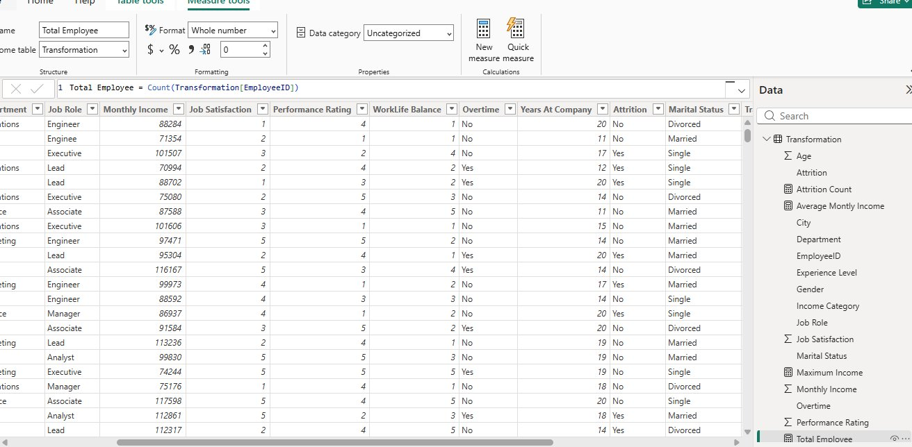
Screenshot 16: DAX — Total Employee Measure
8. Analysis and Visualizations (Power BI)
Dashboard Features:

Visual Type | Purpose / Description
KPI Cards (4) | Attrition Count (236), Maximum Income (120K), Total Employee (500), Avg Monthly Income (68.92K)
Bar Chart | Department-wise Attrition (Yes vs No)
Donut Chart | Attrition by Gender (Yes / No %)
Matrix / Heatmap | Performance Rating by Gender and City
Scatter Plot | Department Income Comparison by Gender
Waterfall Chart | Employee Performance Overview by Performance Rating
Line Chart | Experience and Job Role Analysis (Experience Level vs Monthly Income)
Filled Map | City and Department Distribution (India)
Slicer — Attrition | Filter: Yes / No
Slicer — Department | Filter: Finance, HR, IT, Marketing, Operations, Sales
Table Visual | Monthly Income and City breakdown

Interactivity: Slicers for Attrition and Department. Drill-down on Experience Level and City visuals. Bookmarks and clear titles on all visuals.

SCREENSHOT OF DASHBOARD / REPORT
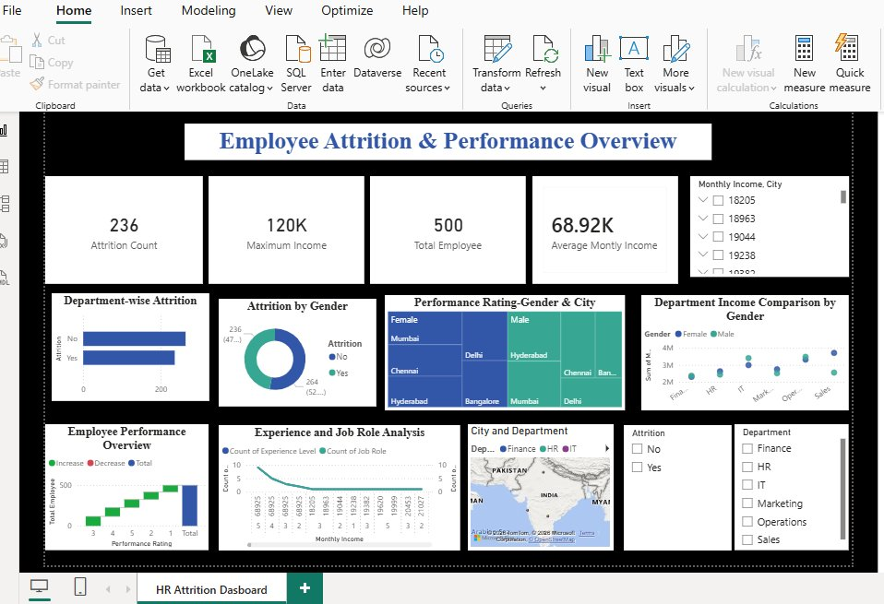
Screenshot 17: Power BI — Employee Attrition & Performance Overview Dashboard
9. Insights & Conclusions
Key Findings:
- Attrition Count: 236 out of 500 employees left (47.2% attrition rate).
- Maximum Monthly Income in dataset: 120K; Average Monthly Income: 68.92K.
- Female employees show higher attrition in certain departments based on gender-wise analysis.
- Performance Rating analysis by City shows Mumbai and Delhi have mixed high/low performers.
- Fresher and Junior experience level employees contribute most to attrition.
- High income employees (>70K) show lower attrition — income is a key retention factor.

Analysis Insights:
- Descriptive: 500 employees across 6 departments; 236 attrited. Spread across all departments.
- Diagnosis: Low experience (Fresher/Junior) + low income category + overtime = highest attrition risk combination.
- Predictive: Employees with <5 years experience, income <30K, and overtime have the highest churn probability.
- Prescriptive: Focus retention efforts on Fresher/Junior employees — offer structured career growth, salary revisions, and overtime reduction policies.
10. Conclusions
The integration of Excel, Power Query, and Power BI proved effective for end-to-end HR data analysis. The enhanced Transformation table with Power Query conditional columns (Experience Level, Income Category) and new DAX measures provided deeper insights into income distribution and performance trends, enabling more targeted HR decisions and retention strategies.

— End of Document —

