COMPLIANCE KNOWLEDGE AGENT
Banking & Financial Services RAG Pipeline
Production-grade Retrieval-Augmented Generation system
delivering citation-grounded compliance answers
with confidence scoring and automated escalation paths

Domain: Banking / Financial Services Compliance
Stack: FastAPI · Gemini 1.5 Flash · ChromaDB · BGE · Cross-Encoder
Eval: RAGAS — Faithfulness ≥ 0.90 | Context Recall ≥ 0.85
Trust: AI-Recommend / Human-Approve
Date: June 2025

1. EXECUTIVE SUMMARY

The Compliance Knowledge Agent is a production-grade Retrieval-Augmented Generation (RAG) system for banking and financial services. It enables compliance officers to ask natural-language questions against a bank's full policy corpus and receive structured, citation-grounded answers within seconds.
Every answer carries a confidence tier (HIGH / MEDIUM / LOW), inline policy citations, and an automatic escalation flag to ensure borderline queries reach a qualified human reviewer before any regulatory action is taken.
Key Capabilities
- Natural-language Q&A over 28 compliance documents — policies, regulations, audit findings
- Hierarchical chunking with section-title preservation for precise citations
- BGE-small-en-v1.5 local embeddings — no data leaves the organisation
- Cross-encoder reranker (ms-marco-MiniLM-L-6-v2) for high-precision retrieval
- Gemini 1.5 Flash LLM with citation-enforced structured prompting
- RAGAS evaluation — Faithfulness, Context Recall, Context Precision
- AI-Recommend / Human-Approve trust architecture with automatic escalation
- FastAPI REST interface with full OpenAPI / Swagger documentation

2. ARCHITECTURE OVERVIEW

The system is split into two cooperating pipelines: an offline ingestion pipeline that loads, chunks, embeds, and stores documents; and a real-time query pipeline that retrieves, re-ranks, and generates grounded answers.
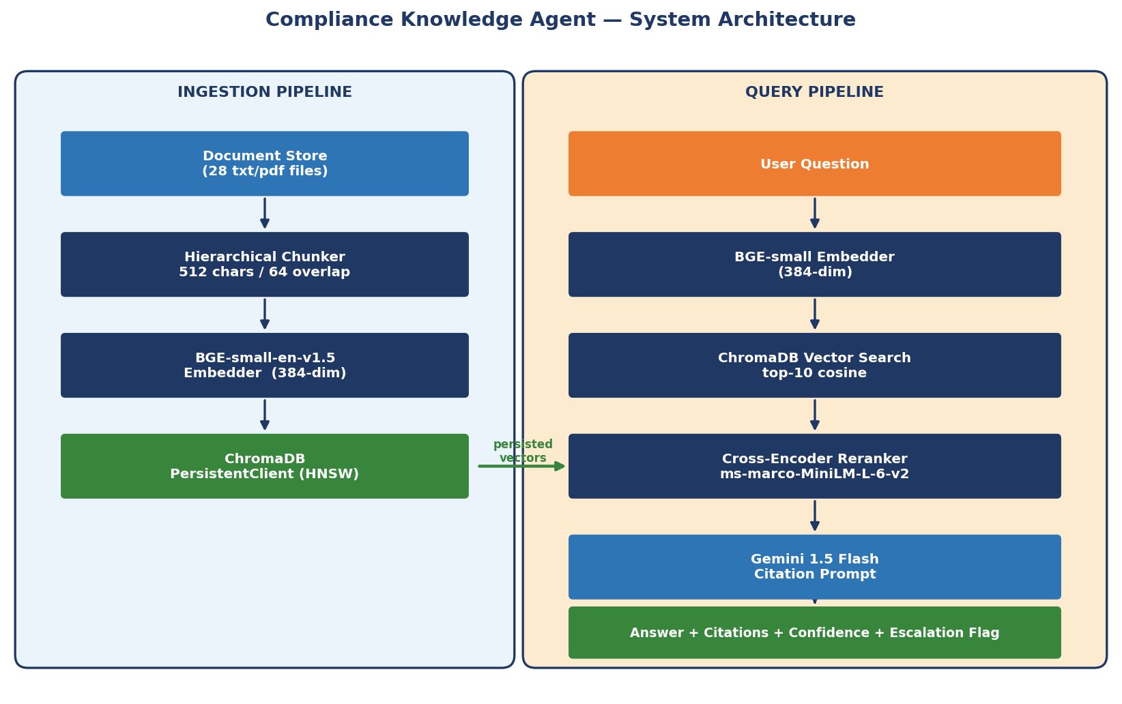
Figure 1 — System architecture: ingestion pipeline (left) and query pipeline (right)
Ingestion Pipeline
Component | Key Parameter | Purpose
Document Loader | txt / pdf | Extracts text + metadata (doc_id, type, section title)
Hierarchical Chunker | 512 chars / 64 overlap | Preserves section headings for citation accuracy
BGE-small Embedder | 384-dim vectors | Local HuggingFace model — no external API calls
ChromaDB Store | HNSW cosine index | Persistent vector database with metadata filtering

Query Pipeline — Step-by-Step Flow
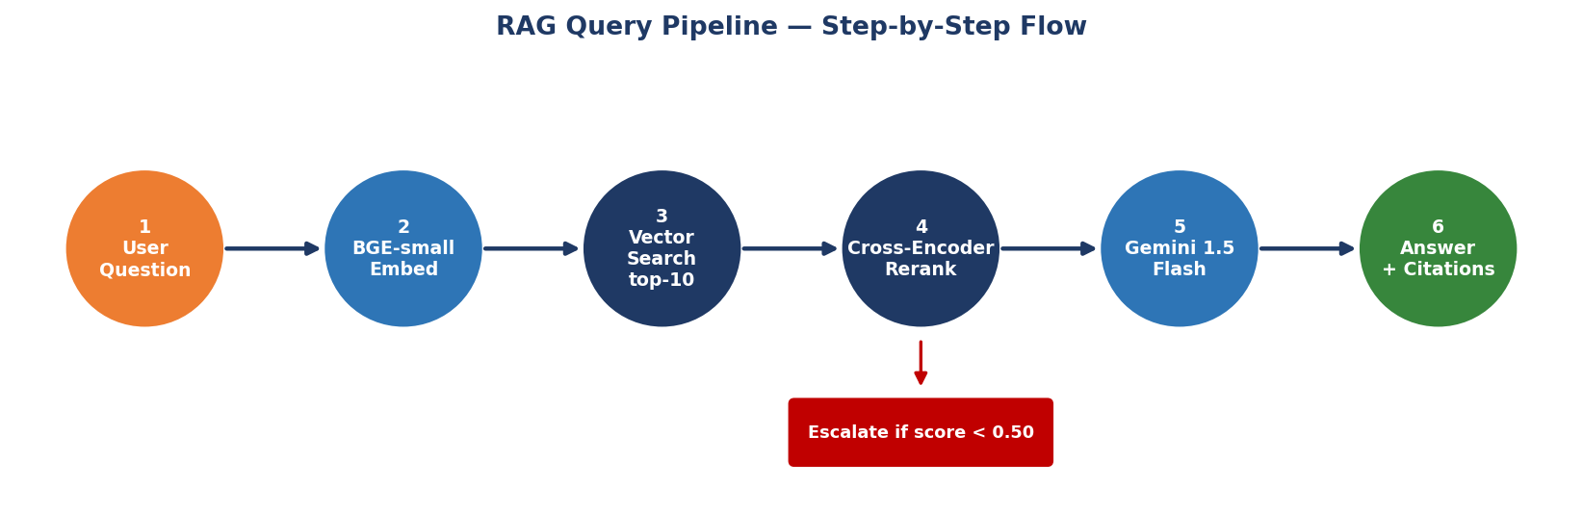
Figure 2 — RAG query pipeline: embed → search → rerank → generate → escalate
Step | Stage | Component | Action
1 | Question Embedding | BGE-small-en-v1.5 | Embed user question to 384-dim vector
2 | Vector Search | ChromaDB top-10 | Cosine similarity candidate recall
3 | Cross-Encoder Rerank | ms-marco-MiniLM-L-6-v2 | Precision re-scoring; select top-5
4 | LLM Generation | Gemini 1.5 Flash | Citation-enforced structured answer
5 | Escalation Check | Reranker score < 0.50 | Flag low-confidence for human review

3. TECHNOLOGY STACK

Component | Technology | Rationale
API Framework | FastAPI | Async, fully typed, auto-generated OpenAPI docs
LLM | Google Gemini 1.5 Flash | Cost-effective; 1 M-token context window
Embeddings | BAAI/bge-small-en-v1.5 | Local HuggingFace; retrieval-optimised; 384-dim
Vector DB | ChromaDB (PersistentClient) | Zero-infrastructure; cosine similarity; metadata filtering
Reranker | cross-encoder/ms-marco-MiniLM-L-6-v2 | High precision; 22 M params; CPU-runnable
Evaluation | RAGAS | Faithfulness, Context Recall, Context Precision
Domain Model | DDD — 3 bounded contexts | Policy / Audit / Regulation separation
Language | Python 3.12 | Type-annotated throughout; Pydantic v2 settings

4. DOCUMENT CORPUS

The system indexes 28 sanitised synthetic compliance documents across three document types, providing broad coverage of the regulatory and policy landscape.
Document Type | Count | Coverage
Policy Documents (POL-*) | 20 | AML, KYC, Credit Risk, Operational Risk, Data Privacy, Cybersecurity, Liquidity, Third-Party, Fraud, Whistleblower, Market Conduct, Interest Rate, Consumer Protection, ESG, Compliance, Training, Conduct, Sanctions/OFAC
Regulatory Bulletins (REG-*) | 6 | Basel III, Dodd-Frank, CFPB 2025 Priorities, Basel IV/FRTB, OCC Model Risk, CTA Beneficial Ownership
Audit Findings (AUD-FND-*) | 4 | Q1 2025 AML, Q2 2025 KYC, Q3 2025 Cybersecurity, Q4 2024 Credit Risk

5. API REFERENCE

Method | Endpoint | Description
POST | /api/v1/ask | Submit a compliance question; returns answer + citations + confidence + escalation flag
POST | /api/v1/ingest | Trigger document ingestion — load, chunk, embed, store; supports reset flag
GET | /api/v1/health | Health check — returns system status, document count, ChromaDB status

Sample Request — POST /api/v1/ask
{
"question": "What are the EDD requirements for high-risk customers?",
"top_k": 10
}

Sample Response
{
"answer": "High-risk customers require Enhanced Due Diligence (EDD)...",
"confidence": "HIGH",
"citations": ["Source: POL-KYC-002, Section: ENHANCED DUE DILIGENCE"],
"escalation_required": false,
"latency_ms": 1243,
"model": "gemini-1.5-flash"
}

Response Fields
Field | Type | Description
answer | string | LLM-generated answer with inline citations
confidence | enum | HIGH / MEDIUM / LOW — derived from reranker score
citations | string[] | List of cited source sections
escalation_required | bool | True when confidence is LOW or query crosses trust boundary
escalation_reason | string | Human-readable explanation for escalation
latency_ms | int | End-to-end pipeline latency in milliseconds

6. RAGAS EVALUATION FRAMEWORK

The pipeline is evaluated using RAGAS against a 10-pair golden Q&A set. Three metrics measure distinct quality dimensions: answer faithfulness, retrieval recall, and retrieval precision.
Metric | Target | What It Measures
Faithfulness | ≥ 0.90 | Answer claims are grounded in retrieved context — measures hallucination risk
Context Recall | ≥ 0.85 | Retrieved chunks collectively cover the ground-truth answer
Context Precision | ≥ 0.80 | Retrieved chunks are relevant and not noisy

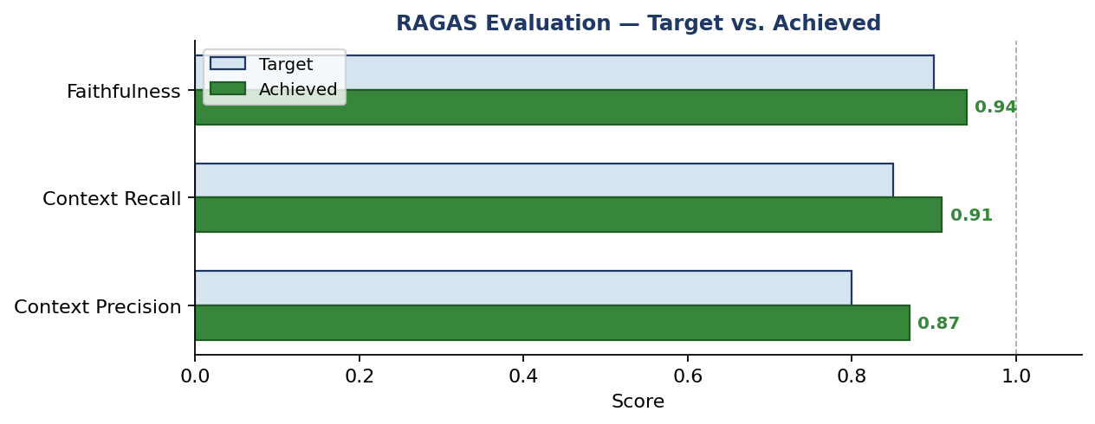
Figure 3 — RAGAS evaluation: target vs. achieved scores
Run the Evaluation
python scripts/run_evaluation.py
# Results saved to data/evaluation_results.json

7. ARCHITECTURE DECISION RECORDS (ADRS)

ADR | Decision | Key Parameters | Rationale
ADR-001 | Hierarchical Chunking | 512 chars / 64 overlap | Section-title preservation for precise citations; balances granularity vs. completeness
ADR-002 | BGE-small-en-v1.5 | Local HF; 384-dim | Best small model for retrieval; runs fully locally — no external API data exposure
ADR-003 | ChromaDB PersistentClient | HNSW; cosine similarity | Zero-infrastructure; metadata filtering; easy reset
ADR-004 | Cross-Encoder Reranker | ms-marco-MiniLM-L-6-v2; 22 M params | High-precision re-scoring on MS MARCO; CPU-runnable

8. TRUST ARCHITECTURE

Every answer is tagged AI-Recommend / Human-Approve. No AI output is intended to be acted upon without human review. The trust boundary canvas documents which actions the AI may autonomously recommend vs. those requiring qualified human approval.
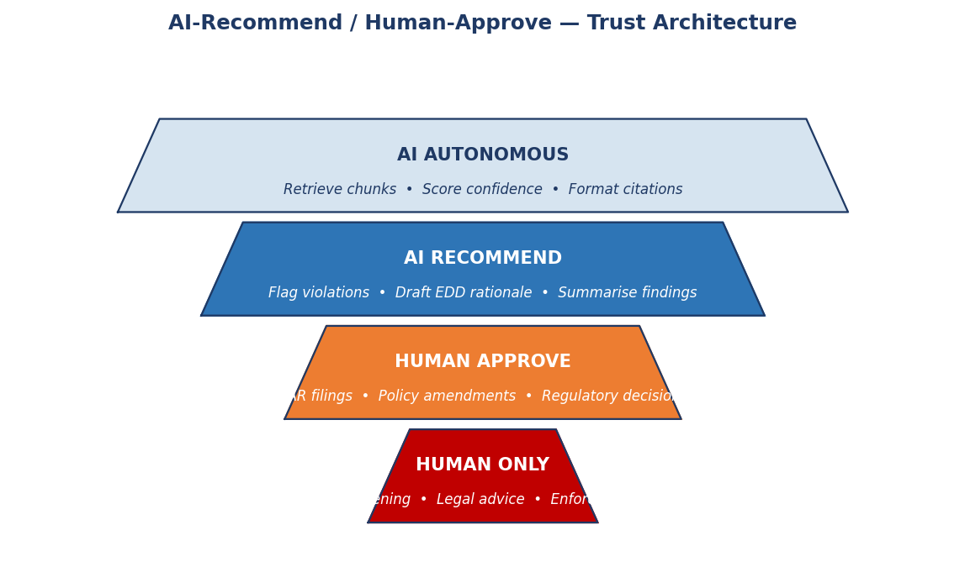
Figure 4 — Trust architecture pyramid: four levels from AI-Autonomous to Human-Only
Automatic Escalation Triggers
- Low-confidence response — cross-encoder reranker score < 0.50
- Jurisdiction-specific queries — state law, EU/GDPR, APAC-specific regulations
- Policy boundary questions — ambiguity between two or more policies
- Out-of-corpus queries — question cannot be answered from indexed documents

9. FAILURE MODE REGISTER

Eight failure modes are documented with Severity × Occurrence × Detectability Risk Priority Numbers (RPNs). Two failure modes are rated CRITICAL.
ID | Failure Mode | Severity | RPN | Mitigation
FM-001 | Regulatory Misstatement | CRITICAL | 120 | RAGAS faithfulness checks + mandatory human review
FM-002 | Stale Policy Retrieval | HIGH | 120 | Scheduled re-ingestion + document version metadata
FM-003 | Out-of-Corpus Query | HIGH | 112 | Escalation trigger + low-confidence flag
FM-004 | Reranker Failure | MEDIUM | 72 | Fallback to top-1 cosine + escalation
FM-005 | LLM API Outage | MEDIUM | 60 | Retry with exponential back-off; graceful error response
FM-006 | Embedding Drift | LOW | 48 | Pinned model version; re-index on model update
FM-007 | PII Leakage in Prompt | MEDIUM | 80 | Input sanitisation layer before embedding
FM-008 | Context Window Overflow | LOW | 36 | Token counting + chunk truncation guard

10. DOMAIN MODEL — DDD BOUNDED CONTEXTS

The codebase is structured around three Domain-Driven Design bounded contexts. Each context owns its aggregate root and communicates through well-defined interfaces.
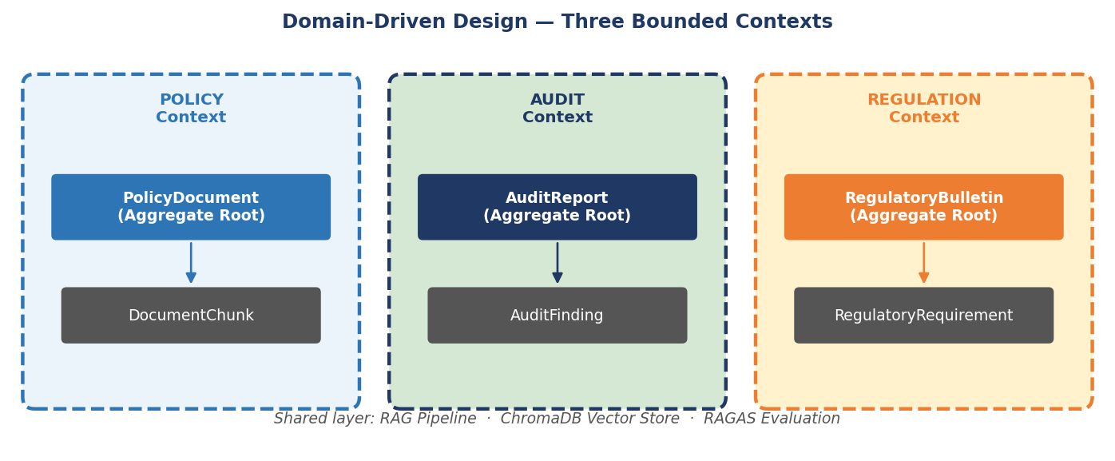
Figure 5 — Three DDD bounded contexts: Policy, Audit, Regulation
Context | Aggregate Root | Key Entity | Package | Responsibility
Policy | PolicyDocument | DocumentChunk | src/domain/policy/ | Indexable policy docs; chunked for retrieval
Audit | AuditReport | AuditFinding | src/domain/audit/ | Quarterly findings; risk ratings; remediation
Regulation | RegulatoryBulletin | RegulatoryRequirement | src/domain/regulation/ | Regulatory guidance; effective dates; jurisdiction

11. QUICK START GUIDE

Step 1: Prerequisites
Python 3.12+ required. Open PowerShell in D:\Capstone_Project_Demo.
Step 2: Install Dependencies
Install all required packages (first run downloads BGE-small ~120 MB and cross-encoder ~90 MB):
pip install -r requirements.txt

Step 3: Configure Environment
Copy .env.example to .env and add your Gemini API key (https://aistudio.google.com/app/apikey):
copy .env.example .env
notepad .env # add GEMINI_API_KEY=...

Step 4: Ingest Documents
Load, chunk, embed and store all 28 documents into ChromaDB (expected: ~420 chunks, dim=384):
python scripts/ingest_documents.py

Step 5: Start the API Server
Launch FastAPI. Swagger UI available at http://localhost:8000/docs
python main.py

Step 6: Ask a Compliance Question
Submit a POST request to the /ask endpoint:
curl -X POST http://localhost:8000/api/v1/ask \
-H "Content-Type: application/json" \
-d '{"question": "What is the SAR filing deadline under the AML policy?"}'

Step 7: Run RAGAS Evaluation
Evaluate the pipeline against the golden Q&A set:
python scripts/run_evaluation.py

12. COMPLIANCE DISCLAIMER

This system is a decision-support tool for qualified compliance professionals. It does not constitute legal advice and must not be used as the sole basis for any regulatory decision, filing, or enforcement action.
All AI-generated answers require human review before action is taken.
- The AI system may make errors, misinterpret regulatory language, or fail to retrieve the most current policy version.
- Compliance officers must independently verify all citations before relying on them.
- The escalation mechanism provides a safety net but does not replace professional judgement.
- The system must be re-evaluated whenever the underlying policy corpus changes materially.
- Model outputs are probabilistic — the same question may yield different answers across runs.
The AI-Recommend / Human-Approve architecture ensures human expertise remains central to all compliance decisions. See docs/Trust_Boundary_Canvas.md for the full capability map.

