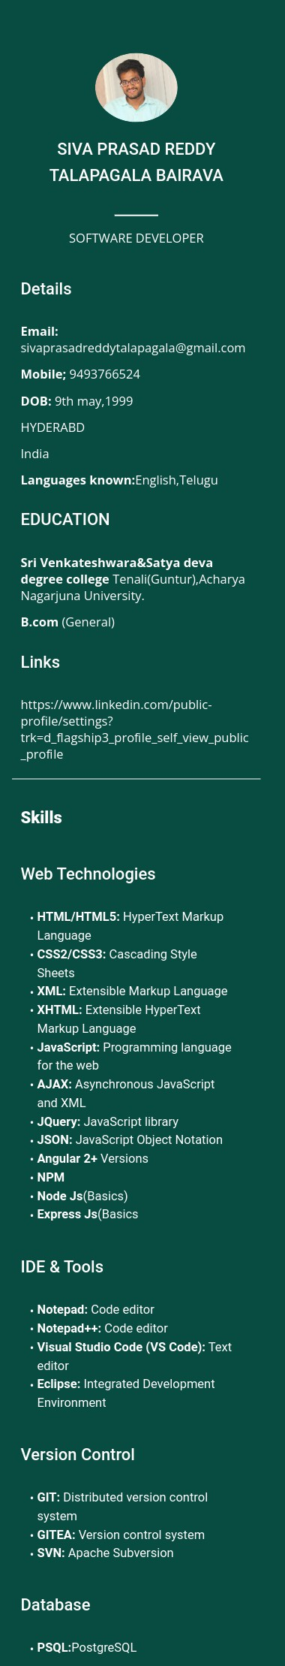

**CAREER OBJECTIVE**

Software Developer with 3+ year of experience in developing Web Applications using Angular , Bootstrap Technologies and Nodejs. Looking for a challenging role in a reputable organization to utilize my technical and management skills for the growth of the organization as well as to enhance my knowledge about new technologies.

**PROFESSIONAL SUMMARY**

*3+ year of extensive experience in Web Application Development with Technologies like Angular2+ versions ,HTML5, CSS3, JavaScript, Bootstrap4/5 and nodejs.

*Experience in Creating Reusable Modules and Components.

*Experience in Developing Angular Web Application with Typescript,Reactive Forms using Angular Components,Routing,Angular Frame work,Rxjs.

*Worked with HTTP/HTTPS protocols by using angular components to build Rest Services.

*Ability to work with API developers in getting the data required for presenting.

*Hands on Development experience in Web based applications.

*Used Angular CLI and NPM for scaffolding the Angular Application.

*Participates in design reviews and provide input to design recommendations.

*Ability to share and integrate knowledge across workgroups.

*Good Communicator,being able to express ideas clearly and concisely.

*Developed robust backend functionalities by creating RESTful APIs for handling GET, POST, UPDATE, and DELETE operations, ensuring seamless communication between the frontend and backend of web applications.

*Proficient in utilizing Sequelize ORM to interact with relational databases, enhancing efficiency in data retrieval, storage, and manipulation within the web applications, thereby ensuring optimized and scalable database queries.

*Worked in various version control systems -SVN,GIT AND GITEA.

*Worked as Angular Developer at **Delta soft technologies** from 7th Dec 2020 to 24th Oct 2022.

*Worked as Angular Developer at **Key Point technologies** from 25th Oct 2022 to Present.

**PROJECTS**

*Cerina Chatbot

*MEITY

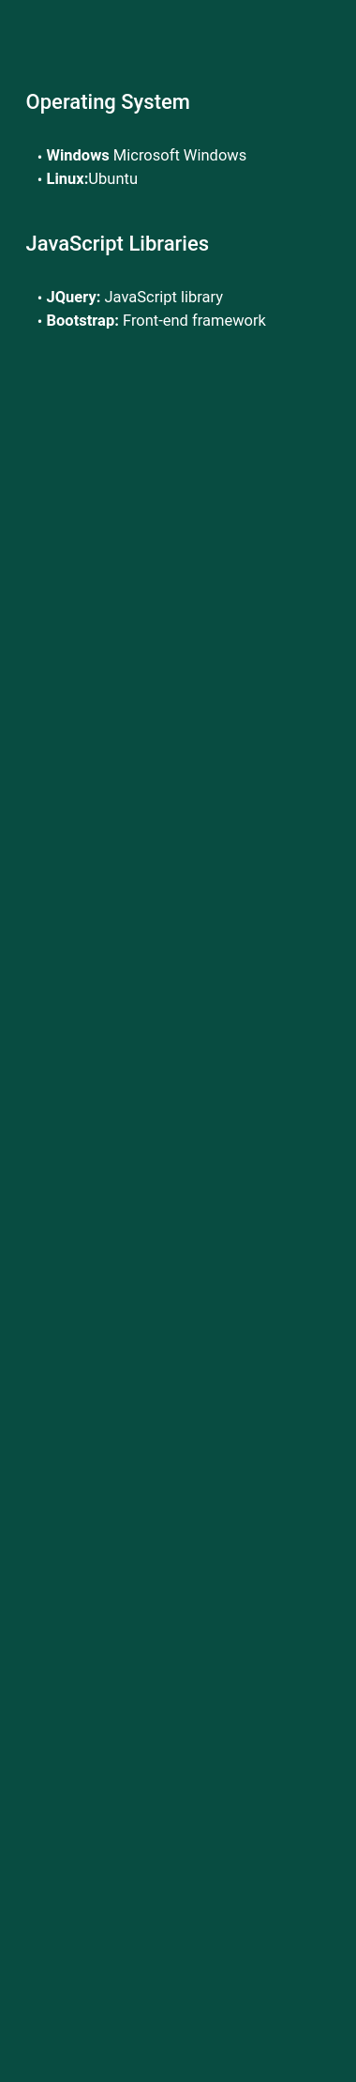

**PROJECT DETAILS**