MongoDb task day 2

// 1.Creating a new database named zen
//use zen;

// 2.users
db.createCollection("users")

// 3.codekata
db.createCollection("codekata")

// 4.attendance
db.createCollection("attendance")

// 5.topics
db.createCollection("topics")

// 6.tasks
db.createCollection("tasks")

// 7.company_drives
db.createCollection("company_drives")

// 8.mentors
db.createCollection("mentors")

// 9.Find all the topics and tasks which are thought in the month of October
db.topics.aggrigate([
{
$lookup: {
from:”task”,
localField:”month”,
forienField:”month”,
as:”task tought in the month”:
}
},
{
$match: {month_name:”October”}
}
])

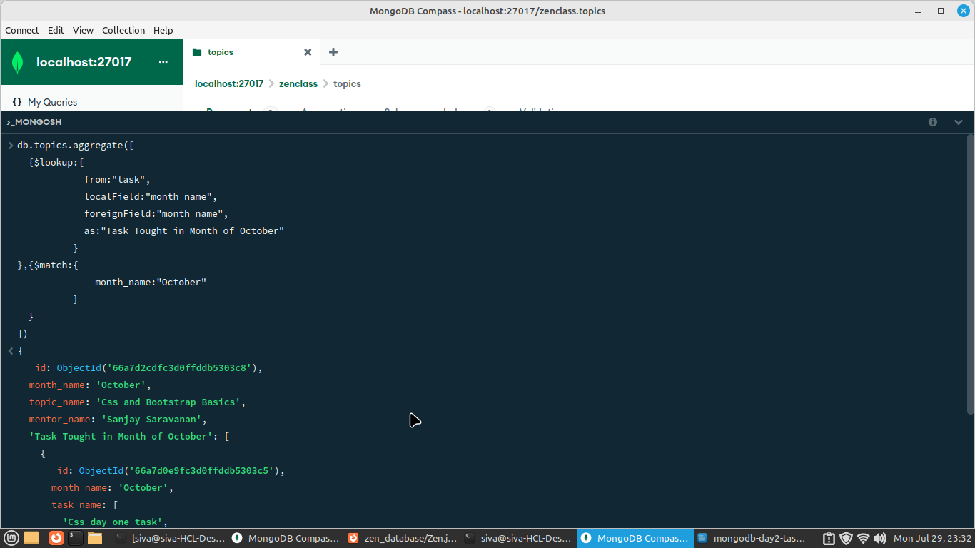
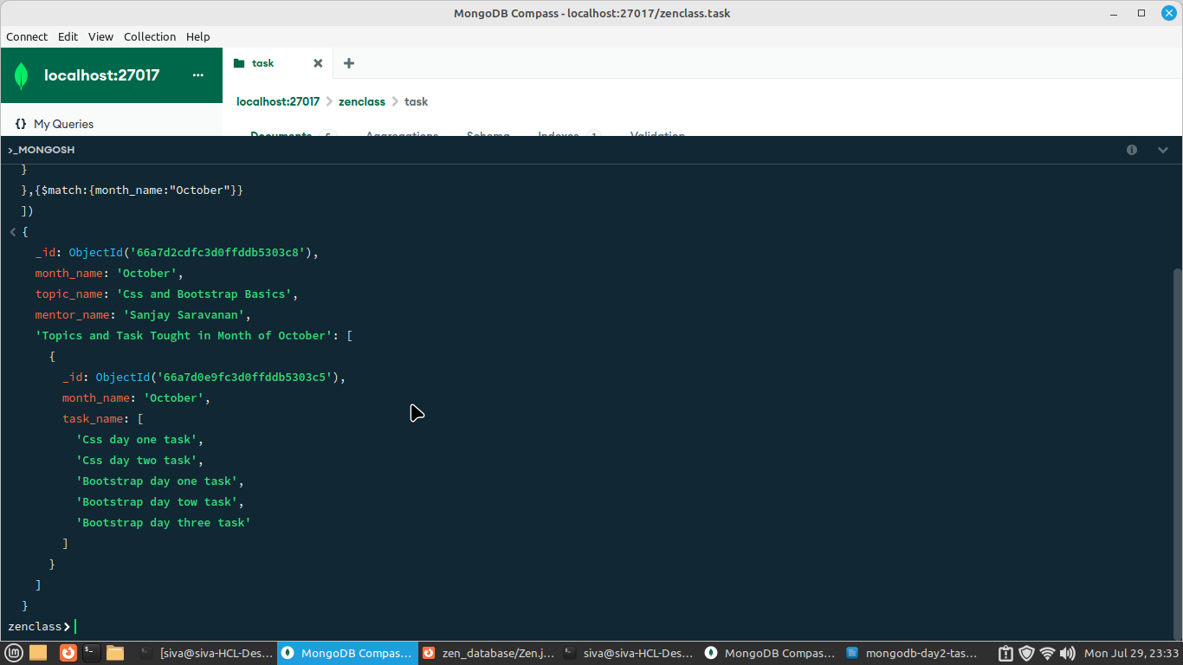
// 10.Find all the company drives which appeared between 15 oct-2020 and 31-oct-2020

db.company_drives.find(
{date_of_visit:{
$gt:ISODate('2020-10-01'),$lt:ISODate('2020-10-31')
}
})

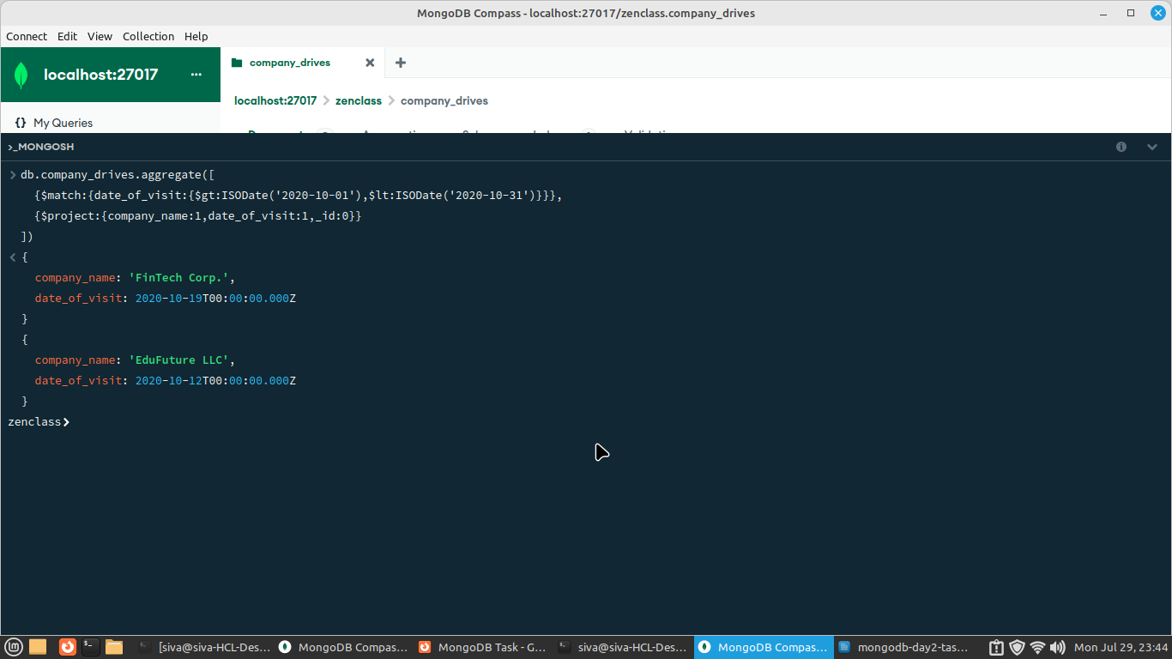

// 11.Find all the company drives and students who are appeared for the placement.
db.company_drives.find({})
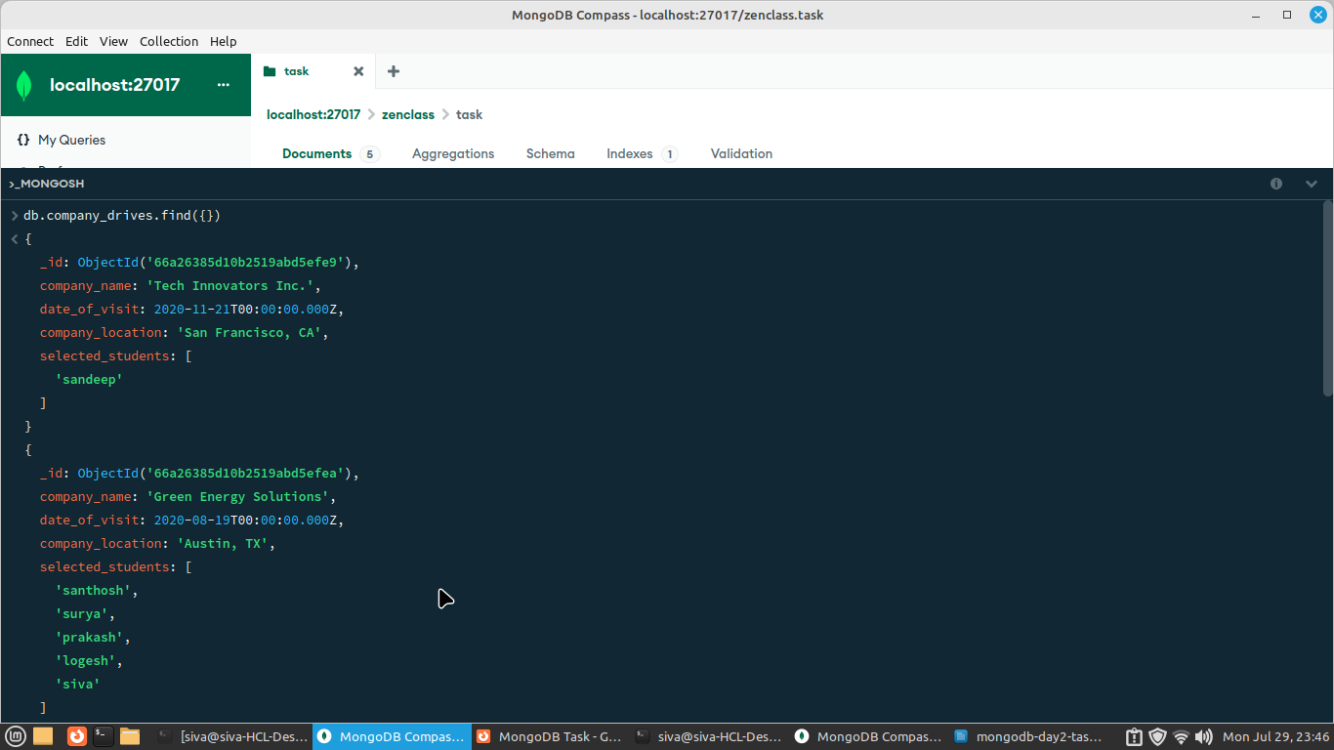

// 12.Find the number of problems solved by the user in codekata
db.codekata.find({})

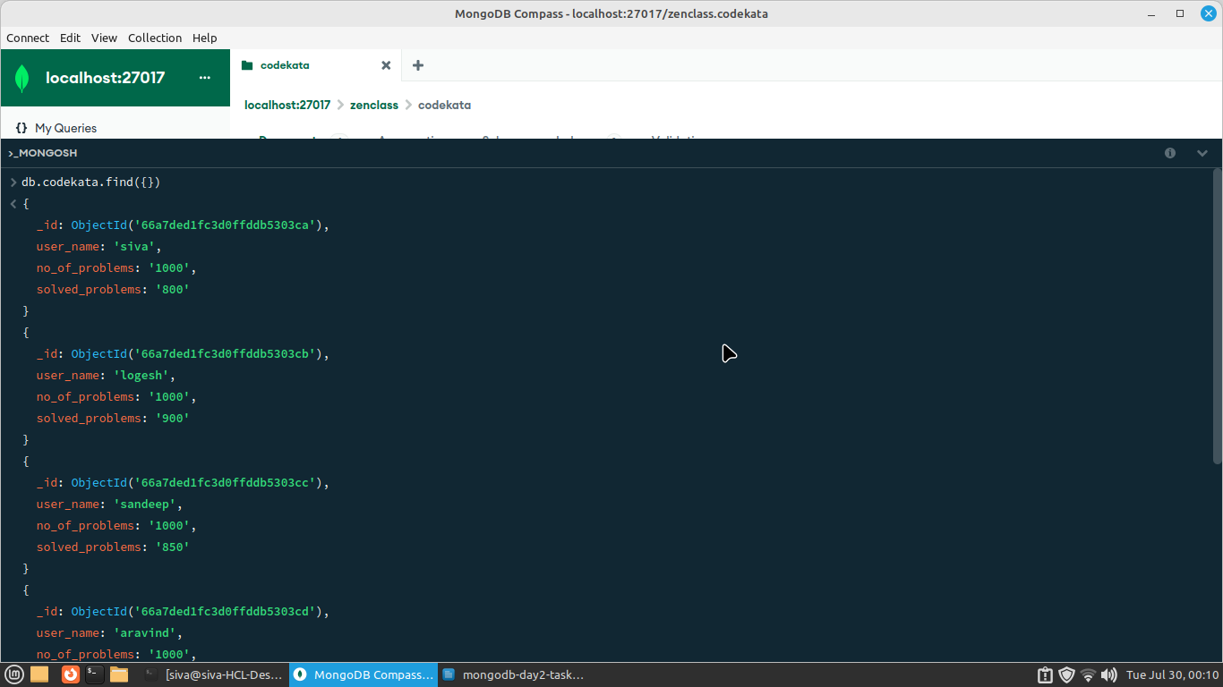

// 13.Find all the mentors with who has the mentee's count more than 15

db.mentors.find({mentee_count:{$gt:15}})
// 14.Find the number of users who are absent and task is not submitted
//between 15 oct-2020 and 31-oct-2020
db.users.find(
{$and:
[
{attendance:"absent"},
{date:{$gt: new Date("15 oct-2020"), $lt: new Date("31-oct-2020")}}

]
}
);

