Day -1 Mongodb task

1. Find all the information about each products?

Query: db.collectionName.find()
db.products.find()
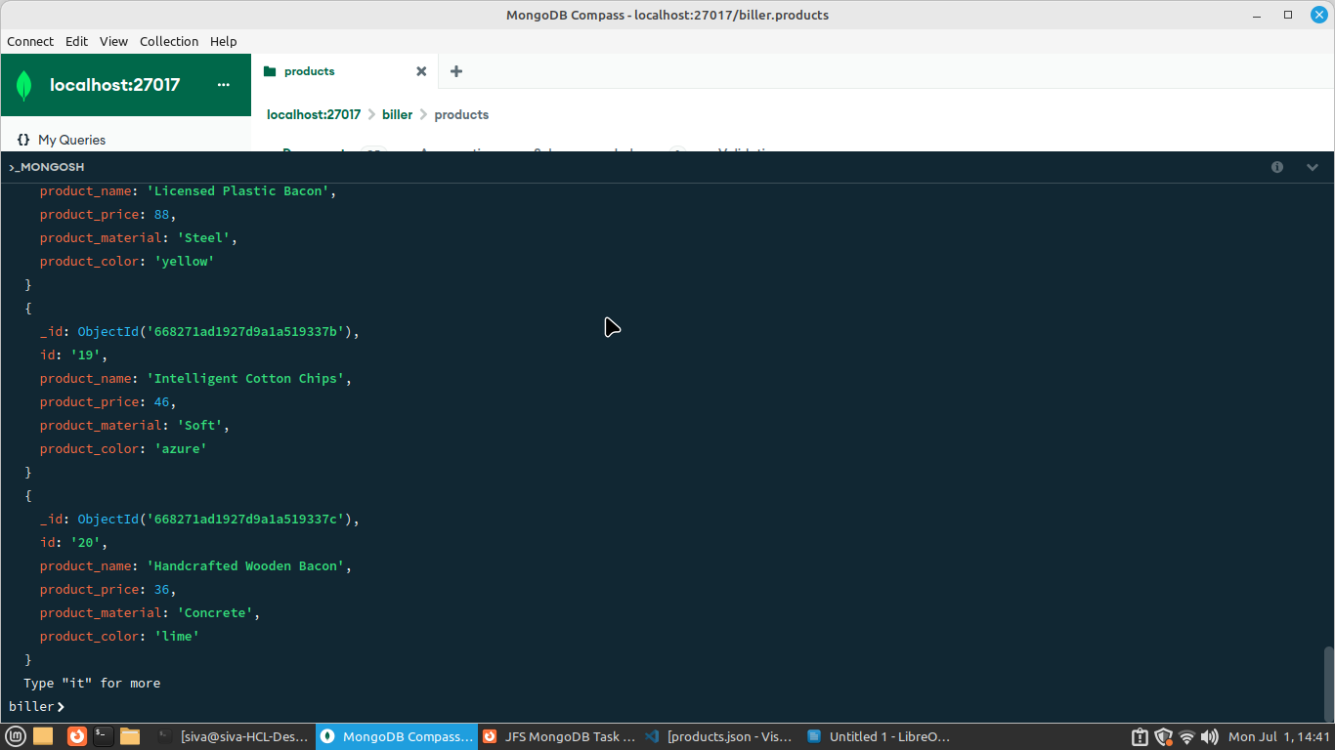

2. Find the product price which are between 400 to 800 ?
Query: db.products.find({$and:[{product_price:{$gt:400}},{product_price:{$lt:800}}]})
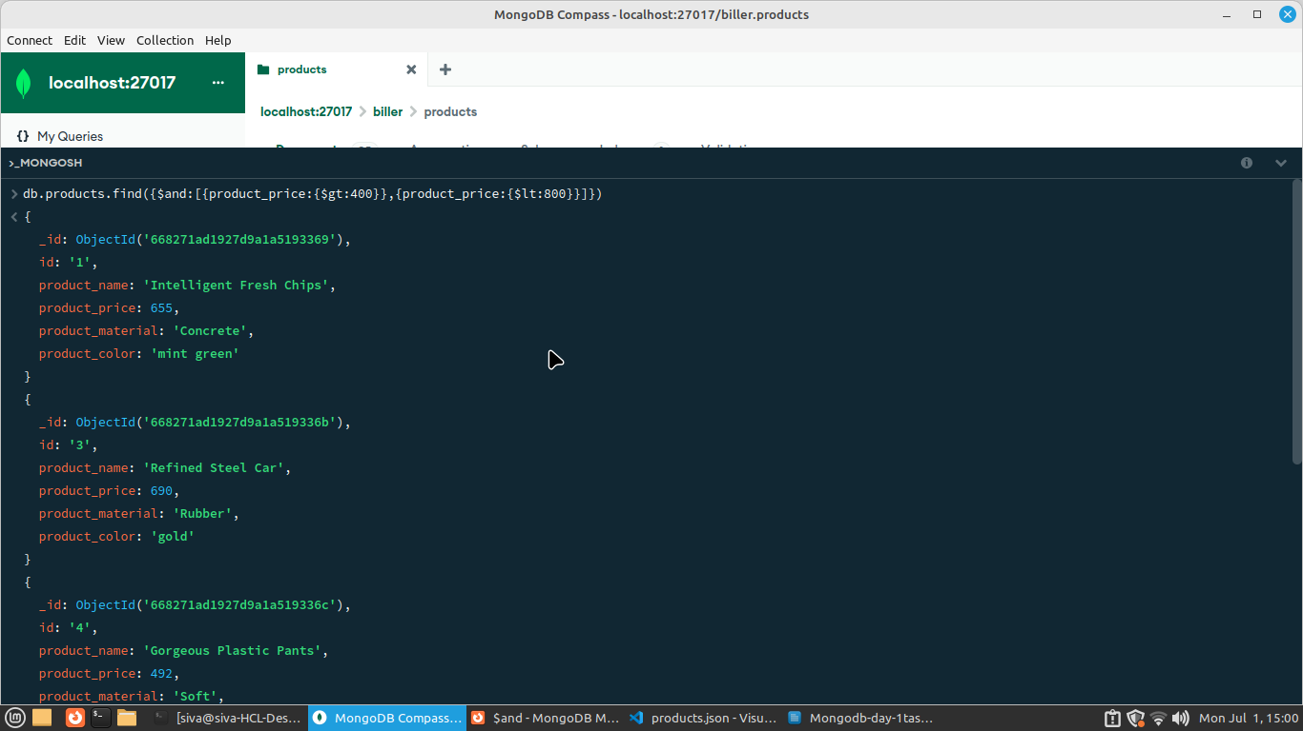

3. Find the product price which are not between 400 to 600?

query: db.products.find({$or:[{product_price:{$lt:400}},{product_price:{$gt:600}}]})

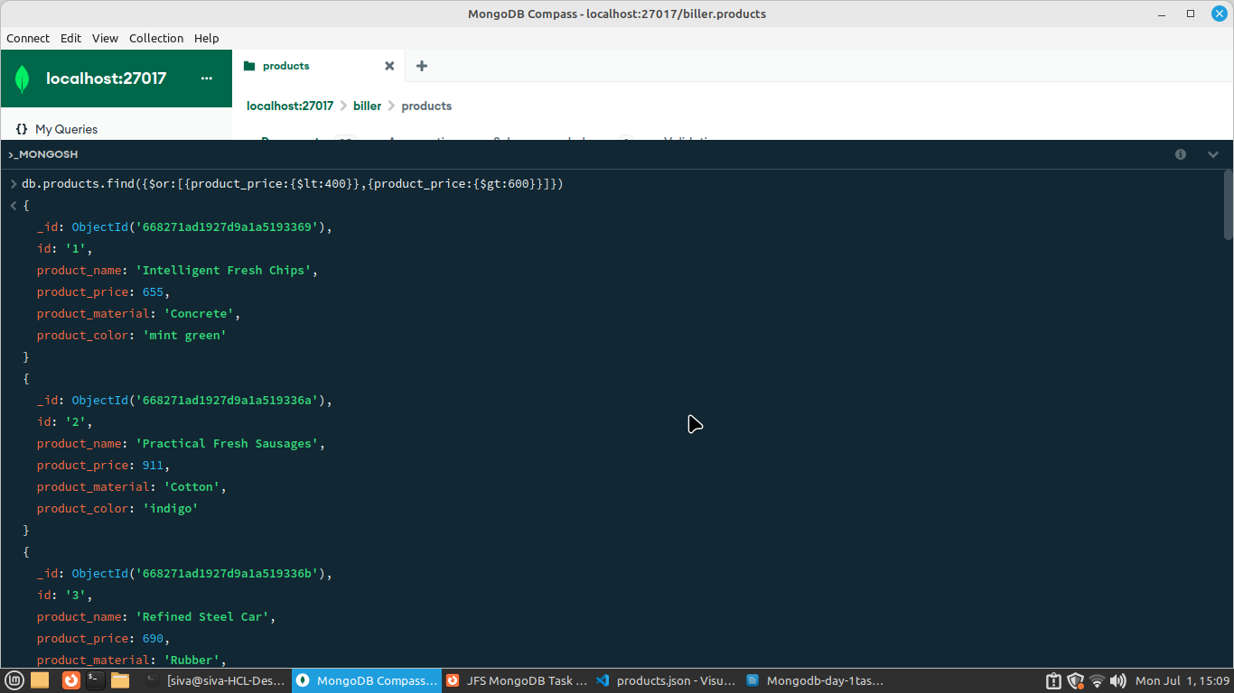
4. List the four product which are greater than 500 in price ?

Query : db.products.find({product_price:{$gt:500}})

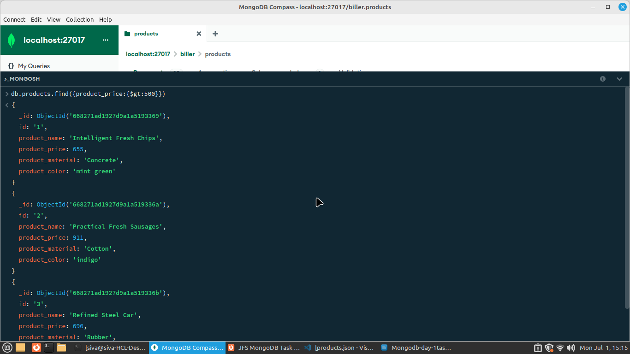
5. Find the product name and product material of each products ?

Query: db.products.find().projection({product_name:1,product_material:1})

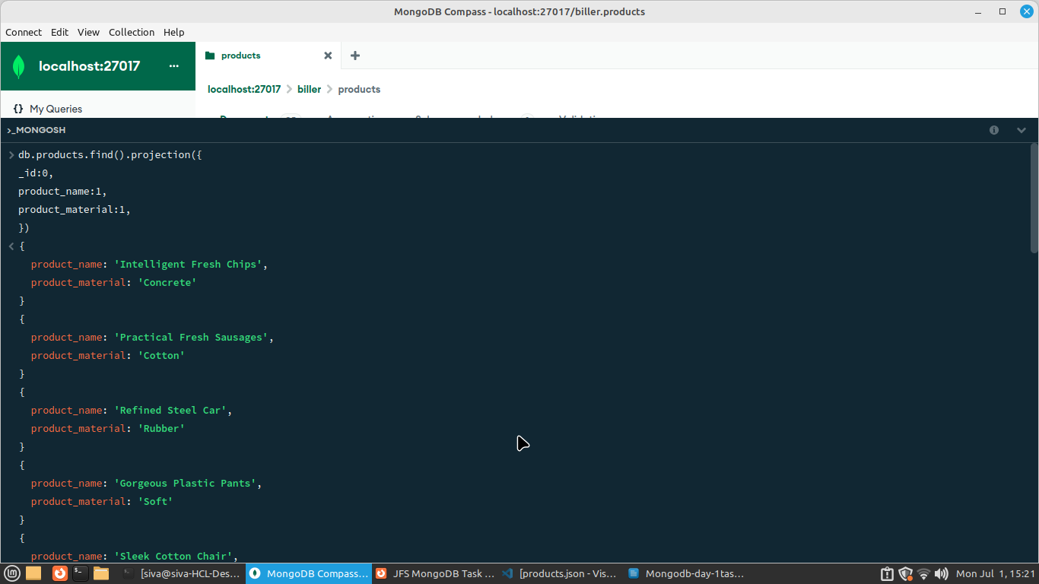

6. Find the product with a row id of 10?

Query : db.products.find({id:”6”})

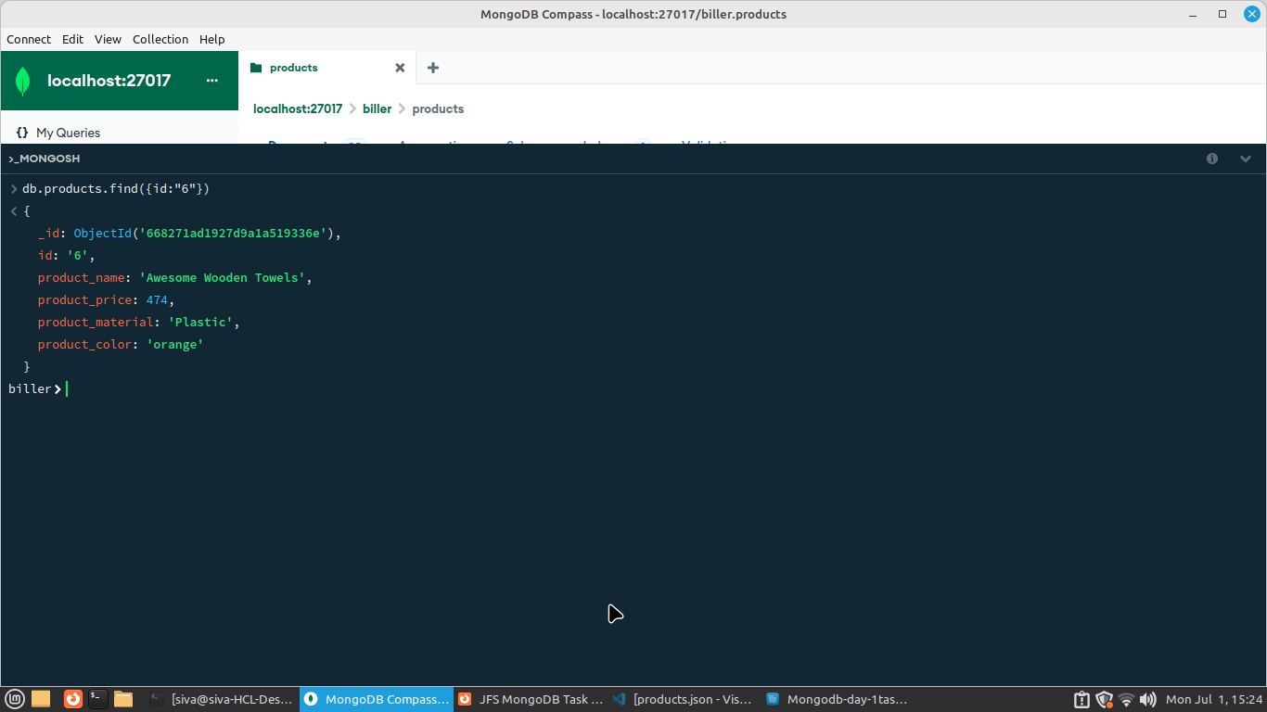
7. Find only the product name and product material?

Query: Query: db.products.find().projection({_id:0,product_name:1,product_material:1})

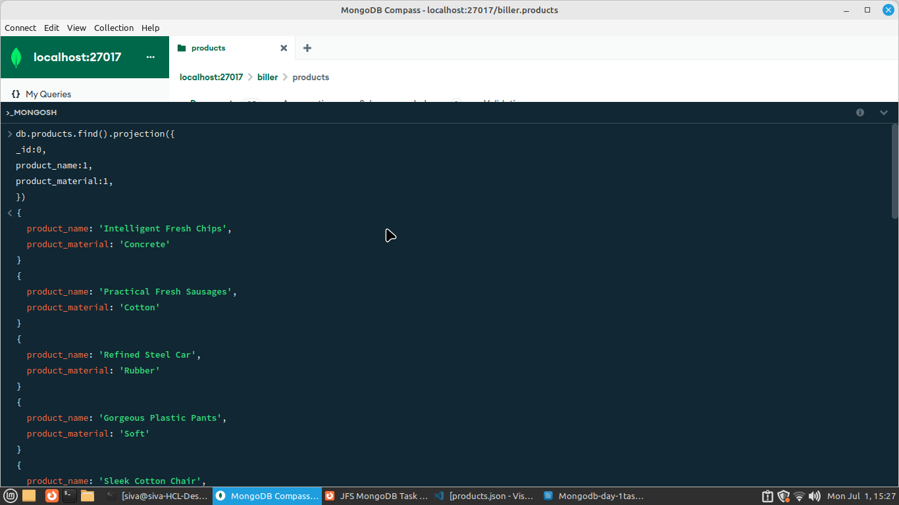
8. Find all products which contain the value of soft in product material​ ?

Query : db.products.find({product_material:”Soft”})

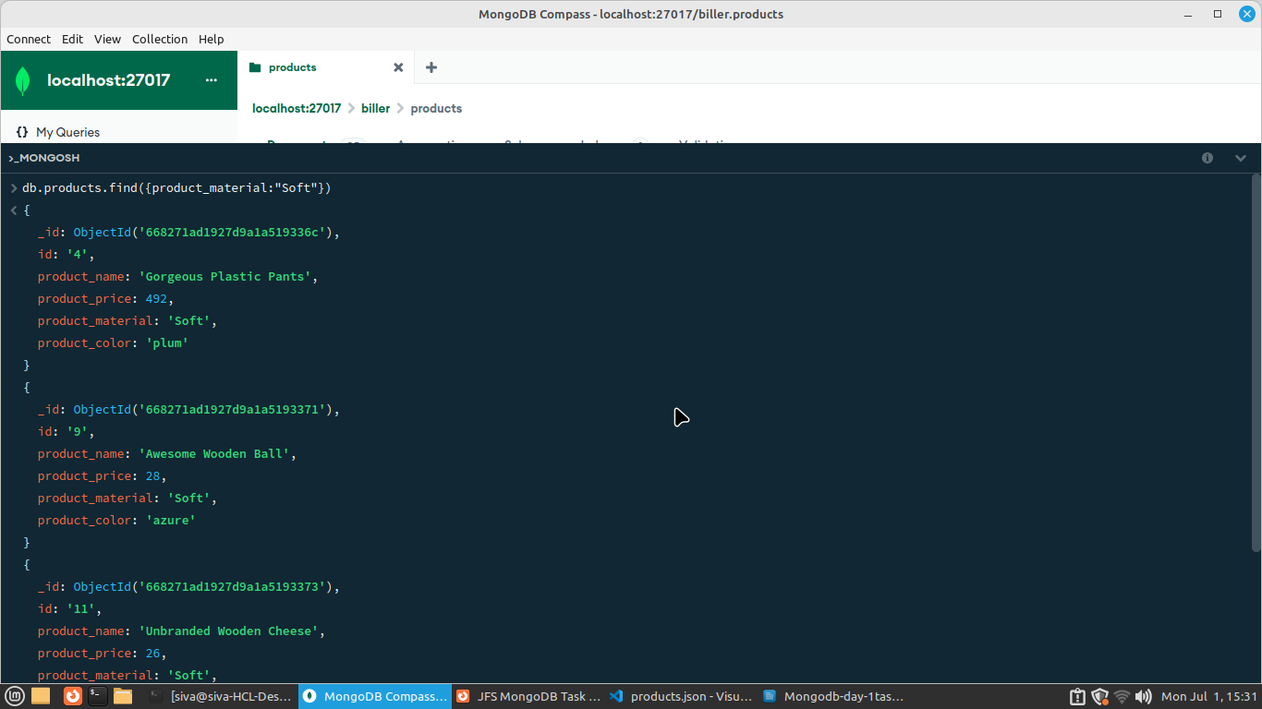
9. Find products which contain product color indigo and product price 492.00 ?

Query : db.products.find({$and:[{product_price:492},{product_color:”indigo”}]})

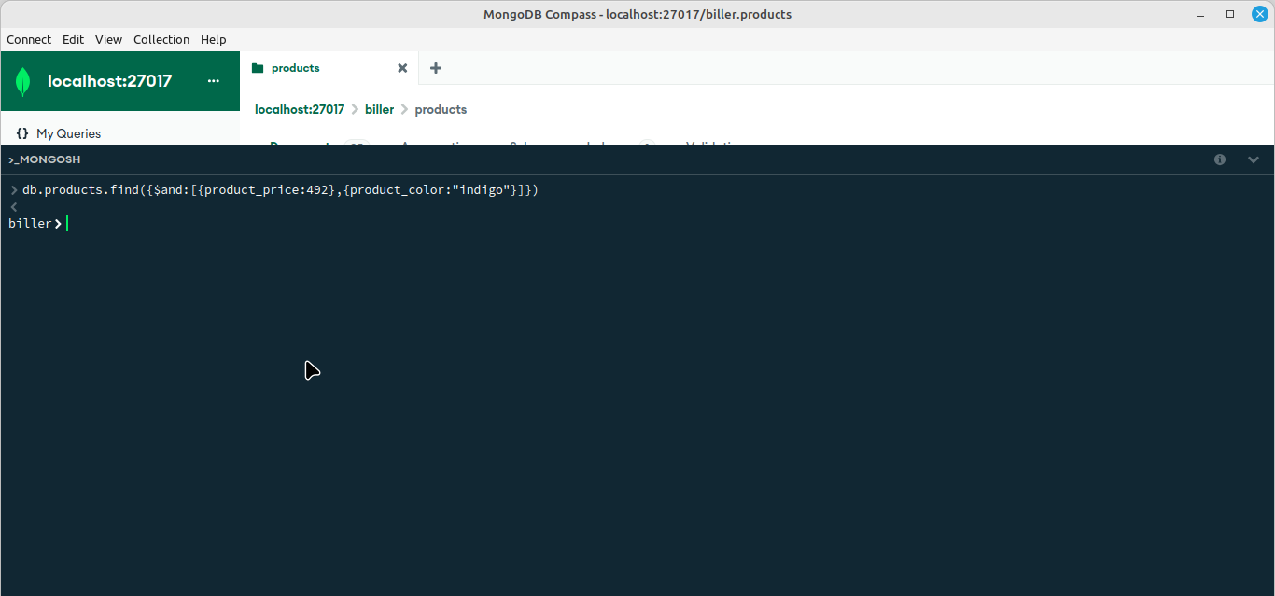

10. Delete the products which product price value are 28 ?

query: db.products.delete({product_price:28})

Before Delete:

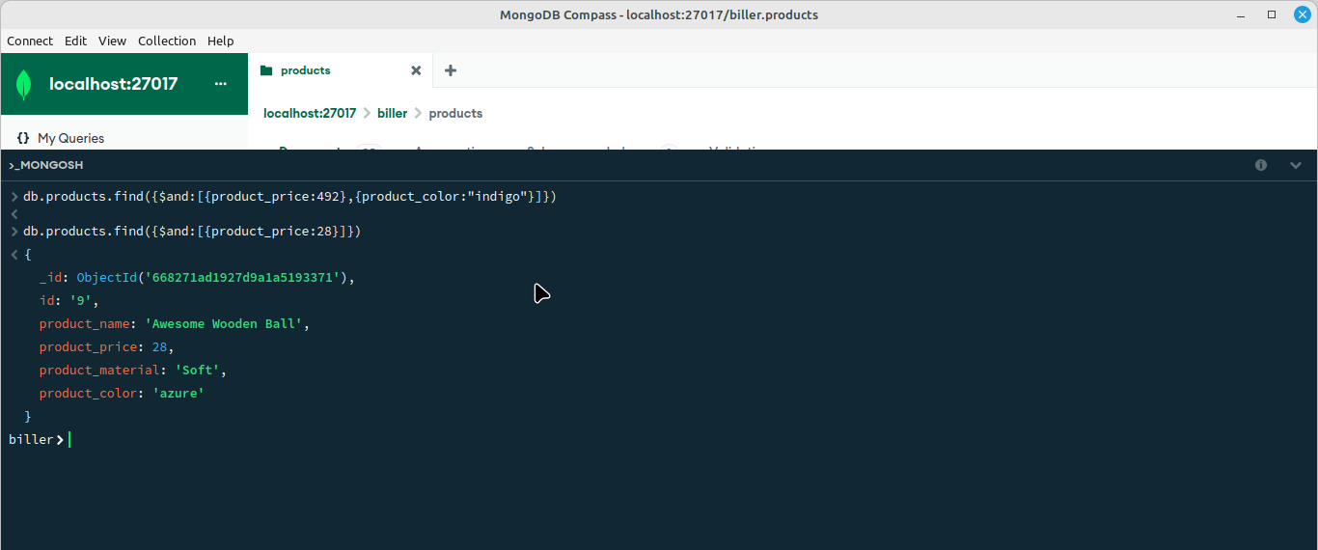

After Delete:

