**Cryptoverse: A Cryptocurrency Dashboard**

1. **Introduction**

Project Title:

Team Members:

Team Leader : SIVARAJ V

Team member : SEMBULINGAM A

Team member : SURYA M

Team member : SRINATH P

Team member : SAI KRUPESH B

## 2. Project Overview

### Purpose

### Cryptocurrency aims to provide a decentralized, secure, and efficient alternative to traditional currencies. It enables peer-to-peer transactions without intermediaries, reduces transaction fees, and offers financial inclusion to the unbanked. Cryptos also serve as a store of value, investment, and a foundation for innovations like blockchain and decentralized applications.

### Features

* **Decentralized**: No central control like banks.Responsive and user-friendly UI.
* **Secure**: Uses encryption to protect transactions.
* **Private**: Some cryptos allow anonymous transactions.
* **Global**: Can be used anywhere with internet access.

## 3. Architecture

### Component Structure

* **/src**
* **├── /components**
* **│ ├── Navbar.jsx # Navigation bar with links**
* **│ ├── Footer.jsx # Footer section**
* **│ ├── Sidebar.jsx # Sidebar navigation for docs**
* **│ ├── DocSection.jsx # Component for individual doc sections**
* **│ ├── MarkdownRenderer.jsx # If using markdown docs**
* **│ └── ...**
* **├── /pages**
* **│ ├── Home.jsx # Home page**
* **│ ├── Details.jsx # Details page**
* **│ ├── Documentation.jsx # Main Documentation page**
* **│ ├── NotFound.jsx # 404 Page**
* **│ └── ...**

### State Management

* **Context API** is used for global state management, storing coins data, user preferences, and exchange details.

### Routing

* **React Router** is used to handle navigation between pages:
  + / Home Page
  + /Cryptocurrencies/:categoryName - Dynamic route for news categories

## 4. Setup Instructions

### Prerequisites

Ensure you have the following installed:

* Node.js (latest LTS version recommended)

### Installation

* Clone the repository:
* Git clone <https://github.com/sivaraj-4s/A-Cryptocurrency-Dashboard.git>
* Navigate into the project directory:
* Extract the File
* Open VS code, open your floder
* npm install:
* npm run dev

## 5. Folder Structure

## /crypto

## ├── /node_modules # Dependencies installed via npm or yarn

## ├── /public # Static assets (not uploaded, but typically exists)

## │ ├── vite.svg

## │ └── ...

## ├── /src # Source code for the application

## │ ├── main.jsx # Entry point referenced in index.html

## │ ├── /components # Reusable React components (likely)

## │ ├── /pages # Page components (likely)

## │ ├── /redux # Redux store setup (based on dependencies)

## │ ├── /utils # Utility functions (if needed)

## │ ├── /assets # Images, styles, etc. (if needed)

## │ └── ...

## ├── index.html # Main HTML file

## ├── package.json # Project metadata and dependencies

## ├── package-lock.json # Locked dependency versions

## ├── README.md # Project documentation

## ├── vite.config.js # Vite configuration file

## └── .gitignore # Git ignored files (if applicable)

## 6. Running the Application

To start the frontend server locally, run:

npm run dev

This will launch the application at <http://localhost:5173/>

## 7. Component Documentation

### Key Components

* **index.html** → Loads the React app in <div id="root"></div>.
* **src/main.jsx** → Renders the app and wraps it with providers.

### Reusable Components

* **src/components/** → Reusable UI components (e.g., buttons, charts).
* **src/pages/** → Main pages for routing (e.g., Home, Details)

## 8. State Management

### Global State

* Uses **Redux Toolkit (@reduxjs/toolkit)** for global state.

### Local State

* Uses **Ant Design (antd)** for prebuilt UI components.

## 9. User Interface

Screenshots or GIFs showcasing:

**Homepage with Cryptocurrency Dashboard**

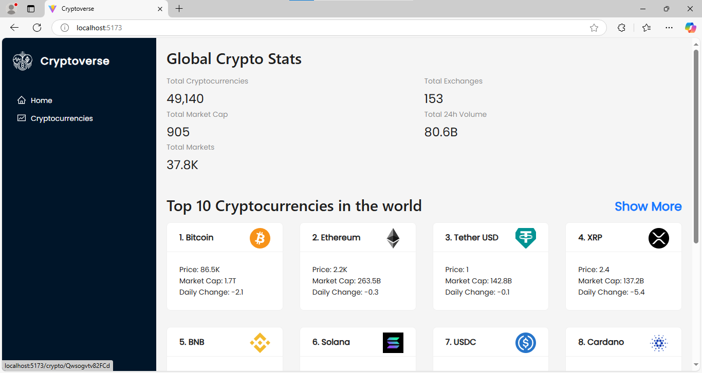

**Cryptocurrencies section**

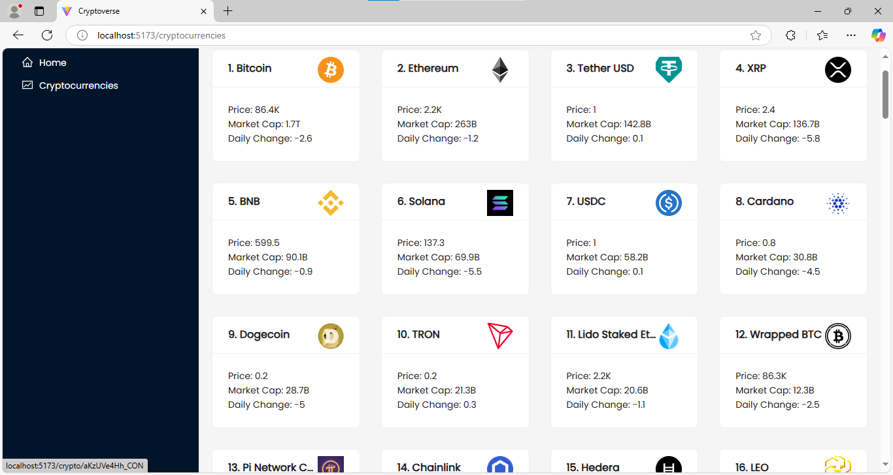

**After Click a Bitcoin menu:**

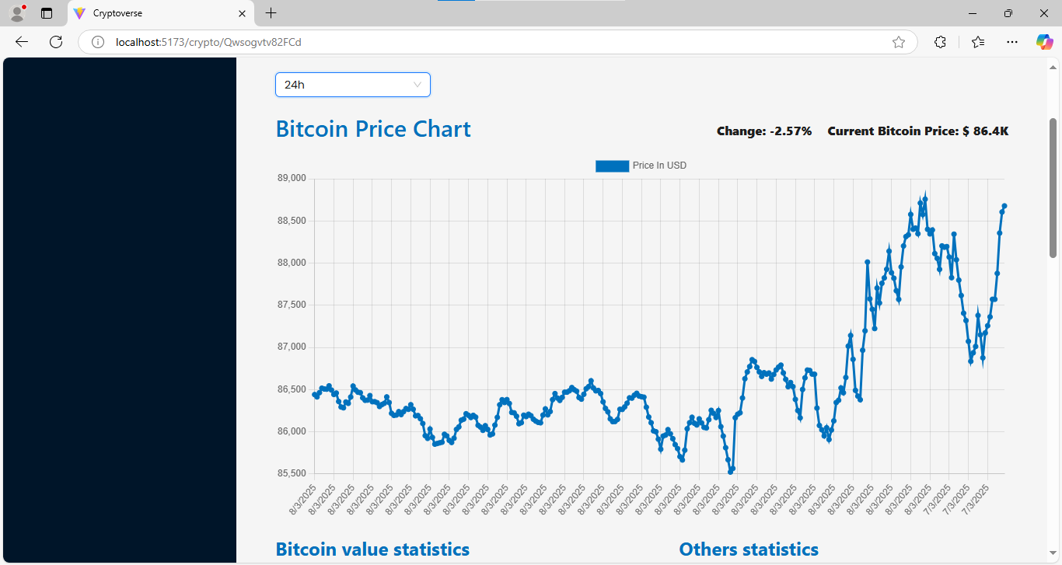

## 10. Styling

### CSS Frameworks/Libraries

* **Styled Components** for modular and dynamic styling.
* **CSS Modules** for scoped styles in individual components.

### Theming

* No theming were include.

## 11. Testing

### Testing Strategy

* **NodeTesting Library** for unit and integration tests.
* (future enhancement) for end-to-end testing.

### Code Coverage

* Code coverage reports generated using node.

## Demo

<https://insight-stream-wheat.vercel.app/>

## 13. Known Issues

* Performance optimizations needed for large crypto datasets.
* Improve mobile responsiveness for small-screen devices.

## 14. Future Enhancements

* Add a search functionality for coins.
* Improve animation and transitions for a smoother user experience.