Project Name: AI BlogNest
Team ID : SWTID-2026-3342
Team Size : 4
Team Leader : SIVARAJ S (sivaraj0827@gmail.com)
Team member : VERON JOSEPH DCOUTO (veronjosephalt2006@gmail.com)
Team member : ALFRED VISHAL A (alfredvishal25@gmail.com)
Team member : NAVIN P (teamxnavin16@gmail.com)

Scenario-Based Case Study

Background
Priya is a content creator who manages multiple blogs but finds it difficult to create, organize, summarize, and manage blog content efficiently. She spends significant time writing content and maintaining posts, categories, tags, and reader interactions.

Problem
- Difficulty creating high-quality blog content quickly.
- Time-consuming process of writing and editing blogs.
- Difficulty organizing posts using categories and tags.
- Limited support for generating content automatically.
- Time-consuming process of summarizing long blog posts.
- Difficulty managing comments and user roles.

Solution
AI BlogNest provides a centralized and secure blogging platform that combines traditional blog management with Generative AI. Users can generate blog content using AI, summarize existing posts, manage blogs, organize content with categories and tags, and handle reader comments. Role-based access allows Admins, Editors, Authors, and Readers to access features according to their responsibilities.

Usage

Author Usage
- Creates new blog posts using manual writing or AI-generated content.
- Generates blog content using the AI Blog Generator.
- Organizes blogs using categories and tags.
- Edits, saves, and manages blog drafts.
- Uses AI summarization to create concise summaries of blog posts.

Editor/Admin Usage
- Reviews and manages submitted blog content.
- Changes blog publishing status.
- Manages categories and tags.
- Moderates user comments.
- Manages user roles and permissions.
- Accesses protected administrative endpoints.

Reader Usage
- Views and searches published blog posts.
- Reads blog content and AI-generated summaries.
- Adds comments to blog posts.
- Interacts with published content.

Outcome
AI BlogNest provides a centralized platform for creating and managing blog content with the support of Generative AI. AI-assisted content generation reduces the time required to create blog posts, while AI summarization helps users quickly understand lengthy content. Role-based access and security controls ensure that users can access only the features permitted for their roles. MongoDB maintains the application's blog, user, and interaction data.

1. Software Requirements
- Operating System: Windows 10/11, macOS, or Linux.
- Node.js: Runtime environment used to run the backend server.
- npm: Package manager used to install and manage project dependencies.
- Express.js: Backend framework used to create RESTful APIs and manage server routes.
- MongoDB: NoSQL database used to store users, blogs, comments, categories, and tags.
- Mongoose: ODM used for defining schemas and interacting with MongoDB.
- Google Gemini AI: AI service used for blog generation and summarization.
- Postman: Used for testing and verifying REST API endpoints.
- Visual Studio Code: Development environment used for writing and managing the project code.

2. Hardware Requirements
- Processor: Intel Core i5 / AMD Ryzen 5 or equivalent.
- RAM: Minimum 8 GB recommended.
- Storage: At least 1 GB of available space for the project, dependencies, and development files.

Epic:-1 PROJECT ARCHITECTURE

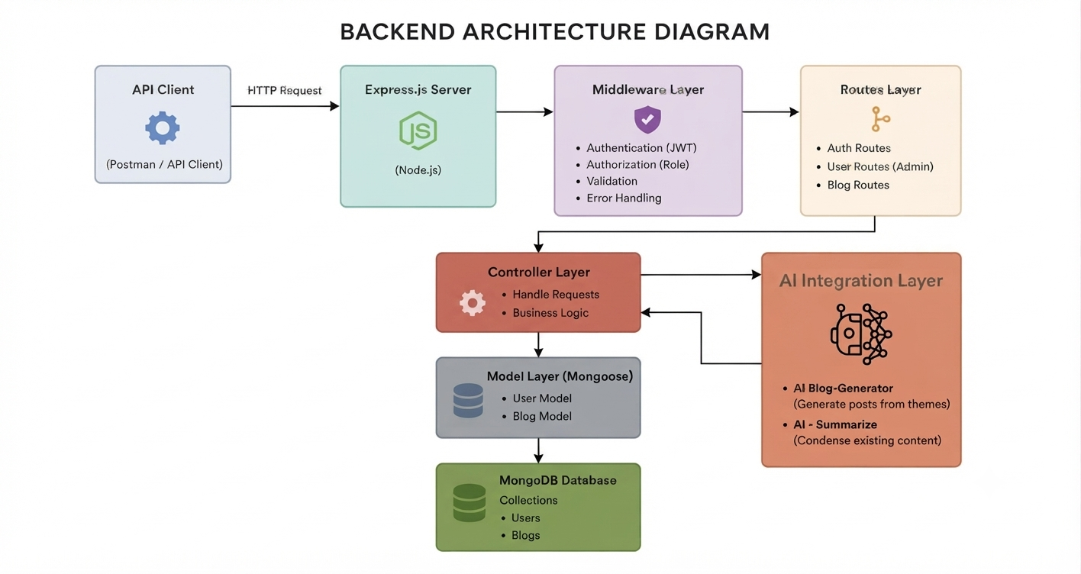

Project Architecture
The AI BlogNest application uses a layered server architecture in which incoming requests pass through authentication, validation, and routing layers before interacting with business logic, AI services,

Components Definition
- Interface:
Tools such as Postman and the frontend send requests to the REST API endpoints and receive responses in JSON format.
- Express Server Gateway:
Handles incoming HTTP requests and maps methods such as GET, POST, PUT, and DELETE to the appropriate API routes. It also processes JSON data and manages CORS.

- Authentication & Role Middleware:
Validates user authentication tokens and checks the user's role before allowing access to protected resources. Different permissions are provided for Admin, Editor, Author, and Reader roles.
- Blog Management Services:
Handles the main blog operations such as creating, reading, updating, and deleting blogs. It also manages blog drafts, publishing status, categories, tags, and comments.
- Database Interface Layer:
Mongoose provides the connection between the application and MongoDB, allowing the system to store and retrieve users, blogs, comments, categories, and tags.
- AI Flow (Service Integration):
Provides AI-powered functionality for blog generation and blog summarization. The backend communicates with the Gemini AI service through dedicated endpoints such as:
  - /api/ai/generate-blog
  - /api/ai/summarize
- BlogGenerator with AI:
A specialized service that sends the user's topic or requirements to the AI service and generates structured blog content, helping users create blog posts more efficiently.

Entity-Relationship (ER) Diagram Description
The underlying document structure manages several collections bound by logical application references:
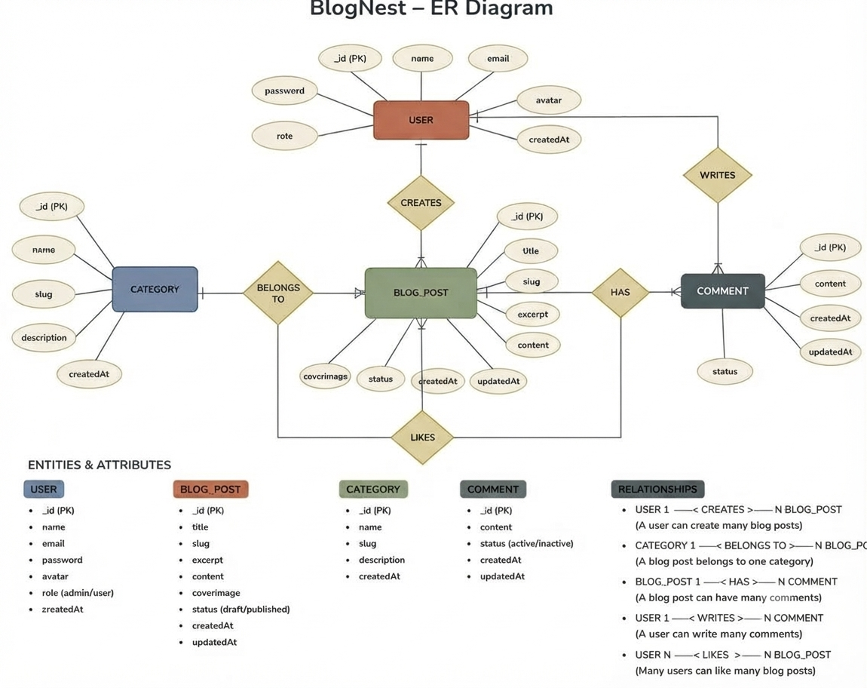

1. User Entity
- _id — Primary Key (ObjectId)
- name — String, Required
- email — String, Required, Unique
- password — String, Hashed, Required
- role — String, Default: "reader"

2. Blog Entity
- _id — Primary Key (ObjectId)
- userID — Reference to User Collection
- title — String, Required
- content — String, Required
- photo — String, Optional image/path link
- category — String
- tags — Array of Strings
- status — String, Default: "draft"
- likes — Number, Default: 0
- timestamps — True

3. Comment Entity
- _id — Primary Key (ObjectId)
- userID — Reference to User Collection
- blogID — Reference to Blog Collection
- comment — String, Required
- status — String, Default: "pending"
- timestamps — True

Key Structural Mappings
- User to Blog (One-to-Many):
One author can create and manage multiple blog posts.

- User to Comment (One-to-Many):
A user can add multiple comments across different blog posts.

- Blog to Comment (One-to-Many):
A single blog post can contain multiple comments from different users.
- User to Role (One-to-One):
Each user has one assigned role such as Admin, Editor, Author, or Reader, which determines their access permissions.

Key Features
- Role-Based Access Control:
- JWT authentication and role-based permissions restrict access to protected features for Admin, Editor, Author, and Reader users.
- CRUD Blog Management:
Allows authorized users to create, read, update, and delete blog posts while managing drafts and publishing status.
- Categories and Tags:
Organizes blog posts using categories and tags, making content easier to filter and discover.
- Comment Management:
Allows readers to comment on blogs and provides moderation options for managing comments.
- Security and Validation:
Validates and sanitizes user input to help protect the application from malicious requests and data manipulation.

- AI Blog Generation:
Uses Generative AI to create structured blog content from user-provided topics, keywords, or requirements.
- AI Content Summarization:
Uses AI to analyze existing blog content and generate concise summaries for easier and faster reading.
- REST API Integration:
Provides structured REST API endpoints that connect the frontend, backend, database, and AI services.

Roles and Responsibilities

Admin
- Manages registered users and their accounts.
- Assigns and manages user roles.
- Manages or removes inappropriate comments.
- Has access to administrative features and protected system resources.
- Monitors overall blog and user management activities.

Editor
- Reviews submitted blog posts and drafts.
- Manages publishing status of blog content.
- Organizes and maintains categories and tags.
- Reviews content before publication.
- Helps maintain the quality and organization of published blogs.

Author
- Creates and manages their own blog posts.
- Uses AI tools to generate blog content.
- Creates and manages drafts.
- Edits and updates their own posts.
- Organizes their posts using categories and tags.

Reader
- Views and reads published blog posts.
- Searches and explores available content.
- Reads AI-generated summaries where available.
- Posts comments on blog posts.
- Interacts with published content.

User Flow:
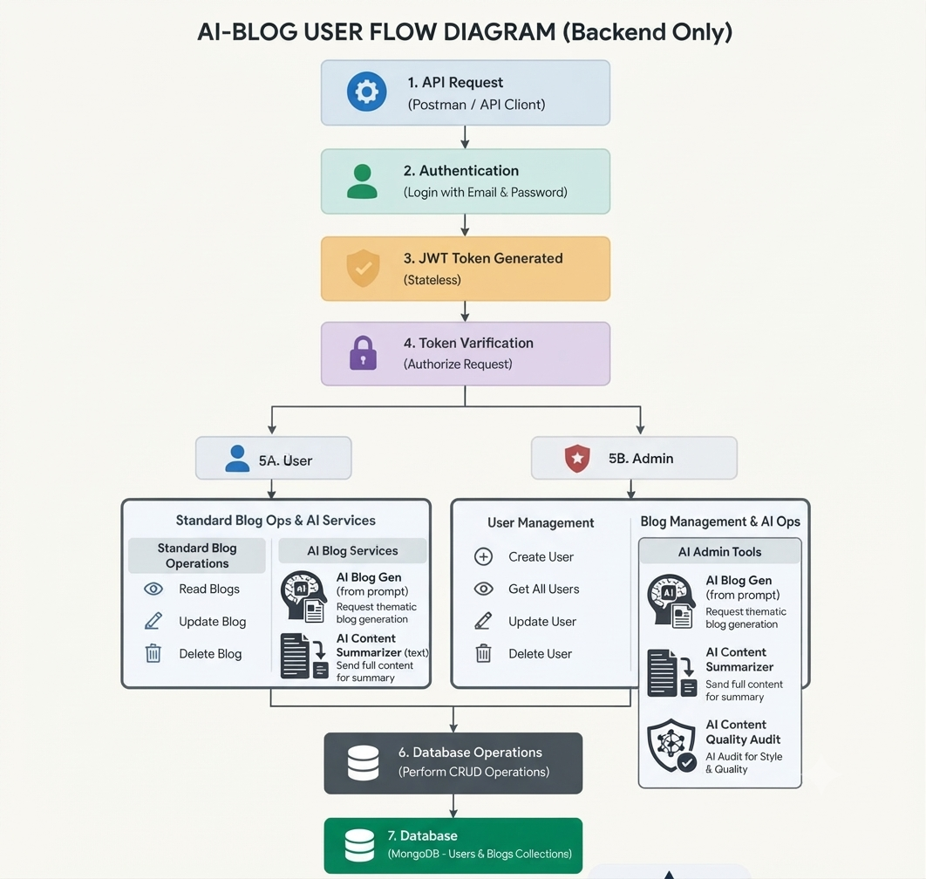

MVC Architecture Pattern
The system architecture structures its source configuration layers around the Model-View-Controller design pattern to completely decouple components:
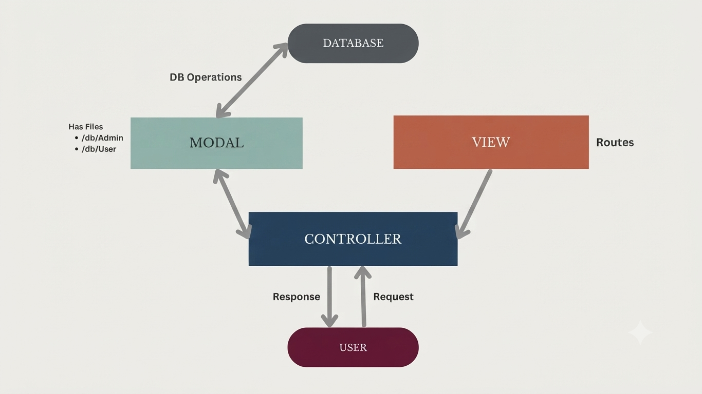
Model Layer (Data Blueprint)
Defines structure blueprints via strongly enforced Mongoose schemas mapping explicit fields into raw collection items inside MongoDB. It sets default states, indexing rules, and transformation parameters before validation persistence occurs.

Controller Layer (Execution Matrix)
The intermediary brain of the ecosystem. It captures request vectors from the execution routes, checks structural request constraints, delegates processing workflows directly to models, and packages the resultant output into standard JSON return arrays.

View Layer (Routing Network Interface)
In this pure headless backend service context, standard user-interface template views do not exist. Instead, the interface layer lives as an API
Routing Layer. It links network requests on specified paths directly to their associated controller handler logic maps.
Epic2: Project Setup and Configuration
Creating Project Folder
- Create a new folder named AI-BlogNest.
- Inside the project folder, create a folder named Client for the frontend files.
- Create another folder named Server for the backend files.
- Open the AI-BlogNest folder in Visual Studio Code.
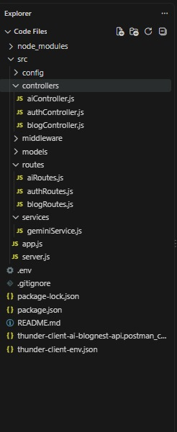

Server Setup (npm init)
- Open the Server folder in the VS Code terminal.
- Initialize the Node.js project using:
npm init -y
- Create the main server file:
server.js
- Create the following folders inside the Server folder

Epic 3: Backend Development
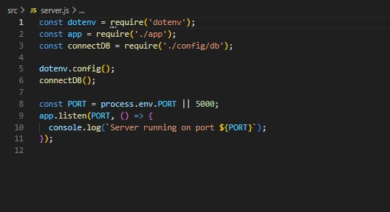

App.js
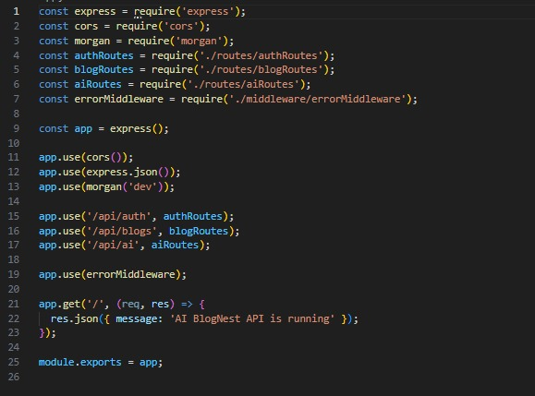

Epic4: Database Configuration
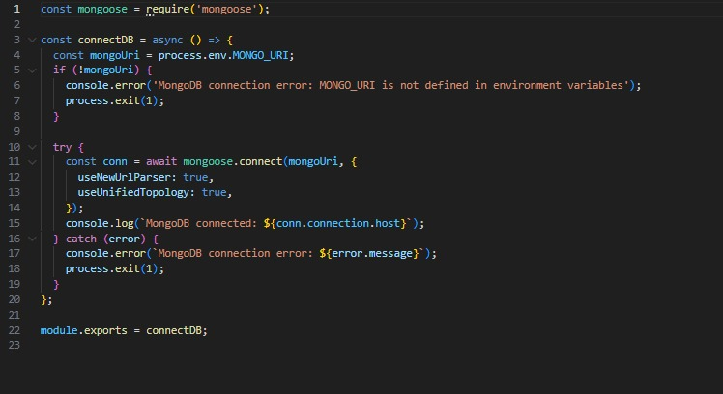

1. Configure MongoDB:
Mongoose is used to connect the Node.js application with MongoDB and define database schemas and models.
In your Server directory, run:
npm install mongoose
- Create database connection.
- Create Schemas & Models.
Create Database connection:
Now, make sure the database is connected before performing any of the actions through the backend. The connection code looks similar to the one provided below

Mongoose Schema Definitions

1. Identity Resource Document Schema (schemas/userModel.js)
Enforces field criteria validations on incoming database creations:
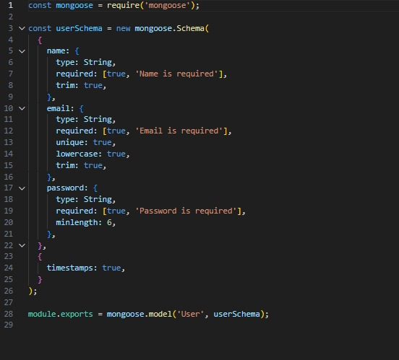
Epic 5: Project Executions:
- Install Postman or ThunderClient (VS Code extension).
- Start the backend server:
“npm start”

API Testing
User Registration :
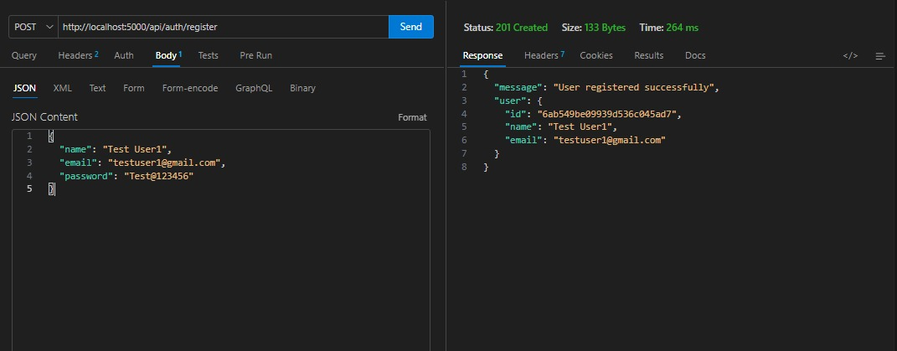
User Login:
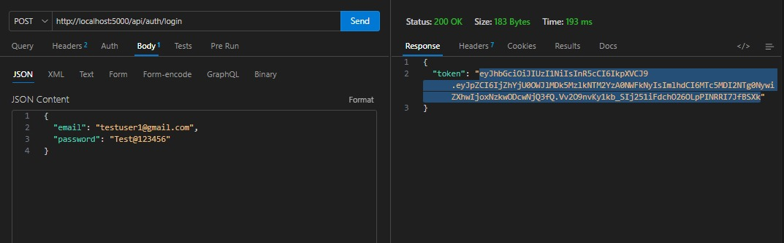

Create Blogs :
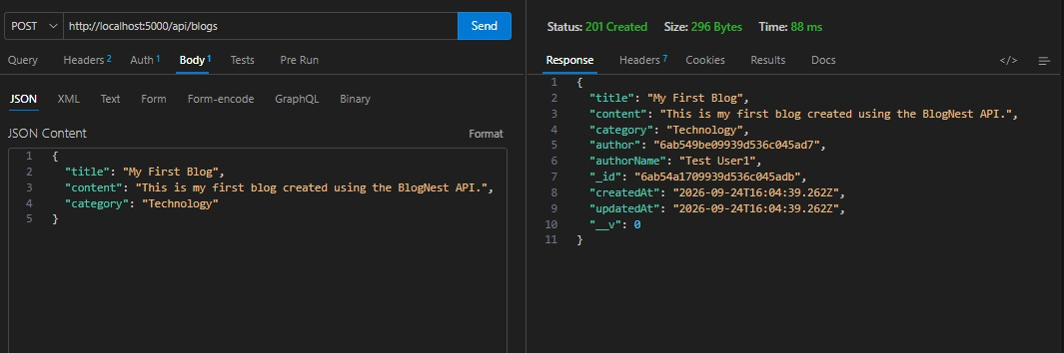
Fetch Blogs :
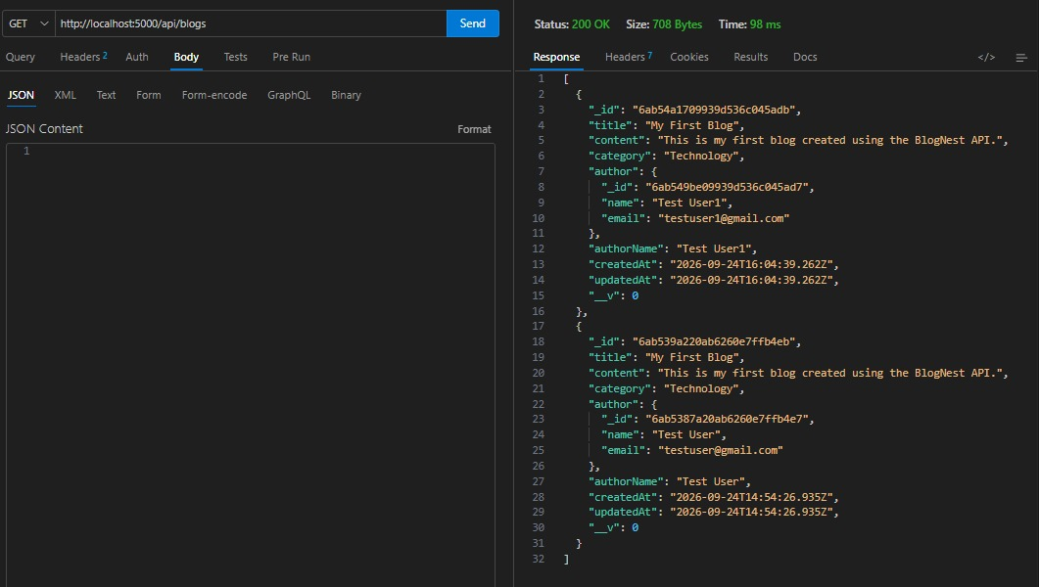

Generate AI blogs :
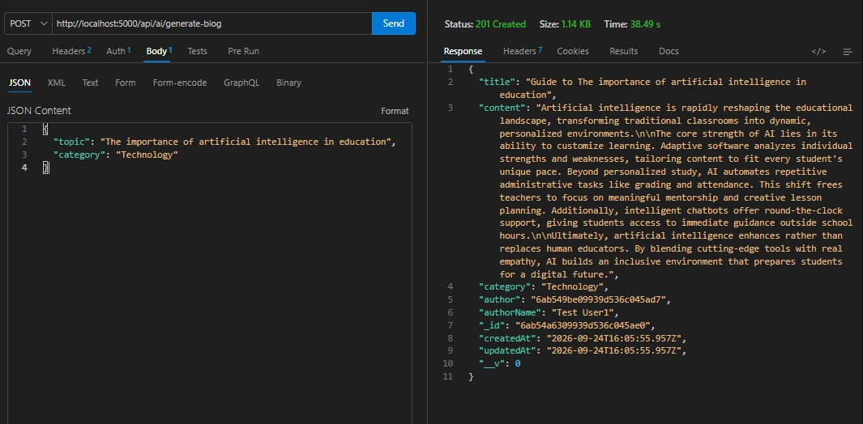
Summarize Blogs :
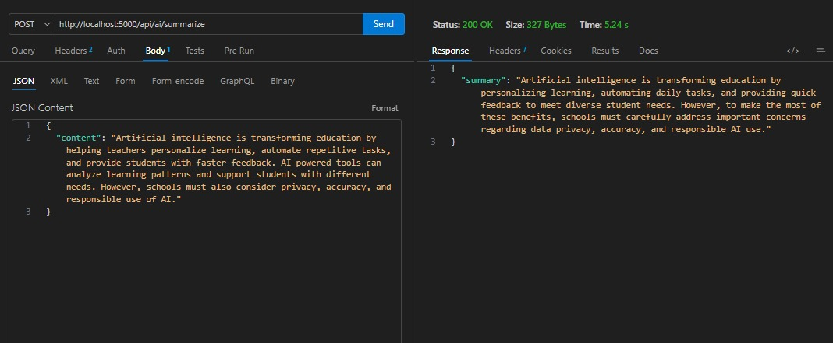
Demo Video :Sivaraj_TN_Skills_V_Sem_Demo_Video - Google Drive
Github Link: https://github.com/sivaraj0827/TNskills_AIblognest

