|  |  |  |  |  |  |  |
| --- | --- | --- | --- | --- | --- | --- |
| |  |  |  |  | | --- | --- | --- | --- | |  | | **MINISTRY OF EDUCATION AND TRAINING** | | | **FPT UNIVERSITY** | | |
| Capstone Project Document |
| Family Album Sharing System |
| |  |  |  |  |  |  |  |  |  |  |  | | --- | --- | --- | --- | --- | --- | --- | --- | --- | --- | --- | | |  |  | | --- | --- | | **Group 12** | | | **Group member** | Huỳnh Trần Minh Nhựt – Leader – SE60936  Tô Đình Tân – Member – SE60926  Trần Lê Tuấn – Member – 60350 | | **Supervisor** | Nguyễn Huy Hùng | | **Ext. Supervisor** | N/A | | **Capstone Project code** | FAMSAM | | |
| – Ho Chi Minh City, September 2014 – |

Table of Contents

1. INTRODUCTION 3

1.1 Project Information 3

1.2 Overview and solution 3

2. SOFTWARE PROJECT MANAGEMENT PLAN 4

2.1 Problem Definition 4

2.1.1 Name of this capstone project 4

2.1.2 Problem abstract 4

2.1.3 Problem overview 4

2.2 Project Organization 5

2.2.1 Software process model 5

2.2.2 Roles and responsibilities 5

2.2.3 Tools and techniques 5

2.3 Project Management Plan 5

2.3.1 Tasks 5

2.3.2 Risk assessment 5

2.3.3 Deliverables 5

2.3.4 All meeting minutes 5

2.4 Coding Convention 5

# INTRODUCTION

## Project Information

* Project name: Family Album Sharing System
* Project code: FAMSAM
* Product Type: Web Application, Mobile Application

## Overview and solution

Nowadays, sharing photos through the internet has become more and more popular. At present, there are several service which provide photo album sharing feature like Facebook, Instagram, Flickr. However, they only support to share photos randomly, not fully support specific characteristics of each family. As result of the fact, users are on demands of a service for family to share their moment such as wedding, baby growing, and ceremonies.

Therefore, the system is created to provide functions like creating albums with stories, sharing albums with other families and users can comment on photos, albums or stories. Photos also can be taken by mobile’s camera and add to album instantly. The system will make families save their memorable moment and connect together easily.

# SOFTWARE PROJECT MANAGEMENT PLAN

## Problem Definition

### Name of this capstone project

Project official name is “Family Album Sharing System”. Project code is “FAMSAM”.

### Problem abstract

In order to satisfy users demand for a photo sharing system, this project is provide a website and mobile application that allow user to create or join families and share their stories/photos with others.

### Problem overview

#### The Current Systems

At moment, there are several services around the world which support photo album sharing as social network:

* Facebook (facebook.com): Facebook is a huge social network, which provide photo album and story sharing feature. However, when using Facebook, people tend to have many friends which they do not even know.
* Instagram (instagram.com): Instagram helps user to take and share picture to friends and family but all its feature only focus on mobile app.
* Flickr (flickr.com): Unlike Instagram, Flickr has rich feature user interface on both website and mobile app while it does not strongly support user to create story.

There are more photo album sharing system but after all, their services are not focus on family characteristic or groups of people that have strong relationship, who want to store, manage and share their specific moment through albums and stories.

#### The Proposed System

This product is a social network that support managing and sharing photo album among families. This also provide the most convenient and effective way to manage photo albums.

For more specific, the system has four component: Family Photo Album Sharing System, Admin Management, Recommendation System and Image Toolkit.

(usecase)

* Family Photo Album Sharing System: provide user interface through website and mobile app for user to join the site, manage and share their album with others.
* Admin Management: provide user interface to administrator the system.
* Recommendation System: system with algorithm to recommend relate albums/stories for user.
* Image Toolkit: Provide toolkit to support user handle their images in the album.

#### Boundaries of the System

The current version of this system focuses on bellow features:

* User can create and join families, manage stories/albums/photos when they create which belongs for their families.
* A simple image toolkit which can detect bad quality image for user.
* For families to connect each other, member of every family can share their stories and albums as well as comment, like and follow other’s shared stories and albums.
* For system administrator to manage user and their image reports.
* Recommendation system which recommend user another similar album which user may interested in.

Due to lack of time, below features will be focused on future:

* Chat system.
* Image filter when upload.
* Multi-language.
* Auto detect and ban violent and obscene images.

#### Development Environment

Product will be the web-based and mobile application which is developed under the following hardware and software environment:

* Hardware: personal computer with at least 2GB RAM, Intel Core i3 2.0GHz.
* Software:
  + .NET Framework 4.5
  + Android 4 or later.

## Project Organization

### Software process model

Our project use **Scrum** as project model.

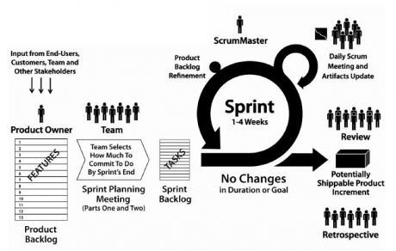

Figure 1 - Scrum Model

Due to Capstone Project characteristic, we decide each sprint takes one week. At the beginning of each sprint, we have sprint planning meeting, all team members will discuss to define sprint backlog which is suitable to be completed within a week. Daily report is operated through online conference meeting.

### Roles and responsibilities

|  |  |  |  |  |
| --- | --- | --- | --- | --- |
| No. | Full name | Team Role | Scrum Team Role | Responsibilities |
| 1 | Nguyễn Huy Hùng | Supervisor | Product Owner | * Outline work in scrum backlog * Prioritize work * Answer question and deliver direction |
| 2. | Huỳnh Trần Minh Nhựt | Team Leader | Scrum Master | * Facilitate productivity – maximize team performance * Complete all individual work |
| 3. | Tô Đình Tân | Team Member | Scrum Team Member | * Commit individual product on time * Support each other to complete team work |
| 4 | Trần Lê Tuấn | Team Member | Scrum Team Member | * Commit individual product on time * Support each other to complete team work |

### Tools and techniques

##### Back-end:

* ASP .NET Web API 2.
* Database: Microsoft SQL Server 2012.
* ORM: Entity Framework 6.
* OWIN.

##### Front-end:

* Web: HTML5, AngularJS 1.2.
* Mobile framework:
  + Development: Apache Cordova, Ionic Framework.
  + Build and deploy: Android 4.3

##### IDE:

* Visual Studio 2013.

## Project Management Plan

### Tasks

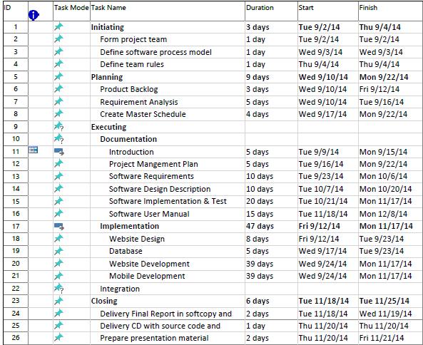

### Risk assessment

* Misunderstand user requirement.
* Study process may expand task’s duration.

### Deliverables

|  |  |  |  |  |
| --- | --- | --- | --- | --- |
| No | Deliverable | Delivery date | Delivery location | Note |
| 1 | Introduction Document | 15/9/2014 | FU – CMS | Report No. 1 |
| 2 | Software Project Management Plan | 22/9/2014 | FU – CMS | Report No. 2 |
| 3 | Software Requirements Specification | 06/10/2014 | FU – CMS | Report No. 3 |
| 4 | Software Design Description | 10/20/2014 | FU – CMS | Report No. 4 |
| 5 | Software Implementation & Test | 17/11/2014 | FU – CMS | Report No. 5 |
| 6 | Software User Manual | 17/11/2014 | FU – CMS | Report No. 6 |
| 7 | Completed version of Report No. 1 to Report No. 6 | 08/11/2014 | Classroom  FU – CMS | Final version |
| 9 | CD contains all Source code and installable system | 08/11/2014 | Classroom | Final version |

### All meeting minutes

## Coding Convention

<https://famsam.googlecode.com/svn/doc/Standard_CSharp%20Coding%20Convention.pdf>