**Use Case Diagram**

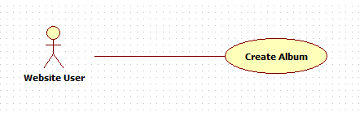

**<Website User> Create Album**

**Use Case Specification**

|  |  |  |  |
| --- | --- | --- | --- |
| **Use Case No.** |  | **Use Case Version** | **1.0** |
| **Use Case Name** | **Create Album** | | |
| **Author** | **Tô Đình Tân** | | |
| **Date** | **30/09/2014** | **Priority** | **Normal** |
| **Actor:**   * **Website User**   **Summary:**   * **This use case allows website user to create new album.**   **Goal:**   * **New album is created successfully**   **Triggers:**   * **Website user clicks on “Create Album” link on topbar menu.**   **Preconditions:**   * **User must login to system.**   **Post Conditions:**   * **Success: Album is added into user’s profile.** * **Fail: Show error message.** | | | |
| **Main Success Scenario:**   |  |  |  | | --- | --- | --- | | **Step** | **Actor Action** | **System Respond** | | **1** | **User clicks “Create Album” link on top bar menu.** | **Create album screen show:**   * **Story : label** * **Title: label** * **Share with: label** * **Description: label** * **Photos: label** * **“Add Photos”: link** * **“Create”: button** | | **2** | **User fills all the required blank. Then click on “Create” button.** | **Message “Album is created successfully” and page “Album Details” are shown.** |   **Alternative Scenario:**  **N/A**  **Exception:**   |  |  |  | | --- | --- | --- | | **No** | **Actor Action** | **System Respond** | | **1** | **User Session Time out** | Show error message “Process timeout” |   **Relationships: N/A**  **Business Rules:**   * **If album is created successful, new album would be added in system database and shown in user’s profile.** * **If album is created fail, no record added.** | | | |

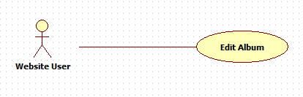

**<User> Edit Album**

**Use Case Specification**

|  |  |  |  |
| --- | --- | --- | --- |
| **Use Case No.** |  | **Use Case Version** | **1.0** |
| **Use Case Name** | **Edit Album** | | |
| **Author** | **Tô Đình Tân** | | |
| **Date** | **30/9/2014** | **Priority** | **Normal** |
| **Actor:**   * **Website User**   **Summary:**   * This use case allows user to edit an existing album.   **Goal:**   * An existing album is updated successfully.   **Triggers:**   * Click “Edit” link in view album details screen to edit.   **Preconditions:**   * User login successful and there is at least one album existed.   **Post Conditions:**   * Success: Album will be updated in user’s profile. * Fail: Show error message and album is not updated. | | | |
| **Main Success Scenario:**   |  |  |  | | --- | --- | --- | | **Step** | **Actor Action** | **System Respond** | | **1** | User clicks on “Edit” link in View Album Details Screen. | Edit album screen show which the following:   * **Story : label** * **Title: label** * **Share with: label** * **Description: label** * **Photos: label** * **“Add Photos”: link** * **“Save”: button** * **“Cancel”: button** | | **2** | User edits album information, and click “Save” button | Show message successful “Edit successful” |   **Alternative Scenario:**  **N/A**  **Exception:**   |  |  |  | | --- | --- | --- | | **No** | **Actor Action** | **System Respond** | | **1** | **User Session Time out** | Show error message “Process timeout” |   **Relationships:**  N/A  **Business Rules:**   * **If album is edited successful, album information would be changed in system database and shown in user’s profile.** * **If album is edited fail, no record changed.** | | | |

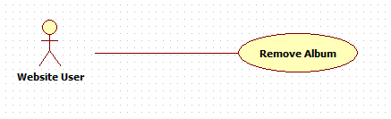

**<Website User> Remove Album**

**Use Case Specification**

|  |  |  |  |
| --- | --- | --- | --- |
| **Use Case No.** |  | **Use Case Version** | **1.0** |
| **Use Case Name** | **Remove Album** | | |
| **Author** | Tô Đình Tân | | |
| **Date** | **30/9/2014** | **Priority** | **Normal** |
| **Actor:**   * Website User   **Summary:**   * **This use case allows user to remove their album.**   **Goal:**   * **Album will be removed successfully.**   **Triggers:**   * **User clicks “Remove” link below album.**   **Preconditions:**   * User login successful and there is at least one album existed.   **Post Conditions:**   * **Success:** Album is removed successful and show success message. * **Fail:** Show error message | | | |
| **Main Success Scenario:**   |  |  |  | | --- | --- | --- | | **Step** | **Actor Action** | **System Respond** | | **1** | **Click “Manage Photos” link on top bar and click “Albums” tab.** | **View all albums tab** | | **2** | **Click “Remove” link below album** | **Show message dialogue** |   **Alternative Scenario:**  **N/A**  **Exception:**  **N/A**  **Relationships:**  **N/A**  **Business Rules:**   * **If album is removed successful, album would be removed from system database.** * **If album is removed fail, no record removed.** | | | |