Abhishek PolyPlast
Client Demo Architecture & Flow
Prepared for client presentation and walkthrough

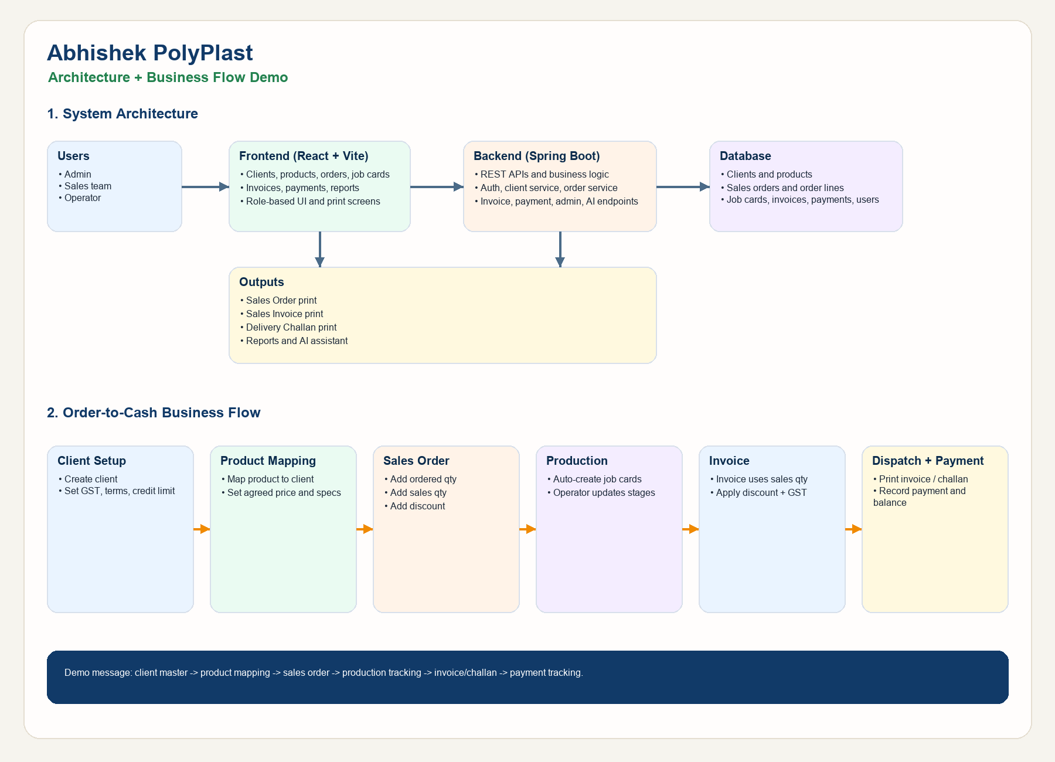
System Architecture
- Frontend is a React + Vite application used by Admin, Sales, and Operator roles.
- Backend is a Spring Boot application exposing REST APIs for clients, products, orders, job cards, invoices, payments, admin actions, and AI support.
- Data is stored in the application database for users, client masters, mapped products, sales orders, job cards, invoices, and payments.
- Print outputs include Sales Order, Sales Invoice, Delivery Challan, client reports, and payment statements.
Business Flow
- Create or update the client with GST rate, payment terms, and credit settings.
- Map products to the client with agreed price, stereo reference, and special specifications.
- Create a sales order with ordered quantity, sales quantity, discount, and delivery date.
- System creates job cards automatically for production tracking.
- Operator updates job card stages through production until dispatch readiness.
- Create the sales invoice using sales quantity, discount, and GST.
- Print invoice and delivery challan for dispatch.
- Record payments and track invoice balance status.
Role Summary
- Admin: manage users, manage all modules, and perform delete-all administration.
- Sales: manage clients, orders, invoices, challans, reports, and payments.
- Operator: update job cards and production stages without rate or amount access.
Demo Walkthrough Script
- Step 1: open a client and show GST, credit limit, and mapped products.
- Step 2: create a sales order with ordered qty, sales qty, and discount.
- Step 3: show the job card and production stage movement.
- Step 4: create an invoice and explain GST and discount calculation.
- Step 5: print the sales invoice and delivery challan.
- Step 6: record payment and show balance due updates.

