

ASHOK LEYLAND

IMPLANT TRAINING

ENNORE

**NAMES: SIVA.P FROM:** 28/06/2016

RAGAVAN.D **TO**: 02/07/2016

**COLLEGE NAME**: VEL TECH HIGH TECH DR.RR & DR.SR ENGINEERING COLLEGE AVADI.

**DEGREE**: B.E

**BRANCH**: (ELECTRICAL & ELECTRONIC ENGINEERING).

DAY:1

ENGINE ASSEMBLY (SHOP 2)

DISMANTLE &ASSEMBLE TOOLS:

* UNIVERSEL FLANGE HOLDING WRENCH
* LOCATER FOR CLUCH DISC
* UNIVERSEL MOUNTING SPINDLE FOR ASSEMBLY STAND
* MOUNTING BRACKET
* ANGLE GAUGE
* MOUNDING PLATE

SEQUENTIAL OPERATION FOR ENGINE ASSEMBLY:

1. PREPARTORY MEASURES
2. MEASURE THE DIAMETER OF THE MAIN AND BIG END BEARING JOURNALS USING A MICROMETER SCREW
3. FIT THE CRANK SHAFT
4. MEASURE THE CRANK SHAFT MAIN BEARING CLEARANCE
5. CHECK THE CRANK SHAFT END FLOAT
6. CHECK THE PISTON RING GAPS
7. ARRANGE THE PISTON RINGS
8. INSTALL THE PISTONS
9. MEASURE THE BIG END CLEARANCE
10. FIT THE BEARING CAPS
11. ADD CRANK SHAFT PILOT BEARING
12. REMOVE THE OIL SEAL FROM THE REAR OIL SEAL HOUSE
13. FIT THE CRANK SHAFT REAR OIL SEAL
14. FIT THE OIL BAFFLE,OIL STRAINER
15. FIT THE SUMP USING A NEW GASKET
16. CENTER THE CLUCH DISC ON THE PRESSURE PLATE
17. FIT THE CLUCH ASSEMBLY
18. BRING THE PISTON OF SIZE25mm POINT BELOW TDC
19. FIT THE CYCLTINDER HEAD AND TIGHTEND THE BOLTS
20. Tighten the cylinder head bolts
21. Tighten the auxiliary cylinder head bolts
22. Bring the piston of cylinder no. 1 to a point approximately 25 mm before TDC.
23. Install the camshafts
24. Bring the camshafts and crankshaft to TDC.
25. Check the new chain tensioned plunger.
26. Install the chain tensioned plunger.
27. Fit the timing chain at the bottom
28. Tighten the timing chain guide rail bolts.

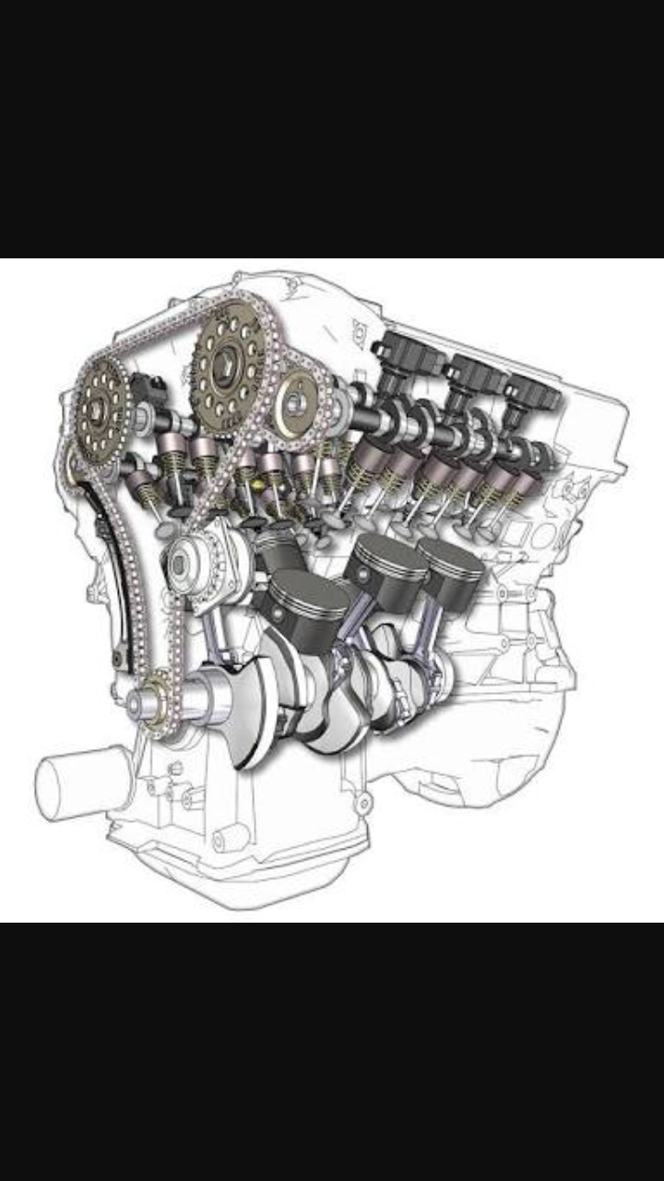

1. Fit the timing chain at the top.
2. Release the chain tensioned plunger.
3. Fabricate an auxiliary tool
4. Check the valve timings.
5. Install the oil pump drive assembly.
6. Fit the crankshaft vibration damper.
7. Connect the crankcase breather (PCV) pipe.
8. Fit the cylinder head cover with a new gasket (11 bolts and 4 nuts).
9. Attach the engine mounting bracket with the engine mounting.
10. Attach the CKP sensor.
11. Attach the oil filter.
12. Install the brackets for the air conditioning compressor and the exhaust
13. Detach the engine from the assembly stand.
14. Attach the engine mounting bracket with the engine mounting
15. Engine is ready for its action to be performed.

DAY: 2

GEAR BOX ASSEMBLY (SHOP1)

An automobile requires high torque when climbing hills and when starting,even though they are performd at low speeds. On the other hand ,when running at high speedson the level roads ,high torque is not required because of momentum . in orde to chance the vehile torque and speed according to the road condition or the driver needs the device is used. Such device is known as GEAR BOX or TRANSMISION BOX..

FUNCTION OF GEAR BOX :

The transmission box is in the second element of the power train in automobile. It is used to change the speed and torque of vehicle variety of road and load conditions.it changes the engine speed into torque when climbing the hills and when the driver required some times it is also known as torque conventer.

MAIN FUNCTIONS OF GEAR BOX IS AS FOLLOWS:

* Provide the torque needed to move the vehicle under variety of road and load conditions.
* It does this by changing the gear ratio between the engine crankshaft and vehicle drive wheels .
* Be shifted into neutral for starting the engine.

MAIN COMPONENTS OF A GEAR BOX:

* COUNTER SHAFT
* MAIN SHAFT
* GEARS
* BEARINGS

COUNTER SHAFT:

Countershaft is the shaft which connects clutch shaft directly. It contains the gear which connects the clutch shaft as well as the main shaft . it may be runs at the engine speed or at the lower than engine speed according to the gear ratio.

MAIN SHAFT:

It is the shaft which runs at the vehicle speed .it caries power from the counter shaft by use of gears and according to the gear ratio it runs at the different speedand torque compares to counter shaft. One end of this shaft is connected to the universal shaft.

GEARS:

Gears are used to transmit power from one shaft to other shaft. They are mostly used component of transmission box because of variation is torque of counter shaft and main shaft is depend on the gear ratio. The gear ratio is the ratio of the driven gear teeth to the driving gear teeth .if the gear ratio larger is, the main shaft revolves at lower speed than the counter shaft and the torque of the main shaft is higher than the counter shaft. On the other hand the gear ratio is less than one, than the main shaft revolves at higher speed than the counter shaft and the torque of the main shaft is lower than the counter shaft. A small car gear box contains four speed gears.

BEARINGS:

Whenever the rotary motion, bearings are required to support the revolving part and reduce the friction. In the gear box both counter and main shaft are supported by the bearing.

WORKING OF PRINCPLE GEAR BOX :

In the gear box ,the counter shaft is mshed to the clutch with ause of a counter of gear .so the counter shaft is always in running condition.when the counter shaft is bring in contact with the main shaft by use of meshing gears,the main shaft start to rotate according to the gear ratio. When want to change the gear ratio,simply press the cluch pedal which dis connect the counter shaft with engine and change connect the main shaft wirth counter shaft by another gera ratio by use of gera shif lever. In an gear box ,the gear teeth and other moving metal must not touch. They must be continuously separate by a thin film of lubricant . this prevent excessive wear and early failure .therfore a gera box runs partially filled with lubricant oil.

DAY: 3

FRAME AND CHASIS ASSEMBLY

Chasis is a French term which denotes the whole vehicle except body in case of heavy vehicles. In case of light vehicles of mono construction it denotes the whole body except additional fitting in the body. Chassis consists of engine, brakes, steering system & wheel mounted on the frame, differential, suspension. Chassis in electronic device consists of the metal frame on which the circuit boards & other electronics are mounted. In absence of a metal frame the chassis refers to the circuit boards & component themselves, not the physical structure. In computer chassis refers to the rigid framework on which motherboard, memory, disk drives & other equipments are mounted

ITS PRINCIPAL FUNCTION:

• To safety carry the maximum load.

• Holding all components together while driving.

• Accommodate twisting on even road surface.

• Endure shock loading.

• It must absorb engine & driveline torque.

CLASSIFICATION OF CHASSIS:

According to control:

• Conventional-forward chassis

• Semi-forward chassis

• Full-forward chassis

Conventional chassis:

• Engine is fitted in front of the driver cabin or driver seat such as in cars.

• Chassi portion can not be utilized for carrying passengers and goods

Semi-forward chasis:

• Half portion of the engine is in the driver cabin & andremaining half is outside the cabin such as in tata trucks

• In this arrangement a part of the chassis is utilized for carrying extra passengers Full-forward chassis

• Complete engine is mounted inside the driver cabin

• Driver seat is just above the front wheel

ACCORDING TO FITTING TO ENGINE :

• Engine at front

• Engine fitted in front but crosswise

• Engine fitted at the centre of the chassis

• Engine fitted at the back

ENGINE AT FRONT:

• Conventionally the engines are fitted at front & drive is given to the wheels from the “rear”.

Advantage :

• Enough space is available for luggage behind the rear seat

• The weight of vehicles is well balance

• Increased efficiency of cooling system

Engine is fitted at front & drive is given to front wheel:

• Low floor is available.

• Vehicle has more road holding capacity.

• clutch , gear box & differential are usually made as one unit, thereby cost is reduced.

Disadvantage:

• Weight of the vehicle shift to the rear wheels which is not desirable for better adhesion/attachment.

Engine is fitted in front but crosswise:

• Drive is given to front wheel

• As in Maruti & B.M.C

Engine fitted at the centre of the chassis:

• Drive is given to the rear

• As in royal tiger world master buses previously piled

• This arrangement provide full space of floor for use

Engine fitted at back :

• Real engine drive

• vehicles employing this system is dolphin

Advantage:

• Flat floor is available since long propeller shafts are eliminated

• With elimination of propeller shaft the centre of gravity lowered giving stable driving

• Better adhesion onroad specially when climbing hill

Disadvantage :

• While Climbing hills proper adhesion may be affected since the weight of vehicles moves to the rear , thereby reducing the weight on the front wheel.

• As a result of grouping of the engine with clutch, gear box and differential, the repair and adjustment become difficult due to congestion at the rear.

FRAME:

• Frame is the main part of chassis on which remaining part of chassis is mounted.

• Frame should be extremely rigid and strong so that it can withstand shocks, twist, stresses and vibrations when vehicle is moving on road

Frame is made of following sections:

•Channel sections

•Box sections

•Tubular sections

Types of Chassis frame:

• Conventional Frame

• Integral Frame

• Semi Integral frame

Conventional Frame:

• It is also known as non load carrying frame. Here loads on the vehicles are transferred to the suspensions by frame.

• This type of frame is not suited to resist torsion.

Semi Integral Frame:

• In this type of frame load is transferred to the body structure also.

• This Frame however is heavy.

• In semi integral frame half frame is fixed in the front end on which engine gear box and front suspension is mounted.

• This type of frame is used in some of the European & american cars

Integral Frame:

• In this type of construction there is no frame and all assembly units are attached to the body.

• The chassis , floor and body are assembled by from a large number of mild steel pressings.

• This is the modern form of construction for almost all cars and lighter commercial vehicles.

Some of important Chassis are:

• Ladder Frame

• Tabular Space Frame

• Monocoque Frame

• ULSAB Monocoque

• Backbone Frame

• Aluminum Space Frame

• Carbon Fiber

Ladder frame:

• The ladder frame is the simplest and oldest of all designs.

• It consists merely of two symmetrical rails

• It consists merely of two symmetrical rails

Tubular space frame:

• It is 3-dimensional design

• Tubular space frame chassis employs dozens of circular section tube, positions in different directions to provide mechanical strength against force from anywhere.

Monocoque:

• Monocoque is a one-piece structure which defines overall shape of the car. while ladder , tabular & backbone provide only stress members

• Today 99% car produced in this planet are made of steel Monocoque chassis

Spot-winding:

• Two plates are connected by resistance to electric current flow & work piece are held together under pressure exerted by electrodes.

ULSAB MONOCOQUE:

• Ultra light steel auto body.

• It has same structure as a conventional Monocoque.

Backbone chassis:

• Colin chapman invented backbone chassis in his elan roadstar

• A strong tubular backbone connects the front & rear axle & provide nearly all mechanical strength

Carbon frame Monocoque:

• Carbon fiber is found in aircraft, superbikes, spaceship, racing cars because of superior rigidity to weight.

• Carbon fibers are used in the body panels or in area where extreme stiffness & lightweight is beneficial.

Aluminium space frame:

• ASF consist of excrude aluminium sections ,vaccume diecast component& , aluminium sheet of different thickness.

ASHOK LEYLAND FRAME AND CHASIS ASSEMBLY IS VAST WORK SHOP WHICH WE HAVE SEEN.THERE THEY HAVE SEVERAL EQUIPMENT TO FIX THE VEHICLE .EVERTHING IS TESTED BEFORE IT IS TO BE USED IN NORMAL USAGE .

DAY: 4

AXLE ASSEMBLY (SHOP 4)

Axle assembly is divided into two parts mainly:

1. Front axle assembly
2. Rear axle assembly

FRONT AXLE ASSEMBLY:

* Front axles are supplied from high-volume commercial-vehicle series production and satisfy the most demanding standards.
* Planetary-hub front axles are supplied as single driven axles and as drive-through axles for tandem front-axle assemblies.
* The axles are equipped with either cam-type drum brakes or disc brakes and have automatic wear compensation.
* The brake cylinders are designed for air operation.
* The double universal-joint shafts are maintenance-free. The brake linings contain no asbestos. The axles can be equipped with an anti-lock brake system (ABS).
* The shafts and gearwheels are of high-strength heat-treatable alloy steel and are carried in substantial taper roller bearings.

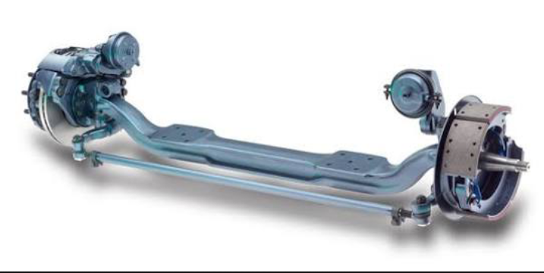

FRONT AXLE ASSEMBLY

REAR AXLE ASSEMBLY:

* The rear axle assembly is used on rear-wheel drive vehicles. This assembly is the final leg of the drive train.
* It is often called the final drive or rear end. The rear axle assembly is often mistakenly called the differential.
* The differential is only part of the rear axle assembly. Solid-axle rear suspension incorporates rigid and nonflexing drive axles and axle tubes; both wheels move as one solid unit in response to bumps and potholes.
* Independent rear suspension incorporates jointed drive axles (no axle tubes) that allow for flexibility and independent axle movement

Construction and Operation Overview:

* The rear axle assembly includes the differential assembly, the rear drive axles, and the rear axle housing.
* They are ruggedly constructed and seldom fail. The most common rear end failures are axle bearing failures.
* In a rear axle assembly, engine power enters the drive pinion gear from the drive shaft assembly and differential pinion yoke/flange.
* The drive pinion gear, which is in mesh with the ring gear, causes the ring gear to turn. The interaction of the ring and drive pinion gears turns the power flow at a 90° angle.
* The difference in the number of teeth on the ring and pinion gears causes a reduction gear ratio.
* This reduces turning speed, while increasing torque. Power from the ring gear flows through the differential case, spider gears, and side gears to the drive axles.
* The drive axles transfer power from the differential assembly to the rear wheels.
* The bearings and rear axle housing are key components of the rear axle assembly. They are designed to support and align the differential assembly and the drive axles.
* Notice that the bearings and axle housing are large, heavy-duty parts. This is to ensure they will stand up under hard usage.
* Seals and gaskets are also very important to the operation of the rear axle assembly. Seals are used at the differential pinion yoke/flange and at the outer drive axles.
* Gaskets are used at housing interfaces, such as between the differential cover and the housing, to provide a tight seal from the outside

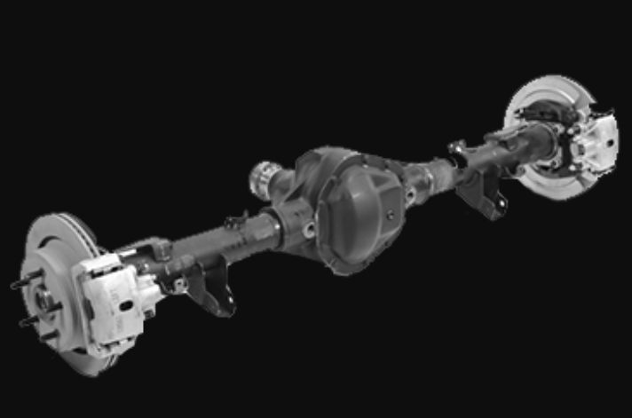

REAR AXLE ASSEMBLY

Differential Assembly:

* The differential assembly in a rear-wheel drive vehicle has three functions. The first, and most obvious, is to redirect the power flow to drive the rear wheels.
* This is accomplished in the differential assembly by the drive pinion and ring gears.
* The second function of the differential assembly is to multiply engine power, reducing speed at the output in the process
* The third function of the differential assembly is to allow the vehicle to make turns.
* If the assembly did not make allowances for the different speeds of the rear wheels during turns, one tire would lose traction with the ground as the vehicle turned corners.

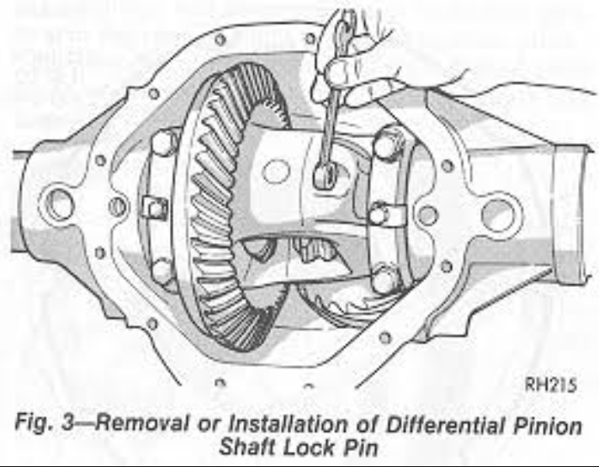

Differential Case Assembly:

* When a vehicle makes a turn, the outer wheel travels a greater distance than the inner wheel—the arc (or radius) of the turn is greater at the outer wheel.
* If the rear drive axles were simply connected together, both wheels would have to travel an arc of the same length during a turn.
* Since this is impossible, one of the tires would lose traction, or slip, during the turn. If the tire did not slip, it would skip over the road surface.
* This condition is called wheel hop. The purpose of the differential case assembly is to allow the vehicle to make turns without slippage or wheel hop.
* It does this with an arrangement of gears that allows the rear wheels to turn at different speeds.
* Two basic types of differential case assemblies used to accomplish this task are the standard differential and the locking differential.

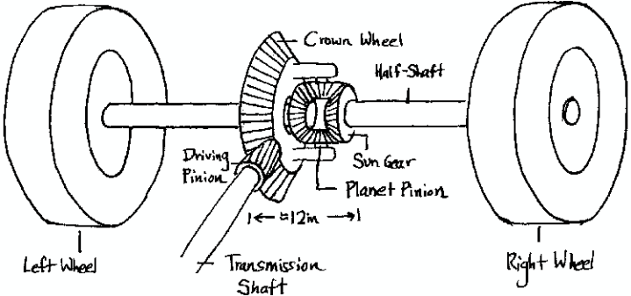

DAY:5

ENGINE COMPONENTS MACHING

Engine is the one in which the thermal energy is converted into mechanical energy.

There are four strokes involved in this engine.

1. Suction Stroke
2. Compression Stroke
3. Power Stroke
4. Exhaust Stroke
5. **Suction Stroke:**

In this stroke the inlet value opens when the piston moves from TDC to BDC. The Vacuem is created inside cylinder, then air fuel mixture is sucked in this stroke.

1. **Compression Stroke:**

In this stroke the piston moves from BDC to TDC and both the valves are kept closed. The air fuel mixture inside the cylinder is compressed in this stroke.

1. **Power Stroke:**

All the end of compression stroke the high pressure air fuel mixture is burnt by spark. This high pressure burnt gases pushes the piston from TDC to BDC with both the valves closed. It is also known as working stroke.

**4. Exhaust Stroke:**

At end of power stroke the exhaust stroke i.e., value opens and inlet valve remains closed. The burnt gases inside cylinder are escaped through this valve by movement of piston from BDC to TDC.



Cylinder Head:

* One of cylinder end is closed by means of a Removable cylinder head which usually contains the inlet valve for allowing mixtures of air fuel and exhaust valve for discharging he products of combustion.
* The main working purpose of cylinder head is to seal the working ends of cylinder and not to permit entry end exist of gases on covered head valve engines the cylinder head usually made of cost iron or Aluminum.

Piston:

* A piston is fitted to reach a phase to receive gas pressure and transmit the thrust to connecting rod; the piston must give gas tight seal to the cylinder through the bore.
* It must slide freely. It should light in weight and off storage in nature, piston are made of cost or Aluminum alloy for tightness.

Cylinder:

* The cylinder contains gas chamber and guides the piston. It is indirect contact with the products of combustion and it must be cooled.

Piston rings:

* The piston must be farely loose fit in the cylinder. If it is tight fit it expands as it got heated and might stick in the cylinder.
* If the piston sticks it would chease the engine, on the other hand if there is too clearance between the piston and cylinder walls.
* The burnt gases vapour will leak piston.

Connecting rod:

* The connecting rod transmits the piston load to crank housing. It converts the reciprocating motion of the piston into rotary motion of crank shaft.

Crank:

* To change the reciprocating motion into rotary motion crank and connecting rod are used. The connecting rod connects the piston to crank.

Crank shaft:

* The crank is the part of crank shaft. The crank shaft of a IC engine receives via its cranks. The effort supplied by piston to the connecting rod.
* It is usually a steel forging, but some makes are use special types of cast irons such as Spheroid, Graphite (or) Nickel alloy castings.

Crank Case:

* The main body of engine is to which the cylinder are attached and which contains the shaft and crank shaft bearings is called as crank case.

Flywheel:

Flywheel secured on the crank shafts performs the following functions:

* Bring the mechanisms out of dead centres.
* Stores energy required to rotate the shaft during preparatory strokes.

Makes the crank shaft rotation move uniform.

Spark Plug:

* The main function of spark plug is to conduct a high potential from ignition system into the construction chamber. It provides the proper gas across the chamber.

Carburetor:

* The function of carburetor is to atomise and meter the fluid and mixes it with air, as it enters the induction system of engine maintaining under all conditions of operations fuel air proportions appropriate to these conditions.

Fuel Pump:

* It is a device which is used to pump the fuel from glass bowl to the carburetor through outside valves.

FINALY ALL THE ENGINE COMPONENTS ARE JOINED TOGETHER .TO FORM A PERFECT ENGINE. AND IT IS READY FOR IGNITION.

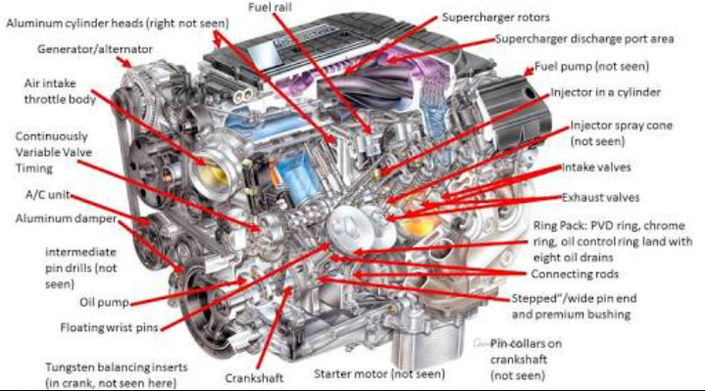

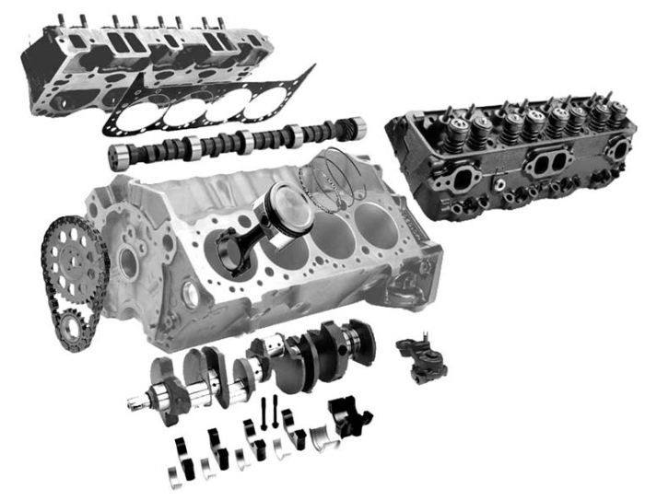

THANK YOU

