WASHWISE – SMART HOSTEL LAUNDRY MANAGEMENT SYSTEM

PHASE I REPORT

Submitted by

MOHAMAD FAYAS N | – | 241701031
SIVARAM G | – | 241701054

in partial fulfilment for the award of the degree of

BACHELOR OF ENGINEERING IN
COMPUTER SCIENCE AND DESIGN



RAJALAKSHMI ENGINEERING COLLEGE

ANNA UNIVERSITY, CHENNAI

OCTOBER 2026

RAJALAKSHMI ENGINEERING COLLEGE

ANNA UNIVERSITY, CHENNAI

BONAFIDE CERTIFICATE

Certified that this Report titled “SMART CAMPUS LAUNDRY MANAGEMENT SYSTEM WITH AI-BASED CLOTHING DETECTION” is the bonafide work of MOHAMAD FAYAS N (241701031) and SIVARAM G (241701054) who carried out the work under my supervision. Certified further that to the best of my knowledge the work reported herein does not form part of any other thesis or dissertation on the basis of which a degree or award was conferred on an earlier occasion on this or any other candidate.

Certified further that the project contributes to SDG 6, SDG 9, SDG 11 and SDG 12, with a primary focus on SDG 12 - Encourages efficient use of washing machines and laundry resources.

Signature of the HOD  Dr. S. Vinodh Kumar  Professor,The Head of the Department  Department of Computer Science and Design  Rajalakshmi Engineering College  Chennai | Signature of the Supervisor  Dr. P. Revathy  Professor  Department of Computer Science and Design  Rajalakshmi Engineering College  Chennai

Submitted for the Phase I Project Viva-Voce examination held on ______________.

INTERNAL EXAMINER EXTERNAL EXAMINER

ABSTRACT

Hostel laundry services commonly depend on manual booking procedures, handwritten records, and verbal communication between students and laundry staff. These traditional practices can make it difficult to manage laundry bookings efficiently, maintain accurate records, communicate order details, and coordinate laundry activities across multiple hostels. Manual processes may also lead to booking conflicts, delays in information sharing, inconsistent record maintenance, and difficulties in monitoring laundry usage. To address these challenges, WASHWISE is proposed as a smart campus laundry management system that integrates essential laundry service operations into a unified web and Android application. The system aims to improve accessibility, streamline booking procedures, and provide a more organized approach to managing hostel laundry services. The application provides a centralized workflow for hostel selection, user authentication, laundry-slot management, booking, and order tracking. It is designed to support structured communication between users and laundry service administrators while maintaining hostel-specific data and booking records. The frontend is developed using React and Vite, with a responsive interface designed to provide a consistent user experience across supported devices. The backend is implemented using Node.js and Express with TypeScript, while Prisma ORM facilitates database interactions with PostgreSQL. The frontend is hosted on Vercel, and the backend service and database are deployed on Render. In addition, Capacitor is used to package the web application as an Android application, enabling access to native device capabilities, including camera-based laundry image capture. To support intelligent laundry management, a separate Python Flask service has been prepared for AI-assisted clothing detection. The intended processing pipeline uses the YOLOv8 object detection model to identify clothing categories such as shirts, T-shirts, pants, jeans, shorts, towels, and bedsheets from uploaded or captured images. The detection results are intended to support automated clothing identification and provide a foundation for future laundry quantity estimation and load-management features. At the current integration stage, mock mode is used to verify communication between the frontend, backend, and AI service. Actual model-based detection requires a suitable trained weights file, integration with the inference pipeline, and further testing to evaluate detection accuracy and reliability. Future enhancements include validating the trained object detection model, improving clothing and weight estimation, refining automated slot allocation, and evaluating system performance under realistic hostel operating conditions. These improvements could contribute to more efficient laundry service coordination, better resource utilization, and a more convenient experience for hostel residents and laundry administrators.
ACKNOWLEDGEMENT

Initially we thank the Almighty for being with us through every walk of our life and showering his blessings through the endeavour to put forth this report. Our sincere thanks to our Chairman Mr. S.MEGANATHAN, B.E, F.I.E., our Vice Chairman Mr. ABHAY SHANKAR MEGANATHAN, B.E., M.S., and our respected Chairperson Dr. (Mrs.) THANGAM MEGANATHAN, Ph.D., for providing us with the requisite infrastructure and sincere endeavouring in educating us in their premier institution.

Our sincere thanks to Dr. S.N. MURUGESAN, M.E., Ph.D., our beloved Principal for his kind support and facilities provided to complete our work in time. We express our sincere thanks to Dr. S. VINODHKUMAR, Ph.D., Professor and Head of the Department of Computer Science and Design for his guidance and encouragement throughout the project work. We convey our sincere and deepest gratitude to our internal guide, DR. P. REVATHY., Department of Computer Science and Design, for her valuable guidance throughout the course of the project. We are very glad to thank our Project Coordinator, Dr. S. P. KARUPPIAH, Ph.D., Department of Computer Science and Design, for his valuable guidance and useful tips during our reviews to build our project.

MOHAMAD FAYAS N (241701031)
SIVARAM G (241701054)

TABLE OF CONTENTS

CHAPTER NO. | TITLE | PAGE NO.
 | ACKNOWLEDGEMENT | iii
 | ABSTRACT | iv
 | LIST OF TABLES | v
 | LIST OF FIGURES | vi
 | LIST OF ABBREVIATIONS | vii
1. | INTRODUCTION | 13
 | 1.1 GENERAL | 12
 | 1.2 BACKGROUND | 12
 | 1.3 PROBLEM STATEMENT | 13
 | 1.4 MOTIVATION | 13
 | 1.5 OBJECTIVES | 14
 | 1.6 SCOPE | 14
 | 1.6.1 INCLUDED SCOPE | 14
 | 1.6.2 SCOPE LIMITATIONS | 15
 | 1.7 EXISTING SYSTEM | 15
 | 1.8 LIMITATIONS OF EXISTING SYSTEM | 16
 | 1.9 PROPOSED SYSTEM | 17
 | 1.10 ADVANTAGES OF PROPOSED SYSTEM | 17
2. | LITERATURE REVIEW | 20
 | 2.1 INTRODUCTION | 19
 | 2.2 REVIEW OF RELATED WORK | 19
 | 2.3 COMPARATIVE ANALYSIS | 22
 | 2.4 COMPARATIVE ANALYSIS OF THE PROPOSED SYSTEM | 23
 | 2.5 RESEARCH GAP | 23
3. | THEORETICAL BACKGROUND AND SYSTEM DESIGN | 25
 | 3.1 GENERAL | 25
 | 3.2 CIVIC ISSUE DATA ACQUISITION | 25
 | 3.3 REPORT VALIDATION AND NORMALIZATION | 25
 | 3.4 ISSUE CLASSIFICATION AND ROUTING | 26
 | 3.5 GEOGRAPHIC DATA AND JURISDICTION | 26
 | 3.6 ISSUE PRIORITY AND CATEGORY RULES | 27
 | 3.7 JURISDICTION RULE ENGINE | 27
 | 3.8 OPENSTREETMAP AND LEAFLET | 27
 | 3.9 MAP-BASED ISSUE TRACKING | 28
 | 3.10 LOCATION MAPPING AND CONTROL | 28
 | 3.11 EVIDENCE AND REPORT ACQUISITION | 28
 | 3.12 TEXT NORMALIZATION | 29
 | 3.13 OPTIONAL CIVIC ASSISTANT | 29
 | 3.14 OPTIONAL CLASSIFICATION MODELS | 29
 | 3.15 ISSUE CLASSIFICATION AND ROUTING | 30
 | 3.16 COMPLAINT WORKFLOW LAYER | 30
 | 3.17 SYSTEM ARCHITECTURE | 30
 | 3.18 DATA FLOW DIAGRAM | 31
 | 3.18.1 LEVEL 0 | 32
 | 3.18.2 LEVEL 1 | 32
 | 3.18.3 LEVEL 2 | 33
 | 3.19 USE CASE DIAGRAM | 34
 | 3.20 ACTIVITY DIAGRAM | 35
 | 3.21 OVERALL SYSTEM DIAGRAM | 36
 | 3.22 CORE CONCEPTUAL CLASSES | 37
4. | METHODOLOGY AND PROJECT DESCRIPTION | 38
 | 4.1 GENERAL | 38
 | 4.2 REQUIREMENT ANALYSIS | 38
 | 4.3 FUNCTIONAL REQUIREMENTS | 38
 | 4.4 NON-FUNCTIONAL REQUIREMENTS | 39
 | 4.5 TECHNOLOGY SELECTION | 40
 | 4.6 SYSTEM MODULES | 41
 | 4.6.1 CIVIC ISSUE REPORTING MODULE | 41
 | 4.6.2 AUTHORITY ROUTING AND TRACKING MODULE | 42
 | 4.6.3 VERIFICATION AND TRANSPARENCY MODULE | 42
 | 4.6.4 WORKFLOW AND ANALYTICS MODULE | 42
 | 4.7 COMPLAINT STATUS AND ACTION MAPPING | 42
 | 4.8 MODULE INTEGRATION | 43
 | 4.9 SYSTEM CONFIGURATION | 44
 | 4.10 FEASIBILITY STUDY | 44
 | 4.10.1 ECONOMICAL FEASIBILITY | 44
 | 4.10.2 TECHNICAL FEASIBILITY | 45
 | 4.10.3 SOCIAL FEASIBILITY | 45
 | 4.11 TESTING METHODOLOGY | 45
 | 4.11.1 UNIT TESTING | 45
 | 4.11.2 INTEGRATION TESTING | 46
 | 4.11.3 FUNCTIONAL TESTING | 46
 | 4.11.4 SYSTEM TESTING | 46
 | 4.11.5 WHITE BOX AND BLACK BOX TESTING | 46
 | 4.12 INITIAL RESULTS | 48
 | 4.13 CHALLENGES | 48
5. | CONCLUSIONS AND FUTURE ENHANCEMENTS FOR PHASE II | 50
 | 5.1 CONCLUSION | 50
 | 5.2 CURRENT PHASE-I STATUS | 50
 | 5.3 LIMITATIONS | 51
 | 5.4 PHASE-II OBJECTIVES | 51
 | 5.5 FUTURE ENHANCEMENTS | 53
 | 5.6 PHASE-II WORK SCHEDULE | 53
 | REFERENCES | 57
 | CO–SDG RELEVANCE RECORD | 58
 | PROGRAM OUTCOMES | 59
 | PROGRAM SPECIFIC OUTCOMES | 60
 | CO–PO–PSO MAPPING | 61

LIST OF TABLES

Table No. | Title | Page No.
Table 1.1 | Limitations of existing laundry request workflows | 17
Table 2.1 | Literature and laundry-management comparison | 23
Table 2.2 | Comparative analysis of laundry-management approaches | 24
Table 3.1 | Core WASHWISE data entities | 37
Table 4.1 | Functional requirements | 39
Table 4.2 | Non-functional requirements | 39
Table 4.3 | Technology stack | 40
Table 4.4 | Technology selection rationale | 40
Table 4.5 | System module descriptions | 41
Table 4.6 | Mapping of user actions to workflow outcomes | 43
Table 4.7 | Hardware configuration | 44
Table 4.8 | Software configuration | 44
Table 4.9 | Prototype acceptance test cases | 47
Table 5.1 | Future enhancements | 53

LIST OF FIGURES

Figure No. | Title | Page No.
Figure 3.1 | WASHWISE system architecture | 31
Figure 3.2 | Data flow diagram – Level 0 | 32
Figure 3.3 | Data flow diagram – Level 1 | 32
Figure 3.4 | Data flow diagram – Level 2 | 34
Figure 3.5 | Use case diagram | 35
Figure 3.6 | Activity diagram | 36
Figure 3.7 | Overall system diagram | 37

LIST OF ABBREVIATIONS

Abbreviation | Meaning
AI | Artificial Intelligence
API | Application Programming Interface
GIS | Geographic Information System
UI | User Interface
UX | User Experience
RBAC | Role-Based Access Control
SLA | Service-Level Agreement
CRUD | Create, Read, Update and Delete
DB | Database
FR | Functional Requirement
NFR | Non-Functional Requirement
ID | Identifier
OSM | React interface
PO | Program Outcome
PSO | Program Specific Outcome
SDG | Sustainable Development Goal
SQL | Structured Query Language
UML | Unified Modeling Language
URL | Uniform Resource Locator
CSV | Comma-Separated Values
API | Application Programming Interface
PII | Personally Identifiable Information

CHAPTER 1

INTRODUCTION

1.1 General
Laundry services are experienced through the complete journey from booking to collection. Students need more than a form that accepts a booking: they need to know whether a slot is available, which clothes were received, who is processing the order, where completed clothes are stored and when collection is possible. WASHWISE addresses this service-design challenge by treating each laundry submission as a traceable order rather than an isolated entry. The platform connects student access, booking, staff intake, status updates, rack allocation and collection confirmation.
The proposed platform begins when a student signs in, selects a hostel and books an available laundry slot. Staff confirm intake, record clothing counts and associate the order with the student. The system tracks order status through received, washing, drying, ready for collection and collected stages. Rack, shelf and slot information can be stored to help staff locate completed orders. The AI service may analyse an uploaded image to suggest clothing categories, but the final count and processing decisions remain reviewable by staff.

1.2 Background
Laundry laundry request processes can become difficult to follow when responsibility is unclear and information is spread across separate channels. Students may submit duplicate laundry orders because they cannot see existing reports, while laundry teams may receive incomplete descriptions or inaccurate locations. A case can be marked ready for collection without a clear mechanism for affected residents to confirm the result. Repeated failures at the same location may therefore appear as unrelated incidents, and laundry system expenditure may be difficult to connect with visible service outcomes. WASHWISE frames these gaps as a connected accountability problem.
The laundry system proposes a unified workflow: student reporting → item/photo record and location checks → hostel allocation-based routing → officer assignment → field action and updates → student collection confirmation → reopening or staff review where needed → public analytics. The system is designed as a prototype and does not assume live integration with hostel databases. Administrative boundaries, laundry team responsibilities and public order records must be validated for the selected pilot geography.

1.3 Problem Statement
Students face recurring laundry problems such as shirts and trousers, overflowing drains, unwashed clothes accumulation, water-supply issues and non-functional streetlights. They may not know the responsible staff assignment, receive little visibility into laundry order progress, or lack a reliable way to challenge a claimed collection. Staff Members also need a consolidated view of duplicates, overdue cases and repeated problems. A conventional laundry order-registration interface alone does not provide the complete traceability needed to connect a report to accountable action and verified outcomes.

1.4 Motivation
The motivation for WASHWISE comes from two related observations. First, a laundry booking is useful only when a student can follow its progress and understand the next step. Second, repeated delays, missing-item disputes and overcrowded storage locations are easier to address when order history and item counts are recorded consistently. Connecting bookings to staff workflows, rack locations and collection confirmation can improve visibility for students and coordination for staff.
WASHWISE aims to make the laundry-collection journey easier to understand without treating transparency as a popularity contest. It separates laundry team execution from representative oversight, requires student feedback after a collection claim, and makes the provenance of laundry information visible. The design prioritizes accessibility, privacy, auditable status changes and a limited pilot scope before expansion.

1.5 Objectives
- To design an integrated laundry accountability platform that allows students to report local problems, follow responsible staff members, verify collections and explore hostel-level service information.
- To collect structured issue details, including category, description, location, impact and optional photo item/photo record, with a unique laundry order identifier.
- To apply category and hostel allocation rules to recommend the likely responsible staff assignment and expose the routing decision to the student.
- To maintain a timestamped laundry order timeline covering submission, review, assignment, laundry processing updates, collection claims and collection confirmation.
- To provide student collection choices—Completely Resolved, Partially Resolved or Not Resolved—with a path for reopening or staff review.
- To support officer and field-worker workflows for reviewing, assigning, inspecting, updating and documenting laundry work.
- To present public order tracking dashboards, recurring-problem analytics and hostel dashboards based on traceable laundry order records.
- To connect laundry requests with public development laundry systems and expenditure information only when a reliable source or clearly labelled sample record is available.

1.6 Scope

1.6.1 Included Scope
- Live video capture from a standard location and item/photo record input and live audio capture from a student report input
- Student registration, sign-in and role-based access for students, laundry staffs, laundry staff members, hostel administrations, administrators and administrators.
- Laundry issue reporting with category, title, description, location, impact details and optional photo/video item/photo record.
- Category- and hostel allocation-based routing, staff assignment review, assignment, reassignment and an auditable laundry order timeline.
- Officer and field-worker dashboards for work queues, inspection notes, status changes and item/photo record uploads.
- Student collection confirmation of claimed collections, with reopen and staff review paths for disputed outcomes.
- Public laundry tracking dashboard with issue markers, filters, recurring-location clusters and role-controlled summaries.
- Hostel dashboard with issue counts, status distributions, overdue cases, categories and response trends.
- Public laundry tracking transparency records with responsible agency, available funding, progress, expenditure and source details.
- Notifications and a simple WASHWISE Assistant for explaining reporting steps and laundry order status; AI is optional and must not make final administrative decisions.

1.6.2 Scope Limitations
- WASHWISE is an academic prototype and is not a replacement for official laundry request portals or emergency services.
- Routing quality depends on accurate location, configured hostel allocation boundaries and up-to-date laundry team mappings.
- Public laundry order and item-count details depend on the availability and reliability of system record data; missing data must be shown explicitly.
- The initial version focuses on a limited set of laundry categories and a single pilot geography rather than every laundry team or hostel.
- Analytics are descriptive and depend on the completeness of submitted records; they must not be interpreted as proof of causation or overall laundry service performance.
- Advanced AI prediction, hostel-system integrations and large-scale deployment are future possibilities, not assumed completed features.

1.7 Existing System
Existing laundry request channels provide important mechanisms for registering public laundry orders, but their user journeys may be distributed across websites, telephone lines, office visits and laundry team-specific applications. Separate tools may handle issue submission, field operations, laundry system information and public reporting. WASHWISE proposes to bring the student-facing journey and a role-controlled public view together while preserving the staff assignment of the responsible laundry team.
Table 1.1 Limitations of existing laundry request workflows
Existing approach | Primary capability
Laundry Team-specific laundry request portals | Accept and track laundry orders within a defined service channel
Telephone / office-based reporting | Provide access for students who cannot use a web form
Public maps and open-data dashboards | Visualize location-based issues or publish selected public records
WASHWISE proposed platform | Connect reporting, laundry workflow routing, tracking, collection confirmation and laundry status visibility

1.8 Limitations of Existing System
Existing approaches often expose only a portion of the journey. A submission receipt does not necessarily explain hostel allocation, assignment, field action, expected timelines or collection confirmation. When a case is closed by an staff assignment, a student may not have a clear, structured way to report that the problem remains. WASHWISE therefore treats the timeline and collection confirmation record as core system objects rather than optional feedback.
A second limitation is fragmented information. Similar issues may be reported repeatedly in one location without a shared hotspot view, and laundry system announcements may be presented separately from laundry orders about the related infrastructure. WASHWISE links records only when the location, category and source information support a defensible relationship. It also labels sample data and avoids exposing students’ personal details in public views.
- Incorrect hostel allocation mapping can send a laundry order to the wrong laundry team and delay action.
- Unstructured reports, missing locations and duplicate submissions can increase the workload of officers and laundry staff members.
- A laundry team’s collection claim may not reflect the affected student’s experience unless collection confirmation is recorded.

WASHWISE combines structured reporting, rule-based routing, timestamped tracking, officer and field-worker workflows, student collection confirmation, staff review, public laundry analytics and laundry tracking transparency. Each laundry order has a unique ID and a history of important actions. Laundry Team officers retain responsibility for execution, while hostel representatives receive an oversight view of recurring and unready for collection cases.
The platform is organised into a student interface, staff assignment workflow and public-information layer. The reporting module captures issue details and item/photo record. A booking and workflow service uses category and configured hostel allocation rules to suggest an staff assignment, with manual review when uncertain. The laundry order service stores assignments and timeline events; collection confirmation and staff review preserve the student’s response. Analytics aggregate records into maps and dashboards, while a separate laundry system module displays source-labelled development information. Authentication and role permissions restrict access to private records.
Student Web App → Issue and Evidence Service → Hostel Allocation / Laundry Workflow Routing → Officer Assignment → Laundry Staff Member Updates → Laundry Order Timeline → Student Verification → Reopen / Escalate → Laundry Analytics and Public Transparency

1.10 Advantages of Proposed System
- Offers one visible journey from laundry order submission to student-verified outcome.
- Makes the responsible laundry team and routing status visible rather than leaving ownership unclear.
- Records timestamped actions, field item/photo record and collection confirmation so disputed closures can be reviewed.
- Highlights recurring locations and categories to support better workload prioritization.
- Separates laundry teamal execution from representative oversight to avoid misleading accountability claims.
- Uses a free-first technology stack and avoids making paid APIs or AI services mandatory.
- Provides source labels and role-controlled staff dashboards while allowing advanced features to be added in phases.

CHAPTER 2

LITERATURE REVIEW

2.1 Introduction
The literature and practice review for WASHWISE focuses on electronic laundry request redress, student participation, geographic information systems, public-service performance measurement and open-data transparency. These areas show why a digital laundry order form alone is insufficient: a usable platform also needs clear ownership, status visibility, item/photo record, accessible participation and trustworthy data. The laundry system uses these ideas as design foundations rather than claiming a new administrative policy or a validated impact result.

2.2 Review of Related Work

[1] Sharma and Singh (2021)
Public laundry request systems provide structured channels for students to submit service-related laundry orders. For WASHWISE, the relevant design lesson is that submission should generate a traceable record and a clear next step. A prototype must not imply that it is officially integrated with any hostel portal unless such access is actually available.

[2] Tasmere, Ahmed and Das (2021)
Student-facing digital services work best when forms use clear language, minimize unnecessary typing and explain what happens after submission. WASHWISE applies this principle through a small set of categories, optional item/photo record, location confirmation and a visible timeline. Accessibility and regional-language support are included as design requirements for the pilot.

[3] Abdullahi and Chamnongthai (2022)
Geographic information systems can reveal spatial concentrations that are hard to see in individual laundry order records. A laundry tracking dashboard can help identify repeated pothole, drainage or streetlight reports within a limited area. However, map clusters are indicators for review rather than proof of a root cause, and laundry tracking views should not reveal private student information.

[4] Abdullahi and Chamnongthai (2022)
Service-performance measurement requires indicators that are defined, traceable and interpreted within their limits. WASHWISE distinguishes laundry teamal collection performance from representative follow-up and student-verified outcomes. This separation reduces the risk of attributing an operational result to an actor who does not control the work.

[5] Kapuscinski and Inglot (2022)
Open-data and transparency initiatives make laundry information more useful when figures are accompanied by provenance, update dates and a clear description of what each figure represents. WASHWISE therefore records a source and collection confirmation state for laundry order and item-count data and explicitly displays “data unavailable” when a reliable value cannot be obtained.

[6] Kern, Niebling and Latoschik (2023)
Digital laundry request workflows involve multiple roles, so access control and auditability matter as much as interface design. Students should see their own case details, laundry staff members should see only assigned work, officers should manage authorized laundry teamal cases, and administrators should see role-controlled aggregates. These role boundaries inform the platform’s proposed permissions.

[7] Tong, Wei, Zhang, Xiao and Wang (2023)
Recurring problems are often a signal that a one-time repair may not be sufficient. WASHWISE groups similar reports by location and category to make recurrence visible to officers and hostel-level viewers. The initial prototype can use transparent rules and database queries; large-scale prediction models are outside the required first version.

[8] Verschae and Bugueno-Cordova (2023)
Trust depends on preventing a simple status change from silently erasing prior events. The laundry order timeline retains assignment, work updates, collection claims and student collection confirmation. Disputed cases can be reopened or manually reviewed, and one anonymous response should not automatically determine official closure.

[9] Tanaka, Nakamura, Matsumoto, Kuzuoka and Narumi (2025)
The laundry system’s public-money feature is designed as a careful association rather than an automatic claim of causation. A recurring laundry rack laundry order may be shown beside a related laundry rack laundry system only when the location and available records support the link. The displayed amount, implementing agency and status must be traceable to an system record or labelled as sample data.

2.3 Comparative Analysis
Table 2.1 Literature and laundry-management comparison
Ref. | Author(s) / Year | Study focus | Methodology / approach | Relevance to WASHWISE
[1] | Hostel of India / current portal | Public laundry request redress | Centralized online laundry request submission and tracking | Shows the importance of a traceable laundry order record; WASHWISE is not claimed to be integrated with CPGRAMS.
[2] | React interface contributors | Open geographic data | Collaborative geographic data and map services | Can support map visualization, subject to data and hostel allocation validation.
[3] | Capacitor documentation | Interactive web maps | Open-source JavaScript mapping library | Supports category filters and order status indicators in the proposed interface.
[4] | World Bank GovTech resources | Digital public services | People-centred digital hostel approaches | Reinforces usability, institutional process and public-service delivery as design concerns.
[5] | United Nations SDG 11 | Sustainable communities | Global goals for inclusive, safe and resilient settlements | Provides context for laundry infrastructure and local service visibility.
[6] | United Nations SDG 16 | Institutions and accountability | Global goals for effective, accountable and inclusive institutions | Aligns with transparent workflows and accessible laundry information.
[7] | PostgreSQL on Render documentation | Application data services | PostgreSQL, authentication and storage services | Offers a practical free-tier option for a student prototype.
[8] | React documentation | Web interface development | Component-based user-interface library | Supports reusable student and role-based dashboard interfaces.

2.4 Comparative Analysis of the Proposed System
WASHWISE combines structured reporting, laundry workflow routing, timeline tracking, student collection confirmation, recurring-issue analytics and laundry process transparency. The comparative advantage is the integration of these stages in one workflow, with explicit privacy and accountability boundaries, rather than a claim that each individual capability is new.
Table 2.2 Comparative analysis of laundry-management approaches
Feature | Separate laundry request channels | Public map/dashboard | WASHWISE proposed platform | Design focus
Structured laundry order reporting | Available in many channels | Limited | Yes | Clear categories, item/photo record and location
Staff Assignment routing visibility | Varies by service | Usually limited | Yes | Category + hostel allocation rules, manual review
Laundry Order timeline | Varies by service | Not primary purpose | Yes | Timestamped lifecycle and assigned staff assignment
Student collection confirmation | Varies by service | No | Yes | Completely / partially / not ready for collection
Recurring issue view | Often fragmented | Yes, if data exists | Yes | Location clusters and category trends
Laundry System/fund transparency | Separate sources | Can publish selected records | Yes, when sourced | Source, status and update date
Unified accountability workflow | Partial | No | Proposed integrated flow | Separate execution from representative oversight

2.5 Research Gap
A further gap concerns the relationship between operational records and public accountability. A staff dashboard may display aggregate counts, but those numbers are useful only when users can understand their definitions, period and source. For example, “ready for collection” can mean that an officer marked work complete, whereas “student-verified” means a student supplied a positive response under the platform’s collection confirmation rules. These values should not be merged into a single number. Similarly, a recurring hotspot may indicate a maintenance issue, a reporting campaign or a location where people are more likely to submit reports; it should prompt investigation rather than be treated as proof of laundry teamal failure. WASHWISE addresses this interpretive gap by proposing separate status and outcome measures, source labels for public order records, and explanations alongside analytics. The research contribution is the integration and careful framing of these elements in a coherent prototype workflow, not a claim that the platform has already improved laundry service outcomes.
The reviewed concepts provide established building blocks, but a common user journey still needs to connect issue submission, responsible staff assignment, field action, collection confirmation and laundry status visibility. A portal can register a laundry order without making the next action understandable; a map can show locations without explaining the collection process; and an expenditure page can list amounts without connecting them to verified local outcomes.
WASHWISE addresses this integration gap at prototype scale. It proposes a unified, auditable workflow and a source-aware laundry information layer. Its value must be assessed through usability testing, routing correctness, completion of the reporting journey, clarity of status information and the quality of the underlying data. The laundry system does not claim that a dashboard alone guarantees better governance.

CHAPTER 3

THEORETICAL BACKGROUND AND SYSTEM DESIGN

3.1 General
WASHWISE is a web-based information system that combines structured data capture, role-based workflows, geographic visualization and descriptive analytics. The system design emphasizes traceability: every laundry order receives an identifier, important status changes become timeline events, and student collection confirmation is stored separately from an staff assignment’s collection claim.

3.2 Digital Image Acquisition
A student creates a report by selecting a category and entering a short description. The user confirms the issue location and can attach supporting item/photo record. The interface validates required fields before submission, and the backend stores the report with a timestamp and unique identifier. Location information is used for hostel allocation lookup and map visualization; public views should generalize or hide details where needed to protect privacy.
Student interface → report form → validation → laundry order record and item/photo record metadata → staff assignment-booking and workflow rules → laundry order timeline

3.3 Image Preprocessing
Preprocessing includes trimming text, checking required fields, validating allowed categories and normalizing location data into the format used by the selected mapping component. Optional item/photo record is checked for permitted file type and size. The prototype should provide clear validation messages and should not reject a valid report solely because an optional field is empty.

3.4 Issue Classification and Routing
Issue classification begins with the category selected by the student and can be supported by keyword rules. The hostel allocation engine combines the category with the configured location boundary to suggest the laundry team. The recommendation remains reviewable: if the boundary or staff assignment is uncertain, an authorized officer or administrator can correct the assignment and the change is recorded.

3.5 PostgreSQL on Render / PostgreSQL
WASHWISE uses an open and modular web architecture. React or Vite can render the student interface and role-based dashboards, while server routes or a lightweight Node.js/FastAPI service handle validation and workflow operations. PostgreSQL on Render PostgreSQL can store users, issues, assignments, timeline events, collection confirmation records and laundry systems. React interface with Capacitor supports order tracking views without requiring a paid map API.
The core data model separates the laundry order from its item/photo record, assignment, timeline and collection confirmation events. This allows the application to preserve history when a laundry order is reassigned or reopened. Public laundry records are stored separately from laundry order records and linked only where supported by available data.
The platform should favor transparent rules over opaque automation in its first version. Category and hostel allocation mappings can be inspected by administrators, and uncertain routing should fall back to manual review. Optional AI can summarize a timeline or explain status terminology, but it must not invent official records or make final administrative decisions.

3.6 Issue Priority and Category Rules
A laundry request can be classified by category, severity, duration, number of people affected and proximity to essential facilities. In the first version, priority can be calculated with explicit rules and displayed with an explanation. Safety risks such as exposed electrical wires or open manholes may be marked urgent, while a recurring issue can be raised for review. The score supports triage; it does not replace an officer’s judgement.
Rule-based prioritization is explainable and inexpensive to implement. Each factor can be displayed to authorized users, and the rules can be tuned after stakeholder feedback. The system should retain the original student report and record any manual priority override with the user, time and reason.

3.7 Hostel Allocation Rule Engine
Staff Assignment routing must use a configured mapping between clothing categories, administrative boundaries and responsible laundry teams. React interface and Capacitor can support location display, but map coordinates alone do not determine legal hostel allocation. The pilot configuration must be reviewed against authoritative administrative information, and uncertain assignments should be flagged for human review.

3.8 React interface / Capacitor
React interface-based mapping and Capacitor provide the map foundation for WASHWISE. The map can display issue markers, filter by category and status, and cluster dense locations. The public layer should show role-controlled summaries, while precise item/photo record and personal details remain available only to authorized users.

3.9 Map-Based Issue Tracking
The order tracking view translates a stored issue location into a visual marker and associates it with category, status and date filters. Repeated reports near the same location can be grouped for review. Location accuracy depends on student confirmation and available boundary data, so the map should not be treated as definitive proof of laundry team hostel allocation.

3.10 Location Mapping and Control
Issue-to-screen mapping places reports within the selected hostel or local-hostel area. Filters should let users compare open, ready for collection, overdue and recurring issues without presenting sample values as live hostel statistics. Where data is synthetic, the dashboard must label it clearly as demonstration data.

3.11 Evidence and Report Acquisition
The system receives structured information from the report form and optional image item/photo record from the student. Uploads should be associated with the laundry order ID and stored using access rules. Evidence supports review but does not automatically prove that a laundry order is genuine or that a repair was completed.

3.12 Text Normalization
Text descriptions can be normalized by removing excess whitespace and checking required fields. Optional voice input may use browser speech recognition where supported, but typed reporting remains available. A transcript should be reviewed by the student before submission so that speech recognition errors do not silently alter the laundry order.

3.13 Optional WASHWISE Assistant
Natural-language processing is optional in the initial version. Simple keyword rules can suggest a category or summarize the laundry order, but the selected category and final routing remain visible and correctable. If a model is introduced later, its output should be presented as a suggestion and evaluated against realistic laundry examples.
The report text is converted into a consistent representation for search, duplicate hints and summaries. Normalization can include lowercasing, whitespace cleanup and common spelling variants, while preserving the original text for audit and review. Any automatic summary should remain linked to the source laundry order.

3.14 rule-based classifications
A machine-learning model is not a mandatory dependency for the core WASHWISE workflow. The laundry system can demonstrate classification and duplicate hints through transparent rules and later evaluate an open-source model if suitable training data becomes available. No model should decide an official status or fabricate laundry system information.
For optional classification, the input may be represented by category labels, keywords, location and timing features. Training data must be reviewed for quality and bias before a model is deployed. Until a validated model exists, deterministic rules and human review provide a safer baseline for a student prototype.

3.15 Issue Classification and Routing
Issue classification and routing translate a report into a suggested workflow destination. The system should show the selected category, likely staff assignment and reason for the routing decision. Officers can reassign a case when hostel allocation is incorrect, and the audit trail retains both the original and revised assignment.

3.16 Laundry Order Workflow Layer
The workflow layer enforces role permissions and valid status transitions. Students create and track their reports; officers review, assign and update authorized cases; laundry staff members submit progress item/photo record for assigned tasks; hostel administrations view hostel-level unready for collection and recurring issues; administrators maintain categories, hostel allocations and source metadata. Every significant action records who performed it and when.

3.17 System Architecture
The presentation layer provides an experience appropriate to each role. Students receive hostel selection, slot booking, order history and status views; laundry staff receive booking queues, intake forms, item-count controls and rack-location tools; administrators maintain hostel, slot and user information. Authentication and authorization protect private student and order records. The service layer validates requests and applies workflow rules, while the data layer stores orders, item counts, locations, notifications and history. An optional AI service can analyse clothing images, but core booking and tracking remain usable if AI is unavailable.
The architecture has six logical layers: presentation, authentication and role control, issue and item/photo record services, hostel allocation and workflow rules, data storage, and analytics/laundry status visibility. Notifications and the optional WASHWISE Assistant sit alongside the core workflow. The core application remains usable without paid AI, mapping or messaging services.
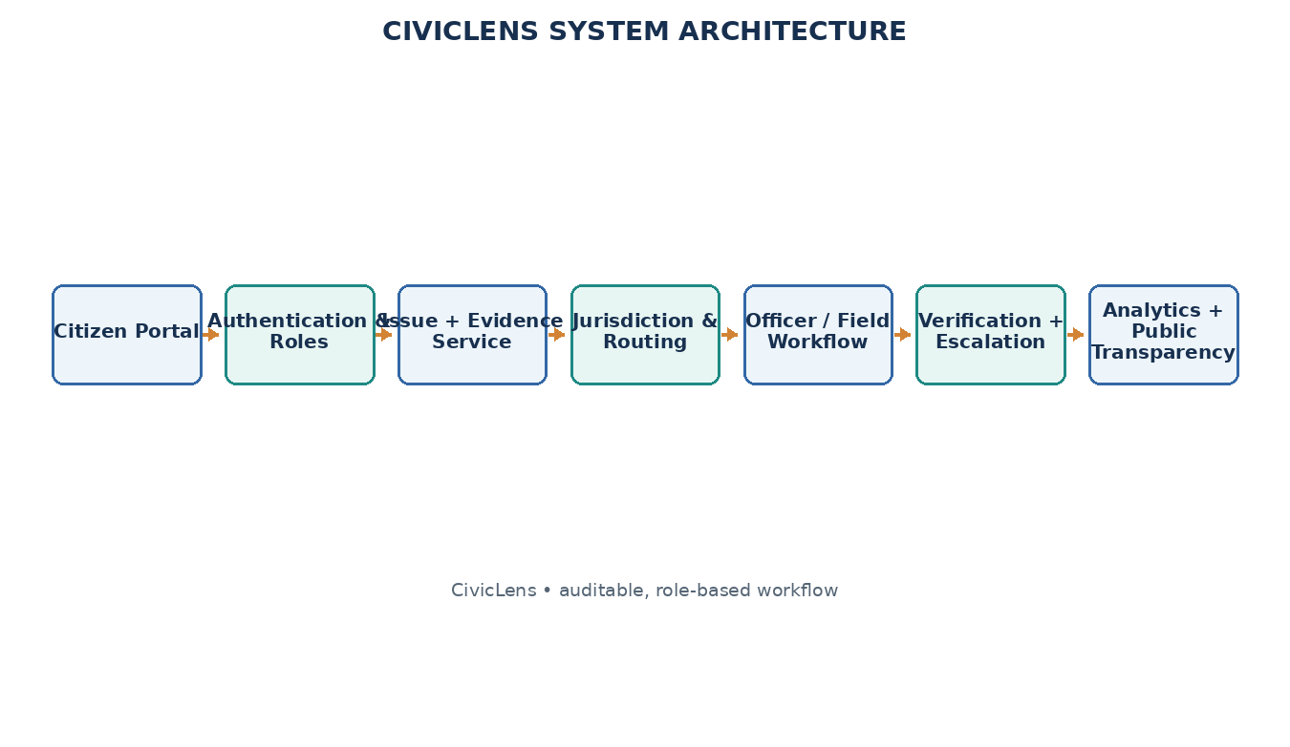

Figure 3.1 WASHWISE system architecture

3.18 Data Flow Diagram
Data handling should follow a predictable sequence. The report service first validates the submitted fields and creates the laundry order record. Evidence metadata is associated with the same issue identifier, while uploaded files are stored under access-controlled paths. The booking and workflow service reads the category and confirmed location, checks the pilot’s hostel allocation configuration and returns a suggested staff assignment together with a routing status. An officer action creates an assignment event. Subsequent laundry processing updates and collection claims are appended to the timeline. Student collection confirmation is stored as a separate event so that an staff assignment’s claim and a resident’s response can both be reviewed. Analytics queries should use approved fields and a clearly defined reporting period. They should exclude private contact data and avoid counting duplicate records as separate ready for collection outcomes when a duplicate relationship has been confirmed. These data-flow rules help the team demonstrate not only the visible interface but also the consistency of the underlying records.
The data flow diagram describes WASHWISE in terms of records and actions. The context diagram shows students, laundry staff and administrators interacting with the platform. Lower-level diagrams expand registration, slot booking, clothing intake, order processing, rack allocation, status updates, notifications and collection confirmation. The optional AI path accepts an image through the backend and returns suggestions to the application.

3.18.1 Level 0
The context diagram treats WASHWISE as one system and shows its external actors. Students submit reports and collection confirmation responses; officers receive assigned cases and return decisions or status updates; laundry staff members submit work notes and item/photo record; hostel administrations view oversight information; and administrators access role-controlled dashboards and source-labelled laundry records. The system returns laundry order IDs, timelines, notifications and aggregate information.
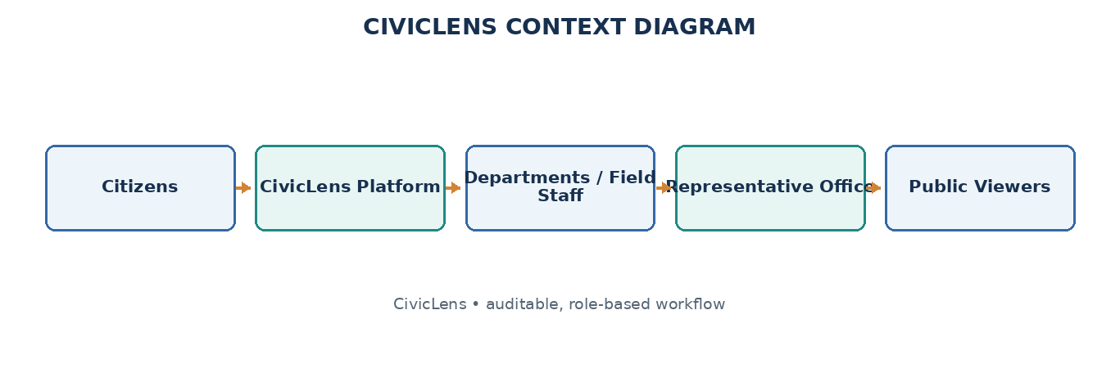
Figure 3.2 Laundry workflow data flow diagram – Level 0

3.18.2 Level 1
The first level decomposes WASHWISE into report intake, item/photo record/location validation, laundry workflow routing, laundry order workflow, field update handling, student collection confirmation and public analytics. The laundry order database stores the main record, while separate timeline events preserve the history of actions. Laundry System data remains a distinct domain and is associated only when a defensible link exists.
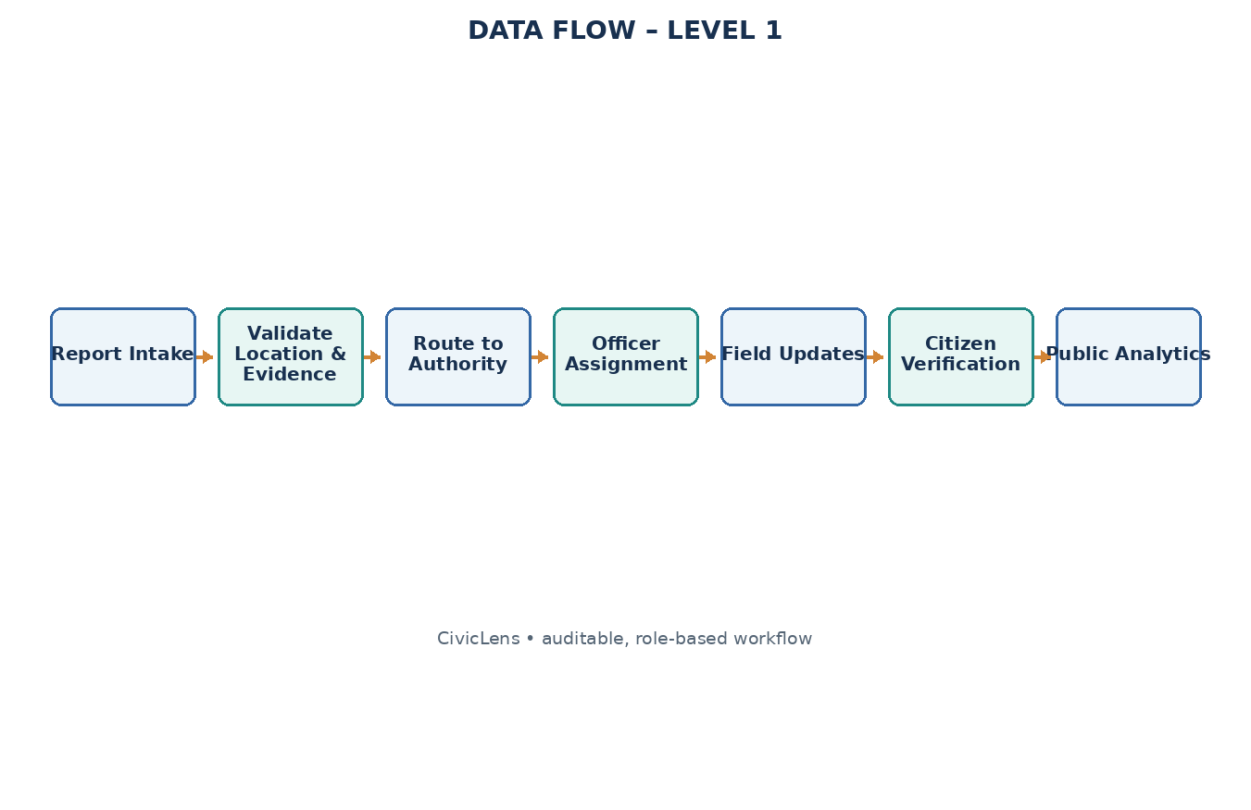

Figure 3.3 Laundry workflow data flow diagram – Level 1

3.18.3 Level 2
The second-level view expands the laundry order workflow into status validation, assignment updates and event recording. A submitted report is checked for completeness, assigned a unique identifier and routed according to configured rules. An officer can accept, reassign or request clarification; a laundry staff member records inspection or work item/photo record; and the collection claim triggers a student collection confirmation request.
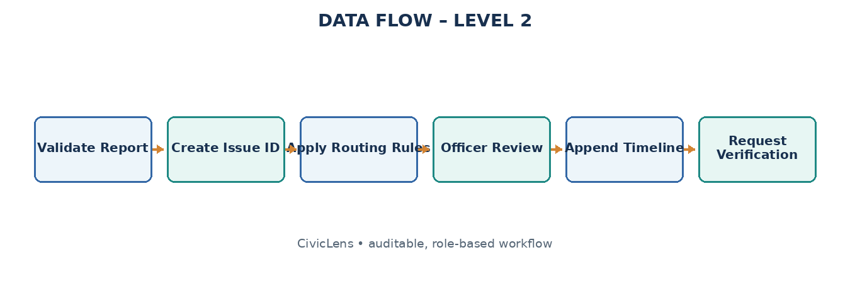

Figure 3.4 Laundry workflow data flow diagram – Level 2

3.19 Use Case Diagram
The primary actors are Student, Laundry Staff, Laundry Staff Member, Hostel Administration, Administrator and Public Viewer. Student use cases include submitting a report, tracking a laundry order, attaching item/photo record and verifying a collection. Officers manage assignments and status, laundry staff members update assigned tasks, hostel administrations monitor aggregate hostel issues, administrators configure the system, and administrators browse published information.
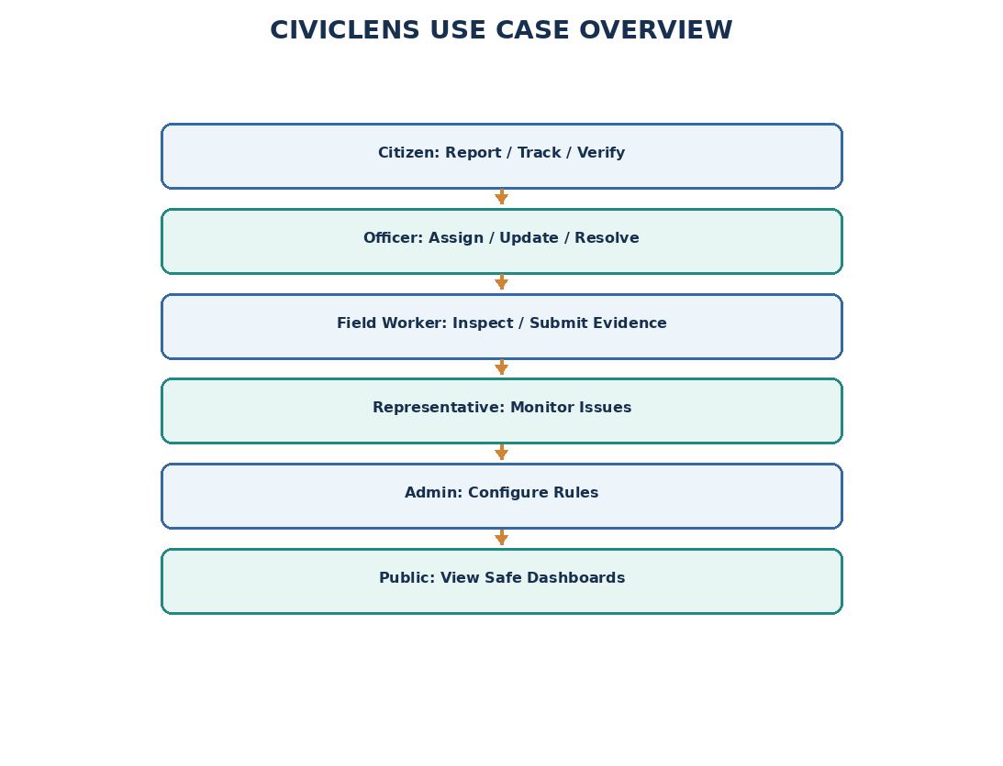
Figure 3.5 WASHWISE use case diagram

3.20 Activity Diagram
The activity flow begins when a student submits a laundry request. The system validates required details, creates a laundry order ID and applies booking and workflow rules. An officer reviews and assigns the case, a laundry staff member records inspection and progress, and the officer may mark the work ready for collection. The student then verifies the outcome. A partial or negative response sends the case back for review, reopening or staff review; verified closure contributes to aggregate analytics.
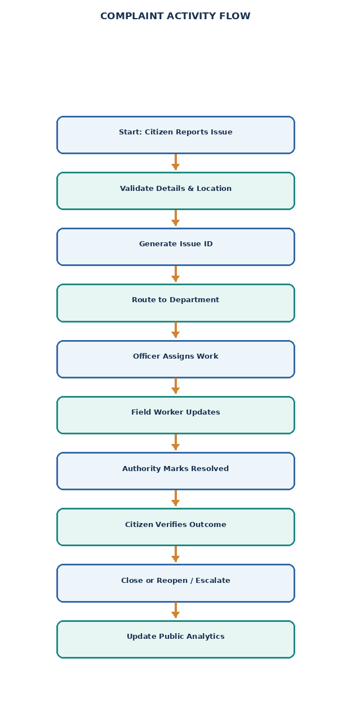
Figure 3.6 WASHWISE activity diagram

3.21 Overall System Diagram
The overall system diagram presents the student, staff assignment and public-information paths as parts of one platform. Student reporting creates the core laundry order record; officers and laundry staff members progress the laundry order; student collection confirmation closes or reopens the workflow; and the analytics layer produces maps and hostel summaries. Public laundry data is displayed with source and collection confirmation labels.
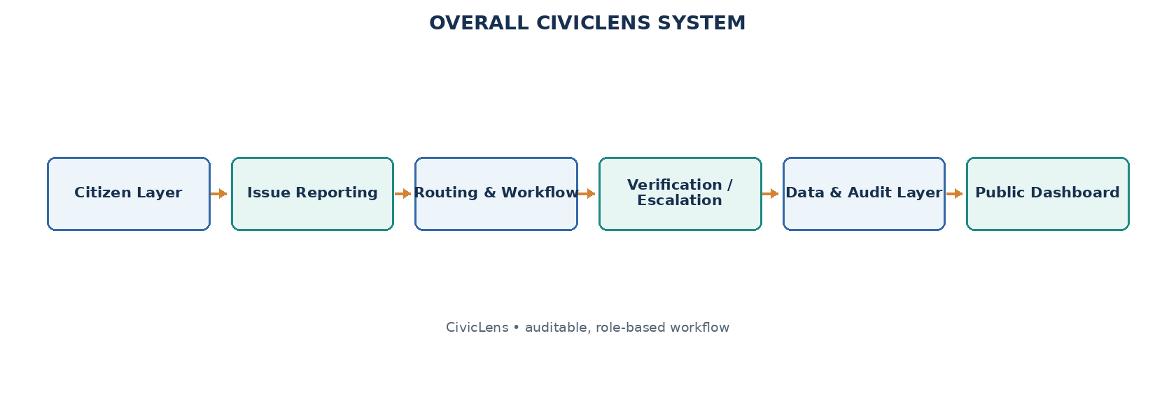
Figure 3.7 Overall WASHWISE system diagram

3.22 Core Conceptual Classes
The laundry order record should contain the minimum structured fields needed for routing and follow-up: a unique identifier, reporter reference, category, title, description, location, created timestamp, current status and privacy setting. Evidence should be represented separately so that access rules can differ from the general laundry order summary. Assignments should record the target laundry team, assigned officer or team, assignment time and any reassignment reason. Timeline events should be append-oriented: a later status must not erase the previous assignment, field update or student response. Verification records should include the selected outcome, optional comment, timestamp and associated laundry order. Escalation records should capture the trigger, destination, reason and review state. Public laundry systems and order records should remain separate entities, with source URL or document reference, reporting date, collection confirmation state and the fields actually available. This model avoids placing every concern in one oversized laundry order table and makes auditability easier to demonstrate.
The conceptual model includes User/Profile, Issue, IssueEvidence, Staff Assignment/Laundry Team, Assignment, TimelineEvent, StudentVerification, Escalation, Hostel Allocation, Laundry System, Laundry SystemFinancialRecord, Notification and AuditLog. The entities are linked by laundry order identifiers and role-controlled references. Table 3.1 summarizes representative classes and responsibilities.
Table 3.1 Core WASHWISE data entities
Class | Representative attributes | Representative methods
User / Profile | userId, role, contact preferences | register(), authenticate(), updateProfile()
Issue / Laundry Order | issueId, category, description, location, status | createIssue(), updateStatus(), getTimeline()
IssueEvidence | item/photo recordId, issueId, fileType, storagePath | attachEvidence(), validateEvidence()
Staff Assignment / Laundry Team | staff assignmentId, categoryRules, hostel allocationId | processOrder(), acceptAssignment(), reassign()
Assignment / TimelineEvent | assignmentId, actorId, timestamp, eventType | assignWork(), appendEvent()
StudentVerification | collection confirmationId, issueId, outcome, comments | submitVerification(), reopenIfRequired()
Laundry System / FinancialRecord | laundry systemId, agency, amount, source, status | validateSource(), updateLaundry SystemRecord()

CHAPTER 4

METHODOLOGY AND PROJECT DESCRIPTION

4.1 General
The Phase I method followed a structured design sequence: understand student and staff needs, define the laundry-tracking gap, select the smallest useful feature set, design the application architecture and data model, specify requirements, and plan prototype testing. The initial target is a hostel laundry workflow with student access, booking, staff intake, status tracking and collection records. AI-assisted clothing analysis is treated as an optional extension rather than a dependency for core booking.

4.2 Requirement Analysis
The requirements establish clear rules for access to student and laundry data. Students should see their own bookings and order details, while staff should see only the information needed to manage assigned hostel operations. Administrative access should be role-controlled. The application should distinguish required and optional fields, provide clear error messages, and allow a student to review a booking before submission. If the AI service cannot respond, the order workflow should continue and staff should be able to enter counts manually.
Requirements were derived from the reported pain points: uncertainty about responsibility, fragmented progress information, disputed collection claims and limited visibility into recurring issues. The proposed system must collect sufficient information for action without making reporting burdensome. It must also distinguish private case details from public aggregates and keep sample laundry data clearly labelled.

4.3 Functional Requirements
The main functional obligations are to authenticate users, provide hostel selection, display available laundry slots, create bookings, record clothing intake and counts, maintain a order timeline, support staff updates, assign rack locations, notify students when orders are ready, confirm collection, and optionally submit clothing images for AI-assisted classification.
Table 4.1 Functional requirements
ID | Requirement
FR1 | The system shall authenticate users and apply permissions according to the assigned role.
FR2 | The system shall accept a laundry report with category, title, description and confirmed location.
FR3 | The system shall allow optional photo/video item/photo record and store item/photo record metadata against the laundry order ID.
FR4 | The system shall generate a unique laundry order identifier and an initial status.
FR5 | The system shall suggest a responsible staff assignment using category and configured hostel allocation rules.
FR6 | The system shall allow authorized officers to accept, reassign or request clarification.
FR7 | The system shall maintain a timestamped timeline for assignment, work updates and status changes.
FR8 | The system shall allow laundry staff members to submit inspection notes and progress/completion item/photo record.
FR9 | The system shall request student collection confirmation when an staff assignment marks a laundry order ready for collection.
FR10 | The system shall support reopening or staff review when a student reports partial or unsuccessful collection.
FR11 | The system shall present role-controlled maps and hostel analytics from stored records.
FR12 | The system shall display laundry process and expenditure information only with source/collection confirmation labels or sample-data labels.
FR13 | The system shall record important actions in an audit trail and restrict access to private records.

4.4 Non-Functional Requirements
Non-functional requirements include usability, accessibility, privacy, traceability, reliability, maintainability and affordability. The system should be responsive on mobile devices, work with free-tier services or local deployment, explain routing decisions and maintain an audit trail for important actions. Public metrics must identify their period, source and limitations.
Table 4.2 Non-functional requirements
Requirement | Description
Usability | Clear categories, minimal typing, mobile-friendly reporting and understandable status labels.
Accessibility | Readable controls, Tamil/English examples and voice-assisted input where supported.
Privacy | Hide personal contact details and sensitive item/photo record from public views.
Traceability | Timestamp important actions and retain assignment, collection confirmation and staff review history.
Reliability | Validate required fields and preserve laundry order history across reassignment and reopening.
Explainability | Show routing rationale and make priority rules inspectable.
Affordability | Avoid paid APIs and services as mandatory dependencies.
Maintainability | Separate reporting, routing, workflow, collection confirmation and analytics modules.

4.5 Technology Selection
The selected tools are recommendations for the intended prototype rather than a claim that every service has already been deployed. The final report should record the actual versions, environment variables, database policies and deployment configuration used by the team. Secrets such as database service keys must remain on the server and must never be embedded in public client code or committed to the repository. Database access policies should be tested with separate student, officer, field-worker and public-viewer accounts. If hosted services are unavailable during a demonstration, a controlled local dataset can be used, provided it is clearly labelled and the demonstration does not imply a live connection to a hostel system. The laundry system should keep its core laundry order workflow functional even if the optional assistant or external notification mechanism is disabled.
Technology choices are guided by the need for a practical student prototype and a deployable web/mobile application. React with Vite supports the frontend; Node.js and Express provide REST API routes; Prisma connects the backend to PostgreSQL; Render hosts the backend and database; Vercel hosts the web frontend; Capacitor packages the frontend for Android; and an optional Python Flask service provides the AI endpoint. The core workflow should not depend on AI being available.
Table 4.3 Technology stack
Component | Technology | Role
Frontend | React + Vite | Responsive student portal and role-based dashboards.
Database | PostgreSQL on Render PostgreSQL / PostgreSQL | Store users, issues, assignments, timeline, collection confirmation and laundry records.
Authentication | PostgreSQL on Render Auth or equivalent | Sign-in and role-controlled access.
File storage | PostgreSQL on Render Storage or local demo storage | Store optional issue item/photo record with access policies.
Maps | React interface + Capacitor | Show issue markers, filters and recurring locations.
Analytics | dashboard charts / dashboard charts + database queries | Visualize category counts, status and recurring trends.
AI fallback | Rule-based logic; optional open-source model | Explain status and suggest categories without mandatory paid APIs.

Table 4.4 summarizes why each selected technology fits the prototype constraints. The stack is illustrative and can be adapted to the team’s actual implementation, provided the report clearly distinguishes proposed components from components already integrated.
Table 4.4 Technology selection rationale
Technology | Reason for selection
React / Vite | Supports reusable, responsive interfaces and can combine frontend routes with server-side functions.
CSS | Enables consistent responsive styling with a small design system.
PostgreSQL on Render PostgreSQL | Provides relational storage suitable for connected laundry order, assignment and audit records.
PostgreSQL on Render Auth | Offers a practical authentication option for a student prototype.
React interface + Capacitor | Supports order-based issue views without requiring a paid mapping API.
dashboard charts / dashboard charts | Provides charts for status, category and recurring-issue summaries.
Rule-based routing | Is explainable, easy to test and can be corrected by authorized officers.

4.6 System Modules
WASHWISE is organized into connected modules rather than separate mini-laundry systems. Authentication establishes role boundaries; hostel and slot management controls availability; booking records student requests; intake records item counts; order tracking coordinates processing; rack allocation records storage locations; notifications communicate important updates; and optional AI analysis suggests clothing categories from an uploaded image. AI and notifications enhance the core journey but are not prerequisites for manual laundry tracking.
Table 4.5 System module descriptions
Module | Description
Authentication & Role Management | Controls access for students, officers, laundry staff members, hostel administrations, administrators and administrators.
Laundry Issue Reporting | Captures category, description, location, impact and optional item/photo record; returns a unique laundry order ID.
Location & Laundry Workflow Routing | Uses category and configured hostel allocation rules to suggest the responsible staff assignment, with manual review.
Laundry Order Tracking & Timeline | Records submission, assignment, acknowledgement, work updates, collection and collection confirmation events.

4.6.1 Laundry Issue Reporting Module
The reporting module collects category, title, description, location, impact and optional item/photo record. Required fields are validated before submission and the user receives a unique laundry order ID. The interface should be mobile-friendly, minimize typing and allow the student to review the report before it is sent.

4.6.2 Laundry Workflow Routing and Laundry Order Tracking Module
The staff assignment and hostel allocation module combines the clothing category with the configured pilot-area rules to suggest a responsible laundry team. It displays the routing result and allows authorized review or reassignment when the mapping is uncertain. Changes are recorded so that the original routing decision remains traceable.

4.6.3 Student Verification and Transparency Module
The workflow and assistance module presents the laundry order timeline, status definitions and next expected step. A simple rule-based assistant can explain how to report a problem, interpret status terms or summarize a case. Optional AI must remain grounded in stored records and must not make administrative decisions.

4.6.4 Workflow and Analytics Module
The collection confirmation and transparency module records the student’s response after an staff assignment marks a case ready for collection. Partial or negative collection confirmation can trigger review, reopening or staff review. Aggregated records feed laundry tracking views and dashboards, while laundry order and item-count details are shown only with source and collection confirmation information.

4.7 Laundry Order Status and Action Mapping
Each report follows an explicit status path such as Submitted, Under Verification, Assigned, Acknowledged, In Progress, Resolved, Awaiting Student Verification, Reopened, Escalated or Closed. Status transitions are controlled by role permissions and logged with timestamps. A claimed collection is not silently treated as student-verified closure.
Table 4.6 Mapping of user actions to workflow outcomes
User / event | Recognized input | System action
Student report | Category, description and location | Create laundry order ID and submit report
Evidence attachment | Photo/video selected by student | Validate and associate item/photo record with issue
Routing engine | Issue category + hostel allocation | Suggest laundry team and record routing rationale
Laundry Team officer | Accept / reassign / request clarification | Update assignment and append timeline event
Field worker | Inspection note / progress photo | Record work update and item/photo record
Staff Assignment collection claim | Mark work ready for collection | Set awaiting student collection confirmation and notify student
Student collection confirmation | Completely / Partially / Not Resolved | Close after collection confirmation or reopen/escalate for review
Escalation rule | Overdue or disputed case | Route to authorized oversight layer and preserve history
Public dashboard | Approved aggregate laundry order records | Update map, category/status metrics and recurring hotspots
Laundry System transparency | Source-verified or labelled sample record | Display laundry system status, funding details and provenance
Public viewer | Filter by area, category, status and period | Show role-controlled published information
Administrator | Category, hostel allocation or role change | Update configuration with audit record
WASHWISE Assistant | Question about process/status | Provide grounded rule-based explanation from available information
Data unavailable | No verified financial/laundry system source | Display unavailable rather than fabricate a value

4.8 Module Integration
A typical end-to-end scenario illustrates how the modules interact. A resident reports a pothole, selects Roads, confirms the map location and attaches a photograph. The system validates required fields and creates an issue identifier. The hostel allocation rules suggest the relevant laundry racks staff assignment and show that routing decision in the issue details. An authorized officer reviews the report, accepts or corrects the assignment and allocates a field task. The laundry staff member records an inspection note and later adds a completion update. The officer marks the work ready for collection, which moves the laundry order into an awaiting-collection confirmation state rather than directly hiding it from the student’s list. The resident can confirm the result or select partially ready for collection or not ready for collection. A disputed case remains visible to authorized reviewers and can be reopened or escalated under the configured rules. Only the resulting approved records are aggregated into staff dashboards. This scenario is also a useful integration test because it exercises identity, role permissions, routing, item/photo record metadata, timeline history, collection confirmation and analytics together.
Integration depends on shared laundry order identifiers and consistent role permissions. The reporting module creates the core record; routing stores the suggested and confirmed staff assignment; officer and field-worker actions append timeline events; collection confirmation updates the case state; and analytics read approved fields from the underlying records. Public laundry records remain separate until a source-supported association is entered.
Two integration concerns require special care. First, routing can be wrong when boundaries or laundry team responsibilities are incomplete, so manual correction and audit history are necessary. Second, student collection confirmation may conflict with an staff assignment’s collection claim, so the platform must preserve both events and route disputes for review instead of overwriting one side.

4.9 System Configuration
For demonstration purposes, each role should be tested with a separate account and a defined set of permissions. A student should not be able to edit another person’s laundry order or view private attachments belonging to an unrelated case. A laundry staff member should only see assigned tasks and should not change hostel allocation rules. An officer should manage records within the configured laundry team scope, while a representative-office account should see oversight summaries without being able to claim that the laundry team’s work has been completed. An administrator can configure categories and hostel allocation mappings, but important configuration changes should still be logged. A administrator should have read-only access to published summaries and source-labelled laundry system information. These role distinctions should be reflected in the database policies and server-side checks, not just in navigation menus. During evaluation, the team should demonstrate both an allowed action and a denied action for each sensitive role boundary. This provides a simple, understandable proof that the prototype treats privacy and accountability as system requirements rather than visual design choices.
The report describes a free-first configuration suitable for a student prototype. Hardware needs are limited to an internet-enabled computer and a smartphone or camera for collecting demonstration item/photo record. The software configuration may use a modern browser, Node.js or Python backend, PostgreSQL/PostgreSQL on Render, Git and GitHub. Actual versions should be recorded after the implementation environment is finalized.
Table 4.7 Hardware configuration
Component | Specification
Processor | Standard laptop/desktop capable of running a modern browser
RAM | 4 GB minimum recommended for local development; more may improve comfort
Storage | Sufficient space for source code, database tools and sample item/photo record
Internet | Required for hosted development/deployment; local demonstration can use local services
Camera / phone | Optional device for collecting demonstration photos of laundry requests
Display | Desktop or mobile screen for responsive-interface testing

Table 4.8 Software configuration
Component | Specification
Operating system | Windows, Linux or macOS
Frontend | React / Vite and CSS
Backend | Vite server routes or Node.js / FastAPI
Database / authentication | PostgreSQL on Render PostgreSQL and Auth, or local PostgreSQL

4.10 Feasibility Study
The scope can be controlled through a staged implementation. The first milestone is a working student report form, database schema and unique laundry order ID. The second adds configured laundry workflow routing and the officer’s assignment queue. The third connects field-worker updates to the timeline and adds student collection confirmation. The fourth introduces laundry tracking views and analytics, followed by source-labelled laundry records. This order is important because the staff dashboard depends on consistent and trustworthy underlying records. Building advanced visualizations before the laundry order lifecycle is stable would create a polished interface without reliable information. A single pilot geography and a small set of categories also make it easier to validate booking and workflow rules, create realistic demonstration records and explain limitations during evaluation. The laundry system should use synthetic or approved sample data where real records are unavailable and should never present seeded values as live hostel statistics.
Feasibility was considered across cost, technical implementation and social adoption. The core functions can be demonstrated with widely available web technologies and a limited pilot dataset. The most important constraints are not expensive hardware but accurate hostel allocation configuration, realistic workflow design, data quality, privacy and stakeholder validation.

4.10.1 Economical Feasibility
The economic feasibility is favorable because the recommended stack uses open-source libraries and free service tiers for a limited prototype. Costs may arise if usage exceeds free limits, if paid notifications are introduced or if production hosting is required. The design therefore avoids paid services as mandatory dependencies and supports local demonstration with labelled sample data.

4.10.2 Technical Feasibility
The technical scope is achievable using common web development tools. The team can implement the reporting form, role-based dashboards, database entities, rule-based routing and status transitions incrementally. Mapping and analytics can be added after the laundry order workflow is stable. Official datasets and hostel allocation boundaries may require additional validation before the system can be used outside a controlled demonstration.

4.10.3 Social Feasibility
Social feasibility depends on whether students understand the categories, status labels and collection confirmation step. Tamil and English examples, readable controls, minimal typing and optional assisted reporting can reduce barriers. Laundry Team officers and laundry staff members need concise work queues, while hostel administrations should receive oversight information without being represented as the executing staff assignment.

4.11 Testing Methodology
A practical acceptance dataset should include ordinary and exceptional scenarios. Ordinary cases can cover a laundry rack defect, uncollected garbage, drainage overflow, water-supply interruption and a broken streetlight. Exceptional cases should include a report with missing location, a possible duplicate, an issue near a hostel allocation boundary, a laundry team reassignment, a long-pending laundry order, a student who rejects a collection claim and a laundry system record without a verifiable financial source. For each case, the expected result should be documented before execution. Test item/photo record can include screenshots, database records and the event timeline, but personal details should be masked in material used for public demonstrations. Defects should be logged with severity and steps to reproduce. A successful visual demonstration is not sufficient on its own: the team should also confirm that the underlying status and audit records are correct, that unauthorized roles cannot change protected data, and that public totals match the records included in the selected reporting period.
Testing should be planned at module, integration, functional and system levels. Because the supplied documents describe the concept and selected modules rather than verified live hostel integration, the report must not claim production validation. Tests should use clearly labelled sample records and confirm that role permissions, routing, status history, student collection confirmation and privacy boundaries behave as specified.

4.11.1 Unit Testing
Unit testing can validate category checks, laundry order-ID generation, hostel allocation lookup, status-transition rules and data formatting independently. Fixed sample records should cover valid submissions, missing fields, unsupported categories and uncertain routing. A unit test passes only when the observed output matches its documented expectation.

4.11.2 Integration Testing
Integration testing should focus on module boundaries: report creation to routing, routing to officer assignment, laundry processing updates to the timeline, collection claims to student collection confirmation, and approved records to public analytics. It should also confirm that private item/photo record and contact information do not leak into public endpoints.

4.11.3 Functional Testing
Functional testing checks each requirement from the user’s perspective. A student should be able to submit and track a report; an officer should be able to assign and update it; a laundry staff member should be able to attach progress item/photo record; and a student should be able to confirm or dispute a claimed collection. Public dashboard figures should match the underlying demonstration records.

4.11.4 System Testing
System testing exercises the complete journey from report creation through assignment, field update, collection claim, student collection confirmation and dashboard aggregation. Additional scenarios should include an incorrect staff assignment assignment, a duplicate report, an overdue case, a disputed closure and unavailable laundry data.

4.11.5 White Box and Black Box Testing
White-box testing examines booking and workflow rules, role checks, status transitions and data transformations. Black-box testing submits realistic laundry scenarios through the user interface and verifies the displayed result. Security and privacy checks should confirm that users cannot modify records outside their permissions and that public pages hide personal details.
The test cases in Table 4.9 define the expected behavior for the proposed prototype. Results should be marked Pass only after execution in the actual build; until then, they are acceptance criteria rather than item/photo record of completed testing.
Table 4.9 Prototype acceptance test cases
Test | Input | Expected output | Result
Report validation | Report missing required category or location | Clear validation message; no incomplete issue created | To be tested
Issue creation | Valid report with category and location | Unique laundry order ID and initial status displayed | To be tested
Staff Assignment routing | Road laundry order in configured pilot area | Mapped staff assignment suggested with routing status | To be tested
Manual reassignment | Officer changes suggested staff assignment | New assignment recorded; prior event retained | To be tested
Field update | Assigned laundry staff member submits note/item/photo record | Timeline updated with actor and timestamp | To be tested
Student collection confirmation | Staff Assignment marks case ready for collection | Student receives Completely / Partially / Not Resolved choices | To be tested
Disputed collection | Student selects Not Resolved | Case reopens or enters authorized review path | To be tested
Escalation | Case exceeds configured response timeline | Escalation event recorded and visible to authorized roles | To be tested
Public privacy | Open public order tracking dashboard | No private phone number, address or sensitive item/photo record exposed | To be tested
Laundry System source | Laundry System record has no reliable source | Data shown as unavailable or labelled sample, never fabricated | To be tested
Analytics consistency | Known sample laundry order dataset | Dashboard counts match approved underlying records | To be tested
Role permissions | User attempts action outside assigned role | Action denied and unauthorized access prevented | To be tested
Recurring issue | Several similar reports in one location | Location/category hotspot identified for review | To be tested

4.12 Initial Results
The Phase I outcome is a defined WASHWISE concept, a reduced twelve-module scope, a role model, an end-to-end workflow, a proposed free-first architecture and a testable set of functional requirements. The design connects student reporting with laundry workflow routing, laundry order timelines, field work, student collection confirmation, staff review, recurring-issue analytics and laundry process transparency.
The system is intended to demonstrate how the core workflow can be implemented using a modest web stack. Its success should be evaluated through routing correctness, successful completion of the report journey, clarity of timeline information, proper handling of disputed closures and consistency between public metrics and the source records. No live hostel integration or measured impact is claimed by this report.

4.13 Challenges
- Data quality: incomplete descriptions, inaccurate locations and duplicate reports can reduce the usefulness of routing and analytics.
- Hostel Allocation mapping: administrative boundaries and laundry team responsibilities must be configured for the pilot area and reviewed by a knowledgeable source.
- Verification disputes: staff assignment collection claims and student feedback may conflict and require an auditable review path.
- Privacy: images, contact information and precise locations must be protected through role-based access and careful public display.
- Public-data provenance: laundry system budgets and expenditure values must be traceable, dated and labelled as official, staff assignment-submitted, student-reported or unavailable.
- Adoption: students and officers may not use the workflow unless the interface is simple and the operational benefit is clear.
- Scope control: advanced prediction, blaundry rack integrations and multi-hostel deployment should not delay a stable core prototype.
- Accountability fairness: laundry team execution and representative oversight must be measured separately, with clear definitions and limitations.

CHAPTER 5

CONCLUSIONS AND FUTURE ENHANCEMENTS FOR PHASE II

5.1 Conclusion
WASHWISE proposes a student-centric laundry accountability platform that connects local issue reporting with laundry workflow routing, transparent tracking, laundry processing updates, student collection confirmation, staff review and laundry information. It goes beyond laundry order registration by preserving the full lifecycle and showing how recurring issues are distributed across a hostel. A separate laundry system-transparency layer can connect laundry problems to relevant development laundry systems and expenditure records when reliable data is available.
The Phase I work establishes the problem definition, design-thinking framing, literature foundation, user roles, system architecture, data model, functional and non-functional requirements, technology choices, module specifications, workflow diagrams and testing plan. The laundry system prioritizes a manageable free-first prototype and explicitly separates proposed features from validated implementation. Public metrics are intended to be item/photo record-based, role-controlled and transparent about their sources and limitations.

5.2 Current Phase-I Status
- Laundry problem and user needs defined from the supplied ideation and concept documents.
- Twelve core modules selected and grouped into one connected reporting-to-accountability workflow.
- User roles and access boundaries specified for students, officers, laundry staff members, hostel administrations, administrators and administrators.
- Laundry Order reporting fields, unique ID and item/photo record-handling requirements documented.
- Category- and hostel allocation-based laundry workflow routing with manual review and audit history specified.
- Laundry Order timeline, officer assignment and field-worker update flow documented.
- Student collection confirmation, reopening and staff review behavior defined.
- Public laundry tracking dashboard, recurring-issue analytics and hostel dashboard scope established.
- Laundry System and expenditure transparency fields, source labels and sample-data safeguards documented.
- Free-first technology stack and optional AI/rule-based fallback specified.
- System architecture, data entities, role model and end-to-end workflow described.
- Acceptance test scenarios prepared for reporting, routing, status updates, collection confirmation, privacy and analytics.
- Prototype execution, stakeholder validation and quantitative usability evaluation remain future work unless separately item/photo recordd.

5.3 Limitations
The proposed platform cannot independently guarantee that a reported issue is genuine, that a laundry team’s hostel allocation mapping is correct or that a laundry process record is complete. Photo item/photo record can be outdated or unrelated, a location can be imprecise, and a student may not respond to a collection confirmation request. The system therefore supports item/photo record review and administrative judgement rather than replacing them. The prototype also depends on the availability of laundry process information and cannot infer actual expenditure from a laundry order or a map marker. Performance indicators require defined periods, denominators and exclusion rules; without those definitions, comparisons between areas or laundry teams may be misleading. These limitations should be shown during the laundry system presentation and revisited during pilot evaluation.
The report describes a design and prototype specification, not a verified production service. Routing depends on correct pilot geography and laundry team mappings; order status indicators depend on location accuracy; analytics depend on the quality and completeness of stored records; and laundry process transparency depends on reliable source data. The initial system also excludes blaundry rack hostel integrations and advanced predictive models. These limits should be made explicit during demonstration.

5.4 Phase-II Objectives
The next phase should produce item/photo record for each major claim made in the demonstration. A routing test should record the expected staff assignment, actual suggestion and whether manual correction was needed. A timeline test should confirm that events appear in chronological order and that reassignment does not erase earlier actions. A collection confirmation test should demonstrate all three student outcomes and confirm that a disputed case remains available for review. A privacy test should inspect public pages and API responses, not only the visible interface. An analytics test should compare dashboard totals with a known set of sample records and document the rules for duplicates, reopened cases and reporting periods. Finally, user evaluation should ask participants to complete realistic tasks and describe whether they understand the responsible staff assignment, the latest action and the next expected step. The results can guide changes to labels, navigation and workflow before the laundry system is expanded to more categories or areas.
- Complete the student reporting and authentication flow with a working database and unique laundry order identifiers.
- Implement hostel allocation-aware routing, officer assignment and a timestamped laundry order timeline.
- Build field-worker task updates with notes and optional item/photo record upload.
- Implement student collection confirmation with completely ready for collection, partially ready for collection and not ready for collection outcomes.
- Add reopening, staff review and overdue-case handling with preserved history.
- Build a public laundry tracking dashboard with category, status and date filters.
- Create hostel dashboards with recurring-location and status analytics based on stored records.
- Implement the laundry process module with source metadata and clearly labelled sample data.
- Add in-app notifications for submission, assignment, status changes, collection confirmation requests and staff review.
- Introduce an optional WASHWISE Assistant using rule-based responses first, with model assistance only if safely grounded in stored records.
- Conduct usability tests with students and role-based test accounts using realistic scenarios.
- Validate the hostel allocation configuration against authoritative administrative information for the chosen pilot area.
- Test role permissions, audit logs, privacy boundaries and public-data consistency.
- Refine Tamil/English accessibility, mobile layout, readable status labels and minimal-typing flows.
- Measure reporting completion, routing correction rate, timeline comprehension and student-collection confirmation completion in a controlled evaluation.
- Evaluate recurring-issue grouping and duplicate hints against a labelled sample dataset.
- Prepare deployment documentation, a demonstration dataset and final laundry system report with limitations clearly stated.

5.5 Future Enhancements
Future evaluation should focus on whether the platform makes the process clearer and more usable, rather than assuming that digitization automatically improves governance. Suggested measures include the percentage of users who can submit a complete report without assistance, the percentage who correctly identify the responsible laundry team after seeing the routing result, the time needed to locate the latest laundry order update, the proportion of collection claims receiving student feedback, and the frequency with which routing needs manual correction. Dashboard evaluation should check whether viewers understand the difference between submitted, staff assignment-marked-ready for collection and student-verified cases. The public-money feature should be reviewed for source completeness and for the risk of implying a financial relationship that the available records do not support. A small usability study can combine task completion, observation and participant feedback. These measures would provide a more defensible basis for refining WASHWISE than relying only on feature counts or visual polish.
Future work is grouped into three areas. The first completes the core workflow: role-based access, reporting, routing, status tracking, laundry processing updates, student collection confirmation and staff review. The second strengthens transparency through maps, recurring-issue analytics, source-labelled laundry records and role-controlled dashboards. The third adds optional enhancements such as notifications, Tamil/English support and a rule-based WASHWISE Assistant. Any AI-assisted classification or summarization should be evaluated against labelled examples and should never replace authorized administrative decisions.

5.6 Phase-II Work Schedule
Table 5.1 Future enhancements
Phase | Planned activity | Expected outcome
Phase II – Core workflow | Complete authentication, reporting, unique IDs, database and order timeline. | Working end-to-end laundry order creation and tracking.
Phase II – Routing and assignments | Configure pilot hostel allocation rules, officer work queues and field-worker updates. | Traceable ownership and field progress.
Phase II – Verification | Implement student collection choices, reopening and staff review. | Disputed closures preserved for review.
Phase II – Public transparency | Build order tracking dashboard, recurring analytics and hostel dashboard. | Privacy-safe view of laundry patterns.
Phase II – Laundry System records | Add source-labelled laundry process and expenditure records. | Transparent provenance and explicit unavailable values.
Phase II – Accessibility | Refine mobile layouts, Tamil/English content and low-typing flows. | More inclusive reporting experience.
Phase II – Notifications | Add in-app updates for assignment, status changes and collection confirmation requests. | Users can follow important events.
Phase II – Validation | Test role permissions, routing, privacy, usability and data consistency. | Evidence for prototype quality and limitations.

REFERENCES
[1] Hostel of India. Centralized Public Laundry Request Redress and Monitoring System (CPGRAMS). Official portal and process information. https://pgportal.gov.in/
[2] React interface contributors. React interface: collaborative geographic data and mapping laundry system. https://www.openstreetmap.org/
[3] Capacitor. Capacitor JavaScript library for interactive maps. https://leafletjs.com/
[4] PostgreSQL on Render. Documentation: PostgreSQL database, authentication and storage. https://supabase.com/docs
[5] United Nations. Sustainable Development Goal 11: Sustainable Cities and Communities. https://sdgs.un.org/goals/goal11
[6] United Nations. Sustainable Development Goal 16: Peace, Justice and Strong Institutions. https://sdgs.un.org/goals/goal16
[7] World Bank. GovTech: putting people first in public service delivery. World Bank GovTech resources. https://www.worldbank.org/en/programs/govtech
[8] React. React documentation. https://react.dev/
[9] Vite. Vite documentation. https://nextjs.org/docs

CO–SDG RELEVANCE RECORD

Laundry System Title : WASHWISE – SMART HOSTEL LAUNDRY MANAGEMENT SYSTEM
Batch Members : Mohamad Fayas N (241701031)
Sivaram G (241701054)
Supervisor : Dr. P. REVATHY, Ph.D.

SDG (No. & Theme) | Addressed COs | Topic/Activity addressing SDG Theme
SDG 9 – Industry, Innovation and Infrastructure | CO2, CO4 | Uses web technologies, mapping and structured data to make laundry service information more accessible.
SDG 11 – Sustainable Cities and Communities | CO1, CO3, CO4 | Helps residents report local infrastructure and service issues and observe recurring problem locations.
SDG 16 – Peace, Justice and Strong Institutions | CO1, CO3, CO5 | Supports transparent workflows, traceable actions, student collection confirmation and accountable laundry information.
SDG 17 – Partnerships for the Goals | CO2, CO4, CO5 | Encourages structured information exchange between students, service laundry teams and public oversight roles.

Signature of the Supervisor
COURSE OUTCOMES
CO1: Analyse laundry-management delivery problems and define requirements for a transparent, student-centred laundry order lifecycle.
CO2: Design a web-based reporting and staff assignment-routing workflow using structured data, hostel allocation rules and role-based access.
CO3: Develop traceable laundry order tracking, field-worker updates, student collection confirmation and staff review processes.
CO4: Apply geographic visualization and descriptive analytics to identify recurring laundry requests and present hostel-level information.
CO5: Evaluate usability, data quality, privacy, fairness and transparency, and identify limitations and future validation work.

PROGRAM OUTCOMES
PO | Outcome | Description
PO1 | Engineering Knowledge | Apply computing and software-engineering knowledge to design a structured laundry information system.
PO2 | Problem Analysis | Analyse reporting, routing, collection confirmation and transparency gaps using stakeholder needs and documented requirements.
PO3 | Design / Development of Solutions | Design role-based workflows, laundry order lifecycle and dashboards that address laundry-management needs.
PO4 | Conduct Investigations of Complex Problems | Plan tests for routing, privacy, status transitions and consistency of analytics using controlled sample data.
PO5 | Modern Tool Usage | Use modern web frameworks, databases, mapping libraries and version-control tools while recognizing their limits.
PO6 | The Engineer and Society | Consider student access, public accountability, privacy and fairness in the handling of laundry reports.
PO7 | Environment and Sustainability | Support visibility of infrastructure and environmental-service issues such as drainage, waste and laundry facilities.
PO8 | Ethics | Use source provenance, role permissions, audit history and non-partisan reporting principles.
PO9 | Individual and Team Work | Collaborate across interface design, backend workflow, data configuration, testing and documentation.
PO10 | Communication | Present technical decisions, laundry order status and laundry information in clear language.
PO11 | Laundry System Management and Finance | Prioritize a limited pilot scope and plan implementation phases within free-tier constraints.
PO12 | Life-long Learning | Evaluate new laundry technology, accessibility practices and open-data methods as the laundry system evolves.

PROGRAM SPECIFIC OUTCOMES
PSO | Area | Description
PSO1 | Computing Foundations | Apply programming, database and software design techniques to implement connected laundry workflow modules.
PSO2 | HCI and Digital Experience Design | Design accessible student reporting and role-based dashboards around user needs.
PSO3 | Research, Innovation and Professional Growth | Identify a laundry-management design gap and evaluate a prototype using structured requirements and tests.
PSO4 | Inclusive and Accessible System Design | Use readable, mobile-friendly, privacy-aware interfaces and simple reporting flows for diverse users.

CO–PO–PSO MAPPING

Laundry System Title : WASHWISE – SMART HOSTEL LAUNDRY MANAGEMENT SYSTEM
Batch Members : Mohamad Fayas N (241701031)
Sivaram G (241701054)
Supervisor : Dr. P. REVATHY, Ph.D.

CO | PO1 | PO2 | PO3 | PO4 | PO5 | PO6 | PO7 | PO8 | PO9 | PO10 | PO11 | PO12 | PSO1 | PSO2 | PSO3 | PSO4
CO1 | 3 | 3 | 3 | 3 | 3 | 3 | 2 | 2 | -- | 2 | -- | 2 | 3 | 2 | -- | --
CO2 | 3 | 3 | 3 | 3 | 3 | 3 | 2 | 2 | -- | 2 | -- | 2 | 3 | 2 | -- | --
CO3 | 3 | 3 | 3 | 3 | 3 | 3 | 2 | 2 | 3 | -- | 3 | -- | 3 | 2 | -- | --
CO4 | -- | -- | -- | -- | -- | 3 | 3 | 3 | 3 | 3 | 3 | 3 | 2 | 3 | -- | --
CO5 | -- | 2 | 2 | -- | 2 | 3 | 3 | 3 | 3 | 3 | 3 | 3 | 2 | 3 | -- | --

1 – Slight (Low); 2 – Moderate (Medium); 3 – Substantial (High). If there is no correlation, put “--”.

Signature of the Supervisor

