**CIS 600**

**Internet Of Things : Application Development  
Spring 2025**

**Name :** Venkata Sri Siva Ramakrishna Palaparthy

**SUID :** 433976193

**NetID :** vpalapar

**Date :** 26 - Mar - 2025

**Assignment - 3**

**Cloud-based IoT System**

1. **Brief Explanation :**

To develop the cloud based IoT system :

* I first set up a new ThingSpeak channel with the name “Environmental Station” with three fields to store sensor data for the temperature, humidity and CO2.
* I then added a new MQTT Device in ThingSpeak named “VirtualStation1” which gave me the credentials generated which include Client ID, Username and Password. And using the built-in MQTT device manager in ThingSpeak, I linked the MQTT device to the channel for seamless MQTT communication.
* Then for the simulation of sensor data, I wrote a python script named “mqtt_thingspeak_publisher.py” which generates random virtual sensor data where the temperature ranges from -50 to 50 Celsius, humidity ranges from 0 to 100%, and CO2 levels ranges from 300 ppm to 2000 ppm. This python script publishes sensor data every 15 seconds using paho-mqtt library and also saves the sensor data locally in an auto generated “sensor_log.txt” file with timestamps.
* After running this python script, I was able to monitor real time data transmission through the live graphs of all three fields in the ThingSpeak channel dashboard’s private view.
* Then for the last five hour data, I wrote another python script named “last_5_hour_data.py” to extract and display the sensor data captured in the last 5 hours. This was done by parsing the locally saved “sensor_log.txt” file based on timestamps and specified filtering of fields (Temperature, Humidity, CO2) as needed.
* Throughout this process, I captured screenshots wherever needed at each important step to document the cloud-based IoT system’s development and successful execution.

1. **Screenshots :**

**Channel Details :**

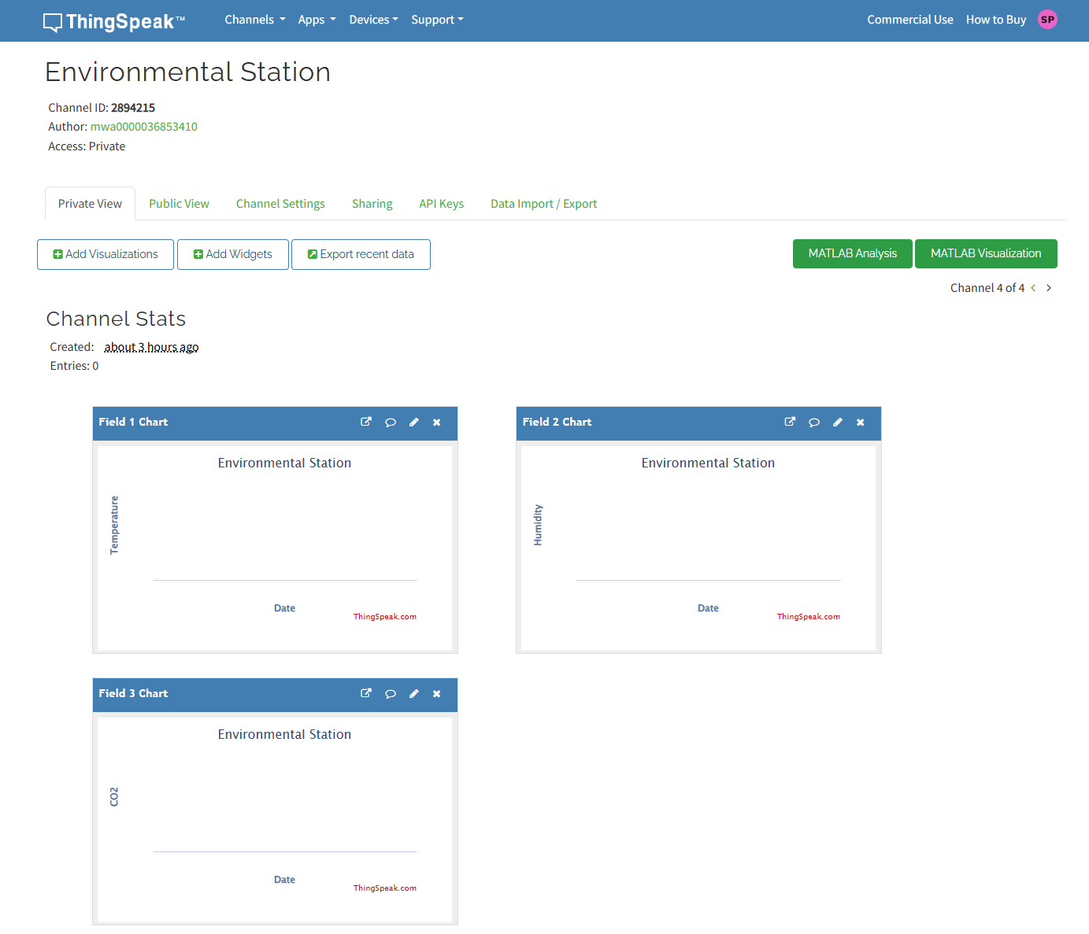

**MQTT device details with credentials (Client ID, Username) :**

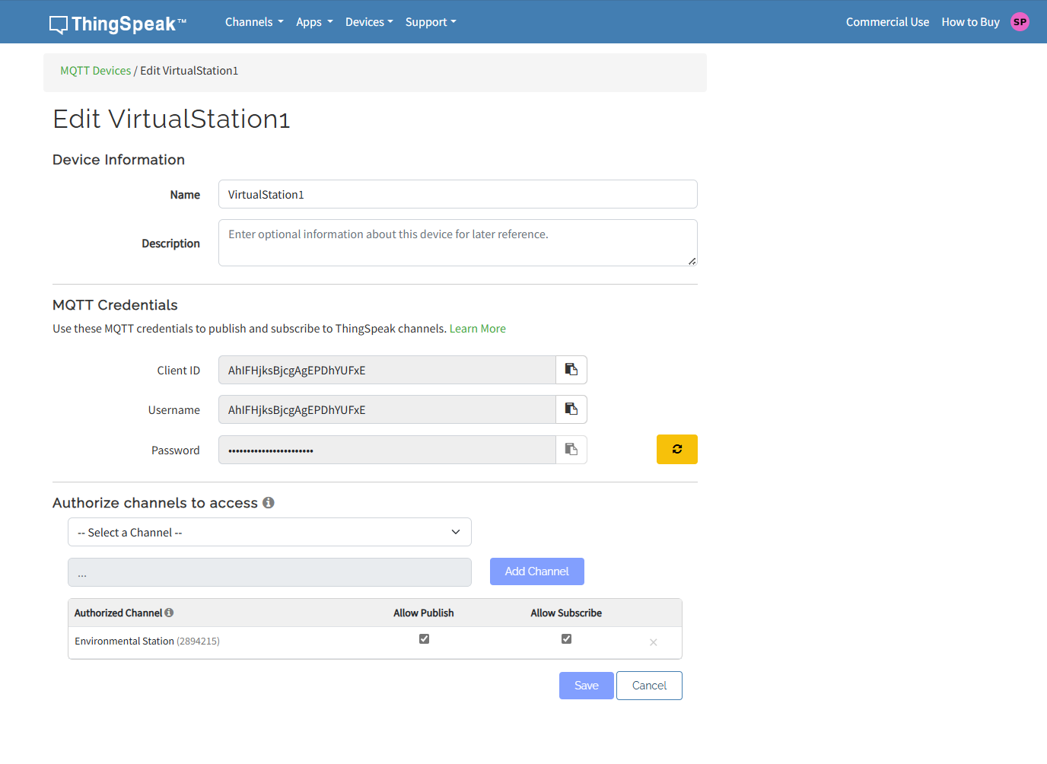

**ThingSpeak dashboard graphs and channel status with real-time sensor updates :**

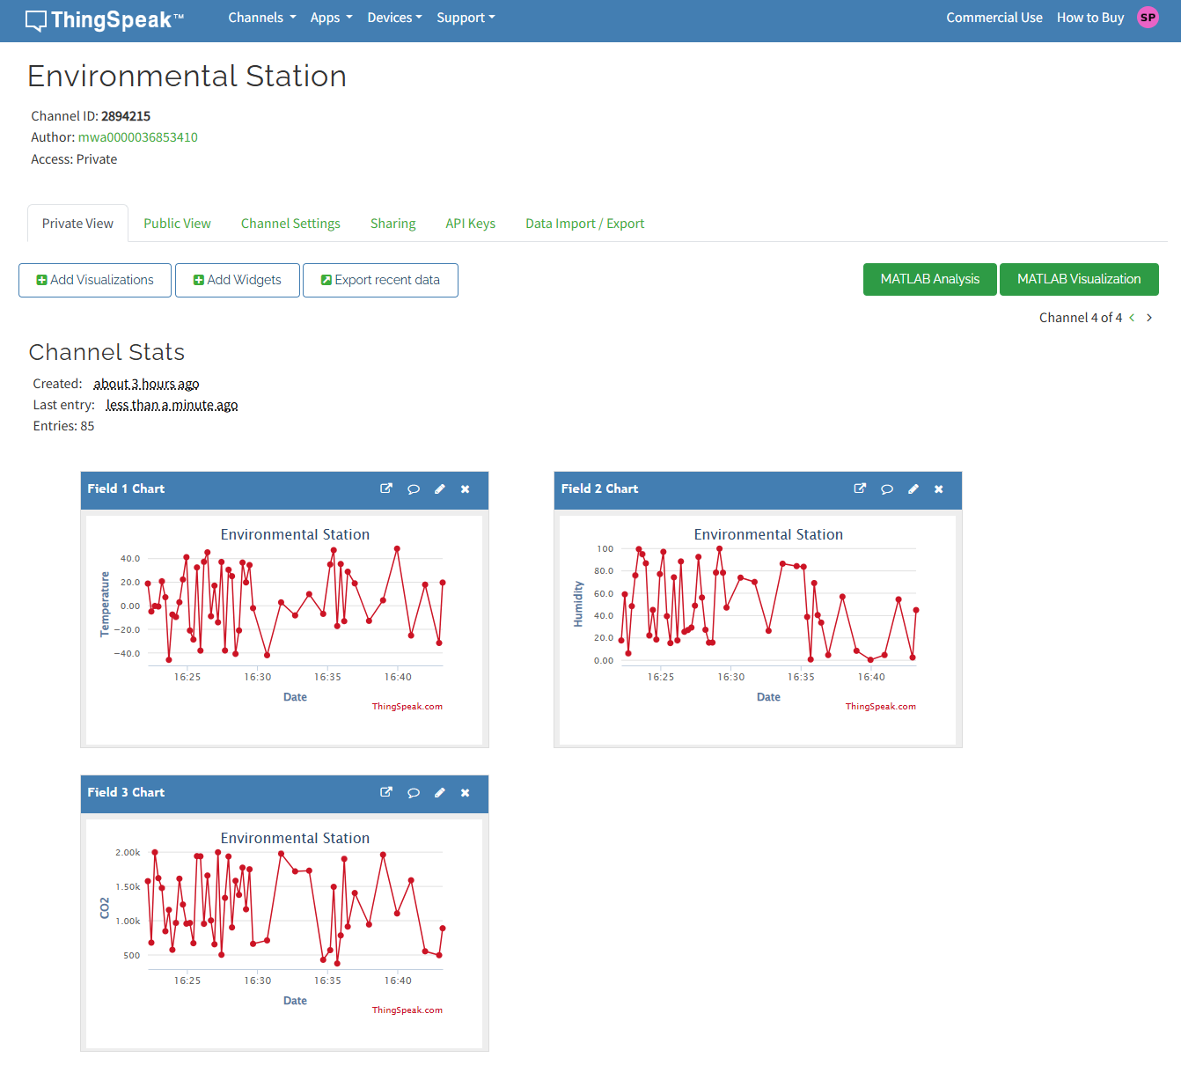

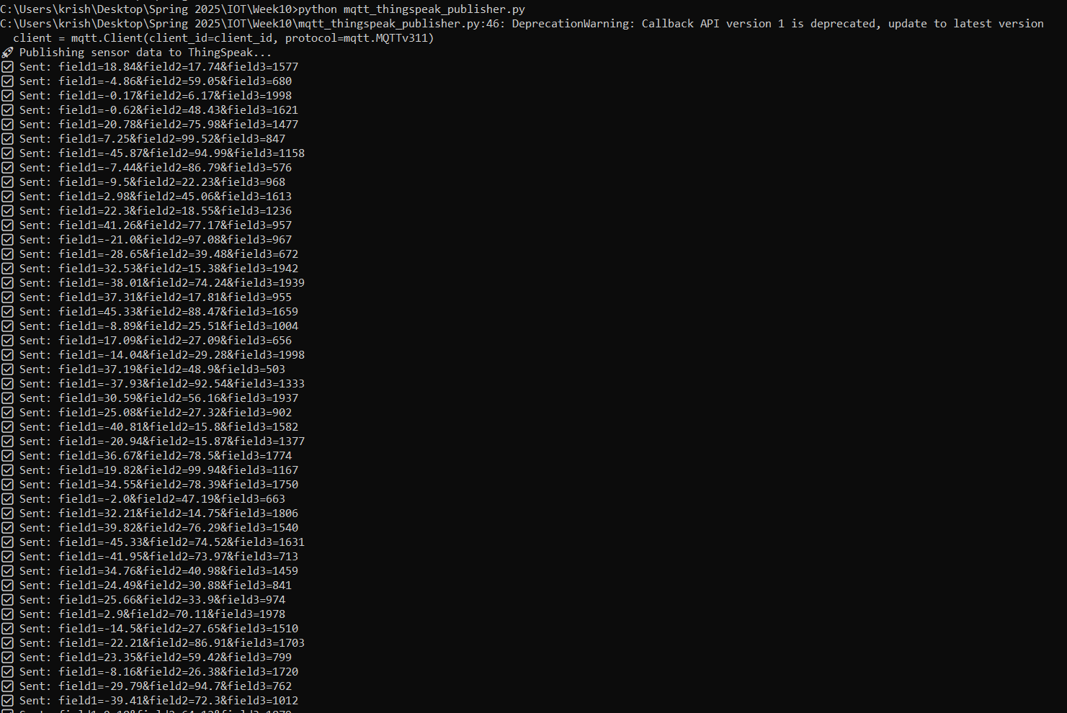

**This is how sensor data is stored locally in “sensor_log.txt” file :**

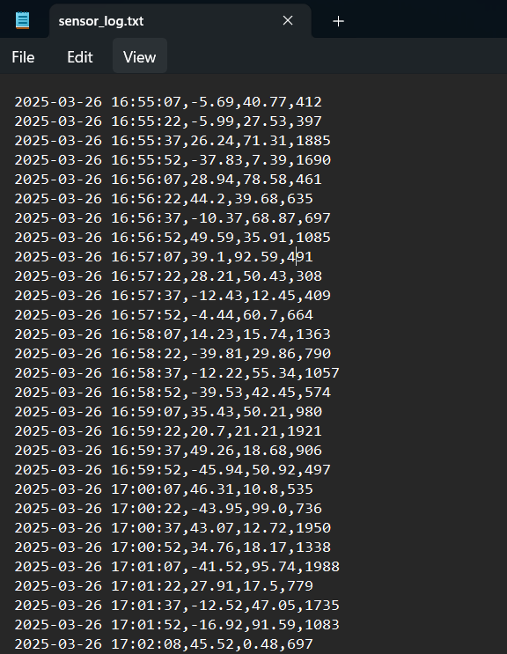

**Outputs for last five hour data :**

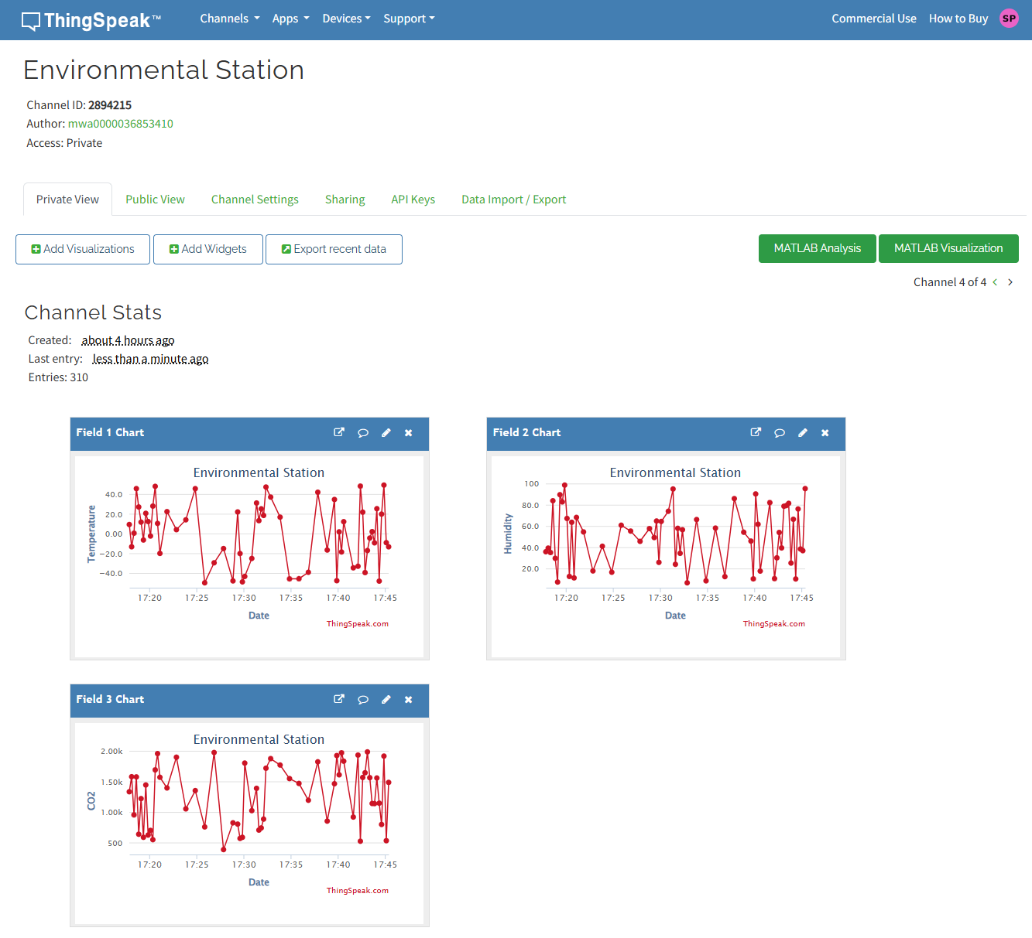

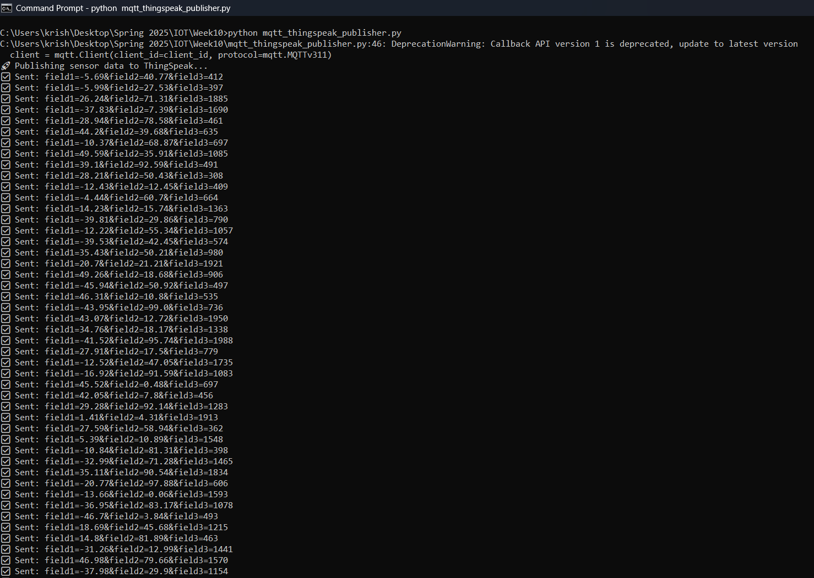

**Outputs from last_5_hour_data.py (Temperature) :**

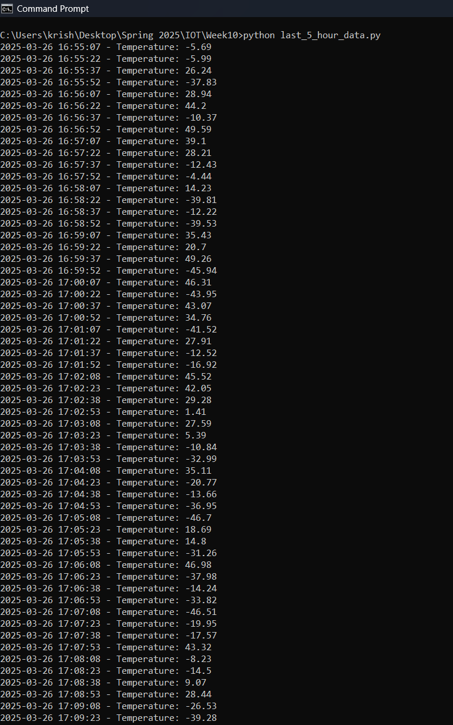

**Outputs from last_5_hour_data.py (Humidity) :**

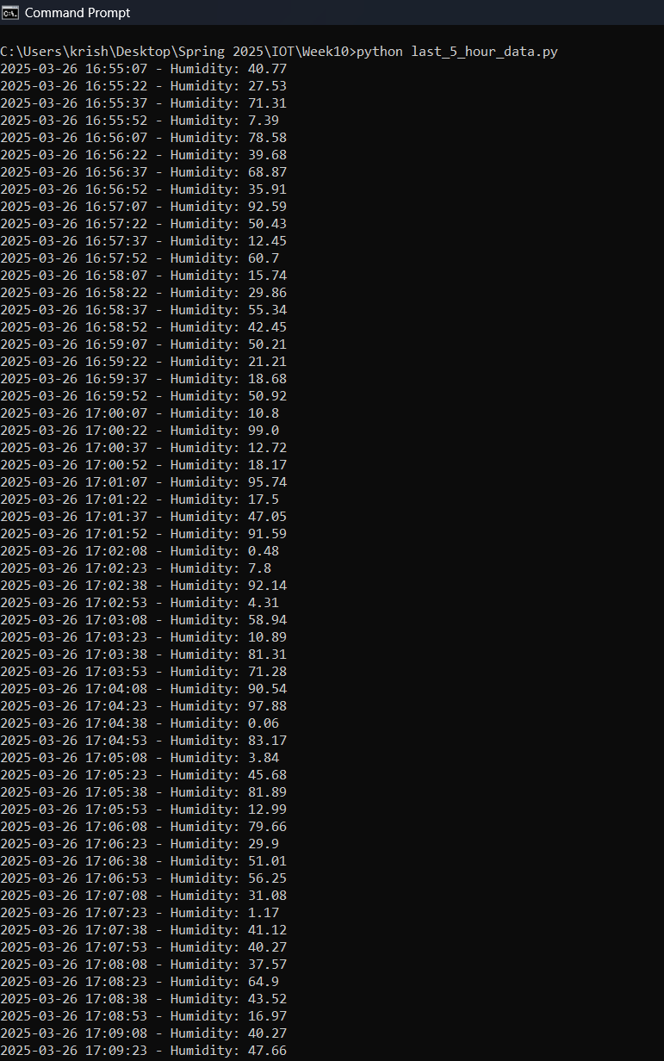

**Outputs from last_5_hour_data.py (CO2) :**

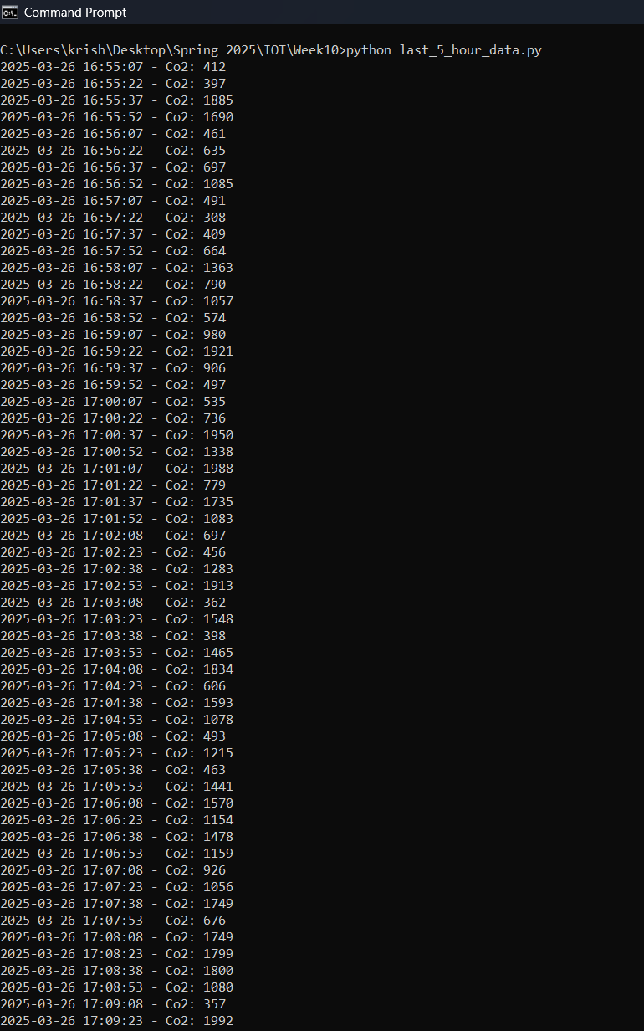

1. **GitHub Repository URL :**

<https://github.com/sivaramakrishna6768/iot-mqtt-simulation>

1. **Reflection :**

* The hands-on experience I had while finishing this assignment made me much more familiar with the entire lifecycle of a cloud-based IoT system - from simulating sensor data values to the integration in the cloud and past data inspection.
* One of the challenges I faced during this process was configuring MQTT correctly, especially when the new paho-mqtt library created an unexpected callback API version error. This made me dig deeper into the documentation and update the client configuration to satisfy the requirements. This was a reminder for me that the libraries evolve and that it is important to be updated.
* ThingSpeak was simple and fun to use. Looking at the actual sensor data transmitted in real-time on the graphs in the dashboard was highly satisfying and made me feel that this IoT system was authentic and real. Also developing a local logging system gave me a better understanding of the offline storage of data as well as filtering the data based on time and required fields which can be truly helpful in the future.
* The most interesting part of the assignment was the way I could emulate the environment data in a realistic manner using the random module in python. I felt as if it was an ideal virtual weather station. It made the assignment not only learning oriented but also fun.
* Overall, the assignment strengthened my knowledge by making me understand the importance of data flow, cloud communication protocols like MQTT, and live and historic data handling which are all important aspects in the building of cloud based IoT systems in real life.