# Collections

What are **Java collections?** Java collections refer to a collection of individual objects that are represented as a single unit. You can perform all operations such as searching, sorting, insertion, manipulation, deletion, etc., on Java collections just like you do it on data.

Now, let us move ahead in this Java collections blog, where we will understand each aspect of it in the following sequence:

1. [What is a Java collection framework?](https://www.edureka.co/blog/java-collections/#framework)
2. [Why use Java collection?](https://www.edureka.co/blog/java-collections/#whyuse)
3. [Java collection framework Hierarchy](https://www.edureka.co/blog/java-collections/#hierarchy)
4. [Interface](https://www.edureka.co/blog/java-collections/#interface)
5. [List](https://www.edureka.co/blog/java-collections/#list)
6. [Queue](https://www.edureka.co/blog/java-collections/#queue)
7. [Sets](https://www.edureka.co/blog/java-collections/#sets)

Let’s get started with the first topic in the Java collections blog.

**What is a Java Collection Framework?**

A Java collection framework provides an architecture to store and manipulate a group of objects. A Java collection framework includes the following:

* Interfaces
* Classes
* Algorithm

Let’s learn about them in detail:

**Interfaces**: Interface in Java refers to the abstract data types. They allow Java collections to be manipulated independently from the details of their representation. Also, they form a hierarchy in object-oriented programming languages.

**Classes:**Classes in Java are the implementation of the collection interface. It basically refers to the data structures that are used again and again.

**Algorithm:** Algorithm refers to the methods which are used to perform operations such as searching and sorting, on objects that implement collection interfaces. Algorithms are polymorphic in nature as the same method can be used to take many forms or you can say perform different implementations of the Java collection interface.

So why do you think we need Java collections? The Java collection framework provides the developers to access prepackaged data structures as well as algorithms to manipulate data. Next, let us move to the Java collections framework hierarchy and see where these interfaces and classes resides.

**Why use Java collection?**

There are several benefits of using Java collections such as:

* Reducing the effort required to write the code by providing useful data structures and algorithms
* Java collections provide high-performance and high-quality data structures and algorithms thereby increasing the speed and quality
* Unrelated APIs can pass collection interfaces back and forth
* Decreases extra effort required to learn, use, and design new API’s
* Supports reusability of standard data structures and algorithms

## ****Java Collection Framework Hierarchy****

As we have learned Java collection framework includes interfaces and classes. Now, let us see the Java collections framework hierarchy.

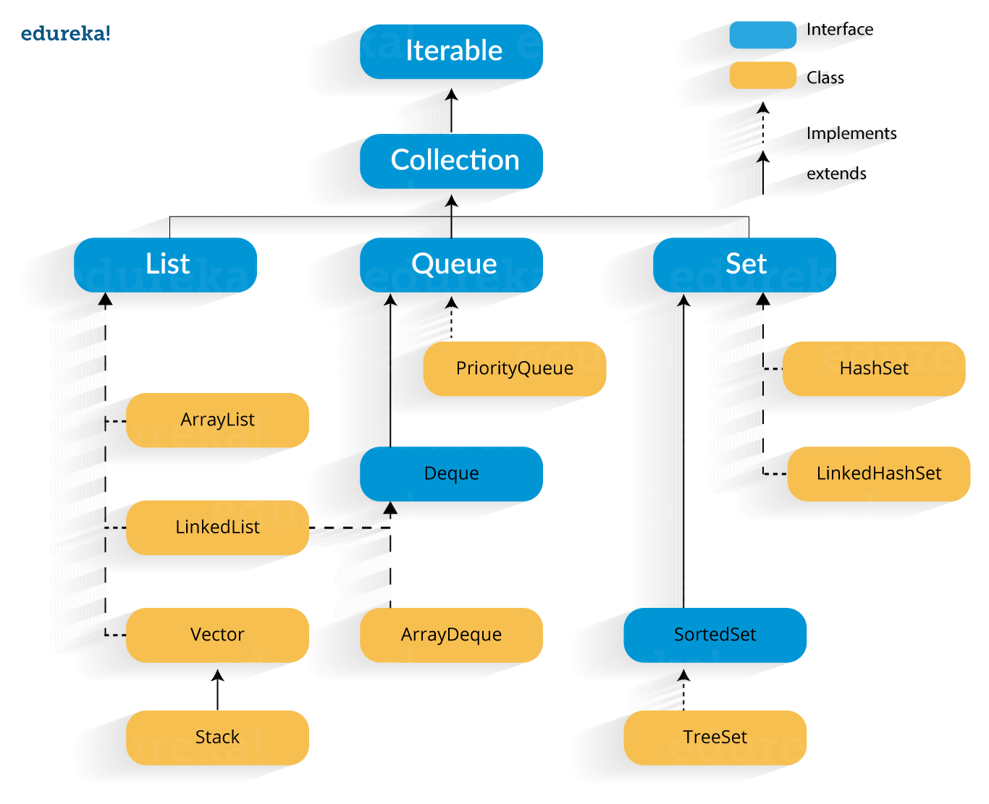

In the above image, blue part refers to the different interfaces and the yellow part defines the class. Now, let us understand these components in detail.

## ****Java Collections : Interface****

**Iterator interface** : Iterator is an interface that iterates the elements. It is used to traverse the list and modify the elements. Iterator interface has three methods which are mentioned below:

1. **public boolean hasNext()** – This method returns true if the iterator has more elements.
2. **public object next()** – It returns the element and moves the cursor pointer to the next element.
3. **public void remove()** – This method removes the last elements returned by the iterator.

There are three components that extend the collection interface i.e List, Queue and Sets. Let’s learn about them in detail:

## ****Java collections: List****

A List is an ordered Collection of elements which may contain duplicates. It is an interface that extends the Collection interface. Lists are further classified into the following:

1. ArrayList
2. LinkedList
3. Vectors

 Let’s go into detail on each one of them:

**Array list:** ArrayList is the implementation of List Interface where the elements can be dynamically added or removed from the list. Also, the size of the list is increased dynamically if the elements are added more than the initial size.

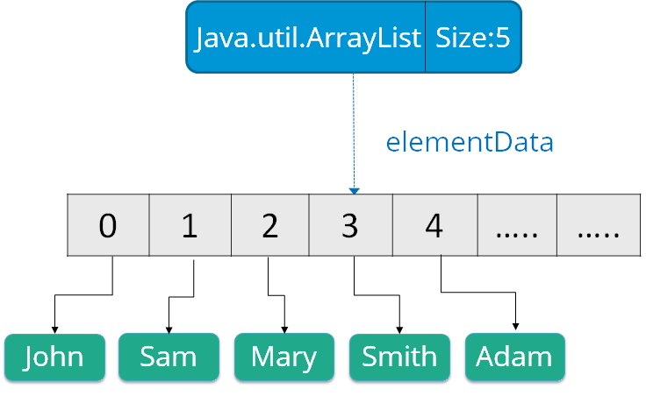**Syntax**:

ArrayList object = new ArrayList ();  
Some of the methods in array list are listed below:

|  |  |
| --- | --- |
| **Method** | **Description** |
| boolean add(Collection c) | Appends the specified element to the end of a list. |
| void add(int index, Object element) | Inserts the specified element at the specified position. |
| void clear() | Removes all the elements from this list. |
| int lastIndexOf(Object o) | Return the index in this list of the last occurrence of the specified element, or -1 if the list does not contain this element. |
| Object clone() | Return a shallow copy of an ArrayList. |
| Object[] toArray() | Returns an array containing all the elements in the list. |
| void trimToSize() | Trims the capacity of this ArrayList instance to be the list’s current size. |

Let us understand Array list with a programmatic example:

|  |  |
| --- | --- |
| 1  2  3  4  5  6  7  8  9  10  11  12  13 | **import** java.util.*;  **class** ArrayListExample{  **public** **static** **void** main(String args[]){     ArrayList al=**new** ArrayList();  // creating array list   al.add("Jack");                // adding elements   al.add("Tyler");   Iterator itr=al.iterator();  **while**(itr.hasNext()){   System.out.println(itr.next());   }   }   } |

In the above code, it will return the names that we have added using add() method i.e:

Jack

Tyler

**Linked List**: Linked List is a sequence of links which contains items. Each link contains a connection to another link.

Syntax: Linkedlist object = new Linkedlist();

Java Linked List class uses two types of Linked list to store the elements:

* Singly Linked List
* Doubly Linked List

**Singly Linked List**: In a singly Linked list each node in this list stores the data of the node and a pointer or reference to the next node in the list. Refer to the below image to get a better understanding of single Linked list.

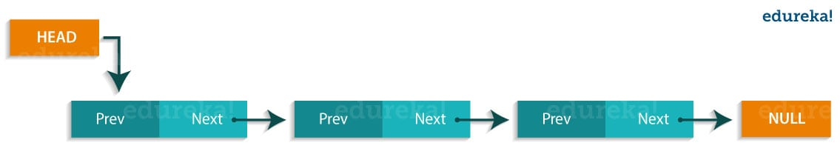**Doubly Linked List**: In a doubly Linked list, it has two references, one to the next node and another to previous node. You can refer to the below image to get a better understanding of doubly linked list.

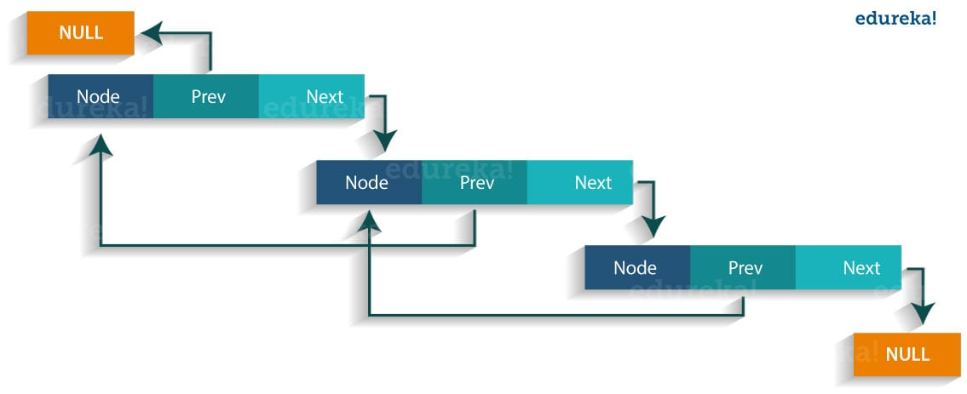  
Some of the methods in the linked list are listed below:

|  |  |
| --- | --- |
| **Method** | **Description** |
| boolean add( Object o) | It is used to append the specified element to the end of the vector. |
| boolean contains(Object o) | Returns true if this list contains the specified element. |
| void add (int index, Object element) | Inserts the element at the specified element in the vector. |
| void addFirst(Object o) | It is used to insert the given element at the beginning. |
| void addLast(Object o) | It is used to append the given element to the end. |
| int size() | It is used to return the number of elements in a list |
| boolean remove(Object o) | Removes the first occurrence of the specified element from this list. |
| int indexOf(Object element) | Returns the index of the first occurrence of the specified element in this list, or -1. |
| int lastIndexOf(Object element) | Returns the index of the last occurrence of the specified element in this list, or -1. |

## 

Let us understand linked list with a programmatic example:

|  |  |
| --- | --- |
| 1  2  3  4  5  6  7  8  9  10  11  12  13 | **import** java.util.*;  **public** **class** LinkedlistExample{  **public** **static** **void** main(String args[]){          LinkedList<String> al=**new** LinkedList<String>();// creating linked list          al.add("Rachit"); // adding elements          al.add("Rahul");          al.add("Rajat");          Iterator<String> itr = al.iterator();  **while**(itr.hasNext()){              System.out.println(itr.next());          }      }  } |

The output of the above program would be:

Rachit

Rahul

Rajat

**Vectors** : Vectors are similar to arrays, where the elements of the vector object can be accessed via an index into the vector. Vector implements a dynamic array. Also, the vector is not limited to a specific size, it can shrink or grow automatically whenever required. It is similar to ArrayList, but with two differences :

* Vector is synchronized.
* Vector contains many legacy methods that are not part of the collections framework.

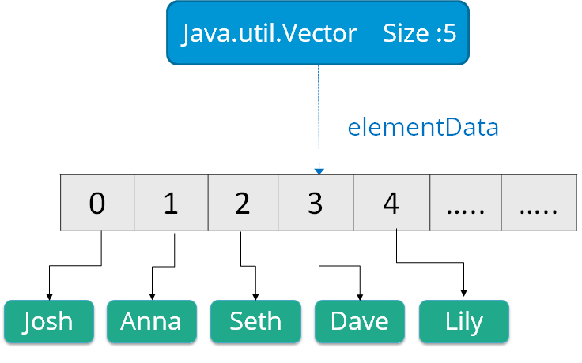**Syntax**:

Vector object = new Vector(size,increment);

Below are some of the methods of the Vector class:

|  |  |
| --- | --- |
| **Method** | **Description** |
| boolean add(Object o) | Appends the specified element to the end of the list. |
| void clear() | Removes all of the elements from this list. |
| void add(int index, Object element) | Inserts the specified element at the specified position. |
| boolean remove(Object o) | Removes the first occurrence of the specified element from this list. |
| boolean contains(Object element) | Returns true if this list contains the specified element. |
| int indexOfObject (Object element) | Returns the index of the first occurrence of the specified element in the list, or -1. |
| int size() | Returns the number of elements in this list. |
| int lastIndexOf(Object o) | Return the index of the last occurrence of the specified element in the list, or -1 if the list does not contain any element. |

Now, let us  move to the next sub type of the Java Collections interface i.e Queue.

**Java collections: Queue**

Queue in Java follows a FIFO approach i.e. it orders the elements in First In First Out manner. In a queue, the first element is removed first and last element is removed in the end. Each basic method exists in two forms: one throws an exception if the operation fails, the other returns a special value.

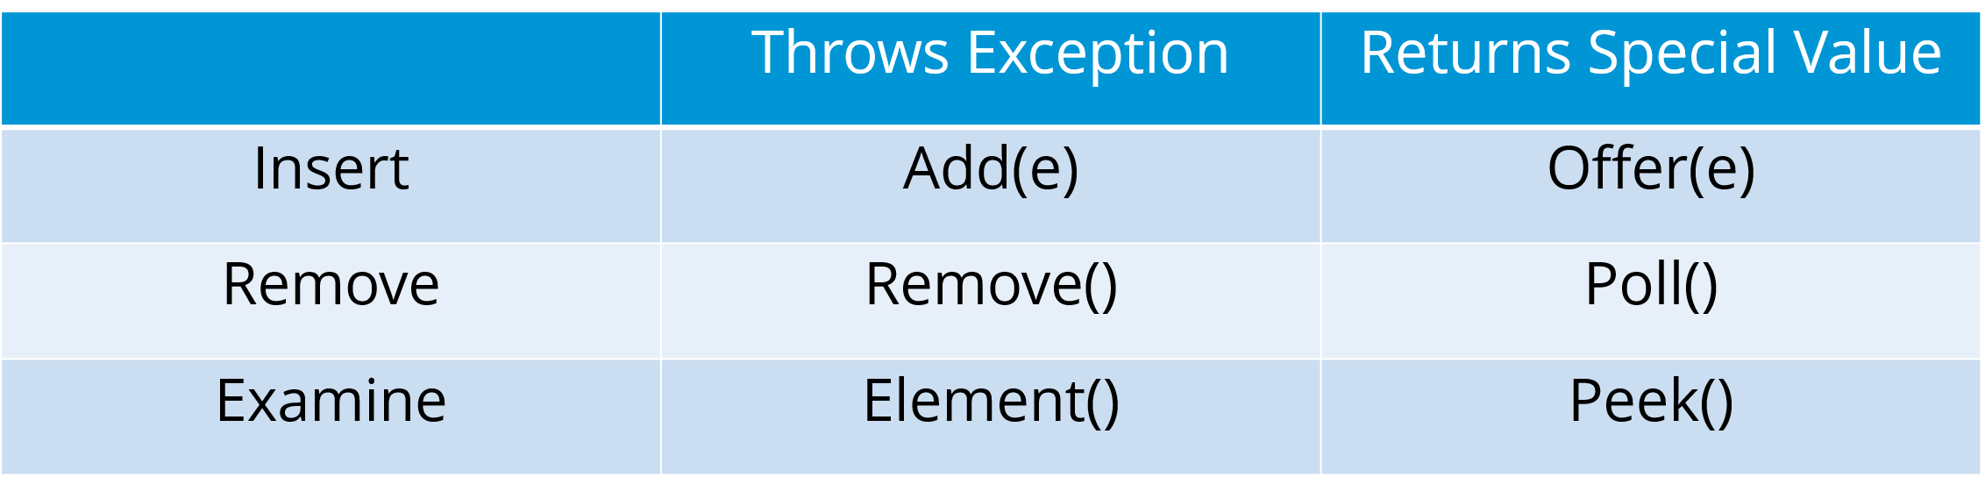

Also, priority queue implements Queue interface. The elements of the **priority queue** are ordered according to their natural ordering, or by a Comparator provided at the queue construction time. The head of this queue is the least element with respect to the specified ordering.

Below are some of the methods of Java Queue interface:

|  |  |
| --- | --- |
| **Method** | **Description** |
| boolean add(object) | Inserts the specified element into the queue and returns true if it is a success. |
| boolean offer(object) | Inserts the specified element into this queue. |
| Object remove() | Retrieves and removes the head of the queue. |
| Object poll() | Retrieves and removes the head of the queue, or returns null if the queue is empty. |
| Object element() | Retrieves, but does not remove the head of the queue. |
| Object peek() | Retrieves, but does not remove the head of this queue, or returns null if the queue is empty. |

Let us understand these priority queues with a programmatic example:

|  |  |
| --- | --- |
| 1  2  3  4  5  6  7  8  9  10  11  12  13  14  15  16  17  18  19  20  21  22  23  24  25 | **import** java.util.*;  **class** QueueExample {  **public** **static** **void** main(String args[]){          PriorityQueue<String> queue=**new** PriorityQueue<String>();          // creating priority queue          queue.add("Amit");          // adding elements          queue.add("Rachit");          queue.add("Rahul");          System.out.println("head:"+queue.element());          System.out.println("head:"+queue.peek());          System.out.println("iterating the queue elements:");          Iterator itr=queue.iterator();  **while**(itr.hasNext()){              System.out.println(itr.next());          }          queue.remove();          queue.poll();          System.out.println("after removing two elements:");          Iterator<String> itr2=queue.iterator();  **while**(itr2.hasNext()){              System.out.println(itr2.next());          }      }  } |

In the above code, the output would be :

head:Amit

head:Amit

iterating the queue elements:

Amit

Rachit

Rahul

after removing two elements:

Rahul

Next, let us move forward to our next topic in “Java Collections” blog, i.e. Sets.

**Java Collections: Sets**

A Set refers to a collection that cannot contain duplicate elements. It is mainly used to model the mathematical set abstraction. Set has its implementation in various classes such as HashSet, TreeSetand LinkedHashSet.

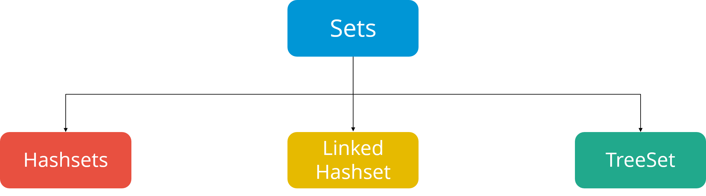

Let’s go into detail on each one of them:

**HashSet**: Java HashSet class creates a collection that use a hash table for storage. Hashset only contain unique elements and it inherits the AbstractSet class and implements Set interface. Also, it uses a mechanism *hashing* to store the elements.    
Below are some of the methods of Java HashSet class:

|  |  |
| --- | --- |
| **Method** | **Description** |
| boolean add(Object o) | Adds the specified element to this set if it is not already present. |
| boolean contains(Object o) | Returns true if the set contains the specified element. |
| void clear() | Removes all the elements from the set. |
| boolean isEmpty() | Returns true if the set contains no elements. |
| boolean remove(Object o) | Remove the specified element from the set. |
| Object clone() | Returns a shallow copy of the HashSet instance: the elements themselves are not cloned. |
| Iterator iterator() | Returns an iterator over the elements in this set. |
| int size() | Return the number of elements in the set. |

Let us understand these Hashset with a programmatic example:

|  |  |
| --- | --- |
| 1  2  3  4  5  6  7  8  9  10  11  12  13  14 | **import** java.util.*;  **class** HashsetExample{  **public** **static** **void** main(String args[]){     HashSet&amp;amp;lt;String&amp;amp;gt; al=**new** HashSet(); // creating hashSet   al.add("Rachit");                 // adding elements   al.add("Amit");   al.add("jack");   Iterator&amp;amp;lt;String&amp;amp;gt; itr=al.iterator();  **while**(itr.hasNext()){   System.out.println(itr.next());   }   }   } |

The output of the above code would be:

Amit

Rachit

jack

**Linked Hashset** : Java LinkedHashSet class is a Hash table and Linked list implementation of the set interface. It contains only unique elements like HashSet. Linked HashSet also provides all optional set operations and maintains insertion order. Let us understand these linked Hashset with a programmatic example:

|  |  |
| --- | --- |
| 1  2  3  4  5  6  7  8  9  10  11  12  13  14 | **import** java.util.*;  **class** LinkedHashsetExample{  **public** **static** **void** main(String args[]){  LinkedHashSet&amp;amp;lt;String&amp;amp;gt; al=**new** LinkedHashSet(); // creating linkedhashset  al.add("Mariana");                            // adding elements  al.add("Rick");  al.add("Sam");  Iterator&amp;amp;lt;String&amp;amp;gt; itr=al.iterator();  **while**(itr.hasNext()){  System.out.println(itr.next());  }  }  }  } |

The output of the above code would be:

Mariana

Rick

Sam

**TreeSet** : TreeSet class implements the Set interface that uses a tree for storage. The objects of this class are stored in the ascending order. Also, it inherits AbstractSet class and implements NavigableSet interface. It contains only unique elements like HashSet. In TreeSet class, access and retrieval time are faster.

Below are some of the methods of Java TreeSet class:

|  |  |
| --- | --- |
| **Method** | **Description** |
| boolean addAll(Collection c) | Add all the elements in the specified collection to this set. |
| boolean contains(Object o) | Returns true if the set contains the specified element. |
| boolean isEmpty() | Returns true if this set contains no elements. |
| boolean remove(Object o) | Remove the specified element from the set. |
| void add(Object o) | Add the specified element to the set. |
| void clear() | Removes all the elements from the set. |
| Object clone() | Return a shallow copy of this TreeSet instance. |
| Object first() | Return the first element currently in the sorted set. |
| Object last() | Return the last element currently in the sorted set. |
| int size() | Return the number of elements in the set. |

Let us understand these TreeSet with a programmatic example:

|  |  |
| --- | --- |
| 1  2  3  4  5  6  7  8  9  10  11  12  13 | **import** java.util.*;  **class** TreeSetExample{  **public** **static** **void** main(String args[]){  TreeSet&amp;amp;lt;String&amp;amp;gt; al=**new** TreeSet&amp;amp;lt;String&amp;amp;gt;();  // creating treeSet  al.add("John");                            // adding elements  al.add("Sam");  al.add("Rick");  Iterator&amp;amp;lt;String&amp;amp;gt; itr=al.iterator();  **while**(itr.hasNext()){  System.out.println(itr.next());  }  }  } |

The output of the above program would be:

John

Rick

Sam

Now you must be wondering what is the difference between all these sets?

HashSet stores elements in random order whereas LinkedHashSet stores elements according to insertion order and TreeHashSet stores according to natural ordering.

This is the end of the “Java Collections” blog. I hope you guys are clear with Java collections framework, it’s hierarchy, interface, list, queue and sets that I have discussed above. Do read my next blog on [**Java Interview Questions**](https://www.edureka.co/blog/interview-questions/java-interview-questions/) where I have listed top 75 interview questions and answers which will help you set apart in the interview process.

Summary

Why collections ?

Array is fixed in size

Array will only allow us to store homogenous data for ex: only string or only integers

Array- duplicate not allowed

Array does not have any underlying data structure- so no ready made methods to perform any operations on data – sorting of values, search a value, add, remove object etc.,

This is why we need collections





Collections – It is a class from java.util that contains methods to perform operations on collection objects

Eg: collections.sort(array)

Collection- It is an Interface . In general collection means Single unit containing group of objects.

Collection Interface - Methods present inside collection interface are common across all collection classes. – child interfaces- List, Set, Queue

List- it is implemented by 1. ArrayList 2. LinkedList 3. Vector (that extends stack)

When Insertion order not preserved and duplicates not allowed , then we use Set instead of List.

Set- It is implemented by classes 1. Hashset 2. Linked hash set

Queue- If you need to follow first in first out process to get data , when we have objects prior to processing , we use Queue ex: send email to group of people will follow first in first out rule

It is implemented by class 1. Priority Queue

There is an independent interface called MAP.

Group of objects to be stored in key value pair , then we use map

101 smith

102 david

103 scott

Duplicate not allowed in keys. Values allows duplicate

Map interface is implemented using Hashmap and Linkedhashmap

<https://www.edureka.co/blog/java-collections/>

<https://www.youtube.com/watch?v=hKhlkx_6HeI>