On the Performance of Different Deep Reinforcement Learning Based Controllers for the Path-Following of a Ship

Sivaraman Sivaraj, Awanish Dubey, Suresh Rajendran

The authors would like to thank the reviewers for their valuable comments and appreciation. Please find our reply below. Replies are shown in blue letters.

As mentioned in the reviewer’s comments for the question 3 and 4, standard deviation of the four algorithm’s action are tabulated as Table.8.

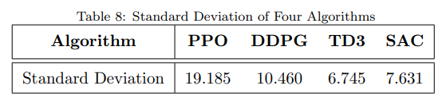

Reviewer #2 Comments and Reply:

1. *It is recommended to include a comparative analysis of the results with existing advanced path following algorithms to emphasize the advantages of the proposed method.*

Answer: The Deep RL results are compared with PID controller with the tuned gains in waves cases. DDPG algorithm is comparatively working better than PID controller in terms of absolute cross track error.

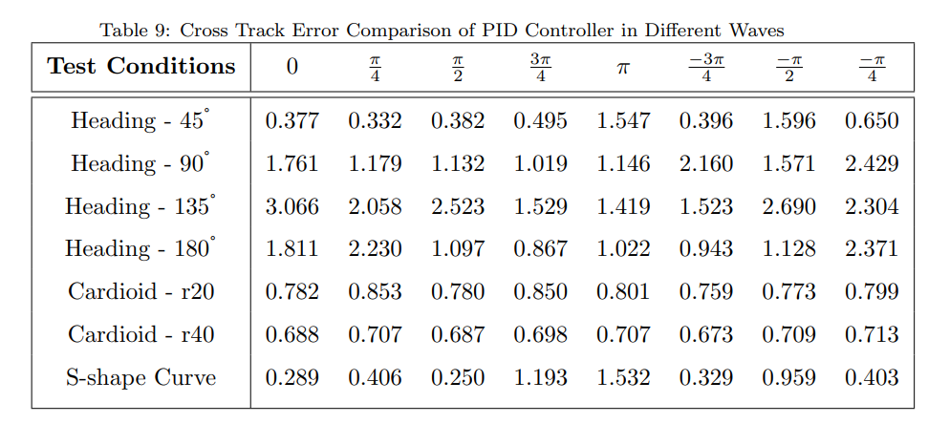

1. *Figures 7 and 8 illustrate a relatively high frequency of changes in the ship's rudder angle. However, in real-world scenarios, is it feasible for the ship's rudder angle to oscillate at such high frequencies?*

Answer: Figures 7 and 8 show the rudder action over the period of 250 seconds and 600 seconds. For these time span, the rudder actions are possible, and it is validated through HIL performance as well.

1. *The table title should be positioned at the top of the table content for better readability and clarity.*

Answer: Title of the table is positioned on the top as mentioned.

1. *The data presented in the text should be consistently presented in either angles or radians to maintain uniformity throughout the manuscript.*

Answer: For better understanding, through out the paper, rudder action is represented in degree.

1. *Figure 6 should clearly depict a noticeable distinction between the starting and ending points to provide a visual differentiation.*

Answer: Start and end points are differentiated through different colors.

Reviewer #3 Comments and Reply:

*1. Remove the comma before citation [23], in the sentence "displacement, and speed" in the introduction on Page 4.*

Answer : corrected…! Checked at all other places as well.

*2. The first letter of "section" in the last paragraph of Introduction on Page 7 should be capitalized.*

Answer : corrected…! Checked at all other places as well.

*3. The first letter of "comparison" in the caption for Figure 2 should be capitalized.*

Answer : corrected…! Checked at all other places as well.

*4. The space before "where the policy gradient…" after Equation 6 should be removed*

Answer : corrected…! Checked at all other places as well.

*5. All equations should be punctuated appropriately, e.g., adding a comma or period after the equation.*

Answer : Eq. format (ending with period) is followed at all the places. In latex, it is not visible because of the citation file red square box.

*6. "the target state" after Equation 14 should be "The target state"*

Answer : corrected…! Checked at all other places as well.

*7. "is defined as in" before Equation 18 should be "is defined as"*

Answer : corrected…! Checked at all other places as well.

*8. "the soft-policy network are" before Equation 19 should be "the soft-policy network is"*

Answer : corrected…! Checked at all other places as well.

*9. "The Four algorithms" in the first paragraph of Section 5.1 should be "The four algorithms"*

Answer : corrected…! Checked at all other places as well.

*10. "The Fig 6 shows" in the last paragraph on Page 20 should be "Fig 6 shows"*

Answer : corrected…! Checked at all other places as well.

*11. "table 6" and "table 7" in the last paragraph on Page 27 should be "Table 6" and "Table 7"*

Answer : corrected…! Checked at all other places as well.