**TERM POLICY**

Creating customer term policy.

**STEP 1**

**CUSTOMER_DETAILS**

CREATE TABLE ISF_CUSTOMER_DETAILS

(FULLNAME VARCHAR2(50),

MOBILE_NUMBER NUMBER(10),

EMAIL VARCHAR2(50),

DOB DATE,

PINCODE NUMBER(6),

GENDER VARCHAR2(10),

NRI VARCHAR2(40),

AGE NUMBER(2));

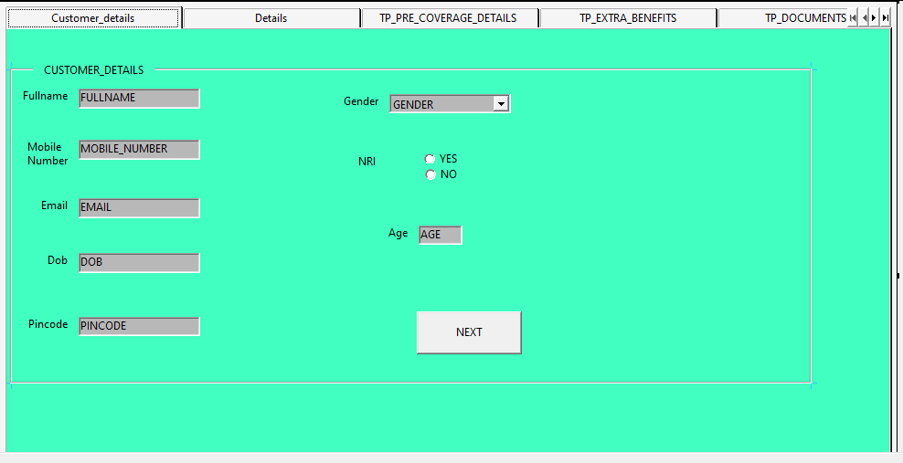

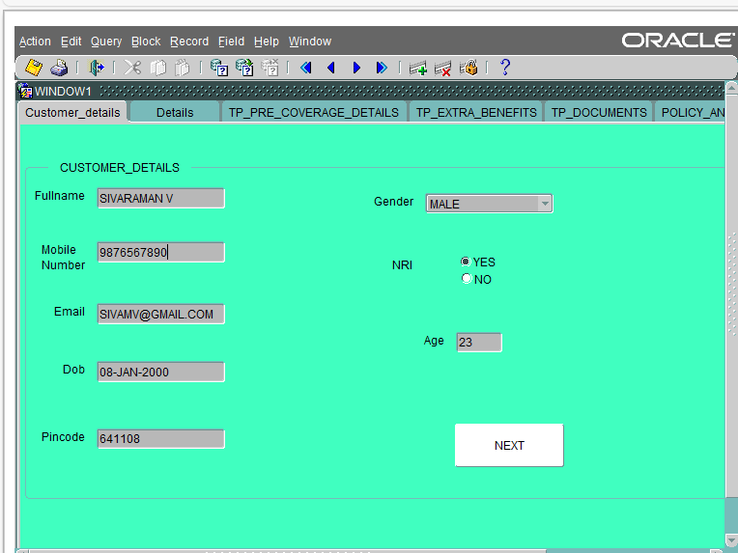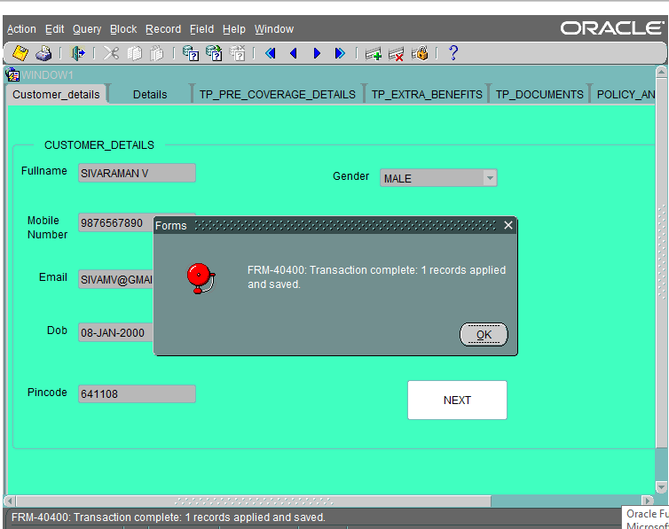

* This screen contains the personal details of a customer.
* Here, the customer enters their Full Name, Mobile Number, E-mail, Date of Birth, Pin code, Gender, and Age.
* After pressing the next button, it will move to the details tab.

**STEP 2**

**DETAILS**

CREATE TABLE CUS_DETAILS

(EDUCATION VARCHAR2(30),

OCCUPATION VARCHAR2(30),

ANNUAL_INCOME NUMBER(10),

DO_YOU_SMOKE VARCHAR2(10),

EXISTING_CUS VARCHAR2(10));

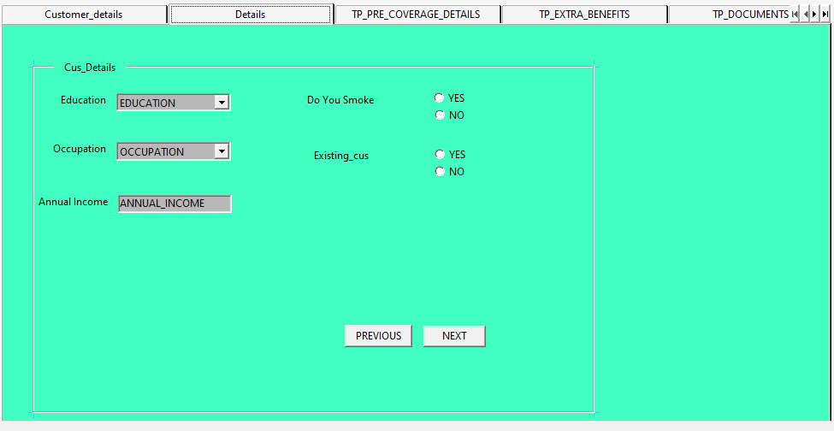

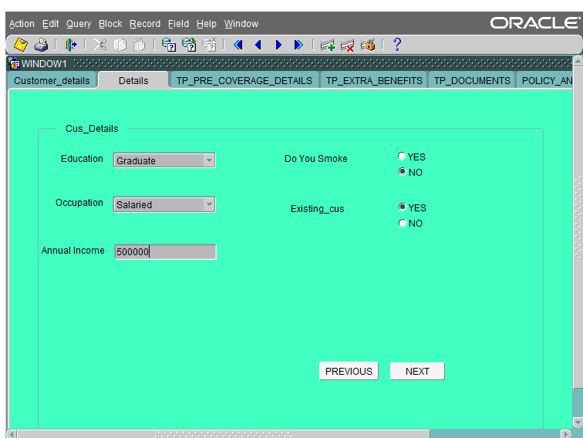

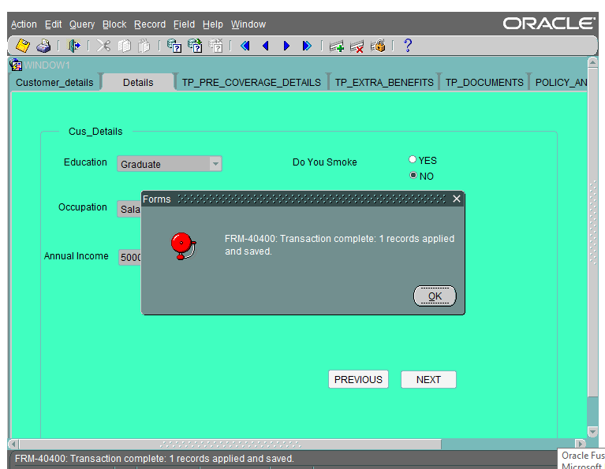

* In the Details tab, the customer should enter their Education, Occupation, Annual Income, Do You Smoke and Existing Customer.
* Pressing the next button will proceed to the 'Pre Coverage Details' block.
* Clicking previous will go back to the 'Customer Details' block.

**STEP 3**

**TP_PRE_COVERAGE_DETAILS**

CREATE TABLE TP_PRE_COVERAGE_DETAILS

(LIFE_COVER_AMOUNT NUMBER(10),

COVER_TILL_AGE NUMBER(2),

PAYMENT_MODE VARCHAR2(30),

PREMIUM_AMOUNT NUMBER(10));

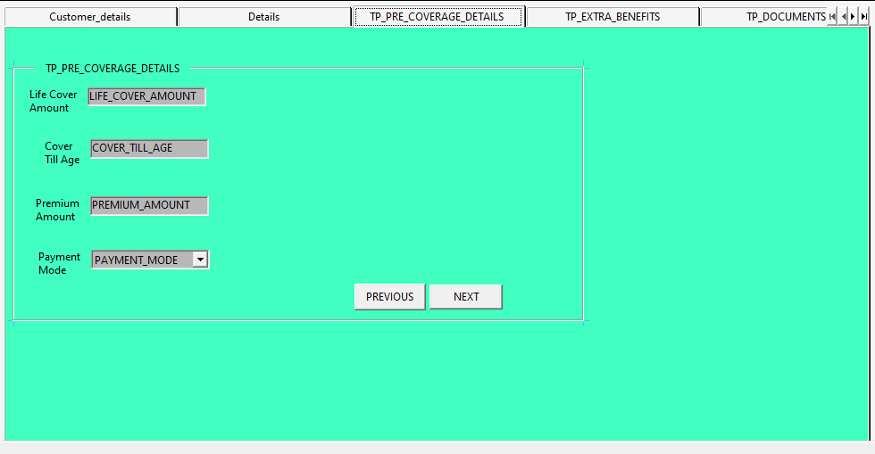

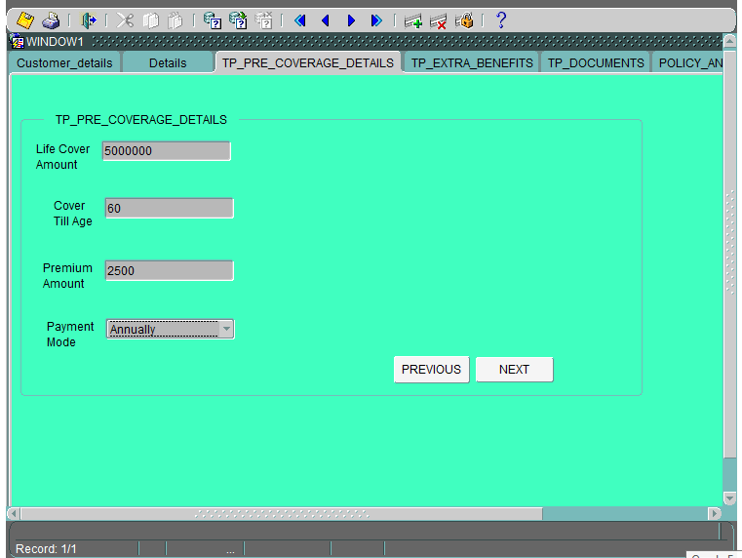

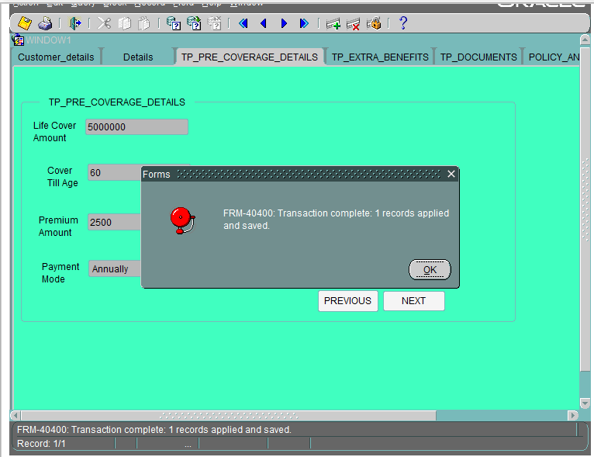

* In the Pre Coverage Details tab, the customer enters the life cover amount, mode of payment for the premium, and the premium amount.
* After entering all the details and pressing the next button, it goes to the ‘Extra Benefits’ block.
* Clicking previous goes back to the ‘Details’ block

**STEP 4**

**TP_EXTRA_BENEFITS**

CREATE TABLE TP_EXTRA_BENEFITS

(CRITICAL_ILLNESS VARCHAR2(10),

TERMINAL_ILLNESS VARCHAR2(10),

ADB_RIDER VARCHAR2(10),

WOP_RIDER VARCHAR2(10));

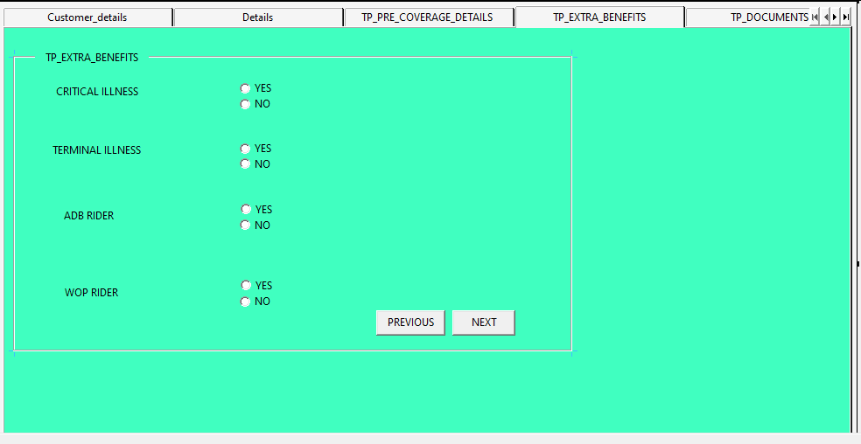

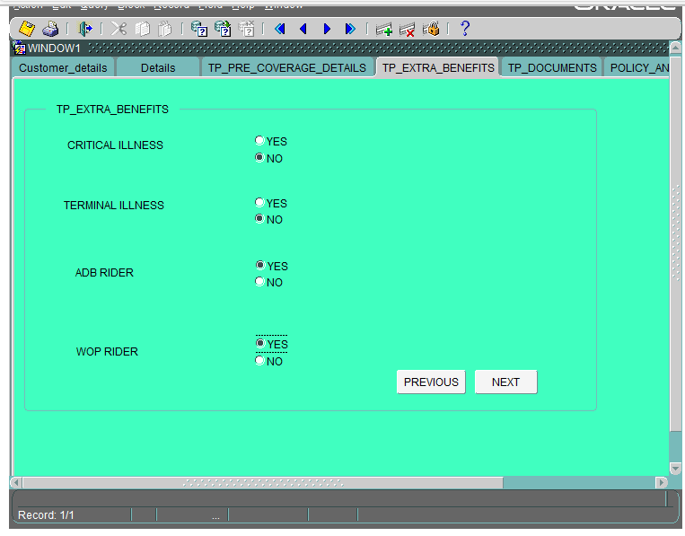

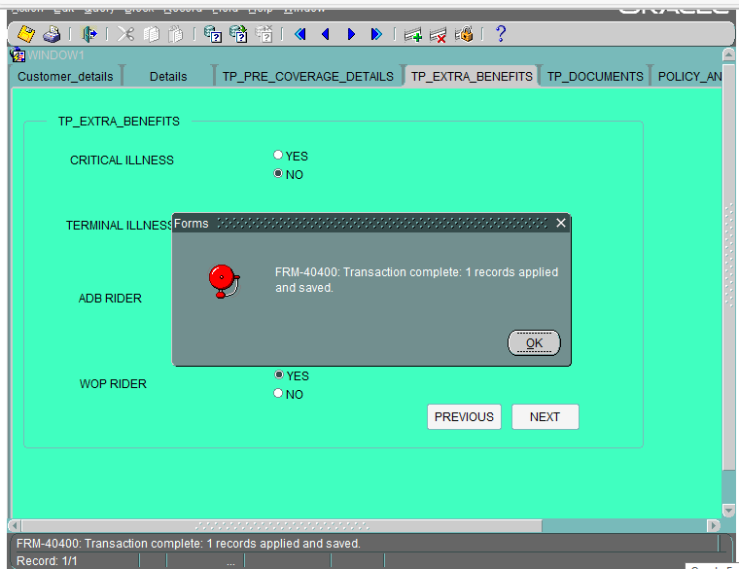

* In the Extra Benefits block, the customer should select additional coverage such as Critical Illness, Terminal Illness, Accidental Riders, and Waiver of Premiums.
* These are all optional.
* If the customer is interested, they can select any of the options,
* Otherwise, it's not compulsory.
* After completing Extra Benefits,
* Clicking the next option goes to the ‘Documents’ block.

**STEP 5**

**TP_DOCUMENTS**

CREATE TABLE TP_DOCUMENTS

(MEDICAL_REPORT BLOB,

AGE_PROOF BLOB,

ADDRESS_PROOF BLOB)

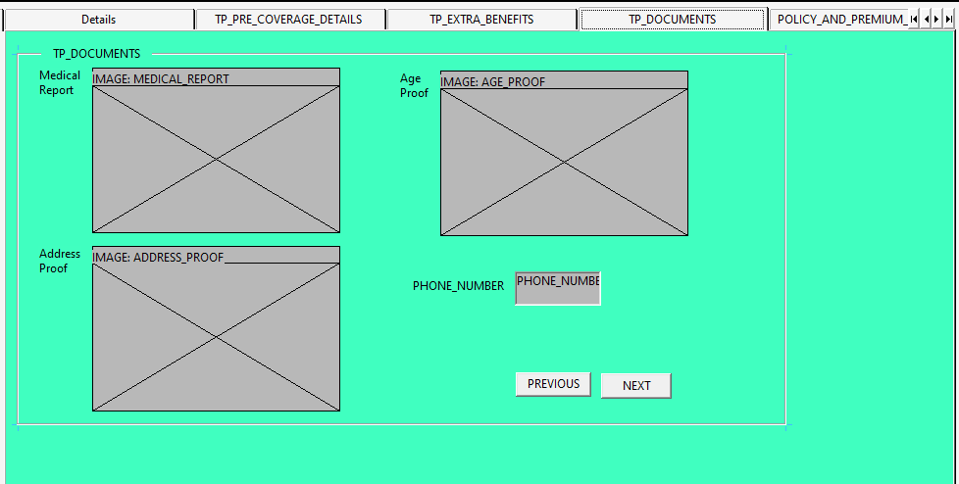

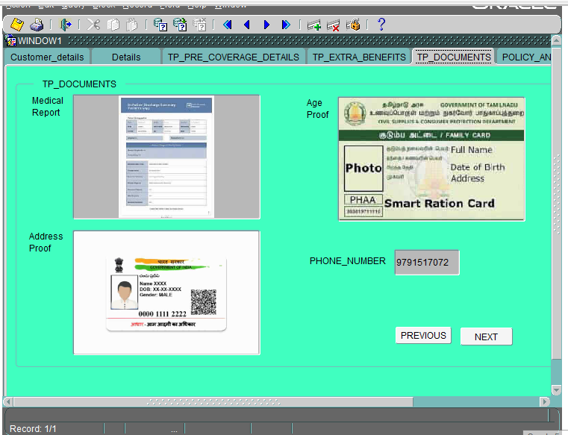

* In the Documents block, the customer can upload documents like a medical report, age proof, and a valid address proof.
* Clicking the next button proceeds to the Policy Details block.

**STEP 6**

**POLICY_DETAILS**

* Here, we fetch the tables from CUSTOMER_DETAILS and TP_PRE_COVERAGE_DETAILS using record groups.
* We retrieve the previously inserted data from both tables, and then use a list of values (LOV) to auto-populated the information.

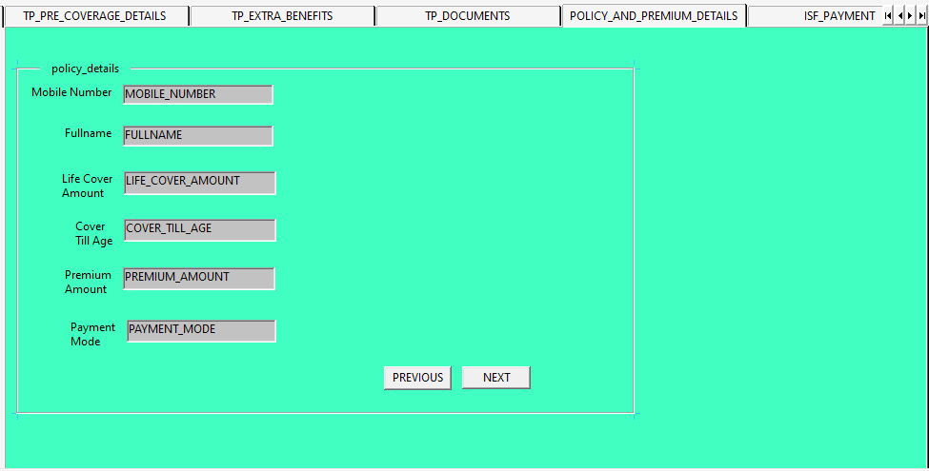

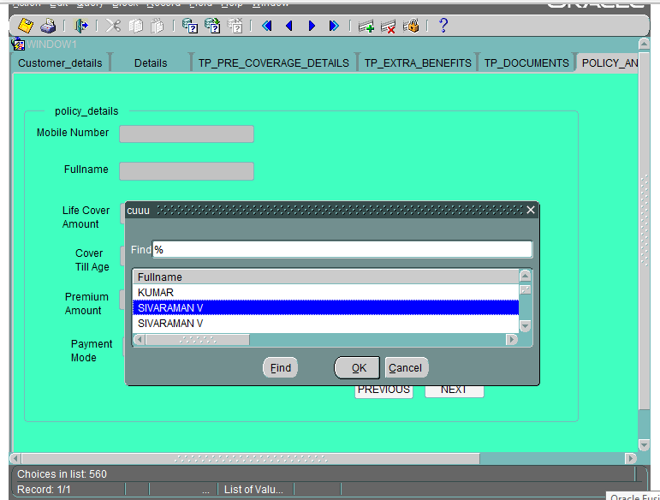

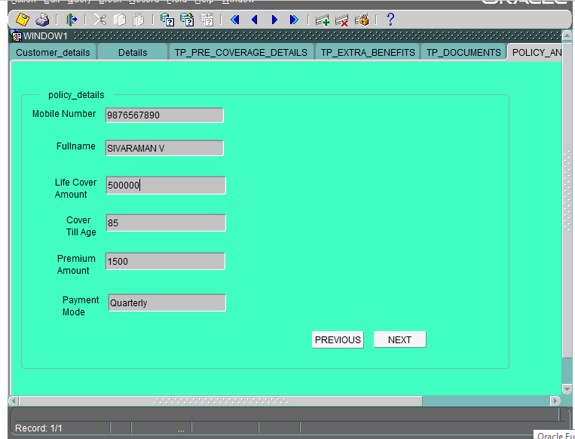

* In the Policy Details block, the customer should ensure that the given details are correct.
* If there are any mistakes, they can make changes and confirm the details.
* Once the details are confirmed, clicking the next button will go to the 'Payment' block.

**STEP 7**

**ISF_PAYMENT**

CREATE TABLE ISF_PAYMENT

(PAYMENT_METHOD VARCHAR2(30),

BANK_NAME VARCHAR2(50),

HOLDER_NAME VARCHAR2(50),

ACCOUNT_NUMBER NUMBER(16)

);

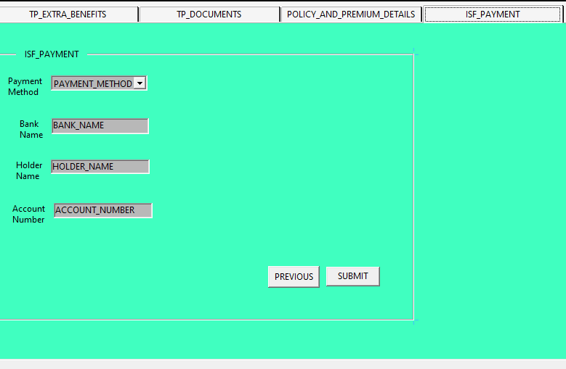

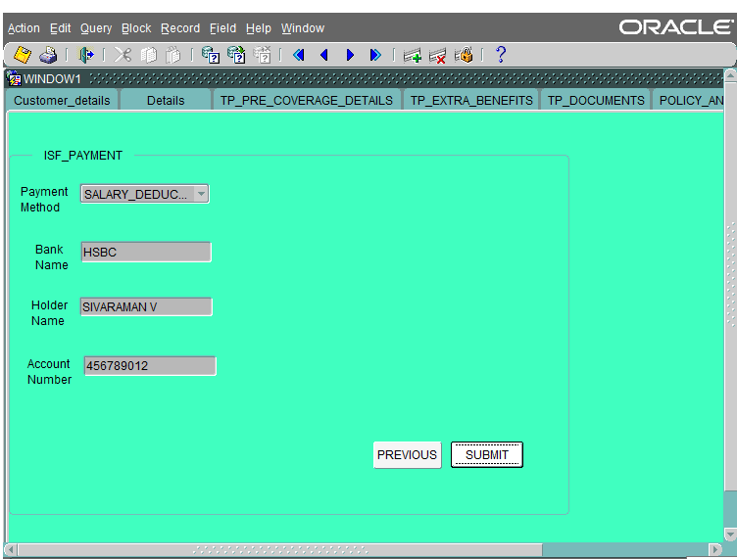

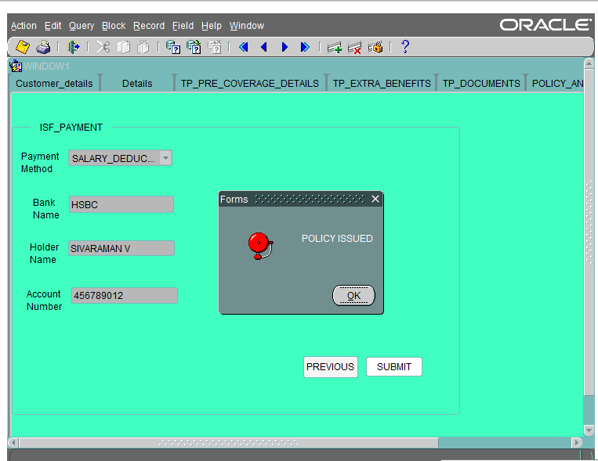

* In the Payment block, the customer can choose the payment method for the premium and submit the details.
* After submitting all the details, an alert will appear stating ‘Policy issued’,
* Thank you for the payment.