**USER GUIDE**

**In Mozilla Science Lab**

***BY:- GROUP 14***

***S.SIVARAMYA***

***S.MAYURI***

***S.SAYINTHA***

***V.THARSAA***

**TABLE OF CONTENTS**

1. Scope and Purpose of the Project

2. Process overview of the project

3. How you can use

3.1 Introduction the structure of Interface

3.2 How to insert, add the organic components in the experimental area

**Screen Shots and Explanation**

**USER GUIDE**

**1. Scope and Purpose of the project**

We are developing a project for organic conversion. Its mostly helpful for the advanced level students. It will be like getting the conversion for the organic components that we are giving as a reactant and a product. Here we can click on the components for choosing the reactant and product. Here we do the project only for aliphatic components. we used php , mysql, js, and CSS. We are contributing this project for Mozilla Science Lab.

**2. Process Overview project**

In our project, we choose the reactant and product and submit . then the conversion is shown in the plane. If we want to add some components with steps, then the conversion is added in the database And also shown in the component chart in the plane.

**3. How you can use**

**3.1 Introduction the Structure of Interface**

This application consist organic components, buttons (add, ok and Help). Here the organic reactants and products are shown in the left and right of the view plane. If you need some information about this conversions, that theoretical parts are shown in the Help page, there is an icon with question mark. And if you need to add the extra organic components, there is an option with “+” sign.

**3.2 How to insert, add the organic components in the Experimental Area**

There are many organic components are shown in the left and right side of the view plane, reactants and products text boxes, ok button also visible in the center. You should click one of the organic component as an reactants or products. Then the reactants and products are inserted.

If you want to add some organic components in the chart, click the add button. after this part, a page visible for adding part. Here we put the reactants, products and steps. Steps option we should give how many steps we need to get the products. After add this detail part there is another box appeared to add the conversions. After this part conversion is stored in the database. So we can see the reactants and products in the home page what we add in the add page earlier.

**Screen Shot and Explanation**

1) Click the Input organic component in reactant table, and product organic component in product table what we want convert

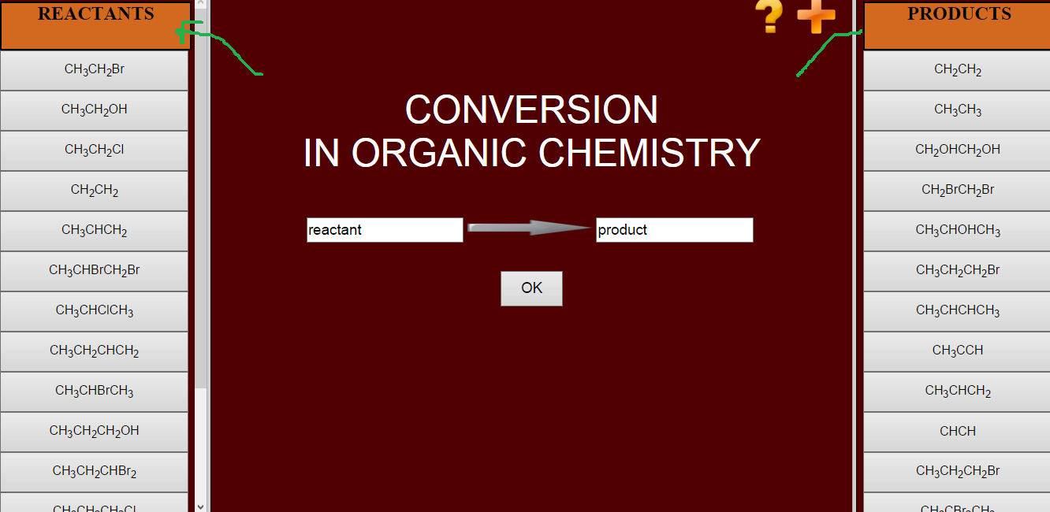

2) Click the OK button after we add the input and output organic component

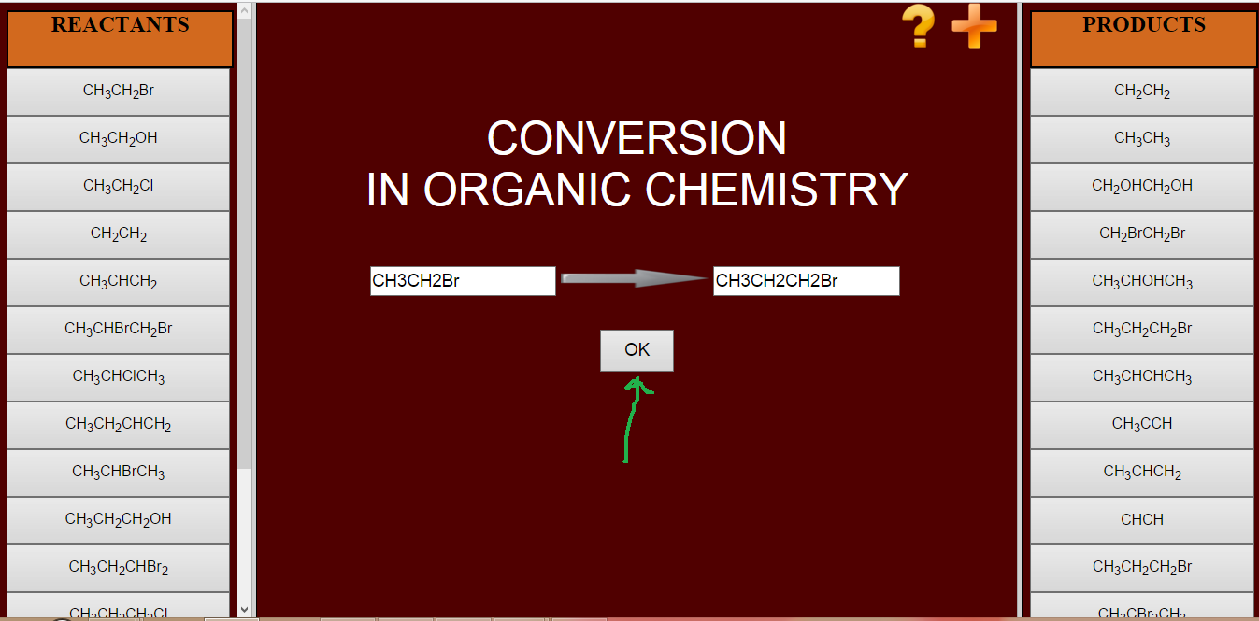

3) After convert one organic component from another we get the output like this, then we can press back button to go to earlier stage

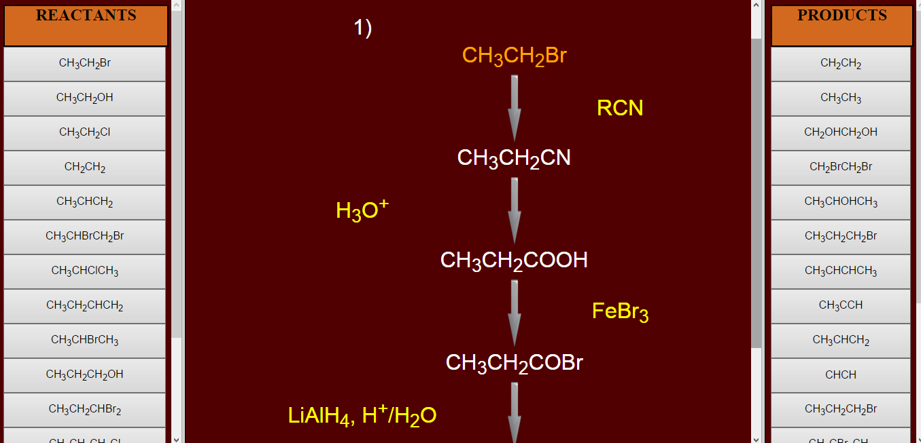

4) If we can’t get what we enter reactant table from product table, then we get an alert message.

5) If we want to get more knowledge about organic conversion go to help button

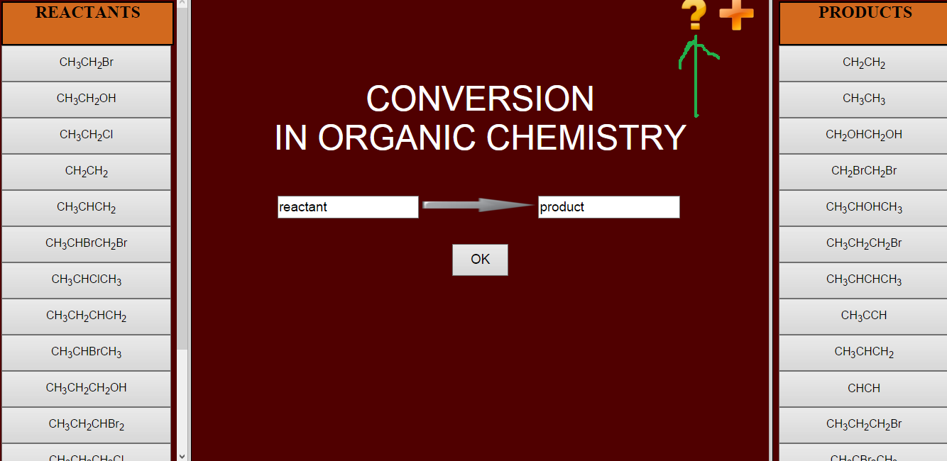

6) Then we get the help page like this

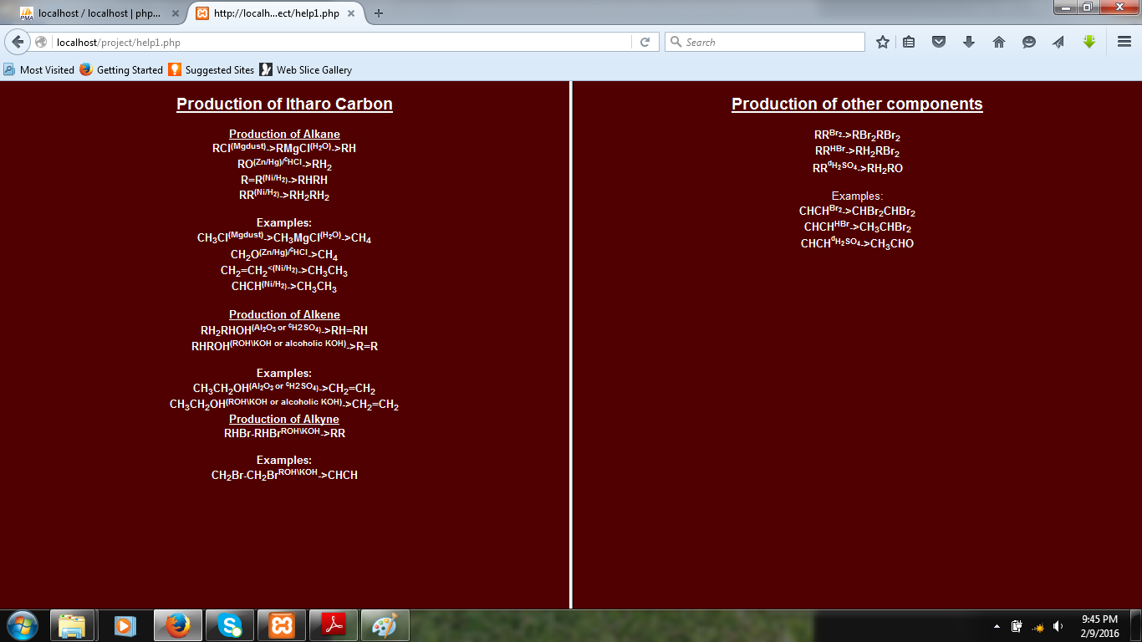

7) If we want to add more organic conversion go to add button

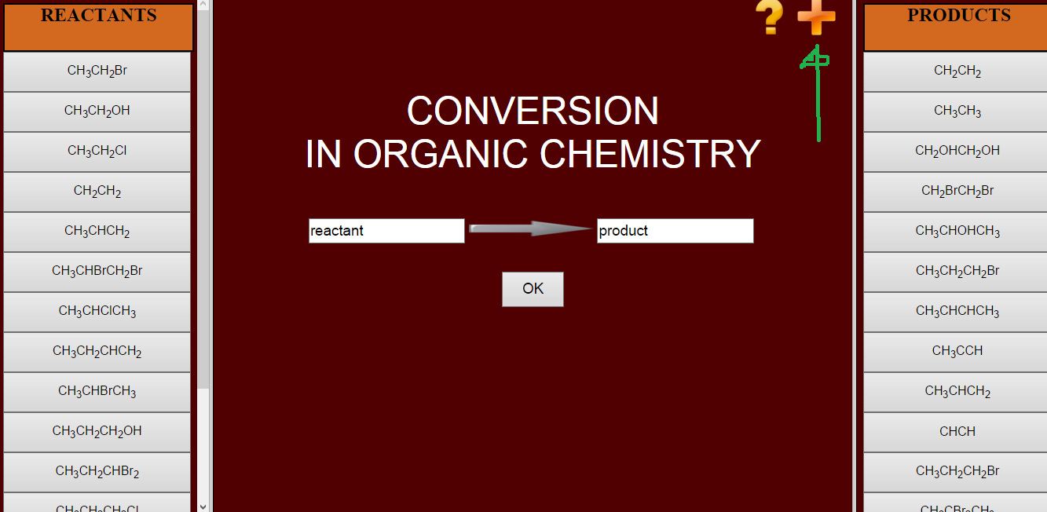

8) Add the details, like what it want in reactant list, what it want in product list, how many steps that we want

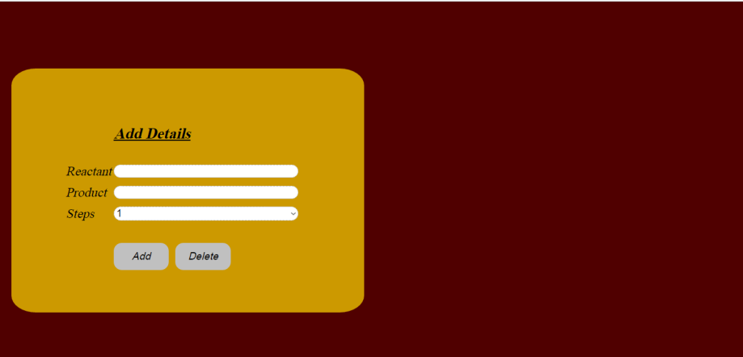

9) After that it will seem like this

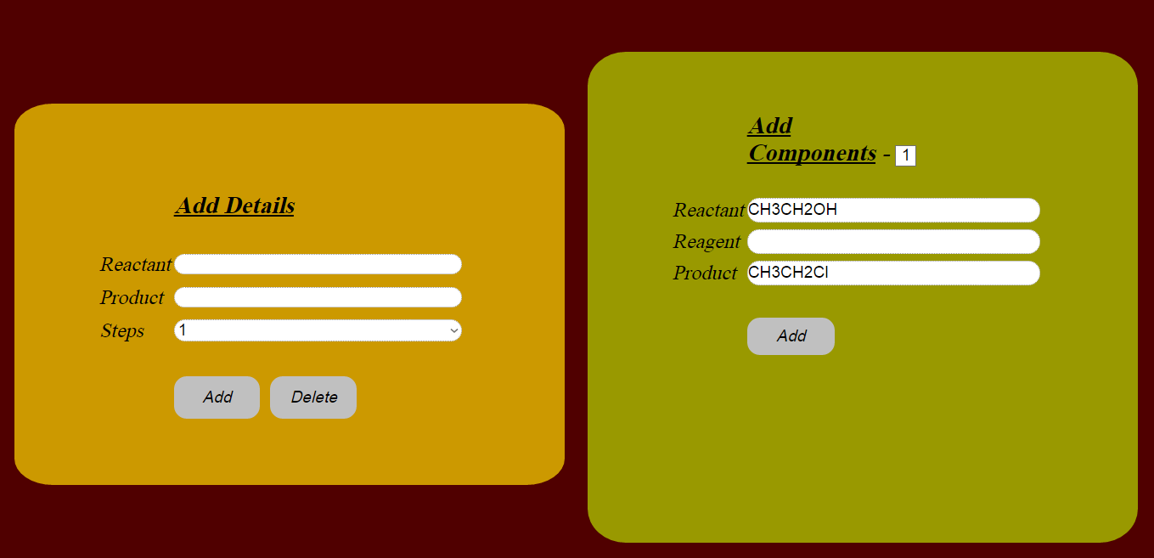

10) Then finally the new item what we add in the add page is in the Home page