


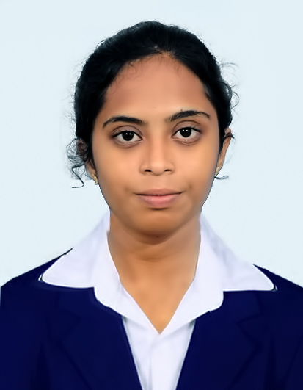

Languages
English
Tamil
DOMAIN KNOWLEDGE
Cloud computing
Advance database Management
Web development

Skills
C Programming
Database Management System
Web Development
CERTIFICATES
Introduction to C
AWS Academy Graduate - AWS Academy Cloud Foundations
Cisco Networking Academy CCNA:
Switching, Routing and Wireless Essentials
Cisco Networking Academy: Data Analytics Essentials

HOBBIES
Painting
Listening to music
Baking cakes

9361401750
Sivaranjani8930@gmail.com
No.192, Pillayar Kovil Street,
Pakkiripalayam, Villupuram, Tamil Nadu.
LinkedIn:
https://www.linkedin.com/in/sivaranjani-s-3a0768335
Github:
https://github.com/sivaranjani8930/sivaranjani.git

Contact

SivaraNJANI S

objective

I am looking for a challenging job with a rapidly growing organization that can provide me with a range of goals and job objectives within a contemporary and economical business setting.

education

Master’s Degree 2024- 2026
Sri Manakula Vinayakar Engineering College, Madagadipet, Puducherry-605 107
Master of Computer Application
SGPA: 9.71
Bachelor’s Degree 2021 - 2024
Achariya Arts And Science College, Villiyanur, Puducherry-605 110
Affiliated to Pondicherry University
B.Sc. Computer Science
Percentage: 76.80%
SSLC 2018- 2019

Subramaniya Bharathi Hr.Sec.School , Thirukkanur, Puducherry -605 501

Percentage: 84%
HSC 2019-2021
Subramaniya Bharathi Hr.Sec.School , Thirukkanur, Puducherry-605 501
Percentage: 89.29%

Projects
Revolutionary Wealth Management
Implemented a blockchain-based platform for startups, enabling secure, transparent recording of investments and donations.
- Tech Stack: Python (3.7+), HTML, CSS, JavaScript, SQLite
Disaster Relief Management System (DRMS)
Developed a web-based where users submit GPS-enabled SOS alerts, volunteers view interactive Leaflet maps to acknowledge tasks and request resources, and admins assign and manage operations through real-time dashboards.
- Tech Stack: HTML, CSS, JavaScript, Bootstrap, Python, SQLite, Leaflet Maps, AI (Random Forest)

extra activities
Completed type writing - Junior [English]
Organized an Technical Event "Technophilia" at AASC.
Co-authored Two Poems (Nappily Ever After and Time)
INTERNSHIP
"Askan Technology Pvt.Limited" On Web Development.
"Syscrop Technology Pvt Limited" On Search Engine Optimization.

