ABSTRACT

In this system, entrepreneurs with startup ideas can upload their projects, and each transaction, be it an investment from an interested party or a donation for education or charity purposes, is securely recorded in a transparent and immutable blockchain.
This ensures an unprecedented level of transparency, as every transaction is verifiable by all parties involved. Investors can seamlessly invest in promising startups, students can request funds for education, and charities can seek support, all while maintaining a trustful and open record of transactions.
This not only enhances accountability but also builds a more efficient and trustworthy ecosystem for fundraising, setting a new standard for monitoring crowdfunding activities. platform, providing a level playing field for all participants and fostering innovation in the finance domain.

LIST OF ABBREVIATIONS

BTC: Bitcoin
ETH: Ethereum
LTC: Litecoin
XRP: Ripple
BCH: Bitcoin Cash
TRX: TRON
DApp: Decentralized Application
ICO: Initial Coin Offering
IEO: Initial Exchange Offering
STO: Security Token Offering
DAO: Decentralized Autonomous Organization
DLT: Distributed Ledger Technology
POW: Proof of Work
POS: Proof of Stake
DPOS: Delegated Proof of Stake
BFT: Byzantine Fault Tolerance

CHAPTER –I
INTRODUCTION

- INTRODUCTION

  - DESCRIPTION OF THE PROJECT:
The project outlined in the paper aims to revolutionize the public welfare crowdfunding sector in India by harnessing the power of blockchain technology, specifically through the adoption of the Proof of Stake (POS) consensus algorithm. Against the backdrop of rapid economic and technological advancements in the country, the public welfare crowdfunding industry has experienced significant growth but has also encountered various challenges. The project proposes leveraging blockchain's core attributes of open consensus, decentralization, and immutability to address these shortcomings. By transitioning from the resource-intensive Proof of Work (POW) algorithm to the energy-efficient POS algorithm, the project seeks to mitigate environmental concerns while enhancing scalability, reducing resource consumption, and improving overall efficiency within the crowdfunding ecosystem. Embracing blockchain technology and transitioning to POS represents a commitment to innovation and resilience, signifying a pivotal step towards building a more sustainable and inclusive future for public welfare crowdfunding in India. Through this project, stakeholders aim to foster transparency, promote community participation, and drive positive social and environmental impact across the nation.

  - PURPOSE OF THE PROJECT:
The purpose of the project is to address the challenges faced by the public welfare crowdfunding sector in India and to pave the way for a more sustainable and resilient future. By harnessing the capabilities of blockchain technology, specifically through the adoption of the Proof of Stake (POS) consensus algorithm, the project aims to overcome limitations associated with the current system, such as environmental concerns and scalability issues. The ultimate goal is to enhance efficiency, transparency, and inclusivity within the crowdfunding ecosystem, thereby empowering communities and driving positive social and environmental change.

CHAPTER-2
LITERATURE REVIEW

2.1 LITERATURE REVIEW:
The growth of China's economy and advancements in science and technology have fueled a thriving public welfare crowdfunding industry. However, this expansion has also brought to light several shortcomings within the sector. In response to the current pain points in public welfare crowdfunding, this article proposes a novel approach leveraging the principles of open consensus, decentralization, and tamper-resistant features inherent in blockchain technology.

Introducing the concept of "public welfare points", the article suggests an innovative application mode for public welfare crowdfunding. The term "public welfare points" could refer to a token or reward system based on blockchain, where participants, including donors, grantees, and other stakeholders, earn or accumulate points based on their contributions and engagement with public welfare initiatives. The proposed model goes beyond traditional crowdfunding by incorporating a reasonable incentive operation mechanism. This mechanism could involve the distribution of public welfare points as rewards for positive contributions, effective use of funds, and active participation in the crowdfunding ecosystem. The goal is to create a system where stakeholders are motivated to engage in ethical and impactful practices, fostering a more accountable and transparent public welfare crowdfunding environment. By integrating blockchain technology, the proposed model aims to enhance trust and participation in public welfare activities.

Technological developments can be effective in every sector, in every subject, as well as in crowdfunding with innovations such as blockchain and bitcoin. While it is important to benefit from funding sources for entrepreneurs, those with investment projects, etc., it is much more important for those who are in a more disadvantaged position to be able to benefit from new and accessible funding sources for their funding needs. Classic crowdfunding can partially provide a solution to these needs. However, classical crowdfunding has some disadvantages as well as other fund alternatives. By taking advantage of the unique opportunities offered by blockchain technology, crowdfunding can come to a much more advantageous position. Blockchain technology-based crowdfunding, which has some features such as being more trustworthy, more understandable, and more open, has emerged from the combination of blockchain technology and crowdfunding. Blockchain technology-based crowdfunding can attract both those in need of funds (e.g., entrepreneurs, investment projects) and those who supply funds (e.g., stakeholders, donors, investors) with the advantages it offers to the processes.

Cryptocurrencies have emerged as a transformative force in the financial and crowdfunding landscape, presenting a secure and decentralized avenue for businesses to raise funds. In contrast to conventional crowdfunding platforms, cryptocurrency systems bring transparency and control to the forefront, offering a novel way to manage donated funds. The integration of social media and crowdfunding platforms facilitates seamless interaction with potential investors and entrepreneurs, streamlining the fundraising process. The use of cryptocurrencies not only provides entrepreneurs with access to international capital but also enhances transparency while reducing transaction costs. Despite the potential advantages, it is crucial to acknowledge and navigate the associated risks, including market volatility, security concerns, and regulatory challenges. The popularity of cryptocurrencies, exemplified by Bitcoin as a decentralized digital currency, has significantly influenced fundraising methodologies.

The proposed initiative to revolutionize the student loan program through blockchain and crowdsourcing responds to the critical challenge of funding higher education in developing countries. Traditionally, governments have been the primary source of student loans, providing financial support through the ministry of education. Students repay these loans with interest once they enter the workforce. However, the global economic crises resulting from events such as COVID-19 and the Russia-Ukraine war have increased government spending, placing additional strain on national budgets. To address this issue, the proposed solution introduces a blockchain-based crowdsourcing decentralized loan platform. This platform aims to involve investors in providing funds for students pursuing higher education. Through registered financial institutions, students can apply for loans from these investors, with the commitment to repay the loans with interest upon entering the workforce. The envisioned platform serves multiple purposes, students gain access to funding for their education, investors receive interest on their investments, and governments can redirect funds previously allocated to student loan programs into other critical areas. This innovative approach introduces a sustainable and efficient mechanism for financing higher education, promoting financial inclusivity and reducing the burden on government resources.

CHAPTER -3
REQUIREMENT ANALYSIS

3.REQUIREMENT ANALYSIS:

3.1 HARDWARE REQUIREMENTS

    - OS: Windows 10 (or above)
    - Processor: Intel(R) core (TM) i5-10th GEN (or above)
    - Ram: 4 GB (or above)
    - Processor speed: 2 GHz
    - Hard disk: 256 GB SSD (or above)

3.2 SOFTWARE REQUIREMENTS:

- Coding language: Python 3.7 and above

- Front End: HTML, CSS, JavaScript

- Back End: Sql lite

3.3 FUNCTIONAL REQUIREMENT:
Functional requirements for the project include:
- Efficient transaction processing
- Secure data handling
- Scalable platform architecture

3.4 NON-FUNCTIONAL REQUIREMENT:
Non-functional requirements for the project encompass:
- Performance: Ensuring system responsiveness and reliability.
- Security: Implementing robust measures to safeguard user data and transactions.
- Scalability: Designing the system to handle increasing user loads without compromising performance.
- Usability: Creating an intuitive and user-friendly interface for both contributors and project initiators.
- Compliance: Adhering to relevant regulatory frameworks and industry standards.
- Interoperability: Ensuring compatibility with existing crowdfunding platforms and blockchain networks.

3.5 PROBLEM DEFINITION:
The proof-of-work algorithm, while effective in securing blockchain networks, has notable disadvantages. One major drawback is its high energy consumption. The computational power required for miners to solve complex mathematical puzzles and validate transactions demands substantial electricity, contributing to environmental concerns and increasing carbon footprints. This energy-intensive process not only poses ecological challenges but also makes the mining process less sustainable and economically viable. Additionally, the proof-of-work algorithm favours miners with significant resources, leading to centralization concerns as larger entities can dominate the mining landscape, potentially compromising the decentralized nature that blockchain technology aims to achieve. The environmental impact and centralization risks associated with proof of work have prompted exploration of alternative consensus mechanisms that address these drawbacks more efficiently.

3.6 EXISTING SYSTEM:
With the advancement of India's economic development and technological prowess, the public welfare crowdfunding sector is experiencing significant growth. However, this expansion has brought to light various shortcomings within the industry. In response to the current pain points in the field of public welfare crowdfunding in India, leveraging the blockchain's foundational principles such as open consensus, decentralization, and tamper-resistant technology can address several of these challenges. Firstly, the use of an open consensus mechanism ensures a transparent and inclusive decision-making process in public welfare crowdfunding initiatives. Blockchain's decentralized nature allows stakeholders to participate in the decision-making process without relying on a central authority. This fosters trust and engagement among participants, as the rules and outcomes are collectively agreed upon through a transparent and open consensus mechanism. Secondly, decentralization in blockchain technology can mitigate issues related to intermediaries and enhance efficiency in the public welfare crowdfunding sector. By eliminating the need for centralized authorities, blockchain reduces the chances of corruption and mismanagement of funds. This not only streamlines the crowdfunding process but also ensures that a higher percentage of the raised funds directly reach the intended beneficiaries, contributing to a more effective and accountable public welfare ecosystem. Lastly, the non-tamperable characteristics of blockchain, particularly through the implementation of proof of work, provide a secure and immutable record of transactions. This helps to build trust among donors and beneficiaries, as the entire history of contributions and fund allocation is verifiable and cannot be altered retrospectively. This tamper-resistant feature adds an extra layer of security and accountability, addressing concerns related to fraud and ensuring the integrity of the public welfare crowdfunding process in India.

3.6.1 DRAWBACKS:

The current public welfare crowdfunding system in India faces several drawbacks. Firstly, its reliance on the resource-intensive Proof of Work (POW) algorithm results in high energy consumption and operational costs, hindering widespread adoption and sustainability. Secondly, this energy-intensive process contributes to environmental concerns, such as carbon emissions and ecological strain. Lastly, scalability limitations pose challenges for accommodating increasing transaction volumes, potentially restricting the system's ability to handle growing demand efficiently. Addressing these drawbacks is crucial for ensuring the long-term viability and effectiveness of public welfare crowdfunding initiatives in India.

PROPOSED SYSTEM

Blockchain technology has significantly transformed the finance sector, particularly in funding mechanisms, by offering a decentralized and transparent alternative to traditional methods.

The proposed system aims to bridge a notable gap in the existing setup by introducing a smart funding platform powered by blockchain.

In this system, entrepreneurs with startup ideas can upload their projects, and every transaction, whether it's an investment from an interested party or a donation for education or charity purposes, is securely recorded in a transparent and immutable blockchain ledger.

This ensures an unparalleled level of transparency, as each transaction is verifiable by all involved parties.

Investors can seamlessly invest in promising startups, students can request funds for education, and charities can seek support, all while maintaining a trustworthy and open record of transactions.

The decentralized nature of blockchain ensures that no central authority controls the platform, providing a level playing field for all participants and fostering innovation in the finance domain.

3.8 GOALS AND OBJECTIVE:
The goals and objectives of the project are centered around leveraging blockchain technology, particularly the Proof of Stake (POS) consensus algorithm, to enhance the public welfare crowdfunding sector in India. The primary goal is to address the existing challenges faced by the sector, such as scalability limitations, environmental concerns, and resource-intensive processes associated with the Proof of Work (POW) algorithm. By transitioning to POS, the project aims to improve efficiency, reduce resource consumption, and mitigate environmental impact, thereby fostering a more sustainable and resilient crowdfunding ecosystem. Additionally, the project seeks to promote transparency, inclusivity, and community participation within the crowdfunding process, ultimately empowering stakeholders and driving positive social and environmental change across India.

3.8.1 ADVANTAGES:
The advantages of transitioning to the Proof of Stake (POS) algorithm in the public welfare crowdfunding sector in India are manifold. Firstly, POS offers a more energy-efficient alternative to the resource-intensive Proof of Work (POW) algorithm, addressing environmental concerns while reducing operational costs. This not only promotes sustainability but also enhances the accessibility of crowdfunding platforms by lowering barriers to entry for both contributors and project initiators. Secondly, POS facilitates scalability, enabling the crowdfunding ecosystem to accommodate increasing transaction volumes without sacrificing efficiency or security.

CHAPTER IV
SYSTEM DESIGN

4. SYSTEM DESIGN:

4.1 SYSTEM ARCHITECTURE:

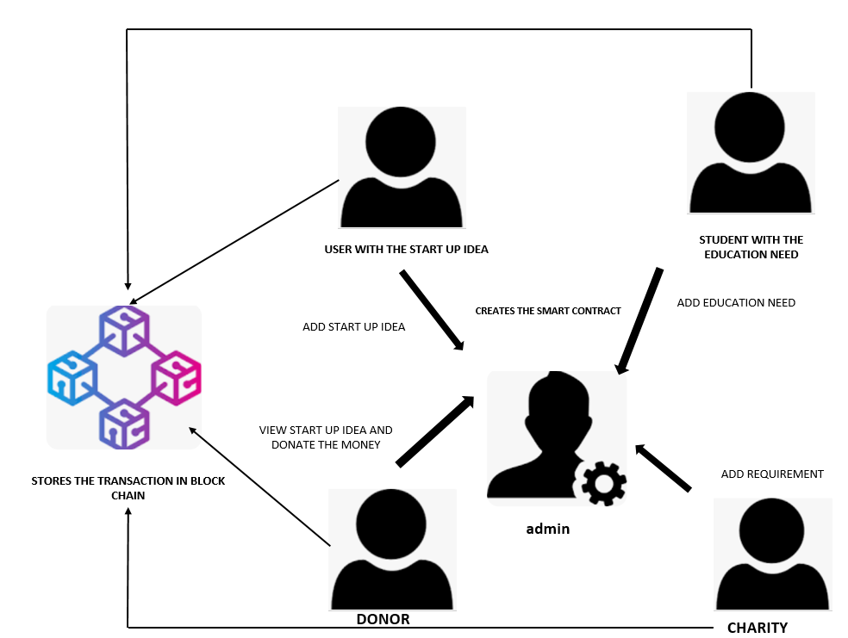

The system architecture of the proposed public welfare crowdfunding platform in India leveraging blockchain technology revolves around a decentralized network powered by the Proof of Stake (POS) consensus algorithm. At its core, the architecture comprises multiple interconnected nodes, each contributing to transaction validation and network security. Smart contracts, deployed on the blockchain, automate the execution of crowdfunding campaigns, ensuring transparency and immutability throughout the process. The frontend interface provides users with access to the platform, enabling them to browse, contribute to, and create crowdfunding campaigns seamlessly. The backend infrastructure manages user authentication, data storage, and interaction with the blockchain network. Additionally, the system incorporates layers of security measures, including encryption protocols and authentication mechanisms, to safeguard user data and transactions. Through this decentralized architecture, the platform aims to foster trust, transparency, and inclusivity, revolutionizing the public welfare crowdfunding landscape in India.

4.2 MODULE DESCRIPTION:
- Creation of user
- Creates the smart contract
- Submit your idea
- Invest the amount
- Student and charity can post the requirement
- Respond by the donor
- Stores the transaction in block chain

USER CREATION:
When you sign up for the platform, you're taking the first step to become a member of the community. You'll start by providing some basic information, like your name, email address, and a secure password. Once you've inputted your details and created your account, you'll gain access to all the features and opportunities the platform has to offer. This secure account ensures that your personal information is protected, and it's the gateway to engaging with projects, making investments, and supporting causes that matter to you.

SMART CONTRACT CREATION:
When you submit your idea or project on the platform, something really cool happens behind the scenes: the platform automatically creates a smart contract for you. Think of a smart contract as a digital agreement that lays out all the terms and conditions of your project in a transparent and secure way. This contract ensures that everyone involved, from investors to project creators, knows exactly what to expect and what their responsibilities are. By outlining these terms upfront, the smart contract builds trust and transparency among all parties, making the crowdfunding process smoother and more reliable for everyone involved.

SUBMIT YOUR IDEA:
As an entrepreneur or project creator, this feature is your chance to showcase your idea to the community. You'll provide all the essential details about your project, such as its goals, timeline, and how much funding you need to bring it to life. This is your opportunity to paint a clear picture of what you're trying to achieve and why it matters. By sharing these details, you're inviting others to join you on your journey and support your vision. Whether you're launching a new startup or pursuing a passion project, this feature empowers you to connect with potential backers and make your idea a reality.

INVESTMENT:
Investors have the opportunity to explore a variety of projects listed on the platform and select the ones that resonate with them. They can review project details, assess potential returns, and decide on the amount they want to invest. Once they've made their decision, the platform facilitates a secure transaction process, allowing investors to transfer their chosen investment amount directly to the project creators. This streamlined and secure process enables investors to support projects they believe in while providing project creators with the necessary funding to bring their ideas to fruition.

STUDENT AND CHARITY REQUESTS:
Students and charities have the opportunity to share their funding needs with the community by posting their requirements on the platform. They can provide detailed information about what they need support for, whether it's tuition fees, educational resources, or funding for charitable initiatives. Additionally, they specify the amount of funding required to meet their needs. By posting their funding requirements, students and charities can connect with potential donors who are interested in supporting their cause. This feature empowers students and charities to reach out to a broader audience and receive the necessary support to achieve their goals.

DONOR RESPONSE:
Donors have the flexibility to browse through the requests posted by students and charities on the platform. They can review the details of each request, including the purpose of the funding and the amount needed. After evaluating the requests, donors can select the ones they feel most compelled to support. Once they've made their decision, donors can respond by offering donations or contributions to help fulfil the specific needs outlined in the requests. This process empowers donors to directly support cuses they care about and enables them to make a meaningful impact on the lives of students and charitable organizations.

TRANSACTION RECORDING:
Recording every transaction securely in the blockchain guarantees transparency and immutability within the crowdfunding platform. This means that once a transaction is recorded, it cannot be altered or deleted, providing assurance to all parties involved. Whether it's an investment in a project or a donation to a student or charity, the transparency of the blockchain allows users to verify transactions independently. This fosters trust among participants and ensures that funds are allocated as intended, creating a reliable and accountable crowdfunding ecosystem.

These modules work together seamlessly to create a user-friendly platform where entrepreneurs can get their projects funded, investors can find promising opportunities, and students/charities can receive the support they need. The blockchain technology ensures transparency, security, and trust throughout the process.

4.3 UML DIAGRAM:
A UML (Unified Modelling Language) diagram is a visual representation of a system or process using standardized symbols and notation. It helps in understanding, designing, and documenting various aspects of a system, such as its structure, behaviour, and interactions. There are several types of UML diagrams, each serving a different purpose:

- Activity Diagram
- Use Case Diagram
- Sequence Diagram
Each type of UML diagram serves a specific purpose and provides a different perspective on the system being modelled. Together, these diagrams help in effectively communicating and understanding the various aspects of a system during the software development lifecycle.

4.4 USE CASE DIAGRAM:

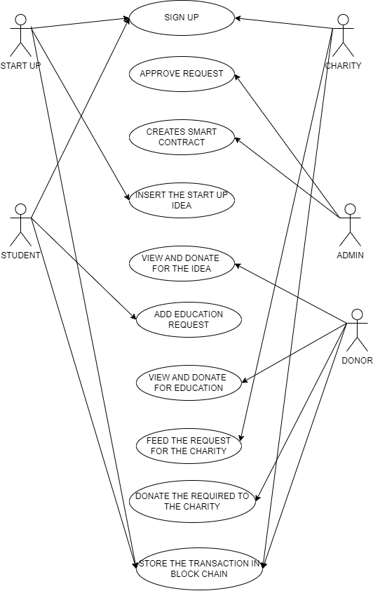

An use case diagram is a visual representation that depicts the interactions between actors and a system. Actors are external entities, such as users or other systems, while use cases represent the functionalities or features provided by the system. Actors are depicted as stick figures or icons outside the system boundary, while use cases are represented as ovals within the boundary. Lines with arrows, called associations, illustrate the relationships between actors and use cases, showing which actors are involved in executing specific functionalities. The system boundary encapsulates all relevant use cases and actors, defining the scope of the system being modelled. Use case diagrams are useful tools for understanding the overall functionality of a system, facilitating requirements analysis, and communicating system behaviour to stakeholders during the software development process.

4.5 SEQUENCE DIAGRAM:

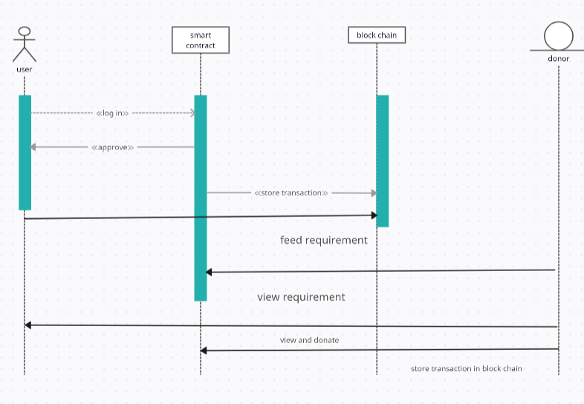

A sequence diagram is a type of UML diagram that depicts the interactions between objects or components in a specific scenario or use case. It illustrates the flow of messages exchanged between objects over time, showing the sequence of actions and their order of execution. In a sequence diagram, objects are represented as lifelines, depicted as vertical lines, with messages exchanged between them represented as horizontal arrows. The sequence of messages is depicted chronologically from top to bottom, reflecting the order in which interactions occur. Optionally, sequence diagrams may include activation boxes to indicate when an object is active during a particular message exchange. These diagrams are invaluable for visualizing the dynamic behaviour of a system, understanding how objects collaborate to achieve a specific task, and identifying potential issues or bottlenecks in system interactions. They serve as effective communication tools for developers, designers, and stakeholders to analyse, design, and document complex system behaviours and interactions during the software development lifecycle.

OVER ALL FLOW DIAGRAM:
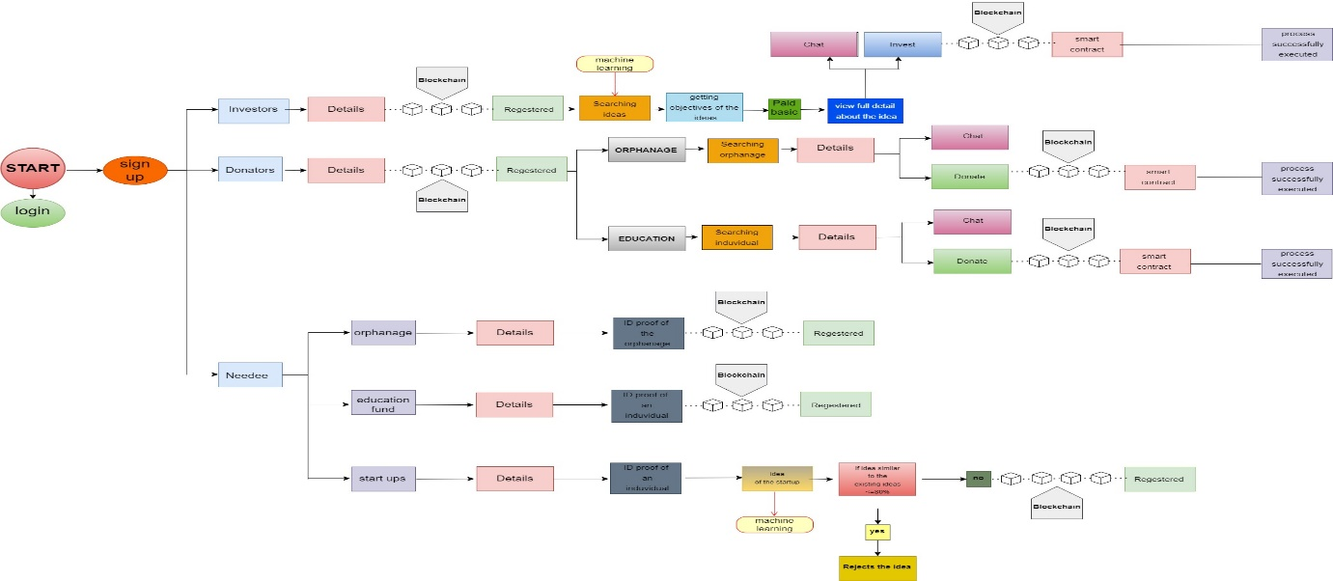

A flow diagram, also known as a flowchart, is a visual representation of a process or workflow, depicting the sequence of steps or actions required to accomplish a specific task or objective. Flow diagrams use standardized symbols and shapes to represent different elements of the process, such as start and end points, decision points, actions, and flow of information or materials. These diagrams typically feature arrows or lines connecting the various elements to illustrate the direction of flow and the relationships between steps. They are widely used in various fields, including software development, engineering, project management, and business process modelling, to analyse, document, and communicate processes effectively. Flow diagrams serve as valuable tools for visualizing and understanding the structure and flow of processes, identifying inefficiencies or bottlenecks, and facilitating process improvement and optimization efforts.

4.5 DATA DESIGN:

4.5.1 DATABASE SCHEMA:

DONOR:

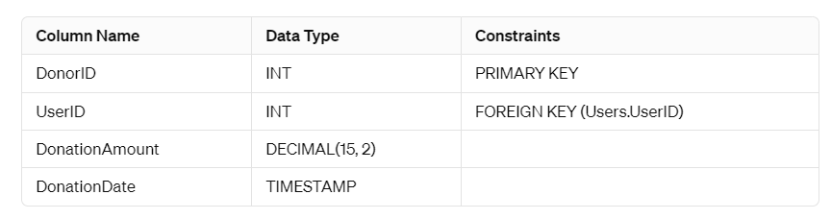

CHARITY:

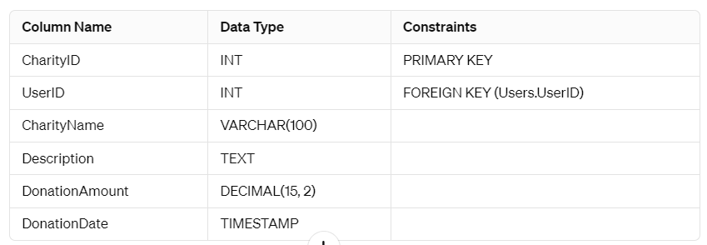

STUDENT:

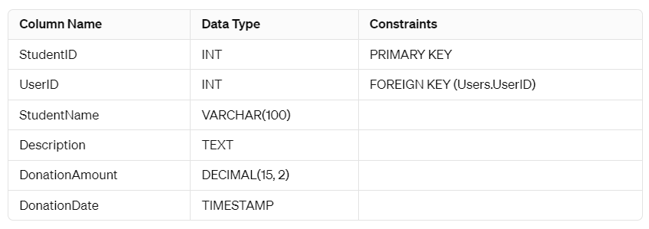
PROJECT:

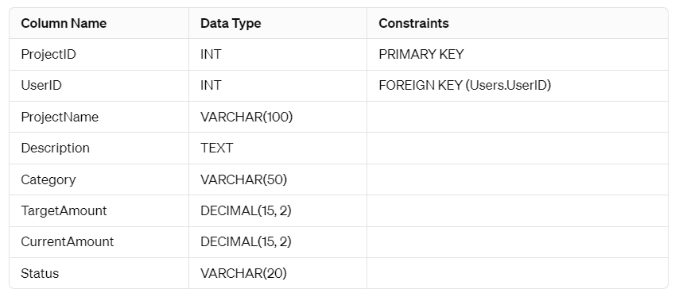

REQUIREMENT:

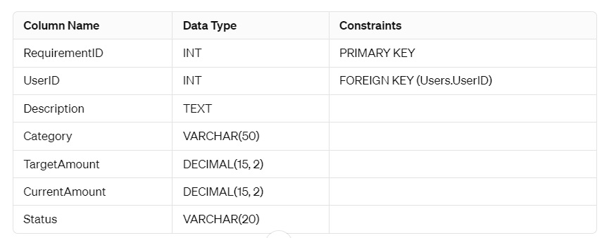

RESPONSES:

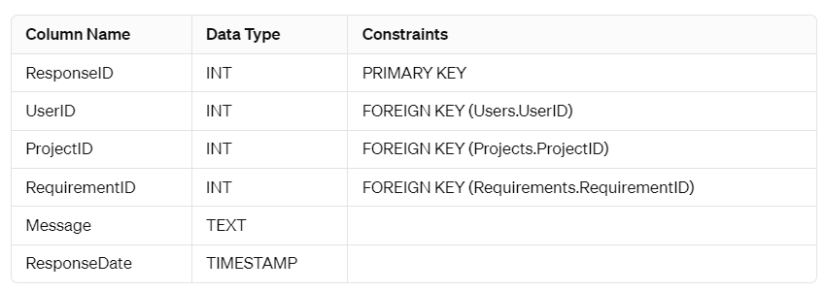

Database design is the process of creating a blueprint for organizing and structuring data within a database system. It involves defining the structure of the database, including tables, columns, relationships, and constraints, to ensure efficient data storage, retrieval, and manipulation. Database designers analyse the requirements of the system and the data it will store, identifying entities, attributes, and relationships that need to be represented in the database schema. They employ techniques such as normalization to eliminate redundancy and ensure data integrity, as well as denormalization to optimize performance in certain scenarios. Additionally, database design involves selecting appropriate data types, indexing strategies, and storage mechanisms to optimize query performance and scalability. The goal of effective database design is to create a well-organized and efficient database schema that meets the functional and performance requirements of the system while minimizing data redundancy and ensuring data integrity.

4.5.2 ER DIAGRAM:

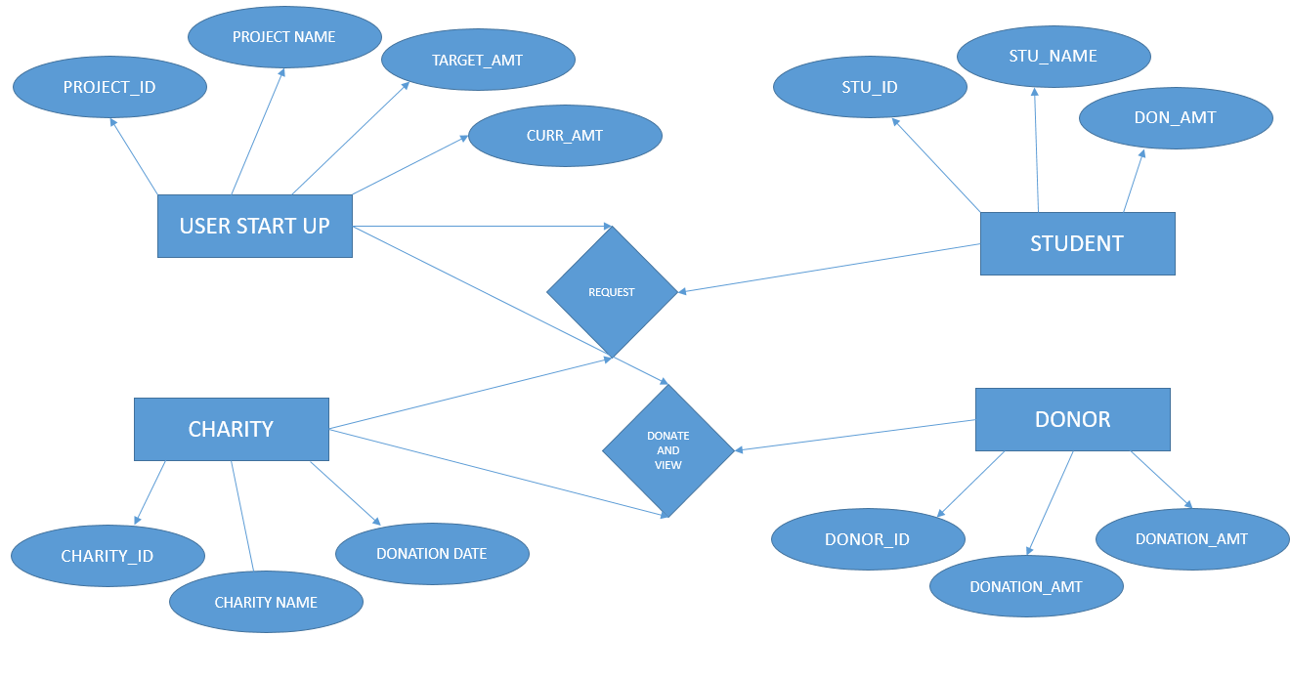

An Entity-Relationship (ER) diagram is a visual representation of the entities, attributes, and relationships within a database system. It illustrates the structure of the database schema, depicting entities as rectangles, attributes as ovals, and relationships as lines connecting entities. ER diagrams help database designers and stakeholders understand the organization of data within the system, providing a high-level overview of its structure and relationships. Entities represent the real-world objects or concepts being modelled, such as customers, products, or orders, while attributes describe the properties or characteristics of those entities. Relationships establish connections between entities, indicating how they are related or associated with each other. For example, a customer entity may be related to an order entity through a "places" relationship, signifying that customers place orders. ER diagrams are essential tools for database design, enabling stakeholders to visualize the database schema, identify potential design flaws or inconsistencies, and ensure that the database accurately represents the real-world domain it is intended to model.

4.6 CODING:
import os
from datetime import datetime
from flask import *
import sqlite3
from werkzeug.utils import secure_filename
app = Flask(__name__)
app.secret_key = "secret key"
app.config['UPLOAD_FOLDER'] = 'static/uploads'
@app.route("/")
def index():
return render_template("index.html")
@app.route('/logon')
def logon():
return render_template('signup.html')
@app.route("/signup",methods=["post","get"])
def signup():
username =request.form['user']
name = request.form['name']
email = request.form['email']
number = request.form["mobile"]
password = request.form['password']
role="student"
con = sqlite3.connect('crowdfunding.db')
cur = con.cursor()
cur.execute("insert into `userid` (`user`,`email`, `password`,`mobile`,`name`) VALUES ( ?, ?, ?, ?,?)",(username,email,password,number,name))
con.commit()
con.close()
return render_template("index.html")
@app.route("/signin",methods=["post"])
def signin():
mail1 = request.form['user']
password1 = request.form['password']
con = sqlite3.connect('crowdfunding.db')
data=0
data =con.execute("select userid,`user`, `password`,mobile from userid where `user` = ? AND `password` = ?",(mail1,password1,)).fetchall()
print(data)
try:
if mail1 == 'admin' and password1 == 'admin':
session['username'] ="admin"
return redirect("userlogin")
elif mail1 == str(data[0][1]) and password1 == str(data[0][2]):
print(data)
session['username'] =data[0][0]
session['mobile'] =data[0][3]
return redirect("userlogin")
except Exception as e:
print(e)
return redirect("/")
@app.route("/userlogin")
def userlogin():
return render_template("Otp.html",mobile=session["mobile"])
@app.route('/logout')
def home():
session.pop('username', None)
return render_template("index.html")
@app.route("/mobileotp",methods=["POST"])
def mobileotp():
# import random as rd
# otp=str(rd.randint(0000,9999))
# print(otp)
# import requests
# mobile=session["mobile"]
# session["otp"]=otp
# url='https://www.fast2sms.com/dev/bulkV2?authorization=xv2Z1X4jYGSJcURzBFwnWusMDq7PpkCg6HblLNrIT9O8tVAhKf9YvmuJZViftd5bQPD3alwG4hzLg1cA&route=otp&variables_values='+str(otp)+'&flash=0&numbers='+str(mobile)
# print(url)
# requests.get(url)
# return render_template("student.html")
return redirect(url_for('check'))
@app.route("/check",methods=["POST","GET"])
def check():
otp=session["otp"]
# sotp=request.form['user']
otp=0
sotp=0
print(otp,sotp)
if(otp==sotp):
users=session['username']
return render_template("success.html",users=users)
else:
return render_template("student.html")
@app.route('/crowdfunding', methods=['GET', 'POST'])
def crowdfunding():
if request.method == 'POST':
eventname = request.form['eventname']
datetimefrom = request.form['datetimefrom']
datetimeto = request.form['datetimeto']
description = request.form['description']
total = request.form['total']
userid = request.form['userid']
# Save crowdfunding data to the database
conn = sqlite3.connect('crowdfunding.db')
cursor = conn.cursor()
cursor.execute('''INSERT INTO crowdfunding (eventname, datetimefrom, datetimeto, description, total, userid)
VALUES (?, ?, ?, ?, ?, ?)''', (eventname, datetimefrom, datetimeto, description, total, userid))
conn.commit()
conn.close()
eventid = cursor.lastrowid
# Handle image uploads
files = request.files.getlist("file")
# Iterate for each file in the files List, and Save them
for file in files:
file.save("static/uploads/"+file.filename)
conn = sqlite3.connect('crowdfunding.db')
cursor = conn.cursor()
cursor.execute('''INSERT INTO crowdimage (eventid, image) VALUES (?, ?)''', (eventid, file.filename))
conn.commit()
conn.close()
return redirect(url_for('uploadfil'))
return render_template('crowdfunding.html')
@app.route("/uploadfil",methods=["POST","GET"])
def uploadfil():
users=session['username']
return render_template("success.html",users=users)
@app.route('/viewfund')
def viewfund():
# Connect to the database
conn = sqlite3.connect('crowdfunding.db')
cursor = conn.cursor()
# Fetch crowdfunding events with their images
cursor.execute('''SELECT * FROM crowdfunding ORDER BY eventid DESC''')
crowdfunding_data = cursor.fetchall()
data=[]
for k in crowdfunding_data:
cursor = conn.cursor()
# Fetch crowdfunding events with their images
cursor.execute('''SELECT * FROM crowdimage where eventid="%s"'''%(k[0]))
crowd_img = cursor.fetchall()
# Close the connection
k=list(k)
k.append(crowd_img)
data.append(k)
print(data)
conn.close()
current_date = datetime.now().strftime('%Y-%m-%d %H:%M:%S')
return render_template('crowdfunding.html', crowdfunding_data=data, current_date=current_date)
@app.route('/viewfundtransaction',methods=["POST","GET"])
def viewfundtransaction():
i = request.args.get('id')
# Connect to the database
conn = sqlite3.connect('crowdfunding.db')
cursor = conn.cursor()
# Fetch crowdfunding events with their images
cursor.execute('''SELECT * FROM crowdfundingtranscanction where eventid="%s"'''%(i))
crowdfunding_data = cursor.fetchall()
conn.close()
# Render the HTML template with the crowdfunding data
return render_template('crowdfundingfund.html', crowdfunding_data=crowdfunding_data)
@app.route("/deletefund",methods=["POST","GET"])
def deletefund():
i = request.args.get('id')
mydb = sqlite3.connect('crowdfunding.db')
mycursor = mydb.cursor()
tx="delete from crowdfunding where eventid={0}".format(i)
mycursor.execute(tx)
mycursor = mydb.cursor()
tx="delete from crowdimage where eventid={0}".format(i)
mycursor.execute(tx)
mydb.commit()
mydb.close()
return redirect("viewfund")
@app.route('/insert_transaction', methods=['POST'])
def insert_transaction():
amount = request.form['amount']
userid = request.form['userid']
eventid = request.form['eventid']
remark = request.form['remark']
transactiondate = request.form['transactiondate']
conn = sqlite3.connect('crowdfunding.db')
cursor = conn.cursor()
cursor.execute('''INSERT INTO crowdfundingtranscanction (amount, userid, remark, transactiondate,eventid)
VALUES (?, ?, ?, ?,?)''', (amount, userid, remark, transactiondate,eventid))
d="update crowdfunding set total =total+'%s' where eventid='%s'"%(amount,eventid)
mycursor = conn.cursor()
mycursor.execute(d)
conn.commit()
conn.close()
return redirect("viewfund")
if __name__ == '__main__':
app.run(debug=True)
import os
from datetime import datetime
from flask import *
import sqlite3
from werkzeug.utils import secure_filename
app = Flask(__name__)

app.secret_key = "secret key"
app.config['UPLOAD_FOLDER'] = 'static/uploads'
@app.route("/")
def index():
return render_template("index.html")
@app.route('/logon')
def logon():
return render_template('signup.html')
@app.route("/signup",methods=["post","get"])
def signup():
username =request.form['user']
name = request.form['name']
email = request.form['email']
number = request.form["mobile"]
password = request.form['password']
role="student"
con = sqlite3.connect('crowdfunding.db')
cur = con.cursor()
cur.execute("insert into `userid` (`user`,`email`, `password`,`mobile`,`name`) VALUES ( ?, ?, ?, ?,?)",(username,email,password,number,name))
con.commit()
con.close()
return render_template("index.html")
@app.route("/signin",methods=["post"])
def signin():
mail1 = request.form['user']
password1 = request.form['password']
con = sqlite3.connect('crowdfunding.db')
data=0
data =con.execute("select userid,`user`, `password`,mobile from userid where `user` = ? AND `password` = ?",(mail1,password1,)).fetchall()
print(data)
try:
if mail1 == 'admin' and password1 == 'admin':
session['username'] ="admin"
return redirect("userlogin")
elif mail1 == str(data[0][1]) and password1 == str(data[0][2]):
print(data)
session['username'] =data[0][0]
session['mobile'] =data[0][3]
return redirect("userlogin")
except Exception as e:
print(e)
return redirect("/")
@app.route("/userlogin")
def userlogin():
return render_template("Otp.html",mobile=session["mobile"])
@app.route('/logout')
def home():
session.pop('username', None)
return render_template("index.html")
@app.route("/mobileotp",methods=["POST"])
def mobileotp():
# import random as rd
# otp=str(rd.randint(0000,9999))
# print(otp)
# import requests
# mobile=session["mobile"]
# session["otp"]=otp
# url='https://www.fast2sms.com/dev/bulkV2?authorization=xv2Z1X4jYGSJcURzBFwnWusMDq7PpkCg6HblLNrIT9O8tVAhKf9YvmuJZViftd5bQPD3alwG4hzLg1cA&route=otp&variables_values='+str(otp)+'&flash=0&numbers='+str(mobile)
# print(url)
# requests.get(url)
# return render_template("student.html")
return redirect(url_for('check'))

@app.route("/check",methods=["POST","GET"])
def check():
otp=session["otp"]
# sotp=request.form['user']
otp=0
sotp=0
print(otp,sotp)
if(otp==sotp):
users=session['username']
return render_template("success.html",users=users)
else:
return render_template("student.html")
@app.route('/crowdfunding', methods=['GET', 'POST'])
def crowdfunding():
if request.method == 'POST':
eventname = request.form['eventname']
datetimefrom = request.form['datetimefrom']
datetimeto = request.form['datetimeto']
description = request.form['description']
total = request.form['total']
userid = request.form['userid']
# Save crowdfunding data to the database
conn = sqlite3.connect('crowdfunding.db')
cursor = conn.cursor()
cursor.execute('''INSERT INTO crowdfunding (eventname, datetimefrom, datetimeto, description, total, userid)
VALUES (?, ?, ?, ?, ?, ?)''', (eventname, datetimefrom, datetimeto, description, total, userid))
conn.commit()
conn.close()
eventid = cursor.lastrowid
# Handle image uploads
files = request.files.getlist("file")
# Iterate for each file in the files List, and Save them
for file in files:
file.save("static/uploads/"+file.filename)
conn = sqlite3.connect('crowdfunding.db')
cursor = conn.cursor()
cursor.execute('''INSERT INTO crowdimage (eventid, image) VALUES (?, ?)''', (eventid, file.filename))
conn.commit()
conn.close()
return redirect(url_for('uploadfil'))
return render_template('crowdfunding.html')
@app.route("/uploadfil",methods=["POST","GET"])
def uploadfil():
users=session['username']
return render_template("success.html",users=users)
@app.route('/viewfund')
def viewfund():
# Connect to the database
conn = sqlite3.connect('crowdfunding.db')
cursor = conn.cursor()
# Fetch crowdfunding events with their images
cursor.execute('''SELECT * FROM crowdfunding ORDER BY eventid DESC''')
crowdfunding_data = cursor.fetchall()
data=[]
for k in crowdfunding_data:
cursor = conn.cursor()
# Fetch crowdfunding events with their images
cursor.execute('''SELECT * FROM crowdimage where eventid="%s"'''%(k[0]))
crowd_img = cursor.fetchall()
# Close the connection
k=list(k)
k.append(crowd_img)
data.append(k)
print(data)
conn.close()
current_date = datetime.now().strftime('%Y-%m-%d %H:%M:%S')
return render_template('crowdfunding.html', crowdfunding_data=data, current_date=current_date)

@app.route('/viewfundtransaction',methods=["POST","GET"])
def viewfundtransaction():
i = request.args.get('id')
# Connect to the database
conn = sqlite3.connect('crowdfunding.db')
cursor = conn.cursor()
# Fetch crowdfunding events with their images
cursor.execute('''SELECT * FROM crowdfundingtranscanction where eventid="%s"'''%(i))
crowdfunding_data = cursor.fetchall()
conn.close()
# Render the HTML template with the crowdfunding data
return render_template('crowdfundingfund.html', crowdfunding_data=crowdfunding_data)
@app.route("/deletefund",methods=["POST","GET"])
def deletefund():
i = request.args.get('id')
mydb = sqlite3.connect('crowdfunding.db')
mycursor = mydb.cursor()
tx="delete from crowdfunding where eventid={0}".format(i)
mycursor.execute(tx)
mycursor = mydb.cursor()
tx="delete from crowdimage where eventid={0}".format(i)
mycursor.execute(tx)
mydb.commit()
mydb.close()
return redirect("viewfund")
@app.route('/insert_transaction', methods=['POST'])
def insert_transaction():
amount = request.form['amount']
userid = request.form['userid']
eventid = request.form['eventid']
remark = request.form['remark']
transactiondate = request.form['transactiondate']
conn = sqlite3.connect('crowdfunding.db')
cursor = conn.cursor()
cursor.execute('''INSERT INTO crowdfundingtranscanction (amount, userid, remark, transactiondate,eventid)
VALUES (?, ?, ?, ?,?)''', (amount, userid, remark, transactiondate,eventid))
d="update crowdfunding set total =total+'%s' where eventid='%s'"%(amount,eventid)
mycursor = conn.cursor()
mycursor.execute(d)
conn.commit()
conn.close()
return redirect("viewfund")
if __name__ == '__main__':
app.run(debug=True)
import sqlite3
# Connect to SQLite database (creates a new database if it doesn't exist)
conn = sqlite3.connect('crowdfunding.db')
# Create a cursor object to execute SQL commands
cursor = conn.cursor()
# Create tables
cursor.execute('''CREATE TABLE IF NOT EXISTS userid (
userid INTEGER PRIMARY KEY,
user TEXT,
name TEXT,
email TEXT,
mobile TEXT,
password TEXT
)''')
cursor.execute('''CREATE TABLE IF NOT EXISTS crowdfunding (
eventid INTEGER PRIMARY KEY,
eventname TEXT,
datetimefrom TEXT,
datetimeto TEXT,
description TEXT,
total REAL,
userid INTEGER,
FOREIGN KEY (userid) REFERENCES userid(userid)
)''')
cursor.execute('''CREATE TABLE IF NOT EXISTS crowdimage (
imageid INTEGER PRIMARY KEY,
eventid INTEGER,
image text,
FOREIGN KEY (eventid) REFERENCES crowdfunding(eventid)
)''')
cursor.execute('''CREATE TABLE IF NOT EXISTS crowdfundingtranscanction (
ctid INTEGER PRIMARY KEY,
amount REAL,
userid INTEGER,
remark TEXT,
transactiondate TEXT,
eventid INTEGER,
FOREIGN KEY (eventid) REFERENCES crowdfunding(eventid),
FOREIGN KEY (userid) REFERENCES userid(userid)
)''')
cursor.execute('''CREATE TABLE IF NOT EXISTS transcrowdamount (
tcid INTEGER PRIMARY KEY,
eventid INTEGER,
requestdate TEXT,
FOREIGN KEY (eventid) REFERENCES crowdfunding(eventid)
)''')
# Commit changes and close connection
conn.commit()
conn.close()
print("Database and tables created successfully.")

4.7 USER INTERFACE DESIGN:
User interface (UI) design plays a pivotal role in shaping the user experience (UX) of software applications and systems. It involves creating interfaces that users interact with to accomplish tasks, access information, and navigate through the application. UI designers focus on elements such as layout, colour scheme, typography, and visual hierarchy to create interfaces that are visually appealing and easy to use. By considering user preferences, behaviours, and needs, UI designers strive to design interfaces that facilitate seamless interactions and enhance overall usability. Through wireframing, prototyping, and iterative design processes, UI designers refine and iterate on interface designs to ensure they meet the functional requirements and align with the goals of the project.

Effective UI design goes beyond aesthetics; it also encompasses usability and accessibility. UI designers employ principles of usability design to ensure interfaces are intuitive, efficient, and easy to learn. This involves organizing content logically, providing clear navigation paths, and minimizing cognitive load to streamline the user experience. Additionally, UI designers consider accessibility standards and guidelines to ensure interfaces are accessible to users with disabilities. By designing interfaces that are inclusive and accessible to all users, UI designers contribute to creating software applications that can be used by a diverse range of people, regardless of their abilities or technical expertise. Collaboration is a key aspect of UI design, as it involves working closely with other team members, including UX designers, developers, and stakeholders. UI designers collaborate with UX designers to ensure that interface designs align with user needs and goals identified through user research and testing. They also collaborate with developers to ensure that interface designs are implemented accurately and efficiently. Throughout the design process, UI designers solicit feedback from stakeholders and iterate on designs based on their input to ensure that interface designs meet project requirements and objectives. By fostering collaboration and communication among team members, UI designers play a crucial role in delivering successful software applications that meet user needs and expectations.

CHAPTER V
IMPLEMENTATION

5. IMPLEMENTATION
Insert screen shot

CHAPTER VI
SOFTWARE TESTING

6. SOFTWARE TESTING:
Testing is an integral part of the software development lifecycle, serving as a critical mechanism for ensuring the quality, reliability, and functionality of a system. By systematically assessing the behaviour of software against predetermined criteria, testing helps identify and rectify defects or issues early in the development process. This proactive approach not only enhances the overall quality of the product but also reduces the likelihood of costly errors reaching the end-users. Various levels and types of testing are employed throughout the software development lifecycle, each serving a specific purpose. Unit testing involves testing individual components or units of code in isolation to ensure they function as intended. Integration testing focuses on verifying that different units or modules work together seamlessly within the system. System testing assesses the system as a whole to validate its compliance with specified requirements and to uncover any discrepancies between expected and actual behaviour. Finally, acceptance testing involves evaluating the system's readiness for deployment by ensuring it meets the needs and expectations of stakeholders. Through rigorous testing practices, software development teams can gain confidence in the reliability and functionality of their products. By identifying and addressing defects early on, testing helps mitigate risks, enhances user satisfaction, and ultimately contributes to the successful delivery of high-quality software solutions. Effective testing methodologies not only detect issues but also serve as a foundation for continuous improvement, enabling teams to refine and optimize their processes for future projects.

6.1 TYPE OF TESTING:

UNIT TESTING:
Unit testing plays a crucial role in software development by facilitating code refactoring and improving code quality and reliability. As developers make changes to the codebase, unit tests provide a safety net, ensuring that existing functionality remains intact and that new features or modifications do not introduce unintended side effects. Additionally, unit tests serve as living documentation, providing insights into the expected behaviour of the code and serving as a reference for future development efforts. Automated testing frameworks and tools, such as JUnit for Java or pytest for Python, streamline the unit testing process by allowing developers to write and execute tests efficiently and enabling continuous integration and delivery practices. By incorporating unit testing into the development workflow, teams can build robust and maintainable software systems while minimizing the risk of regressions and defects.
INTEGRATION TESTING:
Integration testing is a software testing technique where individual units or components of a system are combined and tested as a group to evaluate their interactions and integration. The purpose of integration testing is to uncover defects that may arise due to interactions between different units or components when they are integrated together. Unlike unit testing, which focuses on testing individual units in isolation, integration testing verifies the behaviour of the system as a whole and ensures that all integrated components function correctly together. Integration testing can be performed at various levels, including module-level integration, where modules are combined and tested, and system-level integration, where the entire system is tested as a whole. By identifying and addressing integration issues early in the development lifecycle, integration testing helps ensure the overall reliability and stability of the software system.

VALIDATION TESTING:
Validation testing, also known as acceptance testing or user acceptance testing (UAT), is a type of software testing performed to evaluate whether a system meets the specified requirements and satisfies the needs of its stakeholders. Validation testing involves testing the system against user expectations and real-world scenarios to ensure that it behaves as intended and delivers the expected value to users. Unlike other types of testing that focus on technical aspects of the system, validation testing focuses on validating the business logic, functionality, usability, and overall user experience of the software. Validation testing is typically performed by end-users, customers, or other stakeholders in a production-like environment to simulate real-world usage scenarios and provide feedback on the system's performance and suitability.

FUNCTION TESTING:
Function testing, also known as functional testing, is a software testing technique that focuses on verifying the functionality of a system by testing individual functions, features, or capabilities against specified requirements and use cases. The goal of function testing is to ensure that each function or feature of the system performs as expected and meets the defined functional requirements. Function testing involves executing test cases that cover various scenarios, inputs, and outputs to validate the behaviour of the system under different conditions. It encompasses testing both primary and secondary functions of the system, including user interactions, data processing, calculations, and error handling. Function testing is an essential part of the software testing process and helps ensure the correctness and reliability of the system's functionality.

WHITE-BOX TESTING:
White-box testing, also known as structural testing or clear-box testing, is a software testing technique that focuses on testing the internal structure, logic, and code of a system. Unlike black-box testing, where testers evaluate the system's functionality without knowledge of its internal implementation, white-box testing involves examining the internal workings of the system, including source code, algorithms, and data structures. White-box testing techniques include statement coverage, branch coverage, path coverage, and condition coverage, which aim to ensure that all paths and logical conditions within the code are tested thoroughly. White-box testing is typically performed by developers during the coding phase to validate the correctness of their code and identify any logic errors, bugs, or vulnerabilities. It helps ensure code quality, reliability, and maintainability by uncovering defects early in the development process and facilitating code review and debugging efforts.

CHAPTER VII
7. CONCLUSION AND FUTURE ENHANCEMENT

7.1 CONCLUSION:
In conclusion, the rapid growth of the public welfare crowdfunding industry in India amid economic and technological advancements has underscored the need for innovative solutions to address its inherent challenges. This paper has proposed leveraging blockchain technology, particularly the transition from the resource-intensive Proof of Work (POW) algorithm to the energy-efficient Proof of Stake (POS) algorithm, to enhance the sector's sustainability and resilience. By harnessing blockchain's open consensus, decentralization, and non-temperable characteristics, POS offers a promising avenue for mitigating environmental concerns and improving efficiency in achieving consensus within the crowdfunding ecosystem. Through an exploration of POS's advantages, such as scalability and reduced resource consumption, this paper has highlighted its potential to transform the crowdfunding landscape in India. Embracing blockchain technology and adopting POS, akin to wearing the metaphorical "hardhat" of innovation and resilience, can pave the way for a more sustainable and resilient future for public welfare crowdfunding initiatives in the country. This transition signifies a paradigm shift towards a more efficient and environmentally conscious crowdfunding ecosystem, aligning with the broader goals of sustainable development and social impact in India's evolving economic landscape.

7.2 FUTURE WORK:
- Exploring opportunities for collaboration and integration between blockchain-based crowdfunding platforms and traditional financial institutions to facilitate seamless cross-border transactions, liquidity provision, and access to diverse funding sources.
- Addressing barriers to entry and promoting inclusivity in crowdfunding by developing user-friendly interfaces, supporting multiple payment methods, and ensuring accessibility for individuals with disabilities or limited internet connectivity.
- Enhancing the security and reliability of smart contracts used in public welfare crowdfunding platforms through rigorous auditing processes and the adoption of best practices in smart contract development and deployment.

REFERENCE:

- Li Y, and Hu D.Q, “Application of Blockchain in Charity Donation Use Case,” Information Technology & Standardization, vol. 03, pp.25-27+30, 2017.
- Huang J.H,Gao L.C,Xu Y.Z,Bai X.M,Hu K, “The Design of Smart Contracts on Crowd Funding Private Blockchain,”Journal of Information Security Research, vol. 02, pp.211–219,2017
- Li Q,Li Q,Zhu J.M,Guan X.Y,Wang H,Qie C.X, “Model and Platform of Charity Application Based on Block Chain Technology,” Journal of Computer Applications, vol.37(S2), pp. 287–292,2017.
- Liu H.F,Wang Y.Y, “Application of Blockchain Technology in Public Welfare,” China Management Informationization,vol.22(14),pp.155 ̽ 157,2019
- Cai M.Z,Wang L,Wu J, “Research on the Application of Blockchain Technology in the Field of Internet Public Welfare Crowdfunding,” Library & Information,vol.02,pp.76-80,2020
- Li Y Fan C.J An Y.Z, “Research on the Application of Block chain Technology Based on Internet + Charity in the field of Fundraising”. Intelligent Computer and Applications, vol.10(06), pp.86- 88+91,2020
- Shi Y.X, “Blockchain helps public charity more transparent”. Information and Communications Technology and Policy, vol.04, pp.77-79,2020 [8] Wang X.N, “Research on the Application of Blockchain in Public Welfare Industry”. Computer Knowledge and Technology,vol.16,pp.246- 248,2020
- Adhikary, B. K., Kutsuna, K., & Hoda, T. (2018). Crowdfunding: lessons from Japan's approach. Singapore: Springer. Benila, S., Ajay, V., Hrishikesh, K., & Karthik, R. (2019).
- Crowd Funding using Blockchain. Global Research and Development Journal for Engineering, 4(4), 19-24. Desabathina, N. V. M., Merugu, S., Gunjan, V. K., & Kumar, B. S. (2022).
- Agricultural Crowdfunding Through Blockchain. In ICDSMLA 2020 (pp. 1643-1650). Springer, Singapore. Fan, Y., Ao, C., & Jingren, L. (2021).
- Research on the Application Model of Public Welfare Crowdfunding Based on Blockchain Technology. In 2021 2nd International Conference on ECommerce and Internet Technology (ECIT) (pp. 441-445). IEEE.
- Hassija, V., Chamola, V., & Zeadally, S. (2020). BitFund: A blockchain-based crowdfunding platform for future smart and connected nation. Sustainable Cities and Society, 60, 102145. https://doi.org/10.1016/j.scs.2020.102145
- Jaziri, R., & Miralam, M. (2019). Modelling the crowdfunding technology adoption among novice entrepreneurs: an extended TAM model. Entrepreneurship and Sustainability Issues, 7(1), 353-374.

