E-commerce Sales Data Analysis and Dashboard using Excel

Project Overview:
This project analyses an E-commerce sales dataset using Microsoft Excel. The data was cleaned, transformed, and organised into structured tables for Customers, Products, Stores, and Sales transactions. Using formulas, lookups, Pivot Tables, and charts, an interactive dashboard was created to understand sales performance.

Dataset Description:
The dataset contains transaction level sales data from an e-commerce business.
Each row represents one sales transaction and is linked to customer, product, and store information.
The data is organized into four tables: Customers, Products, Stores, and Sales.
Data Cleaning & Preparation:
• Removed duplicate rows
• Fixed inconsistent text values (example: “male”, “Male” → “Male”)
• Corrected date and currency formats
• Checked and filled missing values where needed
• Created calculated columns:
- Total Price = Quantity × Unit Price
- Discount Amt = Total Price × Discount
- Sales Amount = Total Price – Discount Amt
• Used lookup formulas to bring customer, product, and store details into the Sales table for analysis.

Visualization and Insights
(Used Pivot Charts: Column, Bar, Pie)

Dashboard Overview

Key Insights from Dashboard:
- Total Sales: Overall sales amount is ₹21,70,313.

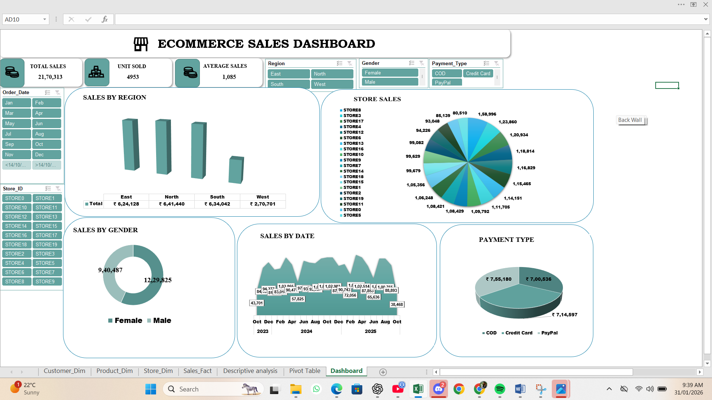

- Gender Contribution:
  - Female customers generate ₹12,29,825 in sales.
  - Male customers generate ₹9,40,487 in sales.
  - Female customers contribute ₹2,89,338 more revenue than male customers.
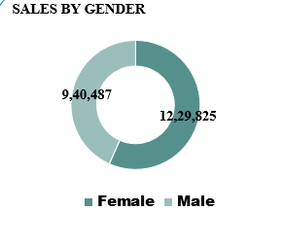
- Preferred Payment Method:
  - PayPal contributes the highest sales with ₹7,55,180.
  - It slightly outperforms Credit Card and COD in total revenue.
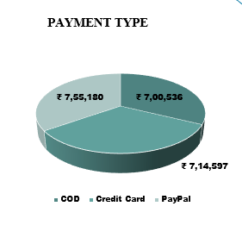
- Best Performing Region:
  - North region records the highest sales of ₹6,41,440, leading all other regions.
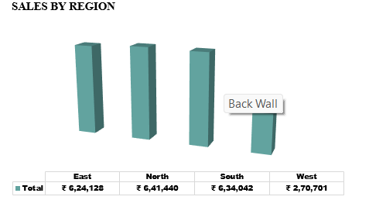

- Top Store:
  - STORE8 is the highest performing store with sales of ₹1,58,996.
  - This indicates strong local demand and effective store performance.
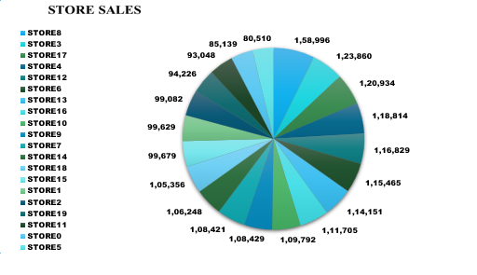

Business Interpretation:
- Focus marketing on the top payment method to increase conversions.
- Replicate best practices from the top store in lower performing stores.
- Target the leading customer segment for personalised campaigns.
- Improve performance in lower sales regions for balanced growth.
Conclusion:
This project demonstrates complete data cleaning, integration, analysis, and visualisation using Excel. The dashboard provides clear, data-driven insights to support business decisions.

