In this project we have built CNN model to detect HELMETS and number plates from 25 different images and we can detect more images but we don’t have sufficient dataset to train CNN model so our application can detect presence of helmet from 25 different images and if helmet not present then it will identify number plate and if helmet detected then it will not identify number plate.

To run project double click on ‘run.bat’ file to get below screen

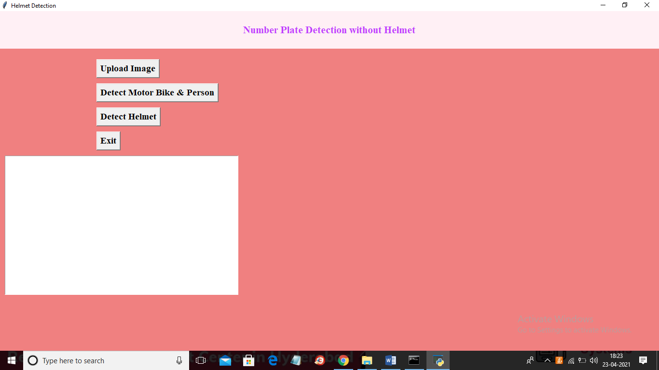

In above screen click on ‘Upload Image’ button to upload image

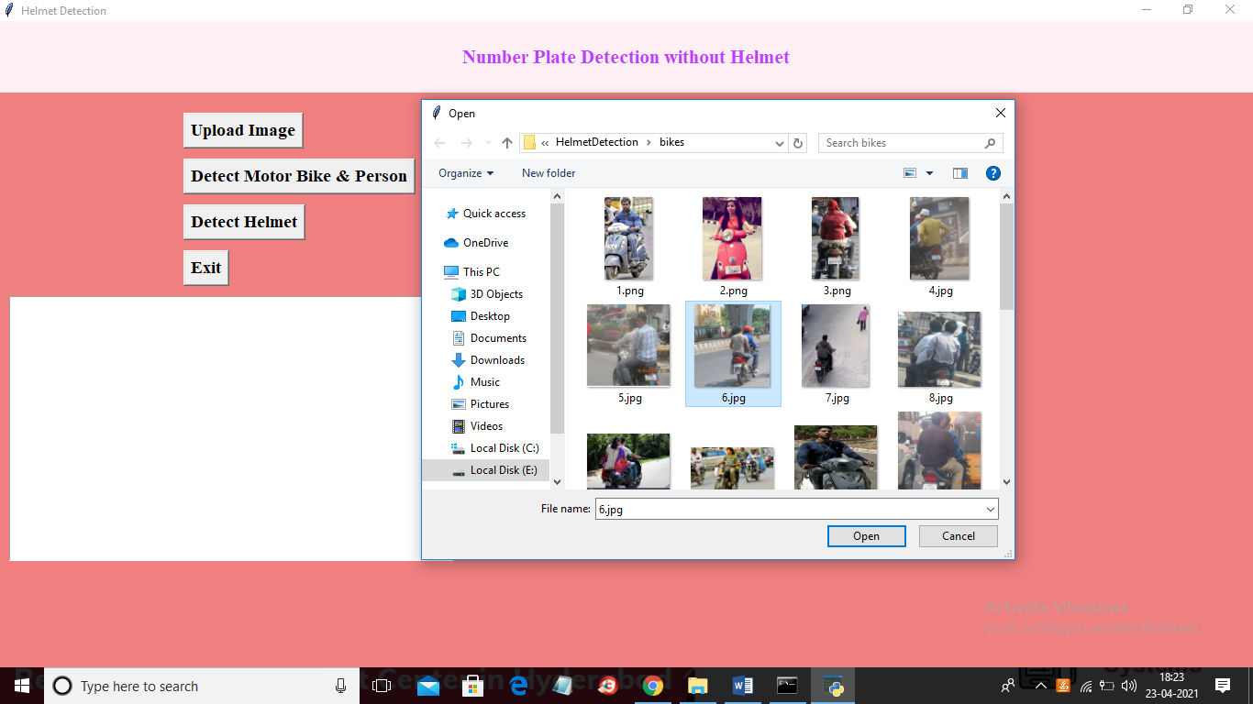

In above screen selecting and uploading ‘6.jpg’ file and then click on ‘Open’ button to load image and then click on ‘Detect Motor Bike & Person’ button to detect whether image contains person with bike or not

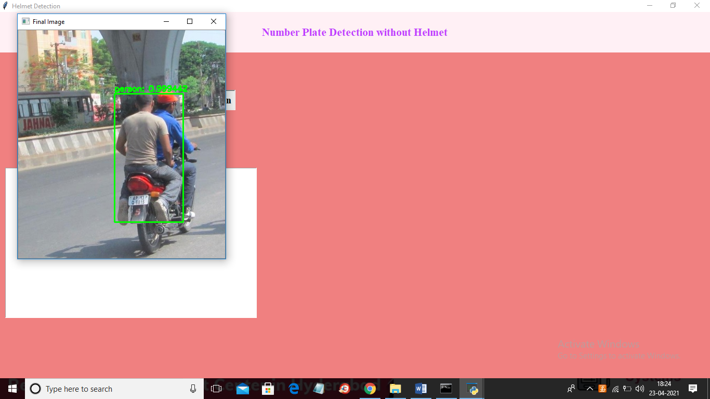

In above screen if person with bike detected then it put bounding box and then click on ‘Detect Helmet’ button to get below output

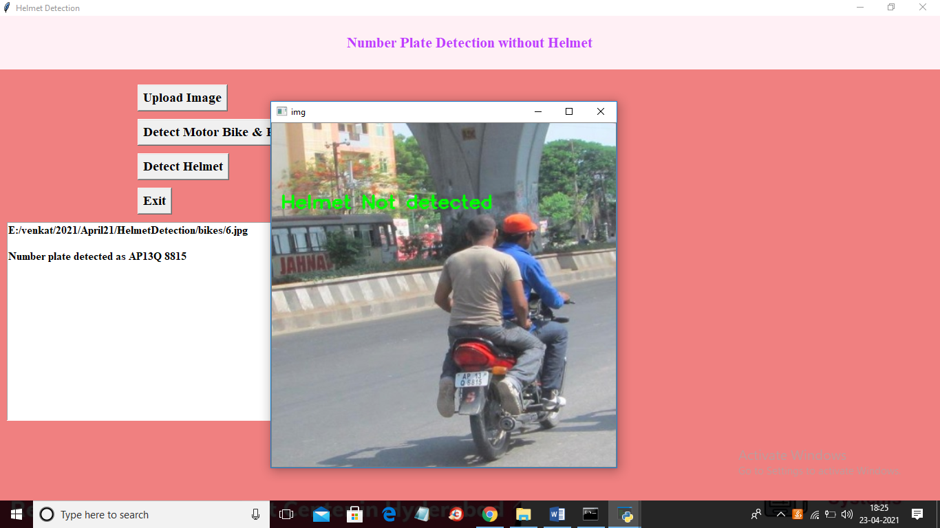

In above screen we can see helmet not detected and then application identify number plate and display on the text area as ‘AP13Q 8815’. Now try with other image by uploading it

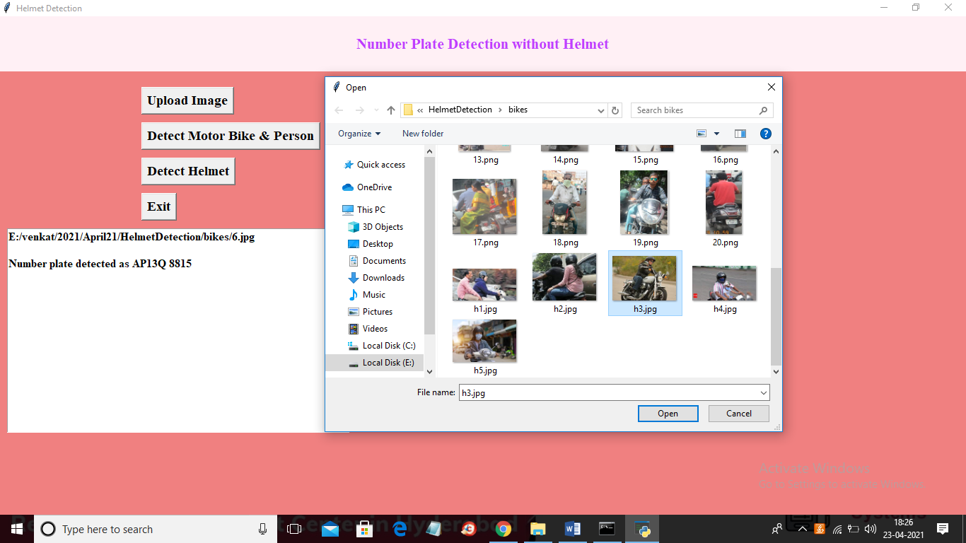

In above screen selecting and uploading ‘h3.jpg’ file and then click on ‘Open’ button then click on ‘Detect Motor Bike & Person’ button to get below result

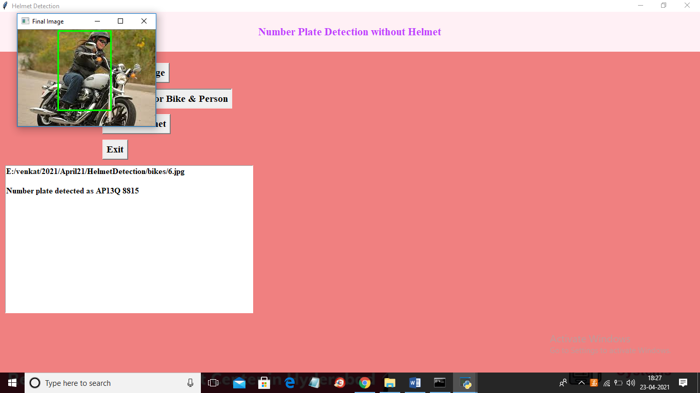

In above screen person with motor bike detected and now close above image and then click on ‘Detect Helmet’ button to get below result

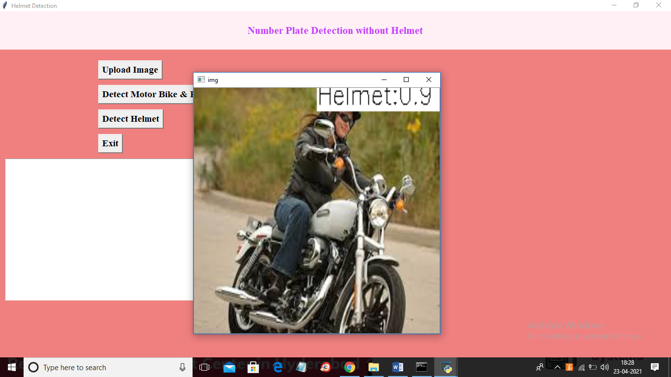

In above screen application detected helmet with helmet matching score as 0.90%. Similarly you can upload other images and test