M.SIVA REDDY

192111362

**EXPT NO: 1 PASSPORT AUTOMATION SYSTEM**

**USE-CASE DIAGRAM:**

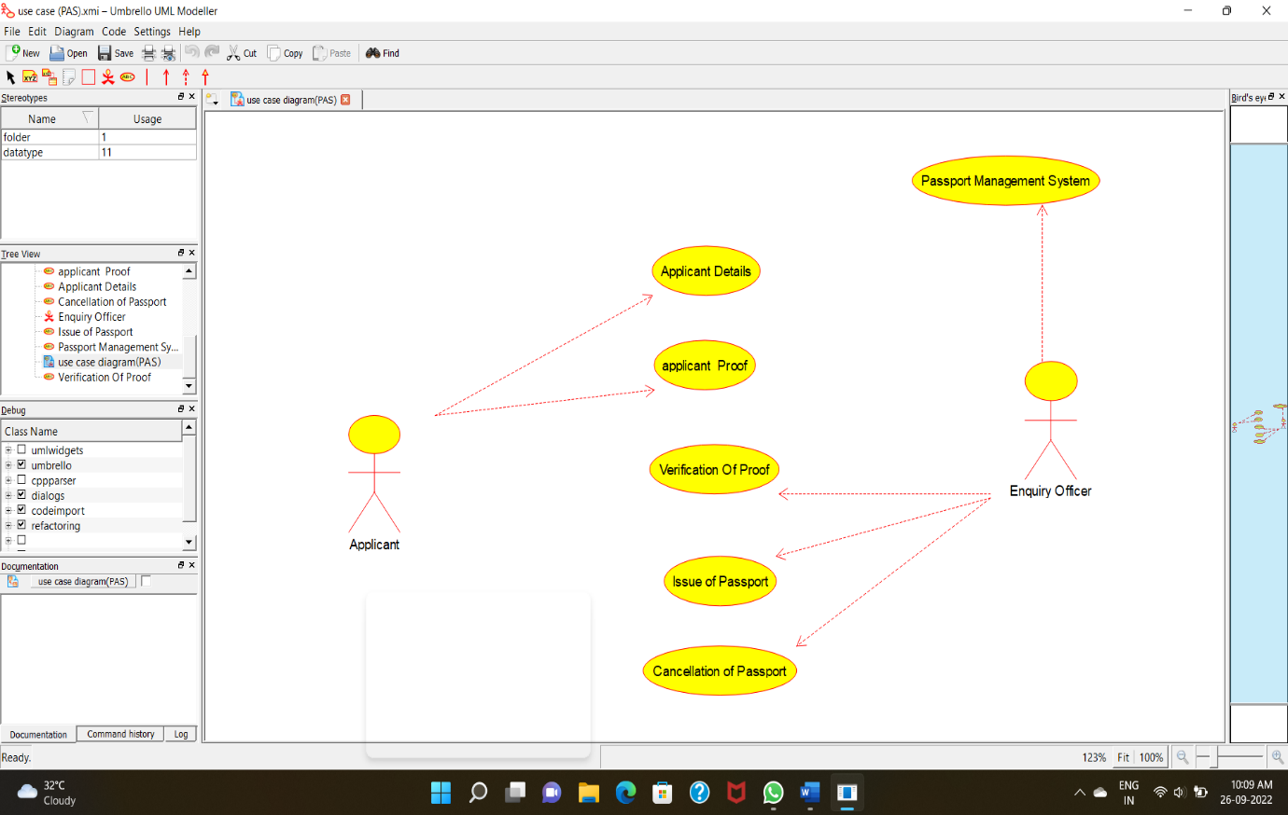

**CLASS DIAGRAM:**

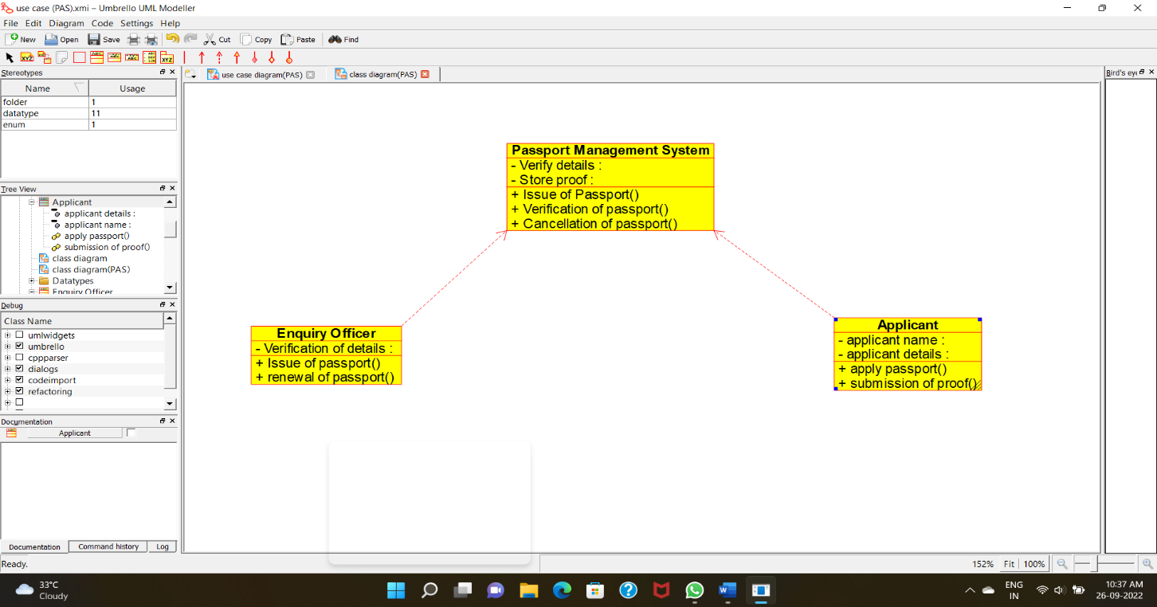

**ACTIVITY DIAGRAM:**

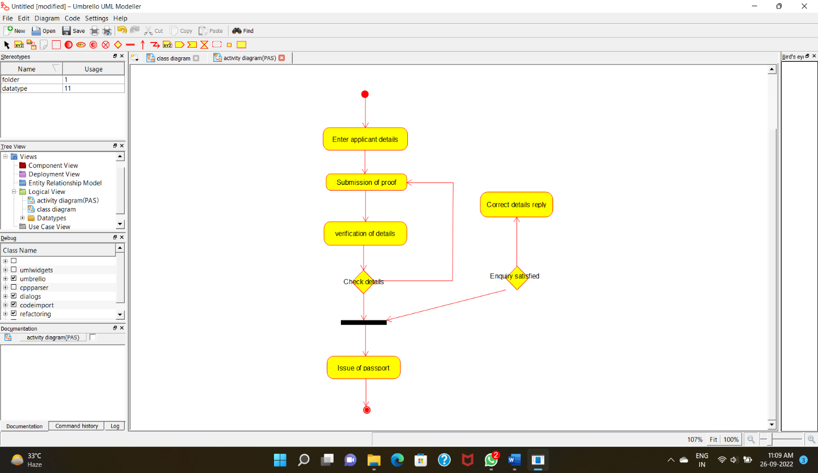

**SEQUENCE DIAGRAM:**

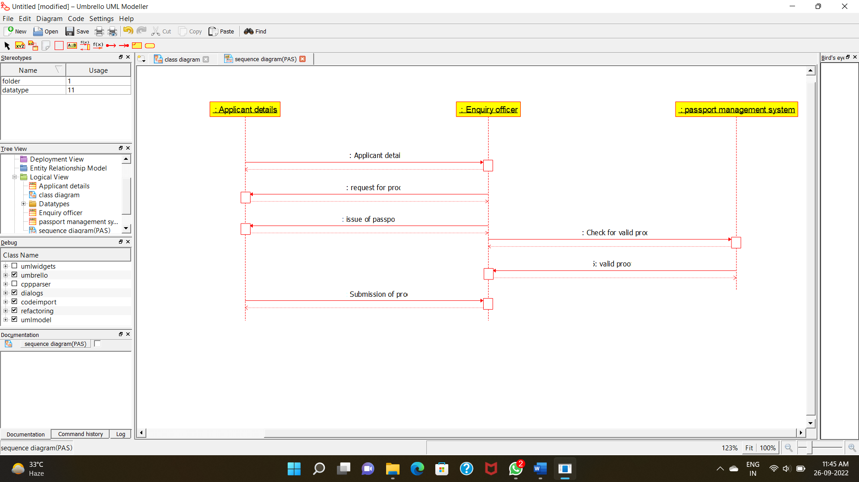

**STATE CHART DIAGRAM:**

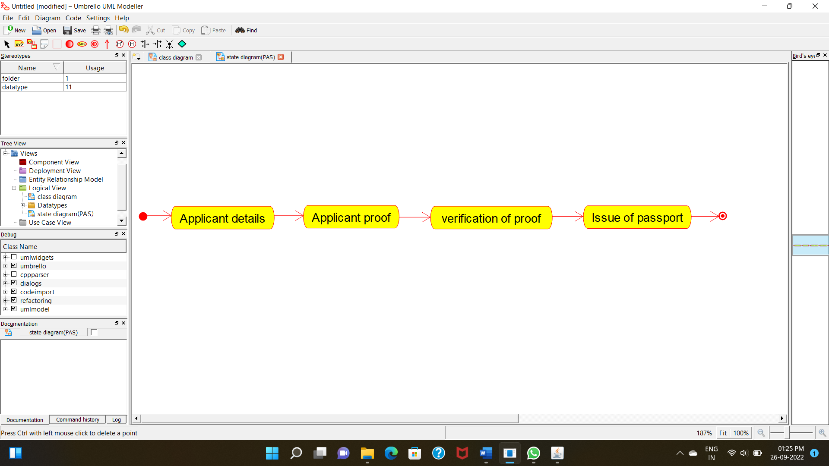

**DEPLOYMENT DIAGRAM:**

