**EXPT NO: 2 BANK BOOK REGISTRATION SYSTEM**

**USE-CASE DIAGRAM:**

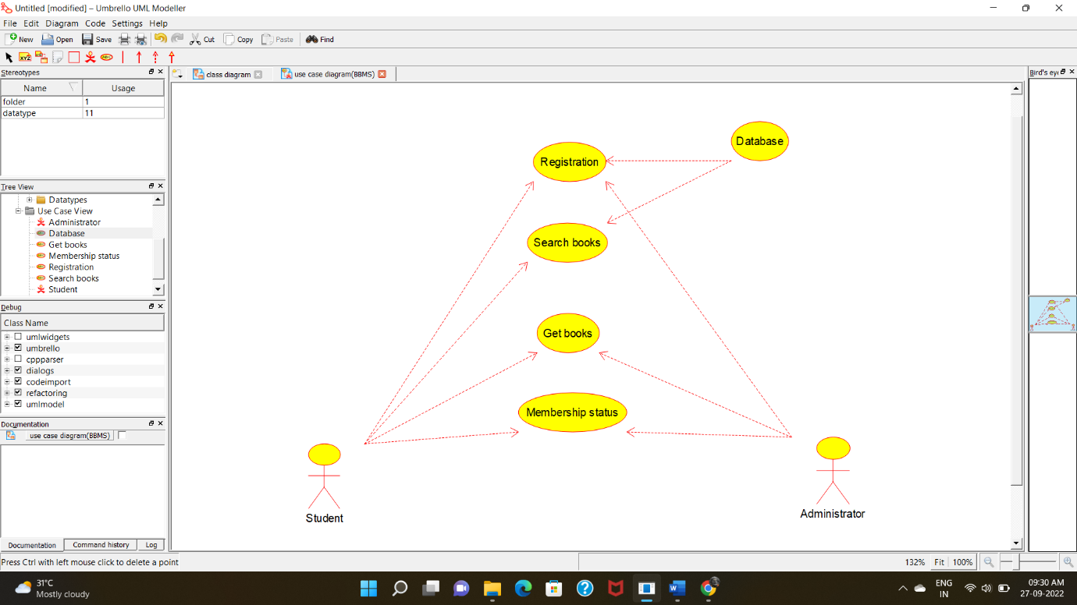

**CLASS DIAGRAM:**

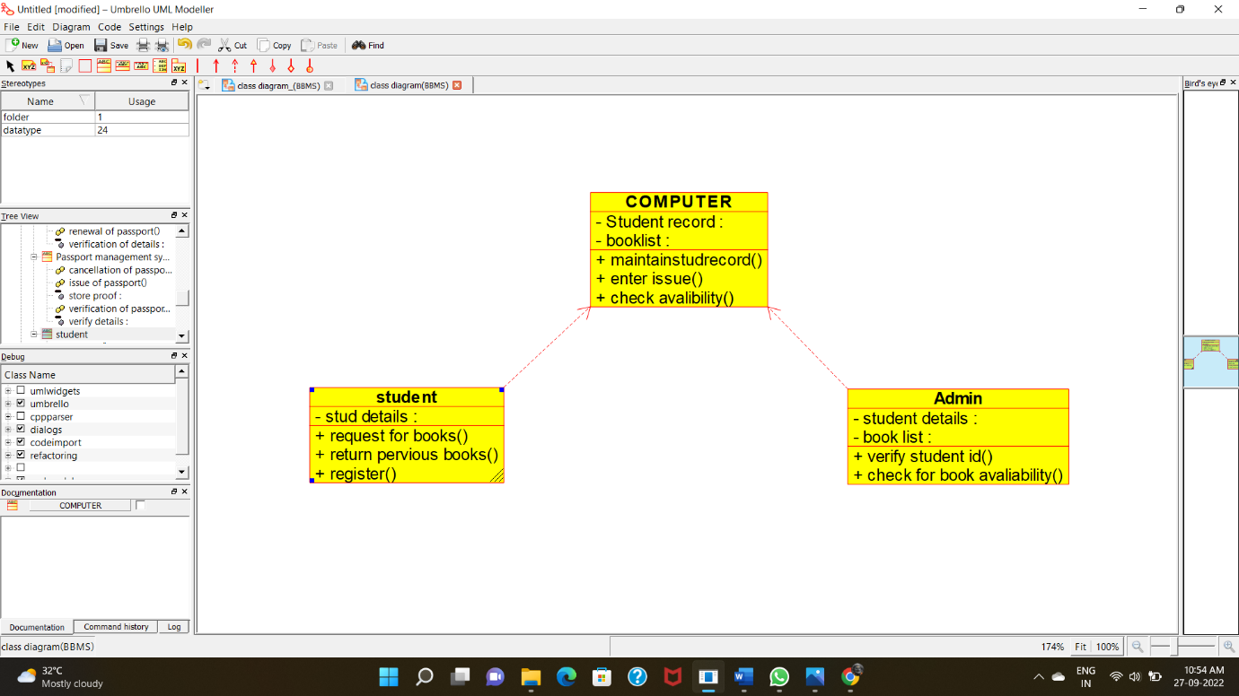

**ACTIVITY DIAGRAM:**

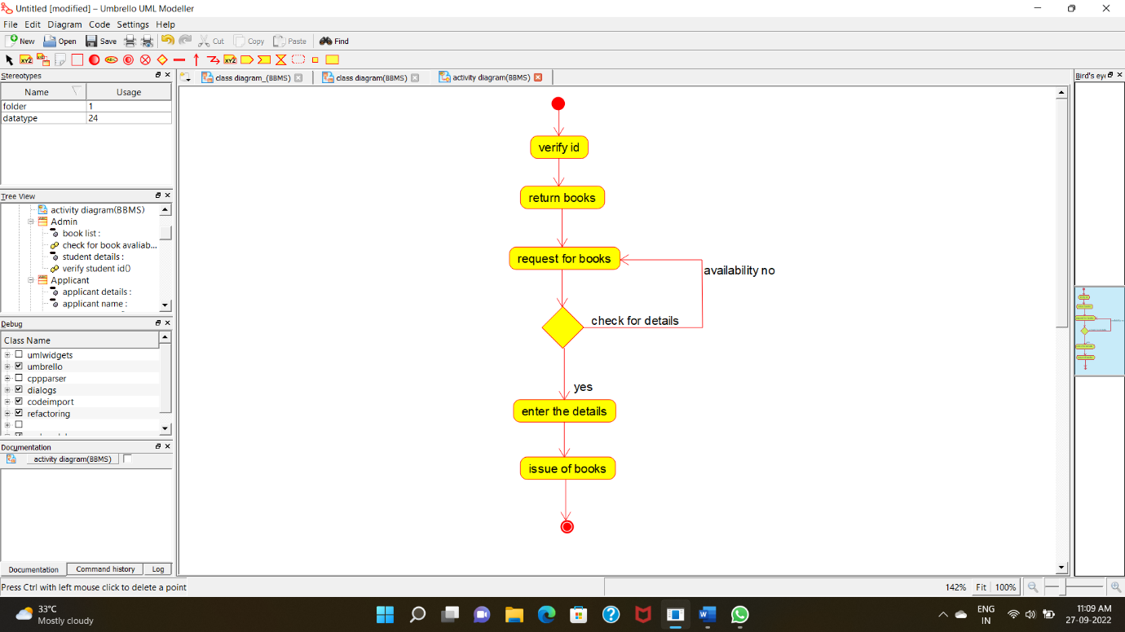

**SEQUENCE DIAGRAM:**

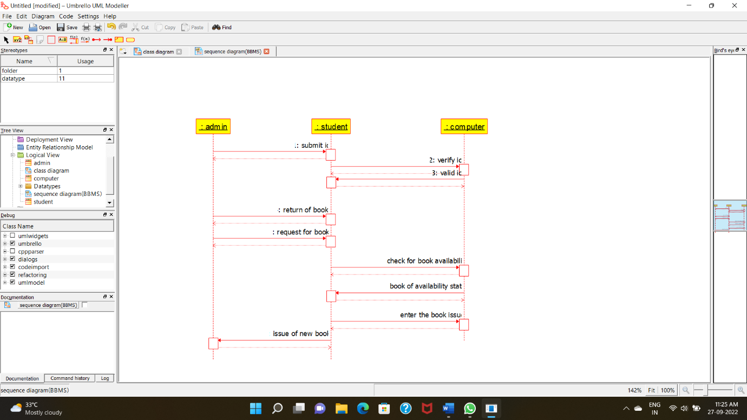

**STATE CHART DIAGRAM:**

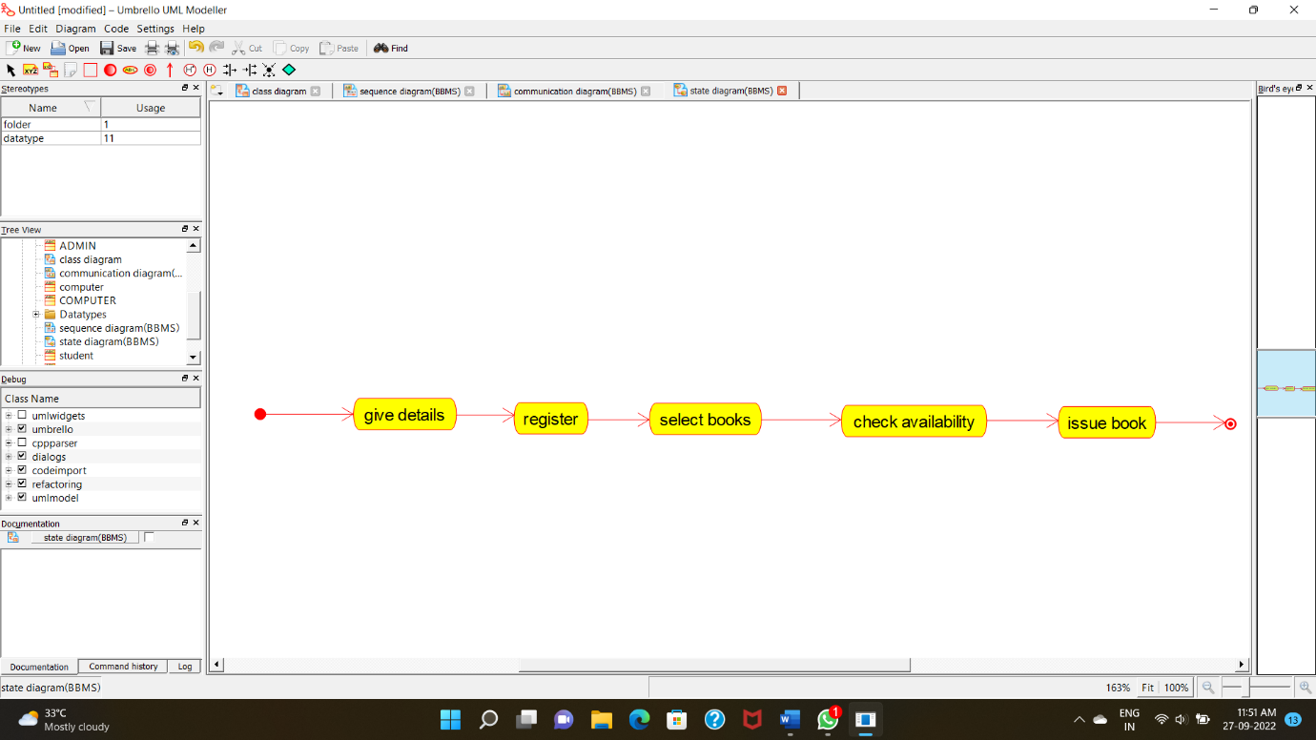

**DEPLOYMENT DIAGRAM:**

