**EXPT NO:5 ONLINE COURSE RESERVATION SYSTEM**

**USE-CASE DIAGRAM:**

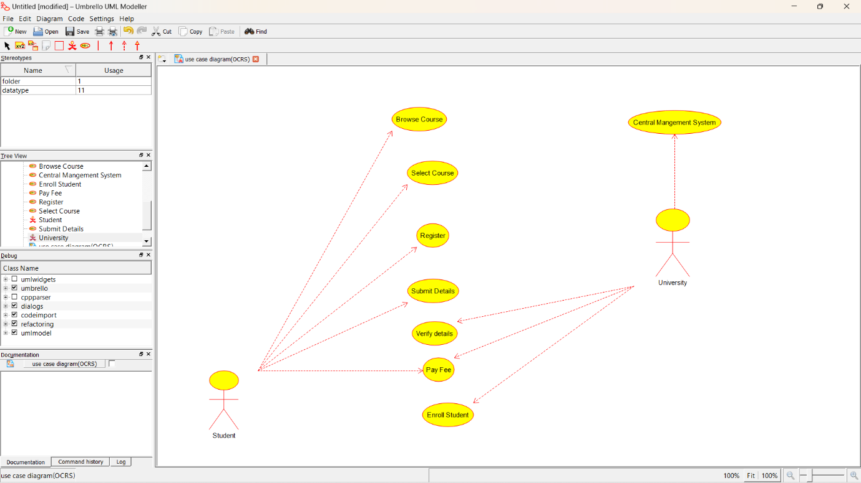

**CLASS DIAGRAM:**

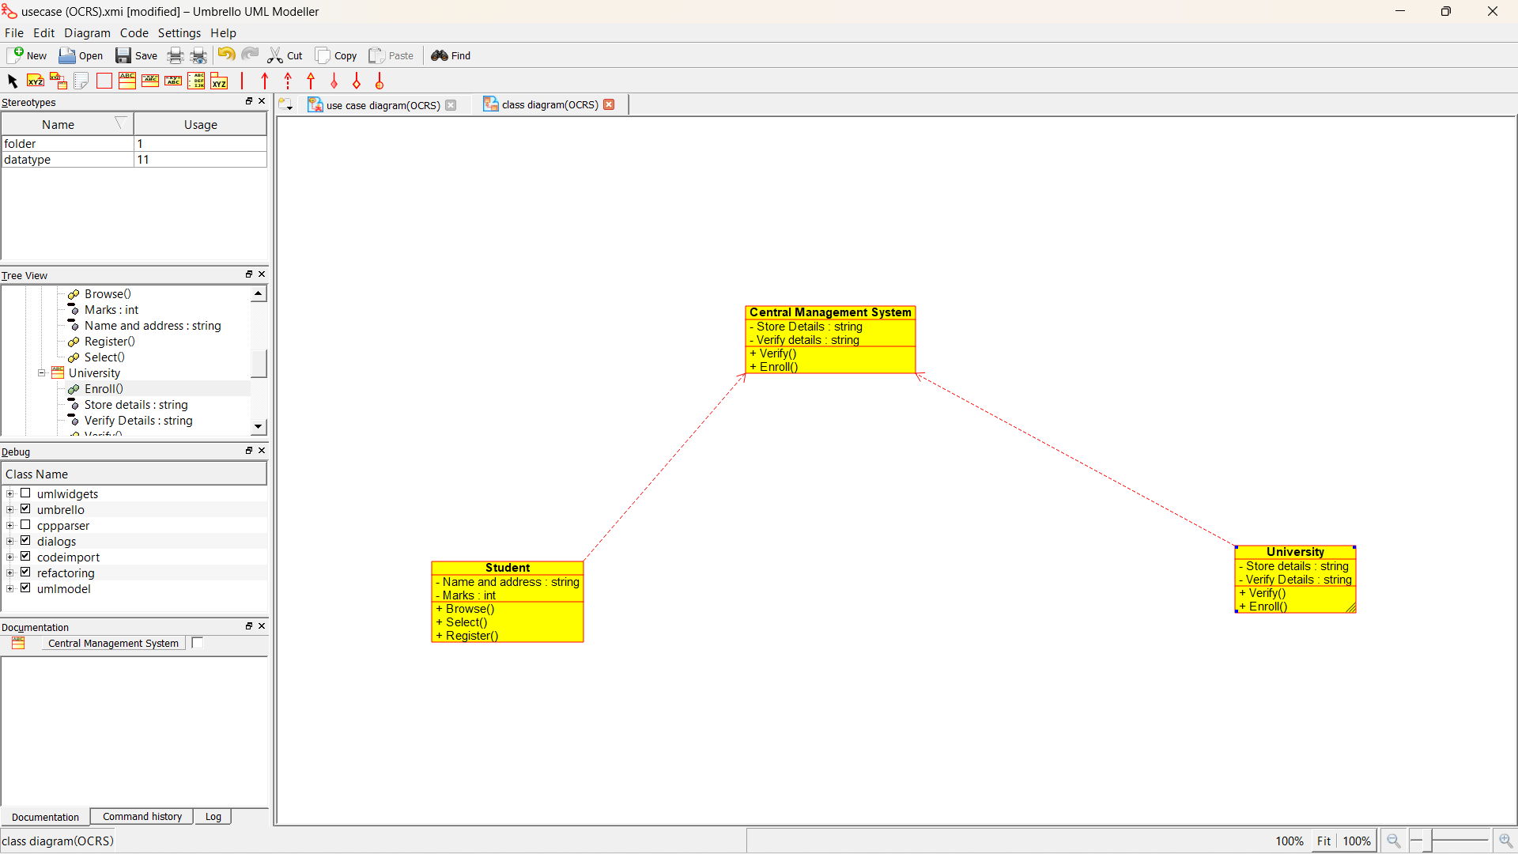

**ACTIVITY DIAGRAM:**

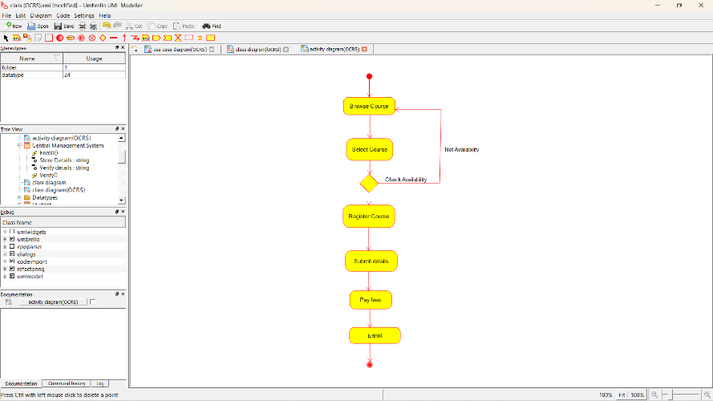

**SEQUENCE DIAGRAM:**

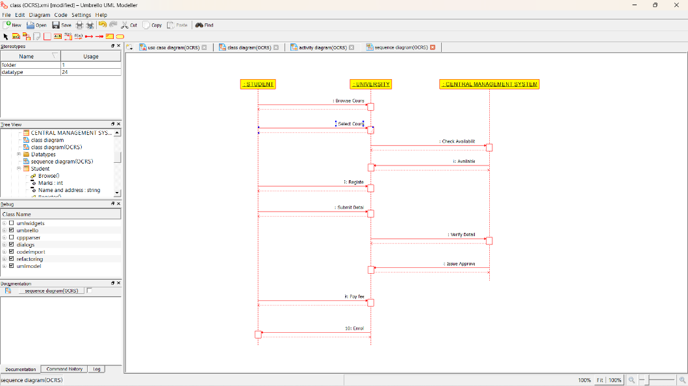

**STATE DIAGRAM:**

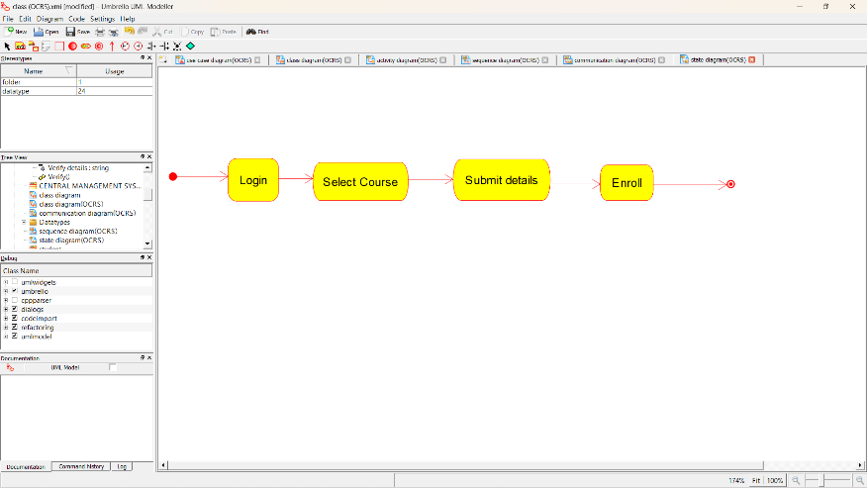

**DEPLOYMENT DIAGRAM:**

