**Internet Of Things (IOT) Enabled Smart Animal Farm**

**Introduction:**

**Overview:**

The term Internet of Things(IoT) was first defined by Kevin Ashton in 1992.It is a new paradigm about the ability of connecting devices to sense and gather data, and then share that data using the Internet facility so that it can be processed and utilized to fulfill common goals. IoT refers to a technology that tells that in near future billions of devices will have internet connectivity and can be accessed from anywhere in the world.

**Purpose:**

There has been strong relationship between humans and animals throughout the centuries. A smart system is needed to operate and monitor animal farm remotely. This system should provide feed and water as required, exhaust the excess of biogas which is produced by the animal waste and detect fire in the farm. The livestock industry could greatly be benefitted from a sophisticated system capable of continuously monitoring the health of animals.

**Literature Survey:**

**Existing problem:**

Animals waste causes biogas emission which can be harmful to them. Incase of emergency like fire accidents in the farm etc.. Keeping track of temperature, humidty we fails.

**Proposed Solution:**

It measures various environmental parameters like temperature, humidity, ammonia gas which plays a vital role in poultry operations.

Flame sensor is interfaced in the farm to avoid any fire accidents.

**Theoritical Analysis:**

**Block diagram:**

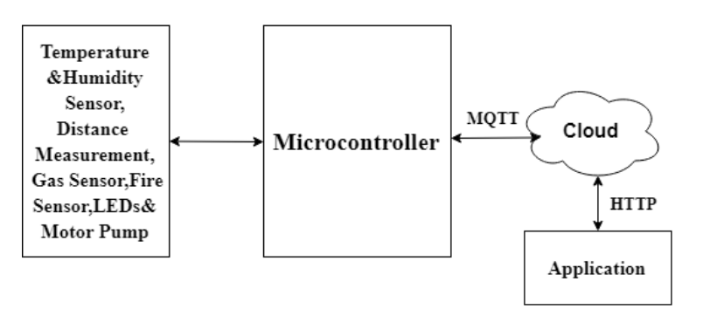

Figure 1: Block Diagram

**Hardware / Software designing:**

The hardware part of the project involves the Raspberry Pi 3 model. The three sensors are connected to the Pi via I2C interface.The sensor values are read by Pi processed and then sent to the IBM cloud services using the Pi’s Wi-Fi module. The data sent to mobile application which has developed using MIT app inventor. Here we use python language for coding.

**Experimental Investigations:**

There are several IoT authentication challenges and issues that need to be understood before employing the right security that can dynamically vary with the situation.

**Flow chart:**

Technical Diagram:

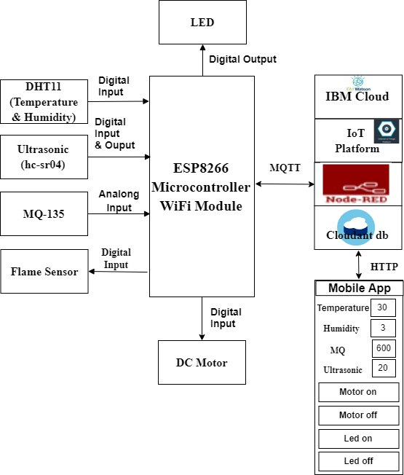

**Result:**

**Advantages & Disadvantages :**

Every application has some pros and cons.

Advantages :

* Remote monitoring
* Study of ventilation and air quality in farms and detection of harmful gases from excrements.
* Lowered operation cost
* Alerts us in emergency situations
* Improved livestock farming

Disadvantages :

Some unwanted issues in the application etc…

**Applications:**

Operator can get updates regarding the internal environmental situation of animal farm by accessing the data using a web page or mobile app.

• With the temperature and humidity values, the exhaust and blower fans are self regulated and can also be controlled manually using the app.

• The lighting in the farm is also adjustable by the LEDs through Web and Mobile App.

**Conclusion:**

we have designed an IoT enabled smart animal farm. Thus the proposed system could gather information about the internal environment of the farm. It can be controlled manually as well as automatically. This kind of system is suitable for any kind of animal farm with little modifications.

**Future Scope:**

It increases more applications for more and different problems and decreases the problems.

**REFERENCES:**

Smith, K.; Martinez, Angel; Craddolph, R.; Erickson, H.; Andresen, D.; Warren, S., "An Integrated Cattle Health Monitoring System," in 28th IEEE Annual International Conference of theEngineering in Medicine and Biology Society, pp.4659-4662, 2006.

Gubbi, J.; Buyya, R.; Marusic, S.; Palaniswami,M. "Internet of Things (IoT): A vision, architectural elements, and future directions," Future Generation Computer Systems, vol. 29, no. 7, 2013, pp. 1645-1660

Applications of IoT, http://www.libelium.com/top_50_iot_sensor_applications_ranking/