**Organizational Behavior Analysis using Game Theory**

### BITS ZG628T: Dissertation

by

Sivakumar Mahalingam

2016HT13407

# Dissertation work carried out at

## Cognizant Technology Solutions, Chennai



**BIRLA INSTITUTE OF TECHNOLOGY & SCIENCE**

**PILANI (RAJASTHAN)**

November 2018

**Organizational Behavior Analysis using Game Theory**

### BITS ZG628T: Dissertation

by

Sivakumar Mahalingam

2016HT13407

# Dissertation work carried out at

## Cognizant Technology Solutions, Chennai

Submitted in partial fulfillment of M.Tech. Software Systems degree programme

Under the Supervision of

Suman Swami Das Chirala, Senior Associate,

Cognizant Technology Solutions, Chennai



**BIRLA INSTITUTE OF TECHNOLOGY & SCIENCE**

**PILANI (RAJASTHAN)**

November, 2018

#### **CERTIFICATE**

This is to certify that the Dissertation entitled Organizational Behavior Analysis using Game Theory and submitted by Sivakumar Mahalingam having ID-No. 2016HT13407 for the partial fulfillment of the requirements of M.Tech. Software Systems degree of BITS, embodies the bonafide work done by him/her under my supervision.

______________________

Signature of the Supervisor

Place: Chennai Suman Swami Das Chirala,

Senior Associate,

Date: 15-Oct-2018 Cognizant Technology Solutions, Chennai

_____________________________

Name, Designation & Organization & Location

Birla Institute of Technology & Science, Pilani

Work-Integrated Learning Programmes Division

First Semester 2018-2019

BITS ZG628T: Dissertation

ABSTRACT

**BITS ID No. : 2016HT13407**

**NAME OF THE STUDENT : Sivakumar Mahalingam**

**EMAIL ADDRESS : sivasai2006@gmail.com**

**STUDENT’S EMPLOYING : Cognizant Technology Solutions, Chennai**

**ORGANIZATION & LOCATION**

**SUPERVISOR’S NAME : Suman Swami Das Chirala**

**SUPERVISOR’S EMPLOYING : Cognizant Technology Solutions, Chennai**

**ORGANIZATION & LOCATION**

**SUPERVISOR’S EMAIL ADDRESS: sumanswamidas.chirala@cognizant.com**

**DISSERTATION TITLE : Organizational Behavior Analysis using**

**Game Theory**

______________________________________________________________________

ABSTRACT :

Objectives of the project are,

1. To provide analysis of what makes employer/employee to enhance and sustain.
2. To provide more enriched insights into attributes for measuring connection between employer and employee.

The project helps to understand the relationship between an employer and its employees. The insights generated by this project will provide to find the attributes that make the employee more engaged, reduce the employee attrition and improve the work place dynamics.

The data will be collected using a survey, which will be filled by employees and merged with the employee data already residing with the employer. This data will be mined to generate the game matrix, as the relationship between the employees and employer is a sequential and cooperative game of game theory.

Broad Academic Area of Work: Data Mining

Key words Data Mining, Data Visualization, Game Theory

**____________________ ______________________**

**Signature of the Student Signature of the Supervisor**

**Name:** Sivakumar Mahalingam **Name:** Suman Swami Das Chirala

**Date:** 15-Oct-2018 **Date:** 15-Oct-2018

**Place:** Chennai **Place:** Chennai

#### **Acknowledgement**

I would like to express my special thanks of gratitude to my supervisor **Suman Swami Das Chirala** for his wholehearted support and valuable sugesstion.

Special thanks to my examiner **Pushpendra Rajotya** who provided his suggesstions and expertise that greatly helped me to improve my project.

My sincere thanks to **Professor Dr. Jabez J Christopher** for the providing guidance and valuable feedback throughout the dissertation

Finally, I would like to thank **Cognizant Technology Solutions** for their support to balance between work and studies.

**Table of Contents**

|  |  |  |
| --- | --- | --- |
| **List of Figures..............................................................................................................** | | **i** |
| **List of Tables...............................................................................................................** | | **i** |
| **List of Acronyms and Abbreviations Used…………………………………………………………….** | | **i** |
| **1 Introduction…………………………………………………………………………………………………..** | | **1** |
| **1.1** | **Background** |  |
| **1.****2** | **Objective** |  |
| **1.3** | **Solution** |  |
| **2** **Implementation Overview……………………………………………………………………………….** | | **1** |
| **2.1** | **Data Collection** |  |
| **2.2** | **Data Processing** |  |
| **2.3** | **Data Mining** |  |
| **2.4** | **Data Visualization** |  |
| **3** **Implementation Approach ………………………………………………………………………………** | | **2** |
| **3.1** | **Employee Survey** |  |
| **3.2** | **Database Modeling** |  |
| **3.3** | **Data Cleansing and Processing using Spark API** |  |
| **3.4** | **Game Identification** |  |
| **3.****5** | **Classification of data using Decision Tree Algorithm** |  |
| **3.****6** | **Creation of Interactive Report** |  |
| **4 Tools Used……………………………………………………………………………………………………..** | | **4** |
| **5 Summary……………………………………………………………………………………………………….** | | **4** |
| **6 Conclusions and Recommendations…………………………………………………………………..** | | **5** |
| **7 Directions for future work………………………………………………………………………………..** | | **5** |
| **References………………………………………………………………………………………………………..** | | **6** |
| **Checklist for the items in the Mid-Sem Dissertation Report…………………………………..** | | **7** |

**List of Figures**

|  |  |  |
| --- | --- | --- |
| S. No | Table Name | Page Number |
| 1 | Application Overview | 1 |
| 2 | Employee Survey Screen | 2 |
| 3 | Database Diagram | 3 |
| 4 | Data Classification | 4 |
| 5 | Game Matrix | 4 |

**List of Tables**

|  |  |  |
| --- | --- | --- |
| S. No | Table Name | Page Number |
| 1 | Database Tables | 3 |

**List of Acronyms and Abbreviations Used**

|  |  |
| --- | --- |
| Acronyms and Abbreviations | Meaning |
| RDBMS | Relational Database Management System |
| SQL | Structured Query Language |
| CSV | Comma Separated Values |
| API | Application Programming Interface |
| IDE | Integrated Development Environment |

i

1. **Introduction**

**1.1 Background**

The relationship between an employer and its employees is not completely researched and understood. By studying the working nature and the behavioral pattern of each side will help to improve the rewards and ease the functioning. The insights which are available currently are not enough to find the attributes that make the employee more engaged, reduce the employee attrition and improve the work place dynamics.

**1.2 Objectives**

1. To provide analysis of what makes employer/employee to enhance and sustain.
2. To provide more enriched insights into attributes for measuring connection between employer and employee.

**1.3 Solution**

The data will be collected using a survey which will be filled by employees are merged with the employee data already residing with the database of the employer. Data collected is cleansed and processed using big data processing api. The processed data used for generating the Game Matrix, by using suitable data mining algorithm. The visualization of game matrix will be implemented by using data visualization tool. This data mining application widely covers the areas of data mining, game theory and data visualization.

1. **Implementation Overview**

**2.1 Data Collection**

A survey created to get feedback from employees and store it in a RDBMS. This uses Microsoft tools (Visual Studio 2013 and SQL Server 2008) to create and maintain data.

**2.2 Data Processing**

The data collected using survey combined with the existing employee related data residing in the database are exported to csv format. This exported data are cleansed and processed using Spark API.

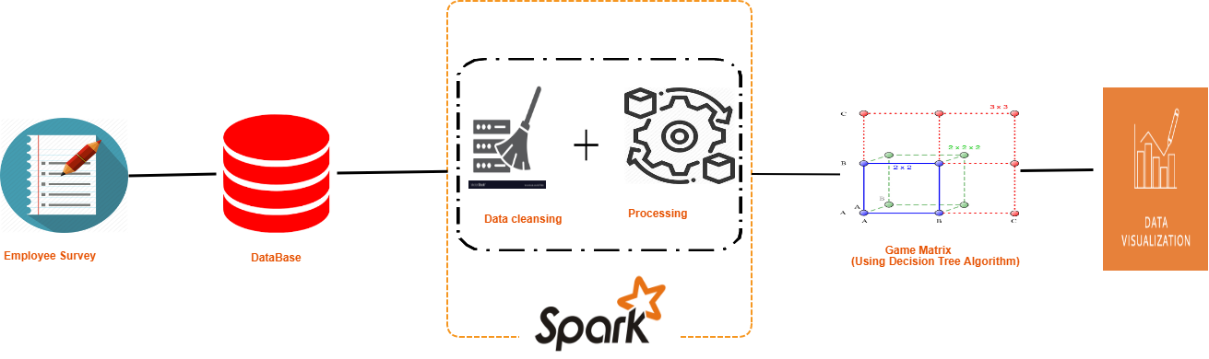

Figure 1: Application Overview

1

**2.3 Data Mining**

The generation of the game matrix using the data collected and cleansed. Typically, this has to use a data-mining algorithm. Decision Tree algorithm is suitable as we need to

categorize the data into two categories (enhance or sustain).

This is a sequential and cooperative game type of game theory classification.

**2.4 Data Visualization**

The generated game matrix has to visualized using a data visualization tool. This can be created using Tableau, where game matrix of employer-employee is available with four quadrants based on the categorization values. The insight generated will give a deeper understanding of the behavior of employee and employer.

1. **Implementation Approach**

**3.1 Employee Survey**

A survey created and integrated to the organizational employee portal, which resides in any organization. Using the portal, the survey can be accessed and filled by the employee.

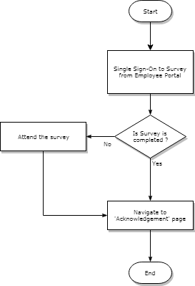

Figure 2: Flow of Employee Survey application

This is implemented as a web application by using Microsoft Visual Studio 2013 IDE with C# programming language backed with Microsoft SQL Server 2008 relational database. The survey can be accessed from the organization’s employee portal with single sign-on authentication. If the survey is taken already then navigate to page where it acknowledges the user about the completion of the survey, else allow the user to take the survey. The survey data is stored in the database once the user submit it and then navigate to the acknowledgement page.

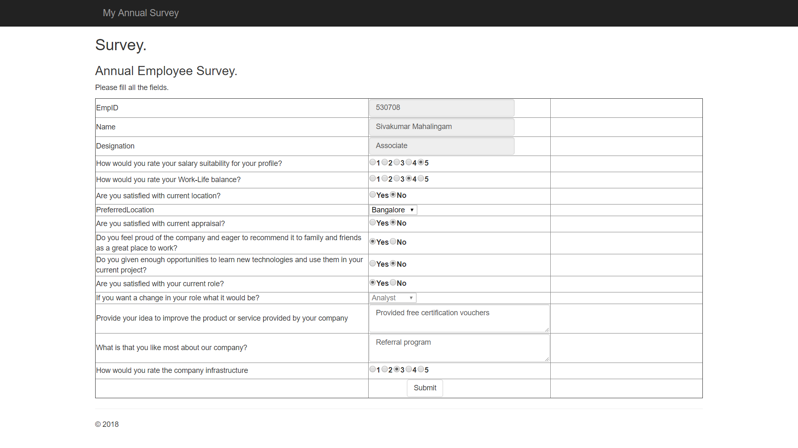

Figure 2: Employee Survey Screen

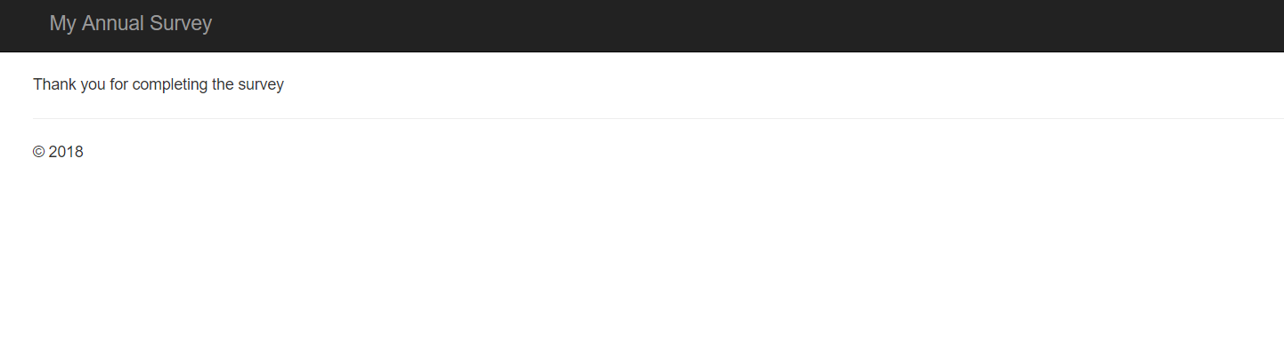

Figure 2: Acknowledgement Screen

**3.2 Database Modeling**

The employer has the data of employee residing in a RDBMS. Microsoft SQL Server 2008 is used for this purpose. It has the employee’s organizational and personal data. The same database is used to store the data collected using the survey web application.

2

This project uses below tables,

|  |  |
| --- | --- |
| Table Name | Description |
| Employees | Has employee’s personal and organizational data |
| Appraisals | Has annual appraisal data of the employee |
| Survey | Has data collected using the survey |

Table 1: Database Tables

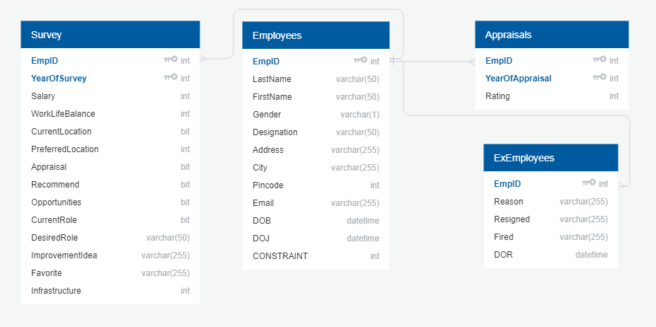

Figure 3: Database Diagram

**3.3 Data Cleansing and Processing using Spark API**

The data collected using survey of current year, survey data of previous year and the existing employee related data residing in the database are combinedly exported as two separate datasets for current and previous year. The exported data is saved into a csv file format.

As the data involved in this process is huge, Spark API used with Scala language to cleanse the data by removing the incorrect entries and process by transforming the data in suitable format, so that it can be used effectively in further modules. Spark is a code based ETL application to process structured/unstructured/semi-structured data in large volumes. The previous year data have the result of whether the employer/employee is satisfied or not for each row of data. The value can be either of the below,

**Enhance** - If employee is the satisfied with the employer or vice versa

**Sustain** - If employee is not the satisfied with the employer or vice versa

The below columns from the database are used for the analysis,

|  |  |
| --- | --- |
| Name | Description |
| EmpID | Employee ID |
| Designation | Designation of the employee |
| City | Residing city |
| DOB | Date of birth |
| Gender | Gender |
| YearOfAppraisal | Year in which the appraisal is given |
| Rating | Appraisal rating value |
| Salary | Is the employee satisfied with their salary or not? Scale of 1 to 5 where 1 means dissatisfied and 5 means most satisfied |
| WorkLifeBalance | Is the employee satisfied with their work life balance or not? Scale of 1 to 5 where 1 means dissatisfied and 5 means most satisfied |
| CurrentLocation | Is the employee satisfied with their current location of work or not? Where 0 means not satisfied and 1 means satisfied |
| PreferredLocation | Employee’s preferred work location. This is applicable only if the employee is not satisfied. |
| Appraisal | Is the employee satisfied with their current year appraisal or not? Where 0 means not satisfied and 1 means satisfied |
| Recommend | Will the employee recommend his\her friends to join the organization, if they get a chance |
| Opportunities | Does the employee get enough opportunities to learn and apply latest and relevant technologies? Where 0 means not satisfied and 1 means satisfied |
| CurrentRole | Is the employee satisfied with their current role of work or not? Where 0 means not satisfied and 1 means satisfied |
| DesiredRole | Employee’s preferred role of work. This is applicable only if the employee is not satisfied. |
| Infrastructure | Employee’s satisfaction level with the organization infrastructure. Scale of 1 to 5 where 1 means dissatisfied and 5 means most satisfied |
| Employee | Enhance/Sustain. |
| Employer | Enhance/Sustain. |

**3.4 Game Identification**

Game Theory give a strategic approach to take decision in any problem statement. By applying game theory, the employer-employee can be viewed as a game between two players (employer and employee). The payoff for a player can be derived from the variable value of the strategy. The variable can be either enhance or sustain. Based on the payoffs, a player can be fit into one of the four quadrants.

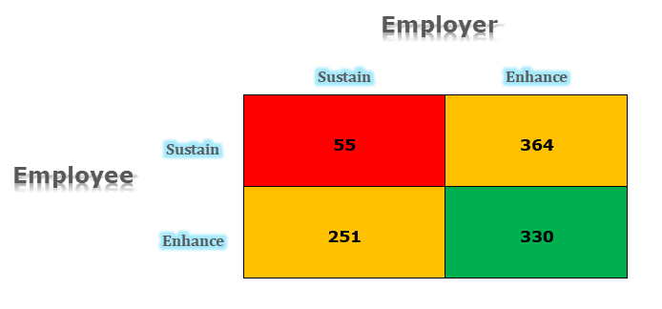

Figure 5: Game Matrix

This game is of sequential and cooperative classification.

*Sequential:* as employees are aware of employer’s action and vice versa.

*Cooperative:* as they adopt a particular strategy through negotiation/agreement.

**3.5 Classification of data using Decision Tree Algorithm**

To generate the Game Matrix we need to classify data into categories. Decision Tree algorithm used to categorize the data, in this project it categorizes the data into two – enhance and sustain. In enhance, the player will have optimal condition and in sustain the will have nominal condition of existence. So every row in the dataset will produce a result of either enhance or sustain for employee and employer based on the data available in it.

3

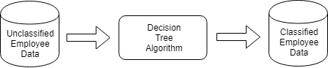

Figure 4: Data Classification

The implementation uses python language and its available libraries - pandas, scikit learn and graphviz – to generate the payoff values. The algorithm uses the survey data of previous year to predict the values of current year. The previous year data is split into 80:20 for training and testing. Once the algorithm is trained and tested, the current year data can be fed to generate the payoff values which predicts the behavior of employee. The satisfaction level of the employer can be derived from the appraisal data available in the database, from the Rating value of the Appraisals table. By this approach, we can have the payoff value of both players - employee and employer - for each record. So each record will fit into any of the four quadrants of the game matrix. So by altering the behavior/strategy of one player the result can be changed. In this way we can have predictive modeling system and the strategies can be changed in such a way that both players are benefited.

**3.6 Creation of Interactive Report**

The categorized data using Decision Tree algorithm have the value of the category for each player – employee and employer. This data used to generate visualization of the Game Matrix, using Tableau. The predicted result will be useful only if we visualize it by applying the game matrix, which is based on game theory.



Figure 5: Game Matrix replace with the Tableau images

Separate insights are generated for each quadrant with employee count. On clicking a quadrant, the report will navigate us to a give further insights – specify the graphs

However, more focus has to be given to the amber quadrant, as there are lot of possibilities exists to move them from amber to red/green quadrant.

Organization can alter the benefits to the employee to bring them to green from amber, with a minimal cost and effort using the insights generated by this project.

1. **Tools Used**

* Microsoft Visual Studio 2013
* Microsoft SQL Server 2008
* Apache Spark 2.0.0
* Tableau Desktop 2018.1
* Eclipse Oxygen

1. **Summary**

In current scenario, where the attrition rate is high and it depends on reasons which can be handled by easy understanding of the need, by applying this project. The behavior of employer and employee can be identified easily based on the game matrix visualization generated by the data collected and processed. The visualization will provide interactive report to read the mind of the employees and to build an optimal employee benefit and engagement plan for the organization.

4

1. **Conclusions and Recommendations**

The relationship between employer and employee in any organization is based on the employee engagement and benefits received. Also, the return of investment for an employer depends on how they treat their employees. The understanding of how this game helps a player (employer/employee) can be easily achieved by applying the game theory and it not only reduce the cost but also increases trust and growth for one another. Based on the environment and need, additional attributes can be included to get insights.

1. **Directions for future work**

* The approach can be implemented on the additional historical data, which will provide the trend in behavior over time, which may provide additional insights to build a more accurate predictive modeling system.
* The algorithm can be modified to generate the game matrix to classify data of students, non-profit organizations, military services and other suitable sectors

5

**References**

**BOOKS**

Jiawei Han, Micheline Kamber and Jian Pei. Data Mining: Concepts and Techniques. Waltham: Morgan Kaufmann Publishers, 2012

Martin J. Osborne. An Introduction to Game Theory. Oxford: Oxford University Press, 2003

**SCHOLARLY JOURNAL ARTICLES**

Rita Yadav, Sarla Pareek, Santosh Singh. "Game Theory in Organizational Psychology." International Journal of Advances in Science Engineering and Technology

Special Issue-1 (2015): 116-120

**DISSERTATION and Theses**

Edward William Rogers. The Relationship Between Employee Perceptions of the Employment Game and Their Perceptions of Cooperative Knowledge Behavior in High Tech Firms [Thesis]. USA: Cornell University ILR School; 2000

Barnaby D Pitt. Applications of Data Mining Techniques to Electric Load Profiling [Thesis]. UK: University of Manchester Institute of Science and Technology; 2000

6

# Checklist of items for the Final Dissertation Report

This checklist is to be attached as the last page of the report.

**This checklist is to be duly completed, verified and signed by the student.**

|  |  |  |
| --- | --- | --- |
|  | **Is the final report neatly formatted with all the elements required for a technical Report?** | Yes / No |
|  | Is the Cover page in proper format as given in Annexure A? | Yes / No |
|  | Is the Title page (Inner cover page) in proper format? | Yes / No |
|  | (a) Is the Certificate from the Supervisor in proper format?  (b) Has it been signed by the Supervisor? | Yes / No  Yes / No |
|  | Is the Abstract included in the report properly written within one page? Have the technical keywords been specified properly? | Yes / No  Yes / No |
|  | Is the title of your report appropriate? **The title should be adequately descriptive, precise and must reflect scope of the actual work done.** Uncommon abbreviations / Acronyms should not be used in the title | Yes / No |
|  | Have you included the List of abbreviations / Acronyms? | Yes / No |
|  | Does the Report contain a summary of the literature survey? | Yes / No |
|  | Does the Table of Contents include page numbers?   1. Are the Pages numbered properly? (Ch. 1 should start on Page # 1) 2. Are the Figures numbered properly? (Figure Numbers and Figure Titles should be at the bottom of the figures) 3. Are the Tables numbered properly? (Table Numbers and Table Titles should be at the top of the tables) 4. Are the Captions for the Figures and Tables proper? 5. Are the Appendices numbered properly? Are their titles appropriate | Yes / No  Yes / No  Yes / No  Yes / No  Yes / No  Yes / No |
|  | Is the conclusion of the Report based on discussion of the work? | Yes / No |
|  | Are References or Bibliography given at the end of the Report?  Have the References been cited properly inside the text of the Report?  Are all the references cited in the body of the report | Yes / No  Yes / No  Yes / No |
|  | Is the report format and content according to the guidelines? The report should not be a mere printout of a Power Point Presentation, or a user manual. Source code of software need not be included in the report. | Yes / No |

**Declaration by Student:**

I certify that I have properly verified all the items in this checklist and ensure that the report is in proper format as specified in the course handout.

**______________________________**

**Signature of the Student**

**Place:** Chennai **Name:** Sivakumar Mahalingam

**Date:** 15-Oct-2018  **ID No:** 2016HT13407

7