**EXPERIMENTAL INVESTIGATION OF MECHANICAL PROPERTIES OF NATURAL FIBER-REINFORCED COMPOSITE MATERIAL**

Gembali Sivasai Rapeta Sundara Ramam

(student) (Associate professor)

Mechanical Department Mechanical Department

Vignan’s Institute of Information Technology Vignan’s Institute of Information Technology

Visakhapatnam, Andhra Pradesh, India-530049 Visakhapatnam, Andhra Pradesh, India-530049

[sivasaigembali521@gmail.com](mailto:sivasaigembali521@gmail.com) [sundar.ramam@gmail.com](mailto:sundar.ramam@gmail.com)

Doppa Yagneshwar Jwalith Boddipalli Vamsi

(student ) (student)

Mechanical Department Mechanical Department

Vignan’s Institute of Information Technology Vignan’s Institute of Information Technology

Visakhapatnam, Andhra Pradesh, India-530049 Visakhapatnam, Andhra Pradesh, India-530049

[Jwalith11@gmail.com](mailto:Jwalith11@gmail.com) funkyvamsi609@gmail.com

***Abstract-*** Natural fiber composites are one of the inventions that has led to their significant rise in the field of engineering. Synthetic fibers made of boron, fiberglass, carbon fiber, and other materials are replaced by natural fiber-reinforced composites. Natural fibers, particularly in domestic uses in plants, animals, and regenerated material, In comparison with conventional synthetic composites, natural fiber reinforced polymer composites have much advantages and are better than those of traditional composites from various points of view as they have greater specific stiffness and specific strength, more resistance to corrosion, better recyclability, large fatigue strength, lower life-cycle costs, more impact absorption capacity, and have lower toxicity. Recently, for their excellent mechanical features, so many sectors have been added, such as vehicles, aerospace, marine, and buildings. Because of these properties, natural fibers have recently become an alternative approach for fiber-reinforced compo-sites for researchers and scientists. The mechanical parameters of sisal, oil palm, and pineapple composites are investigated in this research, including tensile strength, flexural strength, hardness, and impact strength.

***Keywords-***  sisal, oil palm, pineapple, tensile strength, flexural strength, hardness value, impact strength.

1. **INTRODUCTION**

Composites can be reinforced with natural or synthetic fibers. Natural fiber characteristics are unpredictable, however, synthetic fiber-based composites are created based on the contents and quantities of synthetic fibers [1] . Natural fibres have recently piqued the interest of scientists and technologists due to their benefits over traditional reinforcement materials, and the creation of natural fibre composites has been a hot topic in recent years. Natural fibres with low density and high specific characteristics are low-cost. Unlike other reinforcing fibres, these are biodegradable and non-abrasive. They are also widely available, and their specific qualities are equivalent to those of other reinforcing fibres[2]. The use of natural fiber for the reinforcement of the composites has received increasing attention both by the academic sector and the industry. Natural fibers have many significant advantages over synthetic fibers. Currently, many types of natural fibers have been investigated for use in plastics including flax, hemp, jute straw, wood, rice husk, wheat, barley, oats, rye, cane (sugar and bamboo), grass, reeds, kenaf, ramie, oil palm empty fruit bunch, sisal, coir, water, hyacinth, pennywort, kapok, paper mulberry, raphia, banana fiber, pineapple leaf fiber and papyrus[3]. Sisal is a leaf fiber that is part of the agave fibers family called

*Agave sisalana[4]* .It is the most widely produced leaf fibre in the world, accounting for over 70% of all commercial leaf fibre output. According to statistics given by the Food and Agriculture Organization in 2006, global sisal production was expected to be 427,000 tonnes in 2006. The sisal plant produces 200-250 leaves, each of which has 1000-1200 fibre bundles made up of 4% fibre, 0.75 percent cuticle, 8% dry matter, and 87.25 percent water [ 4,5,6]. Lingo-cellulosic fibre Sisal. Sisal fibers are multicellular, with small individual cells bonded together. Single sisal fiber is a composite structure containing cellulose microfibrils which are reinforcements with lignin and hemicellulose as a matrix. Therefore, thecell wall is a composite structure of lignocellulosic material reinforced by helical microfibrillar bands of cellulose,[4,5,6,7] The mechanical properties of sisal fibres are influenced by cellulose concentration, fibrillar angle, and lamellae matrix, according to numerous studies. Sisal fibres offer unique properties that make them ideal for technological applications when compared to other natural fibres. Sisal has a lower cellulose concentration, which results in stronger tensile and stiffness qualities, maximal impact toughness, higher work of rupture, and excellent sound absorption[5,6] .

The oil palm, Elaeis guineensis, has seen a significant increase in cultivation in recent years as the demand for vegetable oils has soared (5). About 2500–3000 fruits are borne on 100–120 spikelets attached to a peduncle from the axil of a frond by the female bunch. The exterior mesocarp of the fruit produces palm oil, and the kernel within the nut produces palm kernel oil[8]. In palm-oil mills, oil palm empty fruit bunches (OPEFBs) are readily available in enormous quantities. The annual number of empty fruit bunches (EFBs) available in Malaysia is estimated to be at 4.43 million t. (dry weight). Currently, 65 percent of the waste is burned, and the resulting ash is used as fertiliser on the plantation. However, due to the production of white smoke from some fly ash, incineration for bunch ash is not environmentally acceptable. Fruit bunches that have been emptied are also valuable biomass wastes that can be easily transformed into energy. They have a 3700 kcal kg1 energy content (dry weight)[9]. pineapple leaves paper properties depend on the chemical compositions of the pineapple leaf fiber, which consist of cellulose, hemicellulose and lignin. The pineapple leaf has a ribbon-like structure and is cemented together by lignin and pentosane-like materials, which bind together with a cellulosic composition. Apart from the lignin, both cellulose and hemicelluloses will lead to the high strength of the fiber produced. The higher composition of the pineapple leaves could affect the properties for paper production. Based on table 1 shows the chemical composition of pineapple leaves that consist of higher content of cellulose which is 66.2% and Holocellulose which is 85.7% which really suitable for making paper[10].

1. **LITERATURE REVIEW**

Natural fibres can help rural communities flourish economically by being used in a variety of engineering and construction businesses. Bio-composites have several advantages over synthetic fibre, including lower fibre density, environmental friendliness, and a lower density coefficient. This raises their profile and has already resulted in a great deal of scientific knowledge[11].

Sisal is a leaf fibre with high tenacity and tensile strength, as well as abrasion and alkali resistance. It is also renewable, eco-friendly, and widely available. Despite its benefits, sisal has a high moisture absorption rate as a natural fibre, which results in lower interfacial adhesion with polymer matrices and limits its use in the composite sector[12]. The preferred method for increasing the mechanical properties of oil palm fibres is alkali treatment. The thermal degradation of Oil Palm fibre accelerates above 300°C[13]. Sisal fibre can be used to strengthen polymer composites. Sisal fibre has prospective use in the aerospace and automobile industries, in addition to its conventional uses (ropes, carpets, and mats). Sisal fiber's physical and mechanical properties are influenced by its source, age, and location, as well as its fibre diameter, experimental temperature, gauge length, and strain rate. Interfacial adhesion between the hydrophilic sisal fibre and the hydrophobic polymer matrix is improved by fibre surface modification or treatment[14]. Natural fibre composites have shown that natural fibres have benefits. Furthermore, the epoxy helps to improve the natural fiber's material qualities. Natural fiber-epoxy will be employed as an energy absorption tool in crashworthiness design[15]. Pineapple is one of the natural fibres with the largest cellulose content, with about 80%. PALF has a density similar to other natural fibres, a high Young's modulus, and the best tensile strength of the related natural fibres. These characteristics make it ideal for use as building and construction materials, automobile components, and furniture[16].

1. **MATERIALS & METHODS**

Bidirectional sisal, oil palm, and pineapple mats (300 GSM) and Epoxy LY556 with hardener HY951 were obtained from Go Greens Ltd. in Chennai, India. The hand layup method was used to prepare the specimens. Initially, the epoxy and hardener were combined in a 10:1 ratio by measuring the proper components. The weight of individual fibers was first determined using a weighing scale. In a 3:1 ratio, epoxy is used. In a 1:10 ratio, the hardener is combined with the epoxy. A stirrer was used to thoroughly combine the resin and hardener. On the relevant fiber material, one layer of the epoxy hardener mix is applied. The epoxy-hardener mixture was then sprayed between the layers. With the aid of rollers, the extra resin is squeezed from the layers. Between the layers, an equal quantity of the resin hardener combination was used. Compression moulding was used to cure the material for 24 hours at room temperature under 0.1 MPa pressure. After curing, laminate cutting was performed to obtain American society for testing materials (ASTM) standard specimen sizes.

**4.EXPERIMENTAL TESTS**

**4.1Tensile test:**

For the tensile test, ASTM D3039 standard specimens were utilized. Test specimens were manufactured to perform the tensile test. The tensile test entails mounting the sample with a clamp and allowing it to be put under tension. The process places the test samples in the setup and increases tension till the fracture occurs. The test was conducted on each sample, and the outcome was examined. The tensile properties of the specimens were measured by using the universal testing machine shown in *Figure 1.*

The given formula (Equation 1), where Fn is the force and A is the cross-section of the gauge section, and σ is called engineering stress, can be used to estimate the tensile strength.

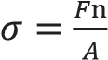 (1)

The elongation is calculated against the applied force when tension is applied. The determined by using the given formula (Equation 2).

(2)

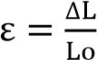

engineering strain () is 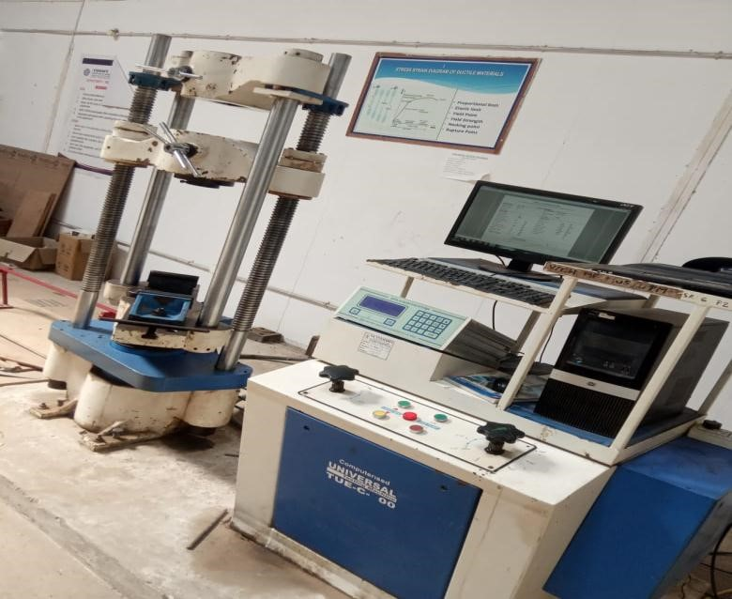

Figure1. Tensile test Apparatus

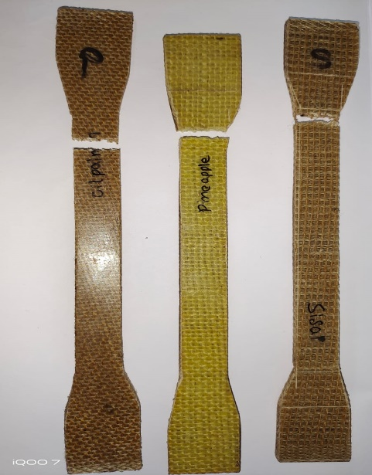

Figure2. Tensile testing specimens

**4.2Hardness Test:**

It is used to assess the hardness of a composite in line with ASTM standards. The specimen is indented by using a hardened steel ball. When the maximum load and equilibrium position are reached to determine the hardness of a material, the external load is removed. The hardness testing apparatus and specimens are shown in *Figure 3* and *Figure 4* respectively

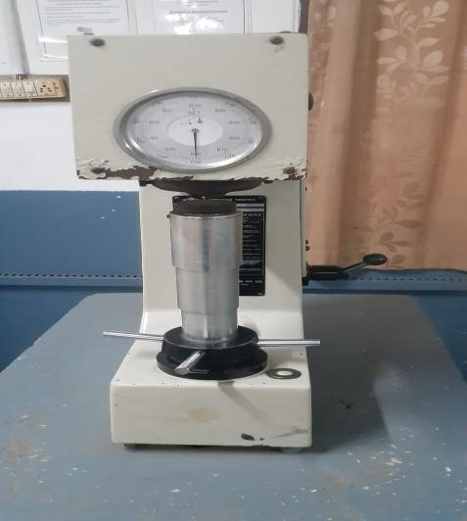

Figure3.Hardness Test Apparatus

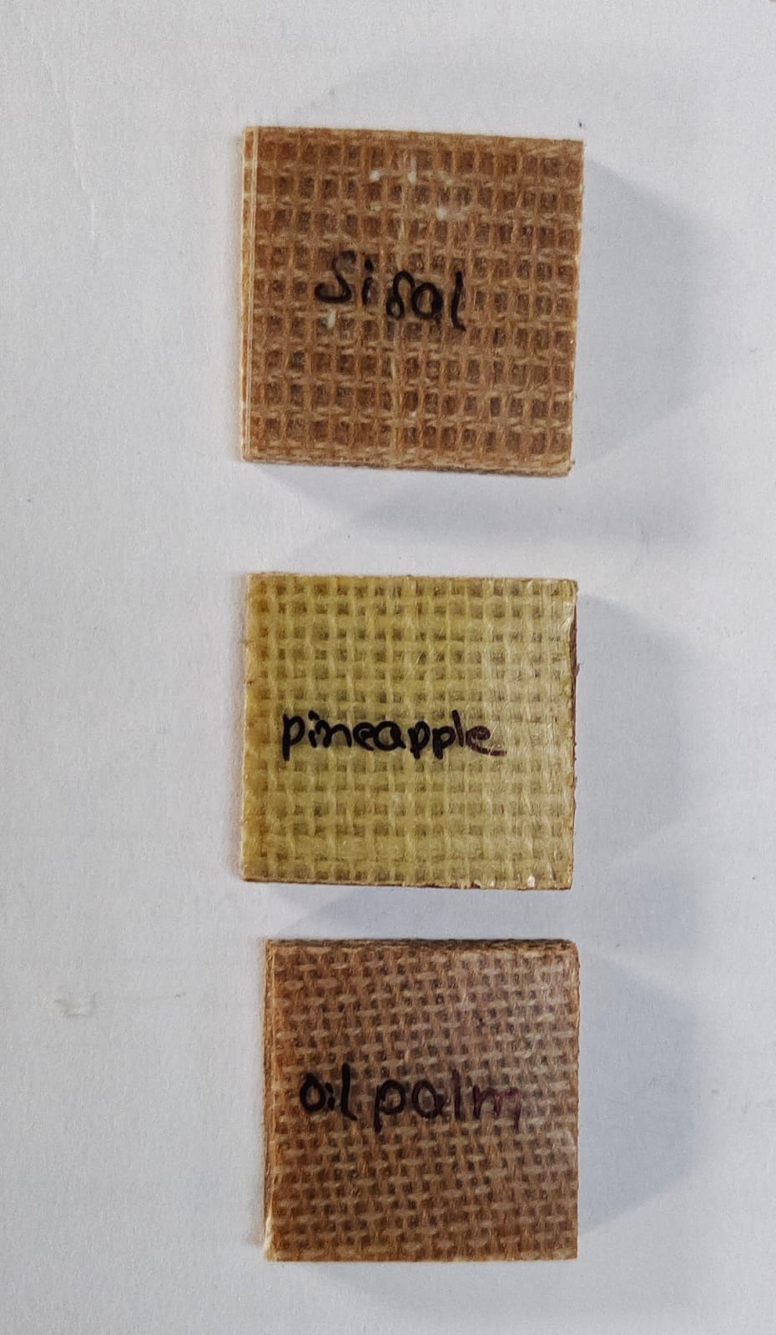

Figure4.Hardness test specimens

**4.3 Impact Test:**

This is a measure of the material's dissipated energy before failure under shock loading conditions. The toughness and yield strength of the material are also measured. It is also feasible to assess the influence of strain rate on the ductility and fracture of the material by performing an impact test. The impact test samples were cut from the individual composites following the ASTM D 256 standard and tested on the impact testing equipment. *Figure 5* and *Figure* *6* show the impact testing device and specimens

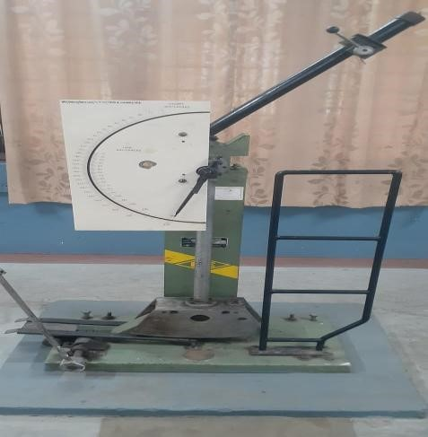

**Figure5.Impact Test Apparatus**

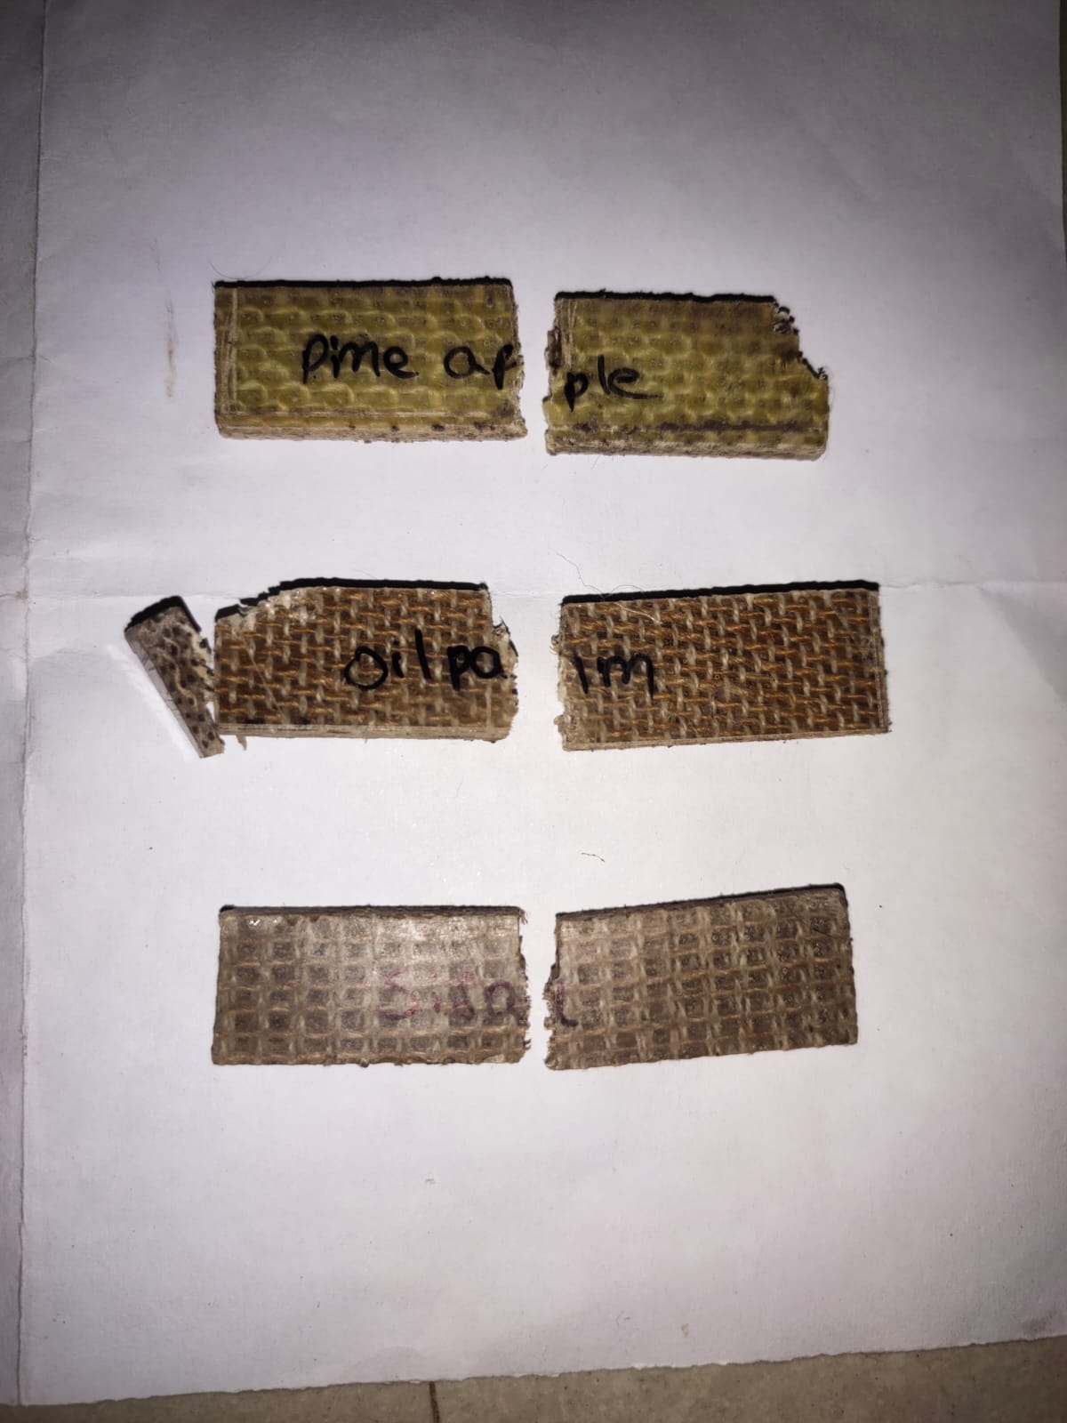

**Figure6.Impact test specimens**

**4.4 Flexural Test:**

The flexure test method measures behavior of materials subjected to simple beam loading. It is also called a transverse beam test with some materials. Maximum fiber stress and maximum strain are calculated for increments of load. Results are plotted in a stress-strain diagram. Flexural strength is defined as the maximum stress in the outermost fiber. This is calculated at the surface of the specimen on the convex or tension side. Flexural modulus is calculated from the slope of the stress vs. deflection curve. If the curve has no linear region, a secant line is fitted to the curve to determine the slope. The 3-point flexure test is the most common for polymers. Specimen deflection is usually measured by the crosshead position. Test results include flexural strength and flexural modulus. As the specimen is cut as per ASTM standards, *Figure7*  and *Figure* *8* show the flexural testing device and specimens.

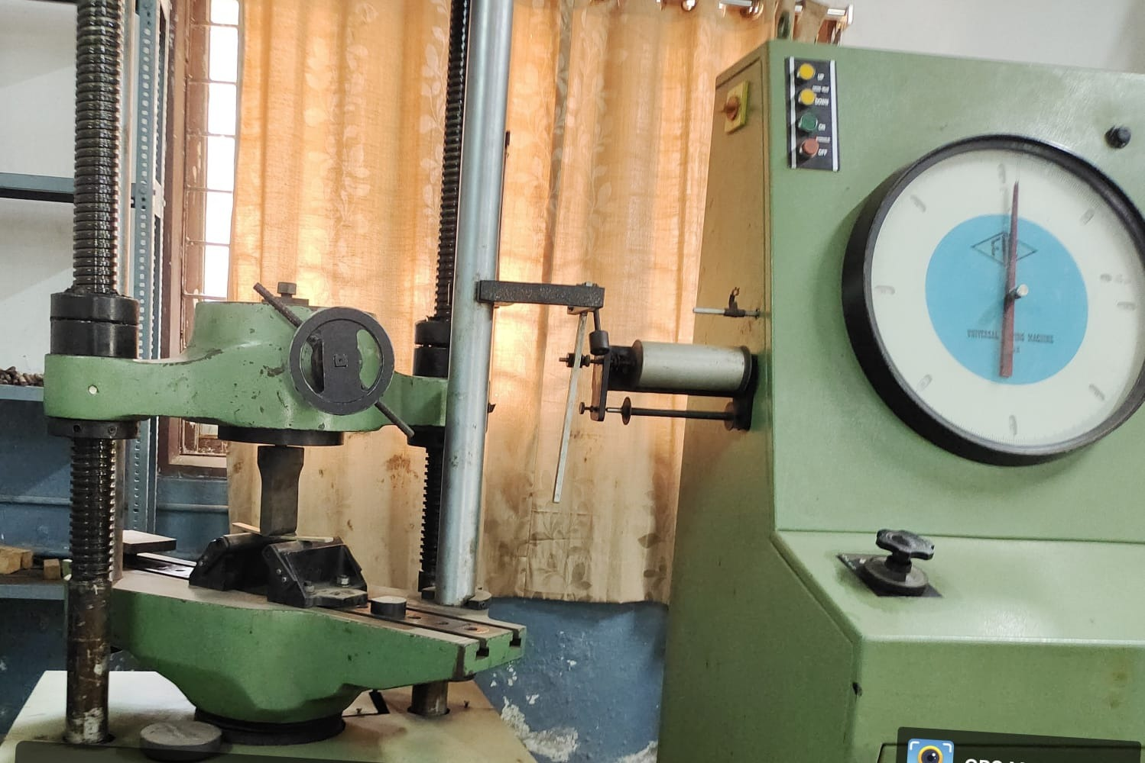

**Figure7.Flexural Test Apparatus**

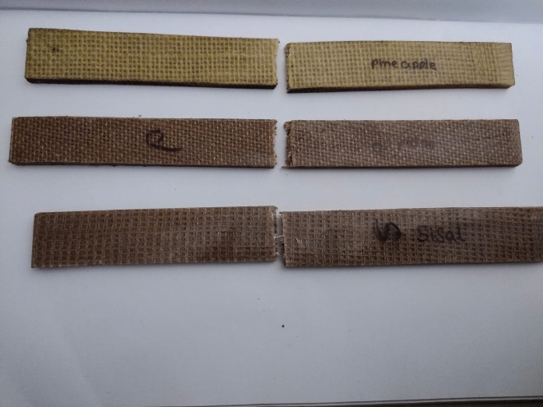

**Figure8.Flexural Test Specimens**

1. **RESULTS**

The results of the tests are shown in this section. Figure 9 shows the results of the tensile test , figure 10 for flexural strength, figure11 for impact strength, figure 12 for hardness values of three samples of sisal, oilpalm, and pineapple fiber-reinforced composites for comparison. In this work, the testing strength of each fiber was assessed in three different samples. sisal, oil palm, and pineapple fiber-reinforced polymers have varied strengths based on their fiber properties. When compared to three fibers, the oil palm gives higher tensile strength, flexural strength and impact strength in three fiber composites. As seen in Figure 9, 10, 11. And pineapple fiber gives higher hardness value as compared with sisal and oil palm fiber composites, shows in figure 12. Stress-strain curves for sisal, oil palm and pineapple fiber composites as shown in Figure 13, Figure 14 and Figure 15, respectively. Table 1, Table 2 and Table 3 show the influence of varying fiber samples on the tensile strength , flexural strength, impact strength, hardnes values of sisal, oil palm, pineapple fiber reinforced composites.

* 1. **Tensile strength**

**Sisal Oil palm**

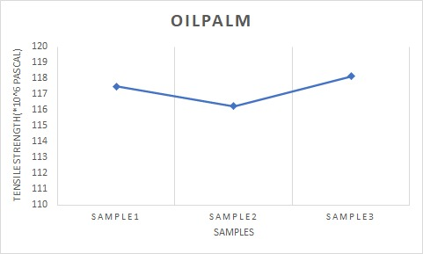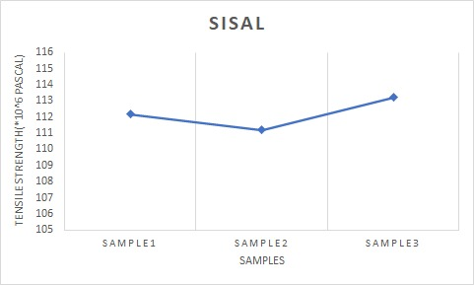

**Pineapple**

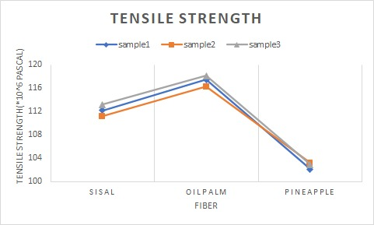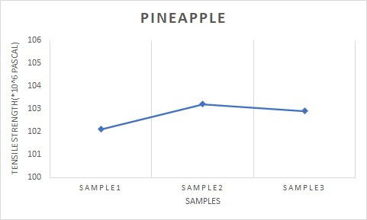

Figure 9: Tensile strength of three fibers

* 1. **Flexural strength**

**Sisal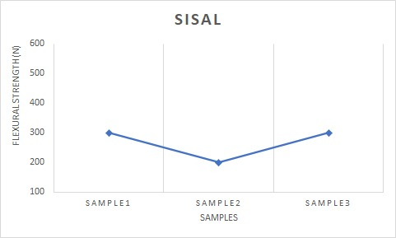 Oil palm**

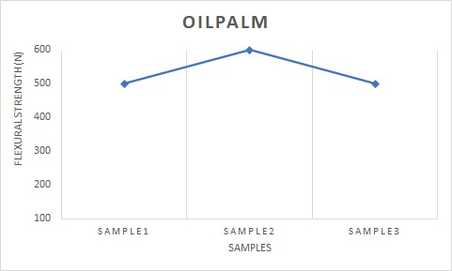

**pineapple**

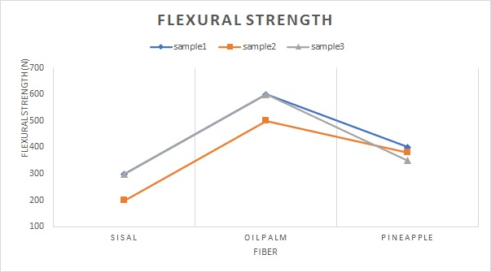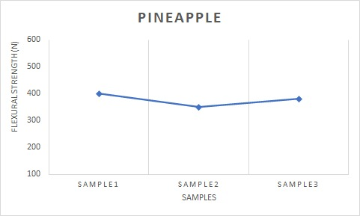

Figure 10: Flexural strength of three fibers

* 1. **Impact strength**

**Sisal Oil palm**

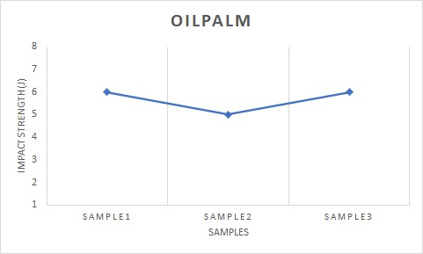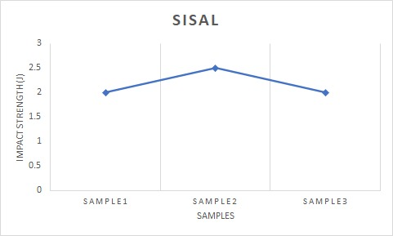

Pineapple

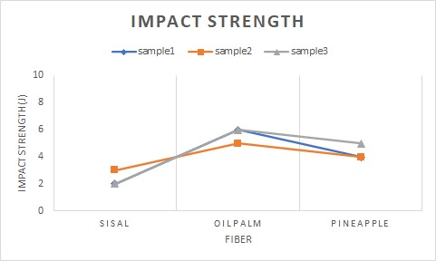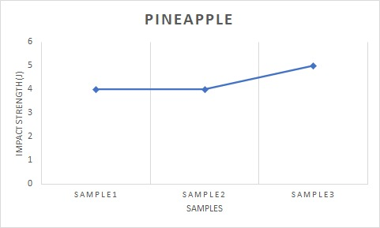

Figure 11:Impact strength of three fibers

* 1. Hardness

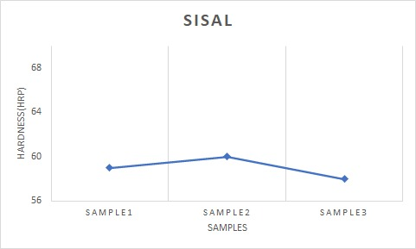Sisal Oil palm

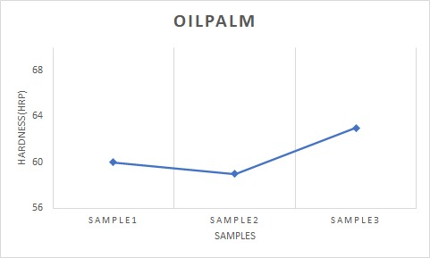

Pineapple

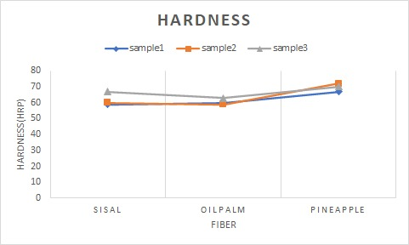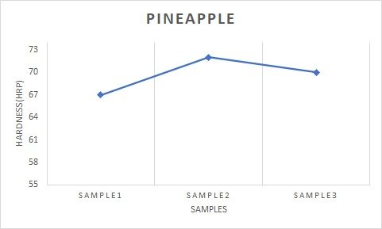

Figure 12: Hardness value of three fibers

Table 1

Tensile strength(*10^6 Pascal):

|  |  |  |  |
| --- | --- | --- | --- |
|  | Sisal | Oil palm | pineapple |
| Sample1 | 112.188 | 117.500 | 102.113 |
| Sample2 | 111.199 | 116.248 | 103.214 |
| Sample3 | 113.229 | 118.142 | 102.912 |

Table 2

Flexural strength(N):

|  |  |  |  |
| --- | --- | --- | --- |
|  | Sisal | Oil palm | pineapple |
| Sample1 | 300 | 600 | 400 |
| Sample2 | 200 | 500 | 380 |
| Sample3 | 300 | 600 | 350 |

Table 3

Impact strength(J):

|  |  |  |  |
| --- | --- | --- | --- |
|  | Sisal | Oil palm | pineapple |
| Sample1 | 2 | 6 | 4 |
| Sample2 | 3 | 5 | 4 |
| Sample3 | 2 | 6 | 5 |

Table4

Hardness(HRP):

|  |  |  |  |
| --- | --- | --- | --- |
|  | Sisal | Oil palm | pineapple |
| Sample1 | 59 | 60 | 67 |
| Sample2 | 60 | 59 | 72 |
| Sample3 | 58 | 63 | 70 |

1. **Discussion**

From the experimental results, it is observed that three fibers influence the mechanical properties such as tensile, flexural, hardness, and impact strength. The three fibers are Figure 9 shows a comparison of the tensile strengths of the three composites of three samples. The tensile strength of three samples of sisal fiber is 112.188 Mpa, 111.199 Mpa, and 113.229 Mpa. For pineapple fiber the values are 102.113 Mpa, 103.214 Mpa, and 102.912 Mpa. For oil palm the values are 117.500 Mpa, 116.248 Mpa, and 118.142 Mpa. The oil palm fiber have high tensile strength values as compared with sisal and pineapple. Figure 10 shows a comparison of the flexural strength of the three composites of three samples of sisal are 300N, 200N, and 300N. For oil palm, the values are 600N, 500N, and 600N. For pineapple, the values are 400N, 380N, and 350N. The oil palm fiber have high flexural strength values as compared with sisal and pineapple Figure 11 compares the impact strength of three composites made from three sisal samples: 2J, 3J, and 2J. The values for pine apple are 6J, 5J, and 6J. The values for oil palm are 4J, 5J, and 4J. In comparison to sisal and pineapple fibres, oil palm fibre has a high impact strength value. Figure 12 compares the hardness values of three composites made out of three sisal samples: 59HRP, 60HRP, and 58HRP. The readings for pineapple are 67HRP, 72HRP, and 70HRP. The values for oil palm are 60HRP, 59HRP, and 63HRP. In comparison to sisal and oil palm fibres, pineapple fibre has a high hardness value. This is due to the epoxy resins' capability to develop a strong bond between matrix and fiber. A complete list of abbreviations is shown in Appendix I

1. **Conclusion**

The mechanical performance of fiber-reinforced epoxy-based polymer composites made of sisal, oil palm, and pineapple fibers was investigated. The following are the outcomes of this experimental investigation:

1. sisal, oil palm, and pineapple fiber reinforced epoxy composite materials have been successfully fabricated.
2. When compared to the other two fiber composites, oil palm fiber has higher tensile strength, flexural strength, and impact energy.
3. Because oil palm has a higher lignin content in its chemical composition than sisal and pineapple fibers, it has more of these qualities.
4. Oil palm fiber has the highest lignin percentage (23.03%), followed by sisal (9.9%), and pineapple (10.5%). So the Tensile strength, flexural strength, and impact strength in oil palm fiber composites are all improved as a result of the variation in lignin content weight percentage.
5. The cellulose content of pineapple is higher than that of sisal (65.8%) and oil palm (31.5%). (70-82 percent ). As a result, the hardness value is higher.

**8. REFERENCES**

1. Shrivastava, V. K., A Review: Sisal Fibre Behavior as Reinforcement in Composites, Journal of Basic andApplied Engineering Research, 4(2), (2017), 172-175
2. Laly, A.P. and Sabu, T. 2003. Polarity parameters and dynamic mechanical behaviour of chemically modified banana fiber reinforced polyester com-posites. Comp. Sci. Tech. 63:1231-1240.
3. Maldas, D., Kokta, B.V. and Daneault, C. 1989. Composites of polyvinyl chloride-wood fibers. IV. Effect of the nature of fibers. J. Vinyl Technol. 11:90-99.
4. Stevens, Christian. Industrial applications of natural fibres: structure, properties and technical applications.Vol. 10. John Wiley & Sons 2010.
5. Varvani-Farahani, Ahmad. "Composite materials: characterization, fabrication and application researchchallenges and directions." Applied Composite Materials 17, no. 2 (2010): 63-67.
6. Wambua, Paul, Jan Ivens, and Ignaas Verpoest. "Natural fibres: can they replace glass in fibre reinforced plastics?." Composites science and technology 63, no. 9 (2003): 1259-1264.
7. Joseph, Kuruvilla, Romildo Dias Tolêdo Filho, Beena James, Sabu Thomas, and Laura Hecker de Carvalho."A review on sisal fiber reinforced polymer composites." Revista Brasileira de Engenharia Agrícola eAmbiental 3, no. 3 (1999): 367-379.
8. Basiron Y. and Chan K.W., The oil palm and its sustainability, *Journal of Oil Palm Research*, **16**(1) (2004) 1–10.
9. Rosnah M.S., Hasamudin W.H.W, Gapor A.M.T., and Kamarudin H., Thermal properties of oil palm fi bre, cellulose and its derivatives, *Journal of Oil Palm Research*, **18** (2006) 272–277.
10. Banik, Shyamal & Nag, Dibyendu & Debnath, Sanjoy. (2011). Utilization of pineapple leaf agro-waste for extraction of fibre and the residual biomass for vermicomposting. Indian Journal of Fibre and Textile Research. 36.
11. Ankit, MotiLal Rinawa, Prashant Chauhan, A review on mechanical properties of natural fiber reinforced polymer (NFRP) composites, Materials Today: Proceedings.
12. Adane Dagnaw Gudayu, Dr. Leif Steuernagel, Sisal Fiber Reinforced Polymeric Composites, International Journal on Textile Engineering and Processes ISSN 2395-3578 Vol. 5, Issue 3 July 2019.
13. Emmanuel Owoichoechi MOMOH, Adelaja Israel OSOFERO, recent developments in the application of oil palm ﬁbersin cement composites, School of Engineering, University of Aberdeen, Aberdeen, AB24 3UE, UK*Corresponding author, The Author(s) 2019.
14. J. Naveen, ... M. Chandrasekar, in [Mechanical and Physical Testing of Biocomposites, Fibre-Reinforced Composites and Hybrid Composites](https://www.sciencedirect.com/book/9780081022924/mechanical-and-physical-testing-of-biocomposites-fibre-reinforced-composites-and-hybrid-composites), 2019.
15. Mohamad Rusydi Zainal Abidin, 2saifulnizan Jamian, short review: crashworthiness characteristic of natural fiber composite, international journal of management and applied science, issn: 2394-7926.
16. M. Asim, Khalina Abdan, A Review on Pineapple Leaves Fibre and Its Composites,Volume 2015 Article ID 950567.
17. Appendix

|  |  |  |
| --- | --- | --- |
| S.No | Abbreviation | Description |
| 1 | ASTM | American society for testing materials |
| 2 | MPa | Megapascal |
| 3 | J | Joules |
| 4 | N | Newtons |
| 5 | HRB | Rockwell hardness measured on the B scale |