npm install bootstrap –save

this line in index.js ====== import ‘bootstrap/dist/css/bootstrap.min.css’;

npm install axios –save

consta axios=”8080 addres”

https://www.youtube.com/watch?v=zXE7dCidXhc&list=PLGRDMO4rOGcNLnW1L2vgsExTBg-VPoZHr&index=9

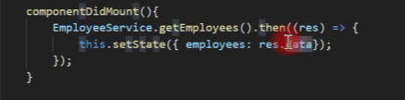

we should add annotation @crossOrigin(origin=” address of the react app”)