change request

Description: logo

**Integra Software Services Pvt. Ltd.**

100 Feet Road (ECR), Pakkamudiyanpet

Pondicherry – 605 008. INDIA

Phone: +91-413-4212124, 4212125

Fax: +91-413-4212190

**Project Number:** IRL-0046-2015 **CR No.:** CR-0029-2019

**Project Name:** iPMP

**Project Definition: iPMP is managing a project by planning, organizing, and managing its different required aspects**.

Prepared by : Sivasamy. N

Date : 21-08-2019

Ver. : 1

Table of Contents

1. Introduction 4

1.1 Current System 4

1.2 Scope / Proposed System 4

2. Change requests 5

2.1 Predecessors 5

2.1.1 Introduction 5

2.1.2 Inputs 5

2.1.3 Output 5

3. Efforts 6

4. Sign-off 7

**REVISION HISTORY:**

|  |  |  |  |  |  |
| --- | --- | --- | --- | --- | --- |
| **Author** | **Date** | **Version** | **List of Changes** | **Reviewed By** | **Approved By** |
| Sivasamy N | 21-08-2019 | 1.0 | Original Version |  |  |
|  |  |  |  |  |  |
|  |  |  |  |  |  |

# Introduction

A web portal, managing a project by planning, organizing, and managing its different required aspects.

## Current System

Feature enhancement to current system as listed below:

## Scope / Proposed System

Following features to be built in proposed system,

1. Predecessors

# Change requests

## Predecessors

### Introduction

Predecessors needed to be used in project scheduling and tracking. It’s linked to the project tasks based on index value. We must give the index value to the predecessor fields.

### Inputs

This predecessor column is included before ‘Assign To’ project task menu item in project scheduling and tracking page. When the Actual end date for a predecessor task changes, provide a pop-up option to User “Autopopulate revised dates ? “ with Yes and No options.

1.The user will be able to enter task numbers in the column separated by comma

2. Start date restriction of Successor:

1. No Actual End date for Predecessor Task: If a project has a predecessor , its planned start date cannot be lesser than the planned end date of the predecessor. Error thrown to user, if entered so.

2. Actual end date entered for Predecessor Task:

When the actual end date is entered for Predecessor task and Actual end date = Planned end date --> No Change in schedule

When the actual end date is entered for Predecessor task and Actual end date <> Planned end date --> Throw an alert to user if the user wishes to Auto populate the dates of sucessor task accordingly.

-If yes, make the relevant Project Start and Project end date changes in scheduling of successor task

- If no, do not make changes to the schedule

3. Gantt chart is used to graphically represent task linking.

4. Sub task logic remains intact.

### Output

#### Reference diagram:

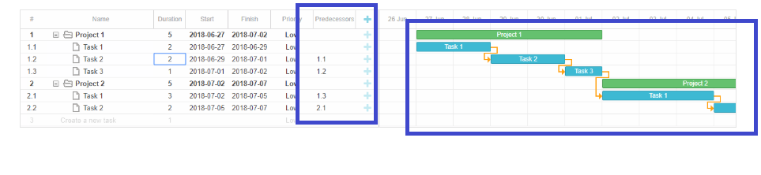

#### Example:

The predecessor task must be complete before the actual task begins.

In the above example, Project 1 Task 2 (1.2) has predecessor value of 1.1 – Planned start date of 1.2 has dependency on actual completion date of 1.1 – Only after 1.1 is complete, 1.2 can begin. For this behavior Gantt chart changes will be done.

# Efforts

**Total Efforts: 15 days**

# Sign-off

**______________________________________ ___________________**

Customer/DU Responsibility Date

(Primary & Secondary responsible persons must sign-off)

**______________________________________ ___________________**

Project Lead Date