Scope Of Work


Integra Software Services Pvt. Ltd.
100 Feet Road (ECR), Pakkamudiyanpet
Pondicherry – 605 008. INDIA
Phone: +91-413-4212124, 4212125
Fax: +91-413-4212190

_____________________________________________________________________________

Project No. : IRL-0046-2015 SOW No. : SOW-0009-2019

Project Name : iPMP
Project Definition : iPMP is a Project Management portal exclusively to schedule, manage and track the projects online. It’s dashboard provides a high visibility on the status of overall projects.

Prepared by : Sivasamy N
Date : 21-08-2019
Ver : 1.0

Contents
1. Introduction 3
1.1 Current System 3
1.2 Scope / Proposed System 3
1.3 Abbreviations 3
2. Functional Requirements 4
2.1 New Menu design 4
2.1.1 Inputs 4
2.1.2 Output 4
2.2 Budgeting Dashboard 5
2.2.1 Introduction 5
2.2.2 Inputs 5
2.3 Scheduling holiday 9
2.3.1 Inputs 9
2.3.2 Output 10
2.4 Import schedules in excel format 11
2.4.1 Inputs 11
2.5 Fields Configuration 12
2.5.1 Inputs 12
2.6 Currency Field in Create Project: 15
2.6.1 Inputs 15
3. Non-Functional Requirements 16
3.1 External Requirements 16
3.1.1 External Requirement 16
3.2 Limitations 16
4. MISCELLANEOUS 17
4.1 Configuration Management 17
4.1.1 Source code management: 17
4.1.2 Source code deployed: 17
5. SOW (SIGN-OFF CHECK LIST) 18
6. Sign-off 20

Introduction
iPMP is a Project Management portal exclusively to schedule, manage and track the projects online. It’s dashboard provides a high visibility on the status of overall projects.

Current System
Feature enhancement to current system as listed below:

Scope / Proposed System
Following features to be built in proposed system,
- New Menu design
- Budgeting Dashboard
- Scheduling holiday
- Import schedules in excel format
- Fields configuration
- Currency Field in Create Project

Abbreviations
Abbreviations used in this document.
CP – Content Producer
PM – Project Manager
PMTL – Client Manager
GBS – Global Business service

Functional Requirements

New Menu design

Inputs
For all iPMP User roles (Client Manager, Project Manager, PMTL, Client, Content Producer TL, CP Super Admin), the new expanded menu must be displayed when logged into iPMP. There should be a toggle button to expand and shrink this menu item.
The menu should have:
- Dashboard
- Create Project
- Projects
- Reports
- Pearson Dashboard (if client is Pearson)

Output
New menu design provided to the home page. Its provided menu toggle button for resize the menu design.
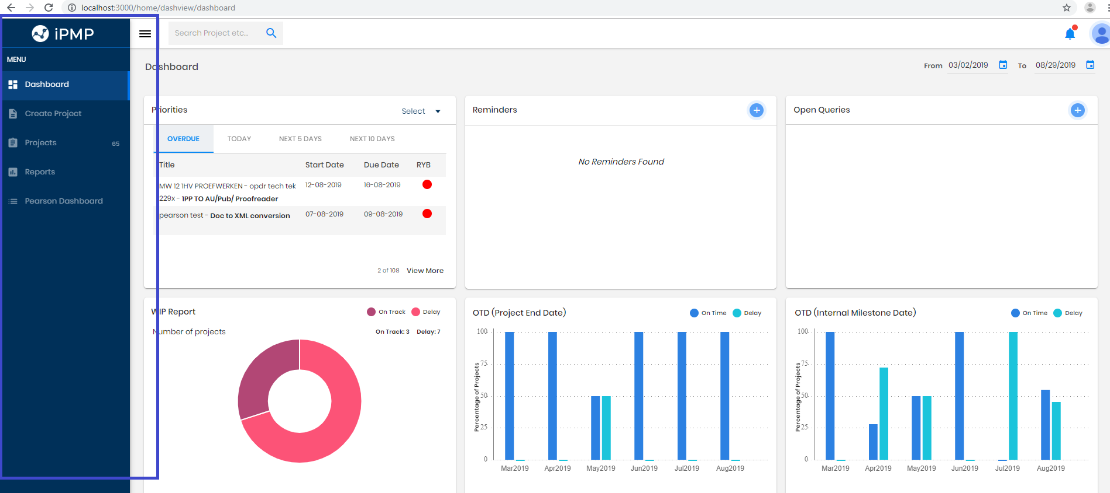

Budgeting Dashboard

Introduction
Purpose: To calculate the budget of the iPMP projects. Users: PM/PMTL to provide the following while project creation
- Schedule variance
- Budget
- Page count

Inputs

Schedule variance:
It is used to track project. Provide Risk status next to this. Schedule variance will project the task schedule as follows:
- Behind
- Ahead
- On Track

Behind:
For projects having delay and delay completion projects.
WIP Projects: Actual Final completion date = Null and Current Task Actual End Date > Planned end Date
Completed Projects: Final Actual Completion Date > Final Planned Completion Date
Ahead:
For projects having Actual start date before Planned Start Date.
WIP Projects: Actual Final completion date = Null and Current Task Actual End Date < Planned end Date
Completed Projects: For projects having Final Actual Completion Date < Final Planned Completion Date
On Track:
For projects having Actual start date equal to Planned Start Date.
WIP Projects: Actual Final completion date = Null and Current Task Actual End Date = =Planned end Date
Completed Projects: For projects having Final Actual Completion Date == Final Planned Completion Date

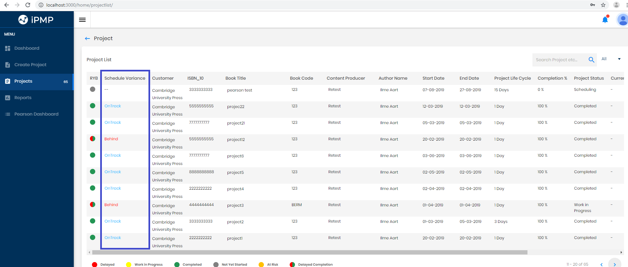

Budget:

While Project creation PM/PMTL selects service. From the Project list, Budget details can be given for each service line as follows. The user can edit the fields.
Budget consist of Service Name, Unit Cost, Currency, Quantity, UOM (unit of measurement), Total Amount and Actual Cost.
The Sum of all Services Actual Cost is compared with Sum of All Services Total Amount:
a. Total - Actual = 0 --> On Budget. Represented by
b. Total - Actual = Negative --> Over Budget. Represented by Red Down Arrow
c. Total - Actual = Positive --> Under Budget. Represented by Green Up Arrow

Revision History is used to display the changes made to the budget
Export to excel option is provided

S.NO | Fields | Validations
 | Service line | Read only
 | Unit cost | Number  Value Type: decimal (12,2)
 | Quantity | Number  Value Type: int
 | UOM | textbox  Value Type: varchar (50)
 | Currency | Dropdown
 | Total Amount | Read only
 | Actual cost | Number  Value Type: decimal (12,2)

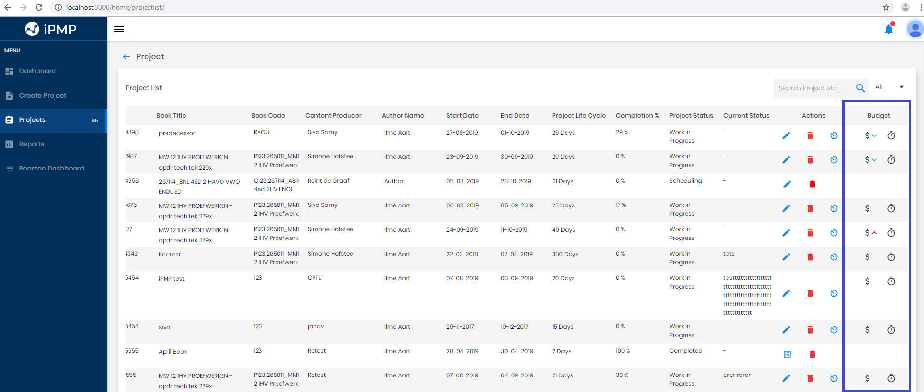
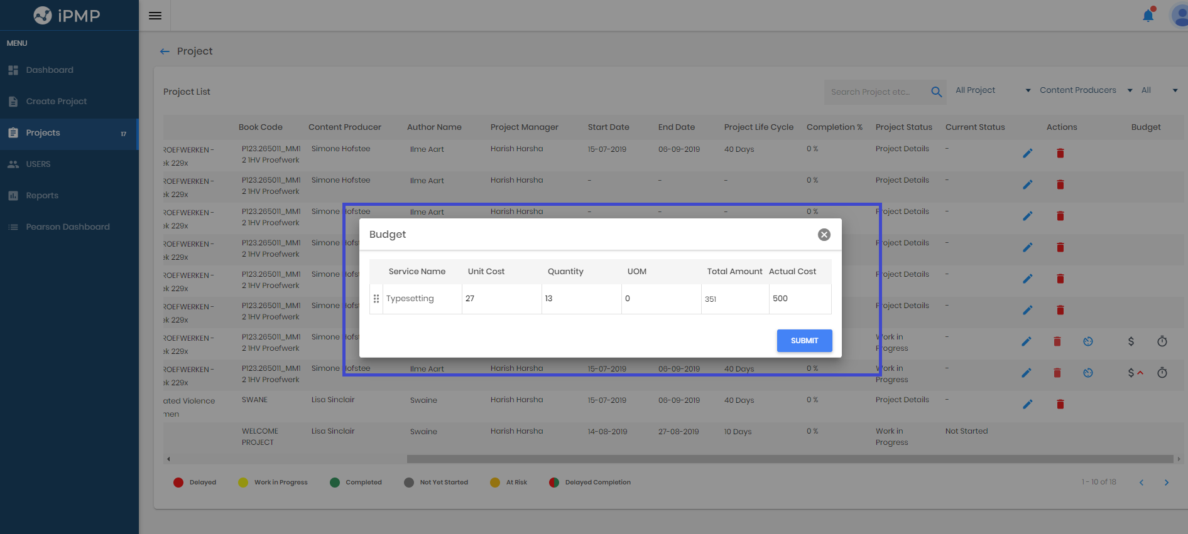

Page Count:
Page count details can be added by PM/ PMTL from Project List for each project. Page count is used to add number of chapters in page count list. It consists of previous edition page count, chapter name and page count.
In Page count list has listed number of chapter added. Each chapter has to be calculated per page count. Difference column displays the calculated difference between cost off and actual amount. Cast off is the page count.
a. Columns: Chapter Name, Cast Off, Actual, Difference, Action
b. Chapter Name: Auto populated from the list entered by user above
c. Cast off: Page Count to be entered by user (field restriction)
d. Actual: Page count to be entered by user (field restriction)
e. Difference: Calculated by system Cast off - Actual

Delete option is provided to user to delete the row from Page Count list.
Revision History is used to display the changes made to the budget.
Export to excel option is provided.
S.NO | Fields | Validations
 | Page Edition Page Count | Number  Value Type: int
 | Chapter name | Textbox  Value Type: varchar  Max length:50
 | Page Count | Number  Value Type: int
 | Cost off | Number  Value Type: decimal (12,2)
 | Cost off blanks | Number  Value Type: decimal (12,2)
 | Actual | Number  Value Type: decimal (12,2)
 | Actual blanks | Number  Value Type: decimal (12,2)
 | difference | Read only

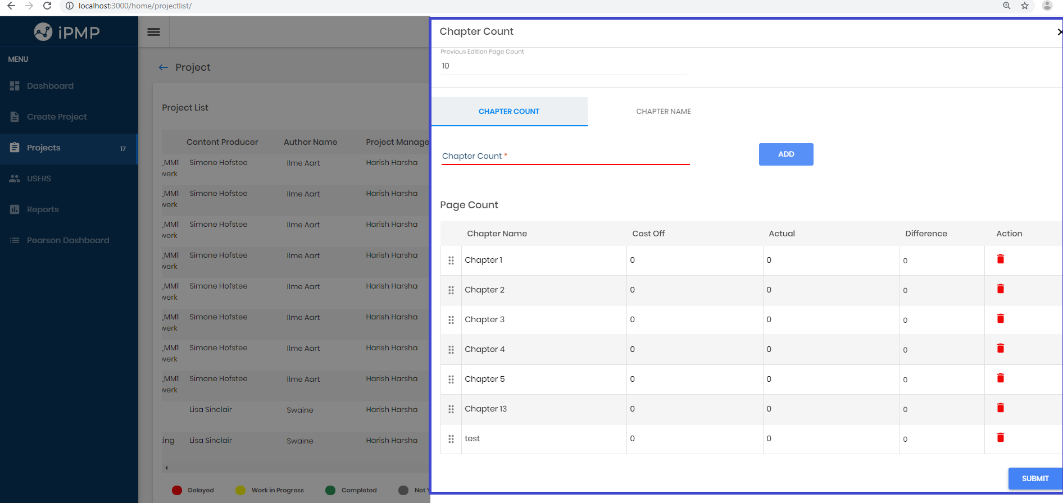

Scheduling holiday

Inputs
When the user clicks on Submit in the Project Creation screen, along with Template popup:
1. There is a section called "Holidays"
2. The user can select Type: External or Internal from the dropdown
3. Once type is selected; the user is shown Date picker to select date and click on Add.
4. User can select as many dates along with types and click on Add.
5. The user is also provided with an option to Delete already added Leave.
6. Saturday and Sunday automatically disabled in Date Picker.

Prerequisite: The internal and external Holidays are set prior to Project scheduling. The user is in Project Scheduling screen and tries to add task:
1. Include "Type " column against Task for user to select Internal or External
2. The user enters duration and selects the Date Picker in Start Date
- Ensure the Internal or External based on user selection above, Holidays are greyed out in selection
- The end Date is automatically calculated omitting the holidays if there are holidays in between
3. The user does not enter duration and selects the Date Picker in Start Date
- Ensure the Holidays are greyed out in selection based on User selection of "Type"
- Ensure in End Date date picker also the holidays are greyed out and not available for selection
- Duration is automatically calculated omitting the Holiday dates in between.
4. The above logic is applicable even when a task schedule is edited.

Output
Scheduling - Include Customer & Integra holiday. Option to add Customer & Internal (Integra) holiday in scheduling screen. PM/PMTL can select the number of holidays project wise. After PM/PMTL submits Project creation details, the Date component as below is popped up to select the holiday dates so that Project scheduling can omit the holidays while scheduling the tasks.
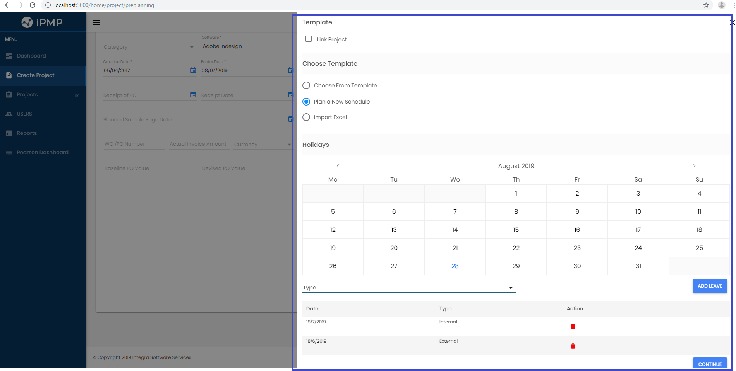

Import schedules in excel format

Inputs
Directly import schedules in excel format. Needed especially when the client provides the schedule via excel format. Option to Download project template and upload. Include “Read me – Instructions” for the user in the downloaded template. Following columns available on excel sheet. * denotes mandatory
- Task Name*
- Sub task name
- Type*
- Notification
- Start date*
- End date*
- Predecessors
- Assign To
The user can fill in the mandatory/ other columns in the template and save it.

Prerequisite: The Schedule Import template is downloaded from system during Project Creation, the user fills in the details and clicks on Import button
1. A pop up is shown to user to select the Upload file from user's computer
2. User selects file and clicks on Import.
3. The imported file is displayed on the screen along with pagination (10 rows max in a page)
4. Validations should be done for the file:
a. File Format (extensions - xlsx)
b. Empty file validation & Task sheet validation
c. Mandatory field validations - Task Name, Type, Start Date and End Date.

The Schedule is imported successfully in the system.
1. The Imported schedule is displayed in the Project Scheduling screen.
2. The duration is filled in automatically based on Start Date, End Date and HOLIDAYS (External or Internal)
3. If the Start Date or End Date provided in excel is a Holiday/ Saturday/Sunday, show an Error Alert to User on that task and do not let the user to submit the schedule until that error is cleared. The user can edit the task and adjust dates accordingly.

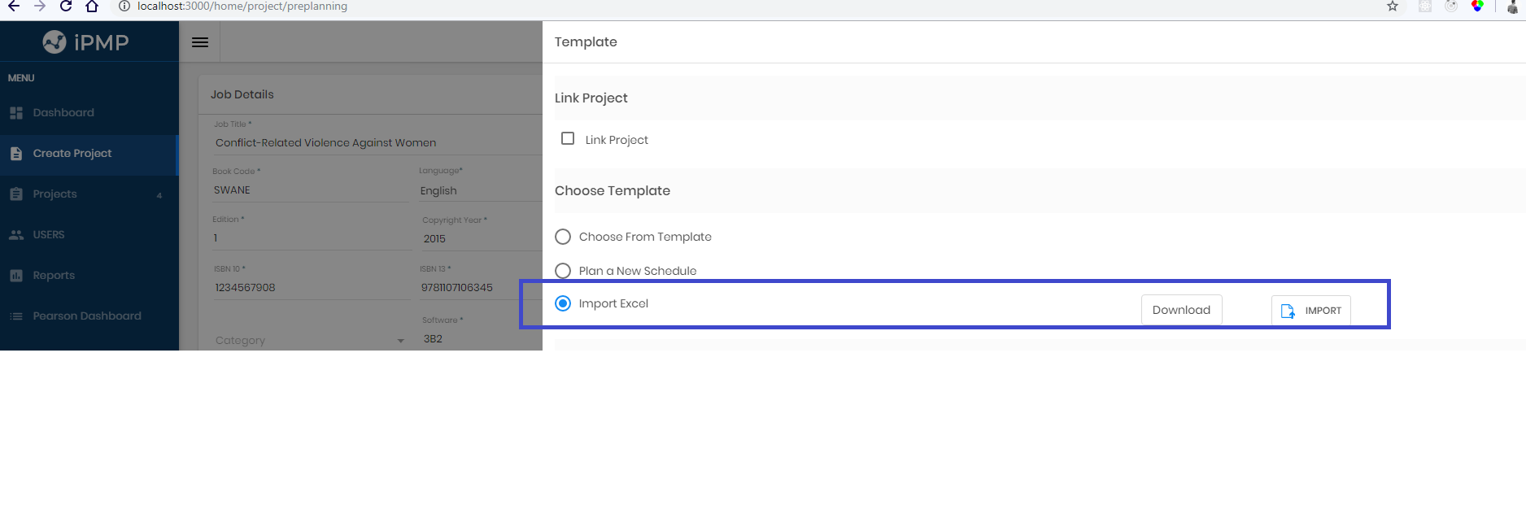

Fields Configuration

Inputs
In iPMP has many departments on ‘Settings’ menu from the user profile. PMTL & PM logins have “Settings API”. Some of the features available now for Pearson may not be needed for all departments. So, we have made the following fields configurable so as to display for Pearson and not display for another DU.
Sl No. | Screen Name | Fields | Pearson | Other Du's
1 | Pearson Dashboard |  | Show | Hide
2 | Create Projects | CSC | Show | Hide
 |  | GBS Delivery Lead | Show | Hide
 |  | GBS Demand Lead | Show | Hide
 |  | Service Recipient | Show | Hide
 |  | Pearson BU | Show | Hide
 |  | Function | Show | Hide
 |  | CP Manager | Show | Hide
 |  | VP Stakeholder | Show | Hide
3 | Project Current Status | No of Errors/Issues/Escalations identified by Pearson /Monthly (Print/Digital) | Show | Hide
 |  | No of QE Errors/Issues reported /Monthly (Digital) | Show | Hide
 |  | Smartsheet Link | Show | Hide
 |  | Jira Link | Show | Hide
 |  | Logictron Link | Show | Hide

Settings:
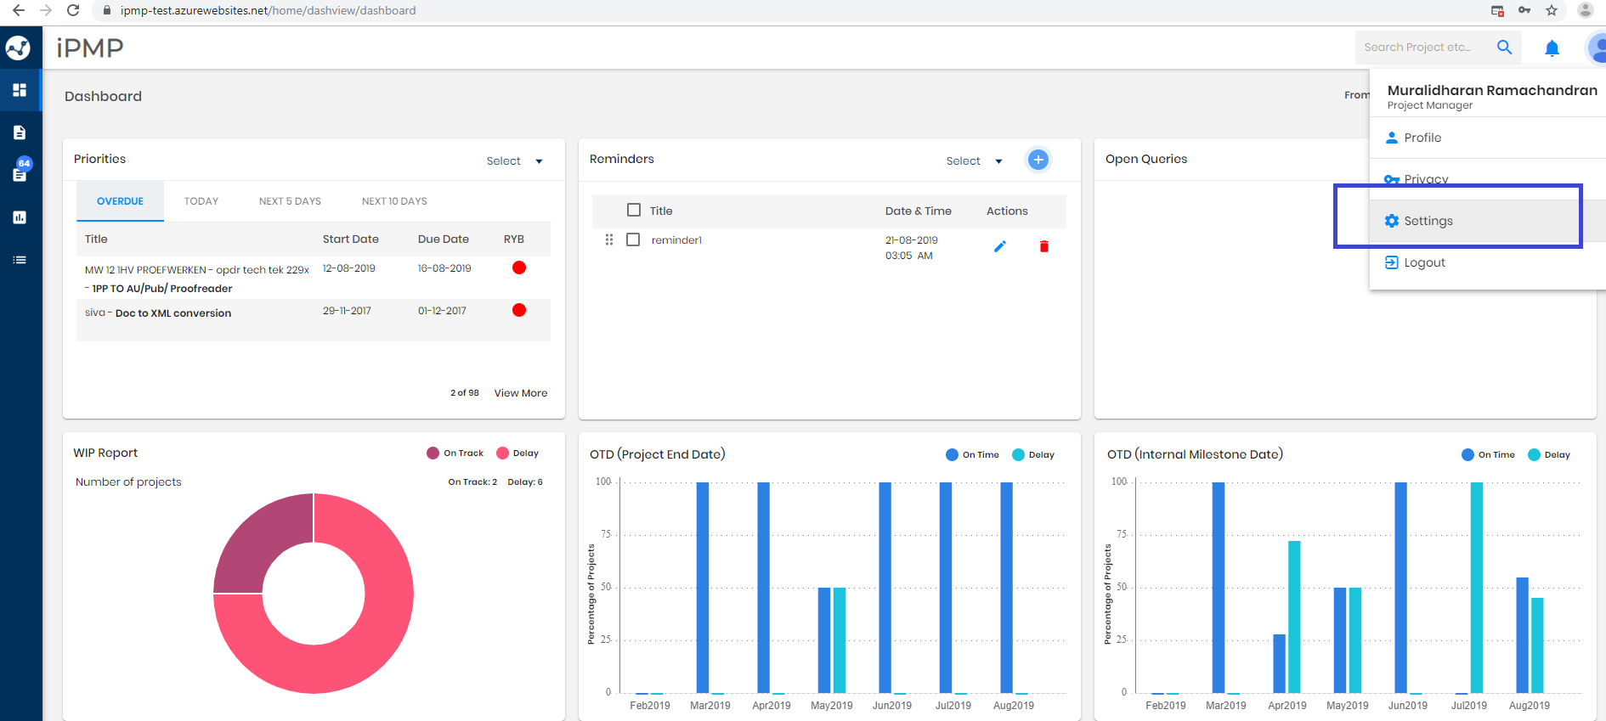

Department dropdown list:
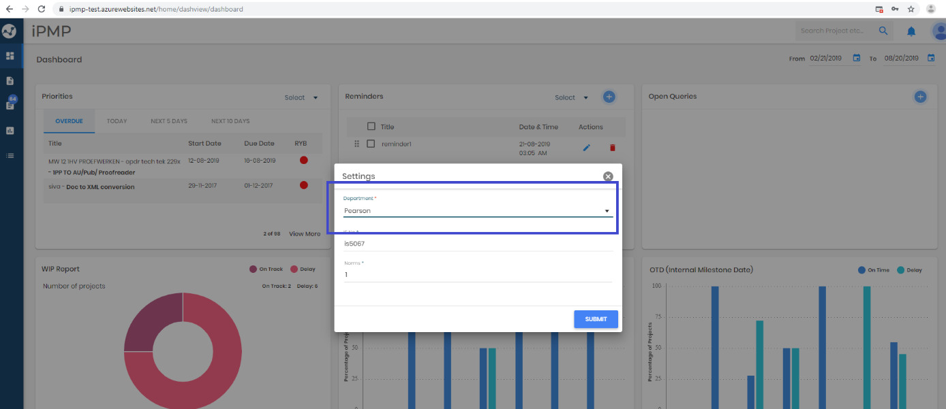

List of departments:
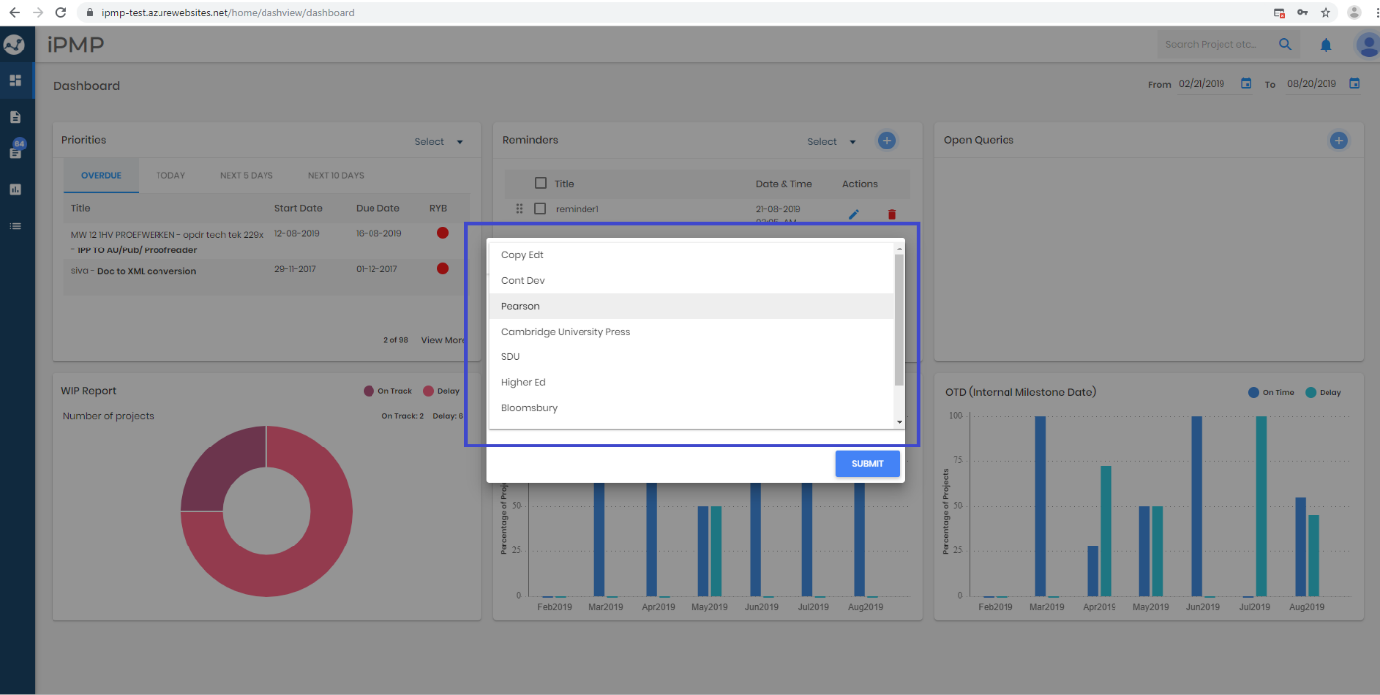

Currency Field in Create Project:

Inputs
When PM/PMTL creates project, dropdown is provided to select currency for Actual Invoice Amount.
Actual invoice amount with currency sign will be update on Pearson dashboard.

The dropdown has the following options:
• $
• INR
• £
• C$
• ¥
• €
• A$

Non-Functional Requirements

External Requirements

External Requirement
<Not applicable>

Limitations
<Not applicable>.

MISCELLANEOUS

Configuration Management

Source code management:
Microsoft Visual SourceSafe (VSS) is a discontinued source control program, oriented towards small software development projects. Like most source control systems, SourceSafe creates a virtual library of computer files of iPMP source code. It has handled check in and check out.

Source code deployed:
FileZilla is one of the most popular FTP clients. The main purpose of Filezilla is to make it easy for you to upload and download files from our iPMP web hosting server. You can also edit the files and save changes without the need of manually downloading and uploading.

SOW (SIGN-OFF CHECK LIST)
Sl.No. | Description | Yes/No | Remarks
1 | All functional points are covered as per URS or given during Requirement Gathering Phase
2 | Risks/Impacts/Constraints/Limitations are accepted
3 | No ambiguities found in the requirements and the SOW is complete
4 | Input, Output formats, validations captured here are correct and acceptable
5 | No. of product + project + business risks highlighted & accepted
6 | Project Tracking sheet is updated as per project plan SOW milestone date

Requestor : _Tintu Thomas _______________
Requestor DU : __Integra________________________
Contact person(s) : __Tintu Thomas__________________________________

Sign-off
(SOW soft-copy to be sent to the requestor as PDF)

______________________________________ ___________________
Customer/DU Responsibility Date
(Primary & Secondary responsible persons must sign-off)

______________________________________ ___________________
Project Lead Date

______________________________________ ___________________
Project Manager Date

______________________________________ ___________________
SDU Head Date

*All iPMP features have been approved by MD

