**Phase1:RoC company analysis:**

**Problem Definition:**

• The problem is to perform an AI-driven exploration and predictive analysis on the master details

of companies registered with the Registrar of Companies (RoC). The objective is to uncover

hidden patterns, gain insights into the company landscape, and forecast future registration

trends. This project aims to develop predictive models using advanced Artificial Intelligence

techniques to anticipate future company registrations and support informed decision-making

for businesses, investors, and policymakers.

**Design Thinking:**

**Data Source**: Utilize the dataset containing information about registered companies, including columns

like company name, status, class, category, registration date, authorized capital, paid-up capital, and

more.

**Data Preprocessing**: Clean and preprocess the data, handle missing values, and convert categorical

features into numerical representations.

**Exploratory Data Analysis (EDA):** Perform EDA to understand the distribution, relationships, and unique

characteristics of registered companies.

**Feature Engineering**: Create relevant features that can contribute to predictive analysis.

**Predictive Modelling**: Apply AI algorithms to develop predictive models for future company

registrations.

**Model Evaluation**: Evaluate the predictive models using appropriate metrics, such as accuracy and

precision.

**The Importance of Measuring Rate of Change:**

• Rate of change is an extremely important financial concept because it allows investors to spot

security momentum and other trends.

• Rate of change is also a good indicator of market bubbles. Even though momentum is good and

traders look for securities with a positive ROC, if a broad-market ETF, index, or mutual fund has a

sharp increase in its ROC in the short term, it may be a sign that the market is unsustainable. If

the ROC of an index or other broad-market security is over 50%, investors should be wary of a

bubble.

**The price change of indicator:**

• The rate of change is most often used to measure the change in a security’s price over time. This

is also known as the price rate of change (also abbreviated ROC). The price rate of change can be

derived by taking the price of a security at time B minus the price of the same security at time A

and dividing that result by the price at time A.

**What Are Other Terms for Rate of Change?**

• Rate of change may go by other terms depending on the context. With respect to speed or

velocity, for instance, acceleration/deceleration is the rate of change. In statistics and regression

modeling, the rate of change is defined by the slope of the line of best fit. For populations, it is

the growth rate. In financial markets, rate of change is often referred to as momentum.

**How Do You Solve Rate of Change Problems?**

• Rate of change problems can generally be approached using the formula R = D/T, or rate of

change equals the distance traveled divided by the time it takes to do so. Depending on the

context involved in the problem, “distance” can be replaced with something else, like change in

value or price.

**How Do Traders Use the Price Rate of Change Indicator?**

• The price rate of change (ROC) indicator is used in technical analysis to measure momentum. A

positive ROC can confirm a bullish trend while a negative ROC indicates a bearish one. When the

price is consolidating, the ROC will hover near zero.

**Conclusion:**

• It can be concluded that the process of incorporation of a company whether public pate, OPC is

completely laid under and done by following the procedures under companies Act 2013, the

ROC (Registrar of Companies is the main authority which authorises the complete registration of

company and lasues the certificate of incorporation to the company. The registration of

company is very essential without this is a legal organisation and any activity came out legally

says under situation of being challenged by the authority of any stage

**Project: RoC Company Analysis**

**Phase2:Innovation**

**Time series forcasting in artificial intelligence**

Time Series pertains to the sequence of observations collected in constant time

intervals, be it daily, monthly, quarterly or yearly. Time Series Analysis involves

developing models used to describe the observed time series and understand the &quot;why&quot;

behind its dataset.

**Ensemble methods for improving RoC**

Ensemble methods aim at improving predictability in models by combining several

models to make one very reliable model. The most popular ensemble methods

are boosting, bagging, and stacking.

**Ensemble technique in machine learning**

Ensemble methods is a machine learning technique that combines several base models

in order to produce one optimal predictive model . To better understand this definition

lets take a step back into ultimate goal of machine learning and model building

Deep learning architecture to improve the prediction

Deep learning programs have multiple layers of interconnected nodes, with each layer

building upon the last to refine and optimize predictions and classifications. Deep

learning performs nonlinear transformations to its input and uses what it learns to create

a statistical model as output.

**Types of deep learning architecture**

• RNN

• LSTM.

• GRU.

• CNN.

• DBN.

• DSN.

**AI algorithms**

So, at the essential level, an AI algorithm is the programming that tells the computer

how to learn to operate on its own. An AI algorithm is much more complex than what

most people learn about in algebra, of course. A complex set of rules drive AI programs,

determining their steps and their ability to learn.

**How to solve this problem**

1. Step 1: Define the Problem. What is the problem? ...

2. Step 2: Clarify the Problem. ...

3. Step 3: Define the Goals. ...

4. Step 4: Identify Root Cause of the Problem. ...

5. Step 5: Develop Action Plan. ...

6. Step 6: Execute Action Plan. ...

7. Step 7: Evaluate the Results. ...

8. Step 8: Continuously Improve.

**How to identify problems to solve**

1. Step 1: Define the Problem. What is the problem? ...

2. Step 2: Clarify the Problem. ...

3. Step 3: Define the Goals. ...

4. Step 4: Identify Root Cause of the Problem. ...

5. Step 5: Develop Action Plan. ...

6. Step 6: Execute Action Plan. ...

7. Step 7: Evaluate the Results. ...

8. Step 8: Continuously Improve.

**Phase3: Development part1**

**Loading and Processing Dataset RoC Analysis**

**Processing data in a Dataset**

• Datasets provides many methods to modify a Dataset, be it to reorder, split or

shuffle the dataset or to apply data processing functions or evaluation functions

to its elements.

• We’ll start by presenting the methods which change the order or number of

elements before presenting methods which access and can change the content

of the elements themselves.

Statistics

AUC, negative group, missing values, positive classification, cutoff value,

strength of conviction, two-sided asymptotic confidence interval, distribution,

standard error, independent-group design, paired-sample design,

nonparametric assumption, bi-negative exponential distribution assumption,

midpoint, cut point, PR curve, stepwise interpolation, asymptotic significance (2-

tail), Sensitivity and (1-Specicity), Precision and Recall.

**Methods**

The areas under two ROC curves, that are generated from either independent

groups or paired subjects, are compared. Comparing two ROC curves can

provide more information in the accuracy resulted from two comparative

diagnostic approaches.

**How do you do a roc analysis?**

**Obtaining an ROC analysis**

• Click Classification to define the cutoff value, test direction, and standard error of

area under the curve.

• Click Statistics to select which statistics to include in the procedure.

• Click Plots to define plotting for the ROC and Precision-Recall curves.

**Is roc good for imbalanced datasets?**

• ROC curves can sometimes be misleading in some very imbalanced applications. A

ROC curve can still look pretty good (ie better than random) while misclassifying most or

all of the minority class. In contrast, PR curves are specifically tailored for the detection

of rare events and are pretty useful in those scenarios.

**How to Create a ROC Curve in Excel (Step-by-Step)**

1. Step 1: Enter the Data. First, let&#39;s enter some raw data:

2. Step 2: Calculate the Cumulative Data. ...

3. Step 3: Calculate False Positive Rate &amp; True Positive Rate. ...

4. Step 4: Create the ROC Curve. ...

5. Step 5: Calculate the AUC

**Data considerations**

**• Data**

PR curves plot Precision versus Recall, and tend to be more informative when the

observed data samples are highly skewed. A simple linear interpolation may

mistakenly yield an overly-optimistic estimate of a PR curve.

**• Assumptions**

The prediction will be in the correct order when a test variable is observed for one

subject that is randomly selected from the case group and the other is randomly

selected from the control group. Each defined group will contain at least one valid

observation. Only a single grouping variable is used for a single procedure.

**How do you manually plot a ROC curve?**

All we need to do, based on different threshold values, is to compute True Positive Rate

(TPR) and False Positive Rate (FPR) values for each of the thresholds and then plot

TPR against FPR. When you obtain True Positive Rate and False Positive Rate for

each of thresholds, all you need to is plot them! is the formula fo

**What is the formula for calculating ROC?**

In finance, the calculation for ROC can also be computed as a return over time, in that it

can takes the current value of a stock or index and divides it by the value from an earlier

period. Subtract one and multiply the resulting number by 100 to give it a percentage

representation.

**Limitations of ROC curves**

Confidence scores used to build ROC curves may be difficult to assign. False-positive

and false-negative diagnoses have different misclassification costs. Excessive ROC

curve extrapolation is undesirable. Net benefit methods may provide more meaningful

and clinically interpretable results than ROC AUC.

**Two parameters of the ROC curve**

An ROC curve (receiver operating characteristic curve) is a graph showing the

performance of a classification model at all classification thresholds. This curve plots

**two parameters**: True Positive Rate. False Positive Rate.

**Algorithms**

1. Step 1 - Load the necessary libraries. ...

2. Step 2 - Read a csv dataset. ...

3. Step 3- Create train and test dataset. ...

4. Step 4 -Create a model for logistics using the training dataset. ...

5. Step 5- Make predictions on the model using the test dataset. ...

6. Step 6 - Model Diagnostics. ...

7. Step 7 - Create AUC and ROC for test data(pROC lib)

**Key metrics on the ROC curve include:**

1. True Positive Rate (TPR): This is the ratio of correctly predicted positive instances to the total

number of actual positives. It corresponds to the y-axis of the ROC curve.

2. False Positive Rate (FPR): This is the ratio of incorrectly predicted positive instances to the total

number of actual negatives. It corresponds to the x-axis of the ROC curve.

Constructing a ROC Curve

Let&#39;s break down the steps involved in constructing a ROC curve using Python and sci-

kit-learn:

Step 1: Importing Necessary Packages

I started by importing the essential libraries, including NumPy, Pandas, CSV, random,

and Matplotlib. These libraries facilitate data manipulation, analysis, and visualization.

Step 2: Generating Synthetic Data for ROC Curve Analysis

I then generate a synthetic dataset. The dataset I created had two columns: &#39;probability&#39;

(predicted probabilities) and &#39;actual_label&#39; (true labels). This dataset serves as the

foundation for constructing the ROC curve.

Step 3: Loading the Synthetic Data into a Data Frame

I proceeded to load the generated data into a Pandas data frame to facilitate data

manipulation and analysis.

Step 4: Visualizing Data Distribution and Overlapping in Scatter Plot

Next, I create a scatter plot to visualize the relationship between &#39;probability&#39; values and

&#39;actual_label&#39; outcomes. This step illustrates the challenge of finding a single separation

line due to data overlap.

Step 5: Constructing and Analyzing the ROC Curve

**Below are the steps to create the ROC Curve:**

• Extract model outputs and actual labels from the data.

• Compute ROC metrics using the roc_curve function, including FPRs, TPRs, and thresholds.

• Calculate AUROC (Area Under the ROC Curve) using the AUC function.

• Visualize the ROC curve with TPR vs. FPR. Include a baseline for random guessing.

• Display the calculated AUROC value to summarize the model&#39;s overall performance.

**Method I: Using plot() function**

rm(list = ls())

#Setting the working directory

setwd(&quot;D:/Edwisor_Project - Loan_Defaulter/&quot;)

getwd()

#Load the dataset

dta = read.csv(&quot;bank-loan.csv&quot;,header=TRUE)

### Data SAMPLING ####

library(caret)

set.seed(101)

split = createDataPartition(data$default, p = 0.80, list = FALSE)

train_data = data[split,]

test_data = data[-split,]

#error metrics -- Confusion Matrix

err_metric=function(CM)

{

TN =CM[1,1]

TP =CM[2,2]

FP =CM[1,2]

FN =CM[2,1]

precision =(TP)/(TP+FP)

recall_score =(FP)/(FP+TN)

f1_score=2*((precision*recall_score)/(precision+recall_score))

accuracy_model =(TP+TN)/(TP+TN+FP+FN)

False_positive_rate =(FP)/(FP+TN)

False_negative_rate =(FN)/(FN+TP)

print(paste(&quot;Precision value of the model: &quot;,round(precision,2)))

print(paste(&quot;Accuracy of the model: &quot;,round(accuracy_model,2)))

print(paste(&quot;Recall value of the model: &quot;,round(recall_score,2)))

print(paste(&quot;False Positive rate of the model: &quot;,round(False_positive_rate,2)))

print(paste(&quot;False Negative rate of the model: &quot;,round(False_negative_rate,2)))

print(paste(&quot;f1 score of the model: &quot;,round(f1_score,2)))

}

# 1. Logistic regression

logit_m =glm(formula = default~. ,data =train_data ,family=&#39;binomial&#39;)

summary(logit_m)

logit_P = predict(logit_m , newdata = test_data[-13] ,type = &#39;response&#39; )

logit_P &lt;- ifelse(logit_P &gt; 0.5,1,0) # Probability check

CM= table(test_data[,13] , logit_P)

print(CM)

err_metric(CM)

#ROC-curve using pROC library

library(pROC)

roc_score=roc(test_data[,13], logit_P) #AUC score

plot(roc_score ,main =&quot;ROC curve -- Logistic Regression &quot;)

**Output**

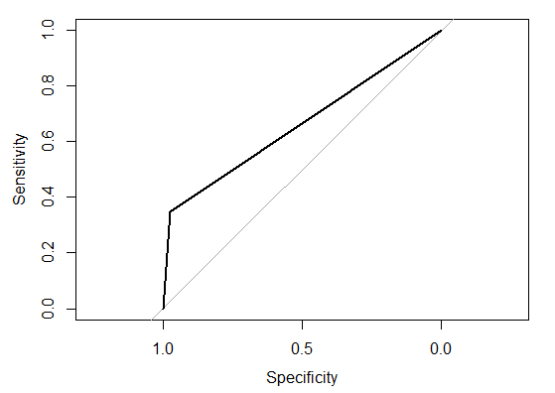

**# 1. Logistic regression**

logit_m =glm(formula = default~. ,data =train_data ,family=&#39;binomial&#39;)

summary(logit_m)

logit_P = predict(logit_m , newdata = test_data[-13] ,type = &#39;response&#39; )

logit_P &lt;- ifelse(logit_P &gt; 0.5,1,0) # Probability check

CM= table(test_data[,13] , logit_P)

print(CM)

err_metric(CM)

#ROC-curve using pROC library

library(pROC)

roc_score=roc(test_data[,13], logit_P) #AUC score

plot(roc_score ,main =&quot;ROC curve -- Logistic Regression &quot;)

**Method II: Using roc.plot() function**

install.packages(&quot;verification&quot;)

library(verification)

x&lt;- c(0,0,0,1,1,1)

y&lt;- c(.7, .7, 0, 1,5,.6)

data&lt;-data.frame(x,y)

names(data)&lt;-c(&quot;yes&quot;,&quot;no&quot;)

roc.plot(data$yes, data$no)

**Output**

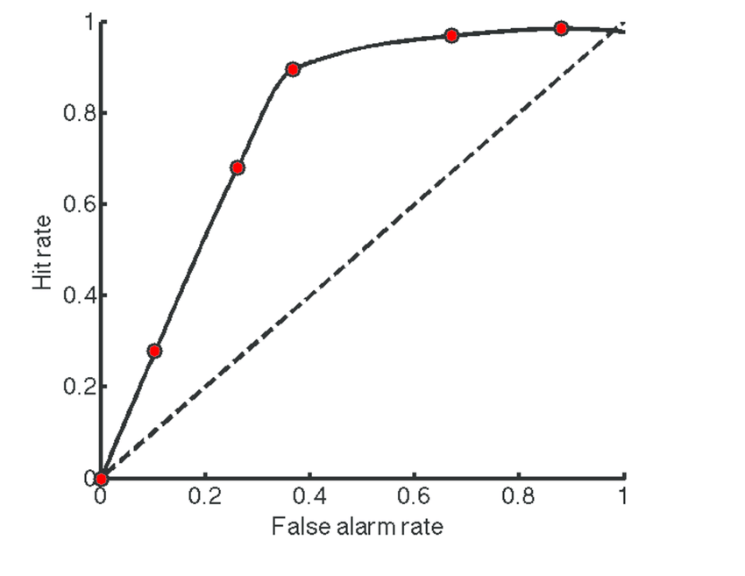

**DATASET EXAMPLE**

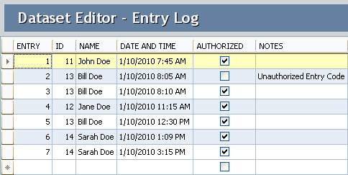

**Phase4 :Development part2**

**Registrar of Company:**

Registrars of Companies (ROC) appointed under Section 609 of the

Companies Act covering the various States and Union Territories are vested

with the primary duty of registering companies and LLPs floated in the

respective states and the Union Territories and ensuring that such companies

and LLPs comply with statutory requirements under the Act. These offices

function as registry of records, relating to the companies registered with

them, which are available for inspection by members of public on payment of

the prescribed fee. The Central Government exercises

**The different feature engineering techniques examples:**

In this blog, we will look at the following feature engineering techniques and understand

their implementations:

• Scaling.

• Normalization.

• Standardization.

• One hot encoding.

• Ordinal Encoding.

• Bucketing/Binning.

• Bag of words.

**• Derived Features.**

Feature based modeling techniques:

Feature-based modeling is the traditional and predominant method of creating 3D

models in CAD/CAM software, which requires defining the geometry and topology of the

model by adding and subtracting features such as sketches, extrusions, fillets, holes,

and patterns.

**What is feature engineering?**

Feature engineering is a machine learning technique that leverages data to create new

variables that aren’t in the training set. It can produce new features for both supervised

and unsupervised learning, with the goal of simplifying and speeding up data

transformations while also enhancing model accuracy. Feature engineering is

required when working with machine learning models. Regardless of the data or

architecture, a terrible feature will have a direct impact on your model.

**Feature engineering consists of various process :**

**• Feature Creation**: Creating features involves creating new variables which will

be most helpful for our model. This can be adding or removing some features. As we

saw above, the cost per sq. ft column was a feature creation.

• **Transformations:** Feature transformation is simply a function that transforms

features from one representation to another. The goal here is to plot and visualise

data, if something is not adding up with the new features we can reduce the number

of features used, speed up training, or increase the accuracy of a certain model.

• **Feature Extraction:** Feature extraction is the process of extracting features

from a data set to identify useful information. Without distorting the original

relationships or significant information, this compresses the amount of data into

manageable quantities for algorithms to process.

**• Exploratory Data Analysis :** Exploratory data analysis (EDA) is a powerful

and simple tool that can be used to improve your understanding of your data, by

exploring its properties. The technique is often applied when the goal is to create

new hypotheses or find patterns in the data. It’s often used on large amounts of

qualitative or quantitative data that haven’t been analyzed before.

**• Benchmark:** A Benchmark model is the end of this article. Now, let’s have a

look at why we need feature engineering in machine learning. A Benchmark Model

is the most user-friendly, dependable, transparent, and interpretable model against

which you can measure your own. It’s a good idea to run test datasets to see if your

new machine learning model outperforms a recognised benchmark. These

benchmarks are often used as measures for comparing the performance between

different machine learning models like neural networks and support vector

machines, linear and non-linear classifiers, or different approaches like bagging and

boosting. To learn more about feature engineering steps and process, check the links

provided at.

**Importance Of Feature Engineering:**

Feature Engineering is a very important step in machine learning. Feature engineering

refers to the process of designing artificial features into an algorithm. These artificial

features are then used by that algorithm in order to improve its performance, or in other

words reap better results. Data scientists spend most of their time with data, and it

becomes important to make models accurate.

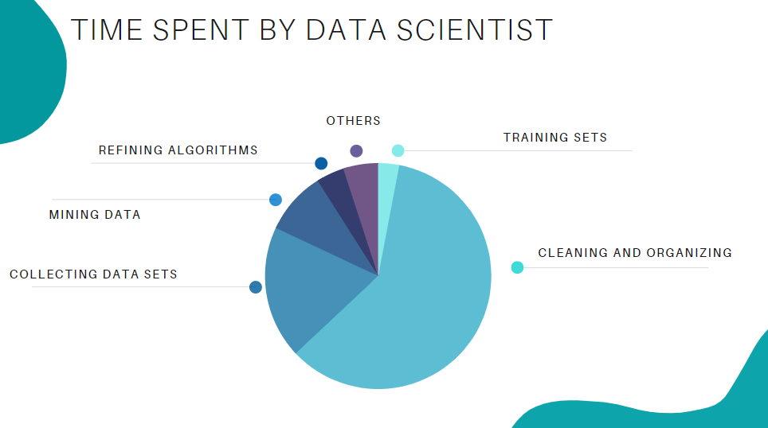

When feature engineering activities are done correctly, the resulting dataset is optimal

and contains all of the important factors that affect the business problem. As a result of

these datasets, the most accurate predictive models and the most useful insights are

produced.

**Feature Engineering Techniques for Machine Learning:**

Lets see a few feature engineering best techniques that you can use. Some of the

techniques listed may work better with certain algorithms or datasets, while others may

be useful in all situations.

**1.Imputation**

When it comes to preparing your data for machine learning, missing values are one of the

most typical issues. Human errors, data flow interruptions, privacy concerns, and other

factors could all contribute to missing values. Missing values have an impact on the

performance of machine learning models for whatever cause. The main goal of

**imputation is to handle these missing values. :**

• Numerical Imputation: To figure out what numbers should be assigned to

people currently in the population, we usually use data from completed surveys or

censuses. These data sets can include information about how many people eat

different types of food, whether they live in a city or country with a cold climate, and

how much they earn every year. That is why numerical imputation is used to fill gaps

in surveys or censuses when certain pieces of information are missing.

#Filling all missing values with 0

data = data.fillna(0)

**• Categorical Imputation**: When dealing with categorical columns, replacing

missing values with the highest value in the column is a smart solution. However, if

you believe the values in the column are evenly distributed and there is no

dominating value, imputing a category like “Other” would be a better choice, as your

imputation is more likely to converge to a random selection in this scenario.

#Max fill function for categorical columns

data[‘column_name’].fillna(data[‘column_name’].value_counts().idxmax(),

inplace=True)

**2.Handling Outliers**

Outlier handling is a technique for removing outliers from a dataset. This method can be

used on a variety of scales to produce a more accurate data representation. This has an

impact on the model’s performance. Depending on the model, the effect could be large or

minimal; for example, linear regression is particularly susceptible to outliers. This

procedure should be completed prior to model training. The various methods of handling

outliers include:

**1. Removal:** Outlier-containing entries are deleted from the distribution. However,

if there are outliers across numerous variables, this strategy may result in a big

chunk of the datasheet being missed.

**2. Replacing values**: Alternatively, the outliers could be handled as missing

values and replaced with suitable imputation.

3**. Capping**: Using an arbitrary value or a value from a variable distribution to

replace the maximum and minimum values.

4. **Discretization :** Discretization is the process of converting continuous

variables, models, and functions into discrete ones. This is accomplished by

constructing a series of continuous intervals (or bins) that span the range of our

desired variable/model/function.

**3.Log Transform**

Log Transform is the most used technique among data scientists. It’s mostly used to turn

a skewed distribution into a normal or less-skewed distribution. We take the log of the

values in a column and utilise those values as the column in this transform. It is used to

handle confusing data, and the data becomes more approximative to normal

applications.

//Log Example

df[log_price] = np.log(df[‘Price’])

**4.One-hot encoding**

A one-hot encoding is a type of encoding in which an element of a finite set is

represented by the index in that set, where only one element has its index set to “1” and

all other elements are assigned indices within the range [0, n-1]. In contrast to binary

encoding schemes, where each bit can represent 2 values (i.e. 0 and 1), this scheme

assigns a unique value for each possible case.

**5.Scaling**

Feature scaling is one of the most pervasive and difficult problems in machine learning,

yet it’s one of the most important things to get right. In order to train a predictive model,

we need data with a known set of features that needs to be scaled up or down as

appropriate. This blog post will explain how feature scaling works and why it’s important

as well as some tips for getting started with feature scaling.

After a scaling operation, the continuous features become similar in terms of range.

Although this step isn’t required for many algorithms, it’s still a good idea to do so.

Distance-based algorithms like k-NN and k-Means, on the other hand, require scaled

continuous features as model input.

**There are two common ways for scaling :**

**Normalization**: All values are scaled in a specified range between 0 and 1 via

normalisation (or min-max normalisation). This modification has no influence on the

feature’s distribution, however it does exacerbate the effects of outliers due to lower

standard deviations. As a result, it is advised that outliers be dealt with prior to

normalisation.

**Standardization**: Standardization (also known as z-score normalisation) is the

process of scaling values while accounting for standard deviation. If the standard

deviation of features differs, the range of those features will likewise differ. The effect of

outliers in the characteristics is reduced as a result. To arrive at a distribution with a 0

mean and 1 variance, all the data points are subtracted by their mean and the result

divided by the distribution’s variance.

**FeatureTools**

Featuretools is a framework to perform automated feature engineering. It excels at

transforming temporal and relational datasets into feature matrices for machine

learning. Featuretools integrates with the machine learning pipeline-building tools you

already have. In a fraction of the time it would take to do it manually, you can load in

pandas dataframes and automatically construct significant features.

**FeatureTools Summary**

• Easy to get started, good documentation and community support

• It helps you construct meaningful features for machine learning and predictive

modelling by combining your raw data with what you know about your data.

• It provides APIs to verify that only legitimate data is utilised for calculations,

preventing label leakage in your feature vectors.

• Featuretools includes a low-level function library that may be layered to generate

features.

• Its AutoML library(EvalML) helps you build, optimize, and evaluate machine

learning pipelines.

• Good at handling relational databases.

**AutoFeat Summary**

• AutoFeat can easily handle categorical features with One hot encoding.

• The AutoFeatRegressor and AutoFeatClassifier models in this package have a similar

interface to scikit-learn models

• General purpose automated feature engineering which is Not good at handling

relational data.

• It is useful in logistical data

**Model training**

Writing and running machine learning algorithms to produce an ML model is the central

component of the ML workflow. A data science team typically uses the model

engineering pipeline, which consists of several procedures, such as model testing,

model evaluation and model packaging, to create the final model.

You can streamline these activities in several ways. For example, you can automate the

machine learning model training process by building a pipeline, which makes it simpler

to scale the solution to larger datasets and maintain and update the model over time.

It is important to understand how crucial and interconnected the stages of model

training, evaluation and testing are in the machine-learning workflow. Model creation is

followed by model training, assessment of the model’s performance on a different

dataset and testing of the model on fresh or previously unexplored data. Since this

process is iterative, it may be necessary to repeat model training several times before

the model’s performance on the testing data is acceptable.

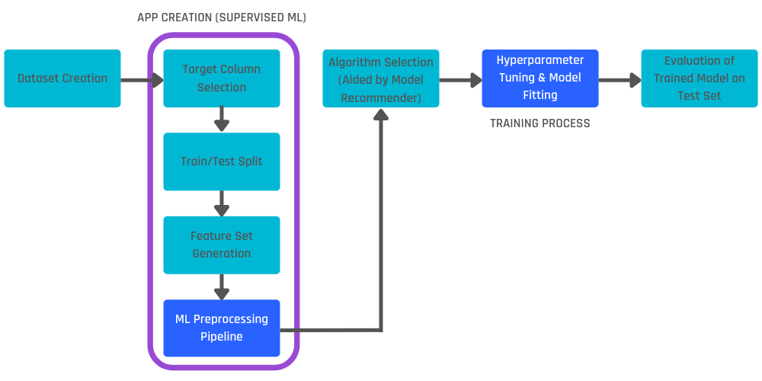

**The model training phase includes these steps/actions:**

• Step1:Depending on the data you need and your learning objectives, choose the

appropriate algorithm.

• Step2:Choose the architecture, model variant or other parameters that will produce the

best results.

• Step3:Set up, fine-tune and create the model parameter values that a machine learning

algorithm eventually learns. The term “hyperparameter” refers to this regulatory

mechanism. In order to get the best results, the model version is chosen with the aid of

this hyperparameter adjustment. Examples include the number of layers, activation

function and learning rate in neural networks, which are all controlled via fine-tuning.

• Step4:To demonstrate which hyperparameters and models are most effective for your

use case, benchmark them.

• Step5:Determine whether the model has the necessary level of explainability.

• Step6Consider using an ensemble technique, which involves running multiple models

concurrently, if applicable, or a more advanced technique if required by the business

challenges or objective.

**Here are a few typical training approaches.**

**• Grid search:** Training the model with all conceivable combinations of hyperparameters

while specifying a range of values for each one.

**• Random search:** Using a set of arbitrarily chosen hyperparameter values that fall within

a predetermined range.

**• Bayesian optimization:** This method employs a probabilistic model to forecast how

various hyperparameter values will perform and to pick the most promising ones for

training.

**• Genetic algorithms: T**o discover the ideal collection of hyperparameters, genetic

algorithms evolve a population of potential hyperparameters over several generations.

**• Manual tuning:** Testing various hyperparameter values and evaluating the model’s

performance.

**Model evaluation**

Model evaluation measures how well a trained machine learning model works to make sure it

meets the original business objectives. The goal of model evaluation is to assess a model’s

ability to predict outcomes correctly and to pinpoint areas for improvement.  To assess a model,

a variety of methods can be applied, such as:

**• Holdout technique:** Data is divided into training and test sets. The model is developed on the

training set, and the test set is used to assess the model’s success.

**• Bootstrapping**: In this method, the model undergoes training using a series of newly

generated datasets. These datasets are crafted by resampling the original dataset, allowing the

same data point to appear multiple times within a resampled dataset. By employing this method

of replacement, the model&#39;s performance is evaluated based on the insights gathered from

these resampled datasets.

**• Cross-validation**: In this method, the data is divided into different subgroups, each of which is

used as a test set while the other subsets are used for training. This technique aids in lowering

the danger of over-fitting which can lead to poor predictive performance.

**• Metrics**: Depending on the kind of issue being solved, different metrics can be used to assess

how well a machine learning model is performing. Accuracy, precision, recall, F1 score, AUC-

ROC and mean squared error are a few typical measures.

**• Visual inspection:** In some circumstances, the output of the model can be visually inspected

to assess the success of the model. For instance, in image classification, the model’s success

can be evaluated by comparing its predictions to the labels applied.