
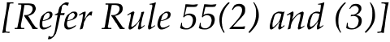






The owner of motor vehicle/authorised dealer of registered vehicle



