1. create two files - student.txt and employee.txt and add them to staging area

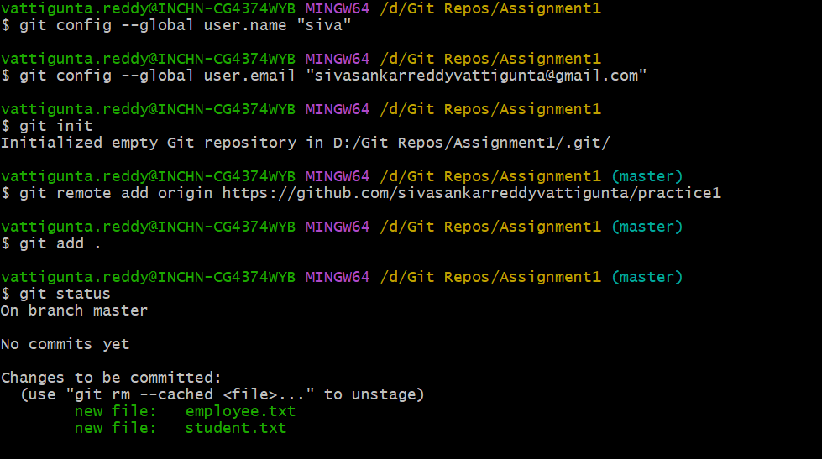  
2) add one more file - dept.txt into staging area but at same time restore the employee.txt and modify some changes inside the student.txt

3) push all files to remote repo

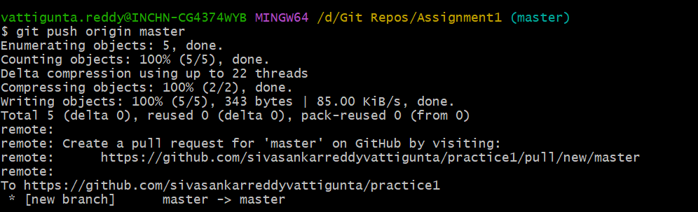  
4) create a new file - hello.txt in remote repos directly and bring to the working directory

5) send all files from working directory to remote repos



6) remove a file from the remote repos and sync the changes into your working directory

