Project Implementation:
On completing the development part, we then ran the application one last time to verify all the functionalities and look for any bugs in it. The user interface of the application looks a bit like the one provided below.
Landing Page :
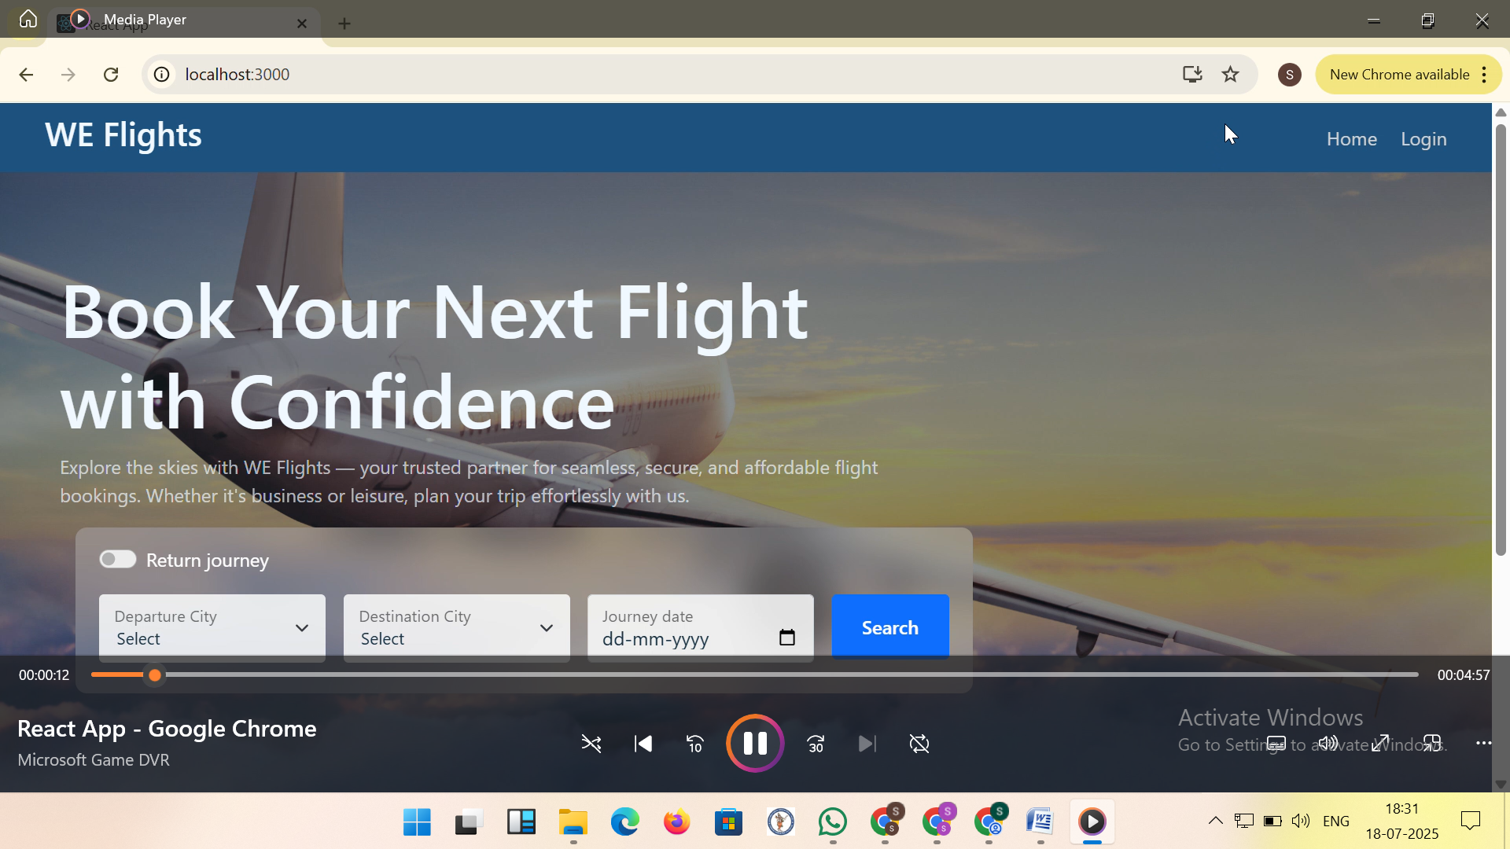
Admin Dashboard :

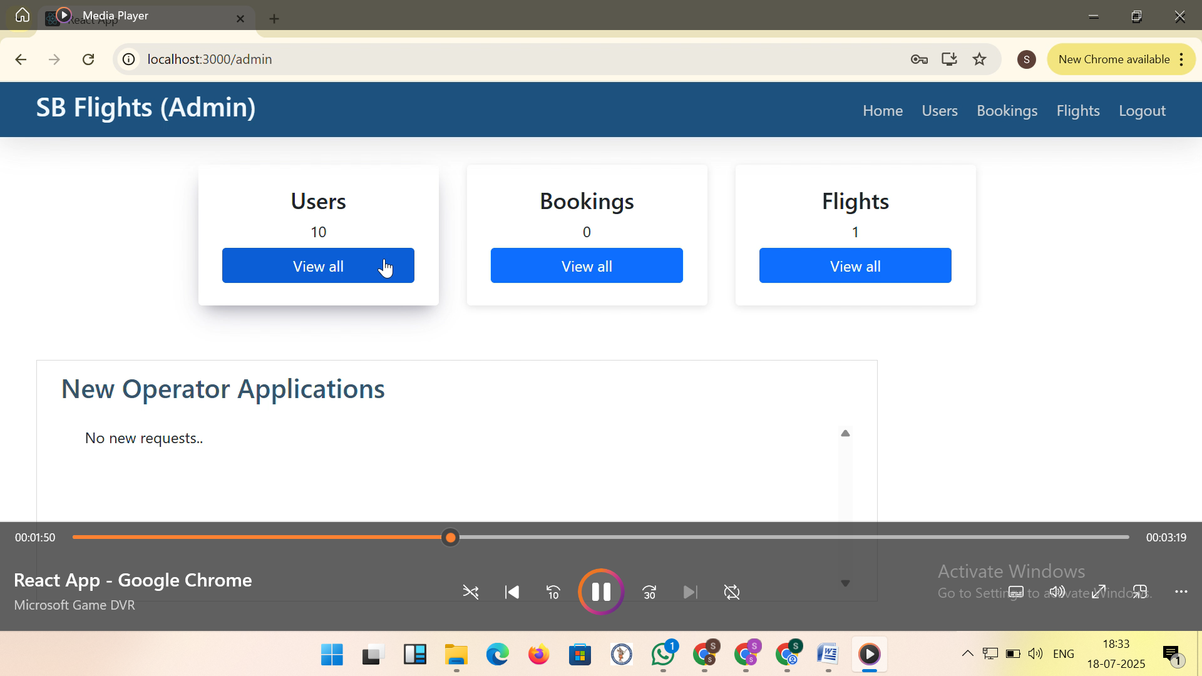

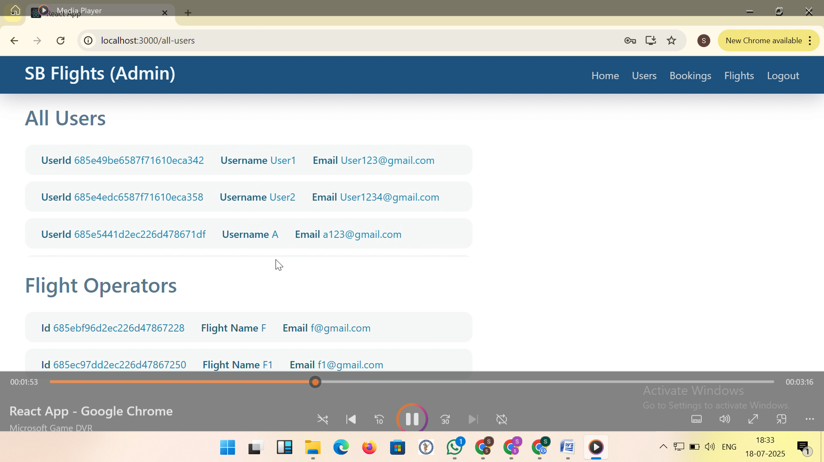
Users List :

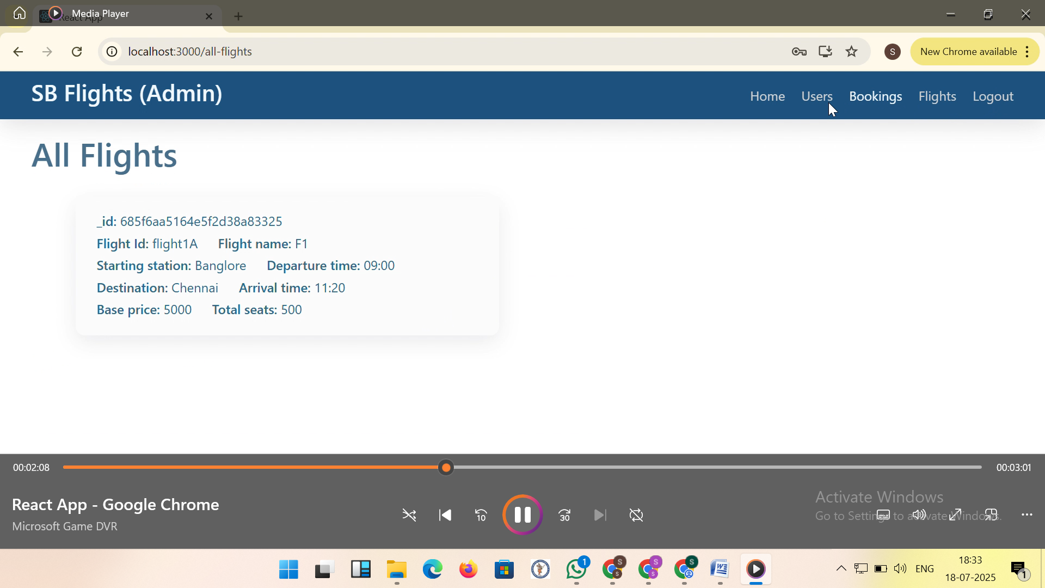

Flights List :
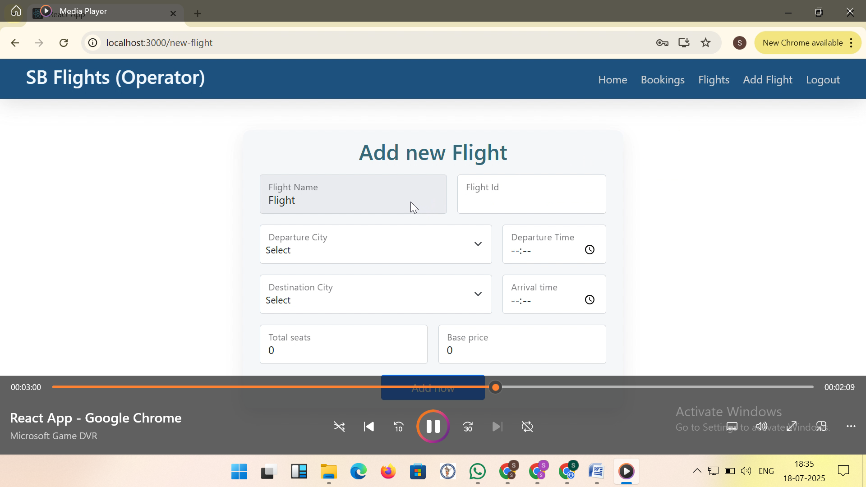

Add New Flight :


Booking Management :
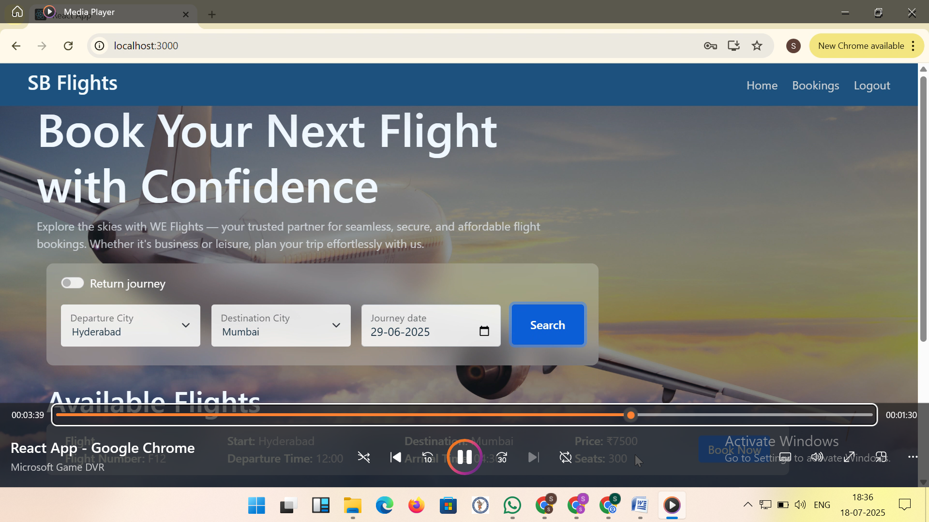

The demo of the Website is available at:
https://drive.google.com/file/d/1JrG5MTU1-wu3uKi6q0i91n0hdZY6KxPD/view?usp=drivesdk

